Use case:  
  
table has   
  
  
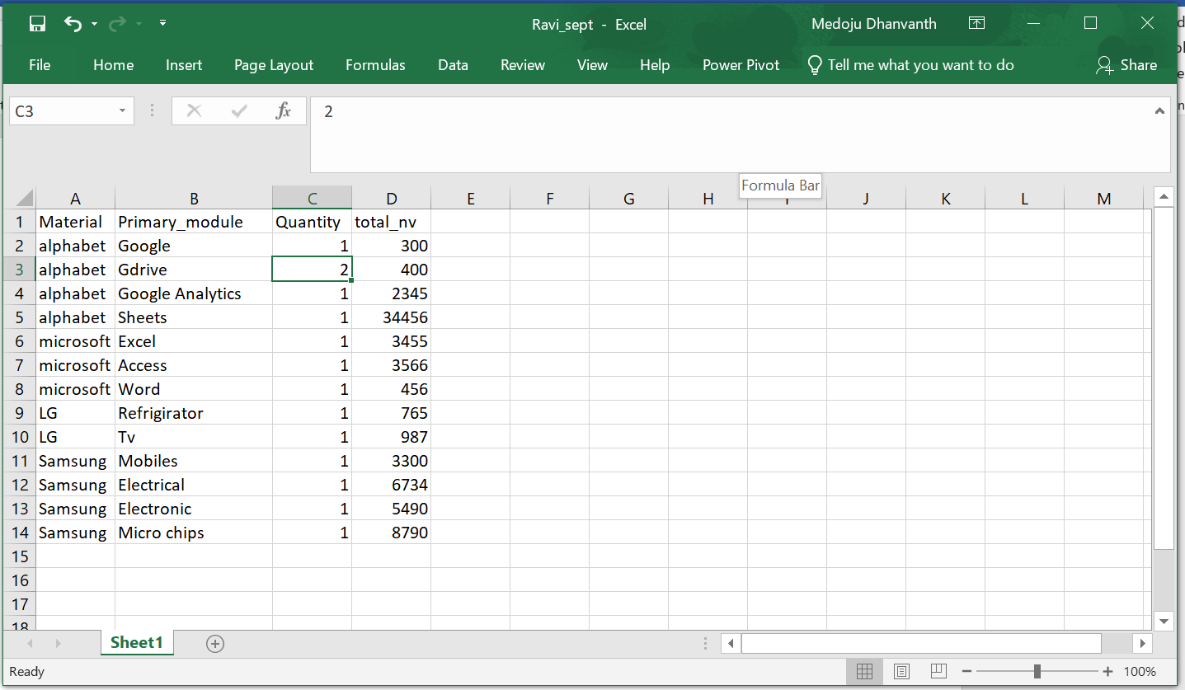  
  
  
so in Power bi  
if we make two table visuals side by side  
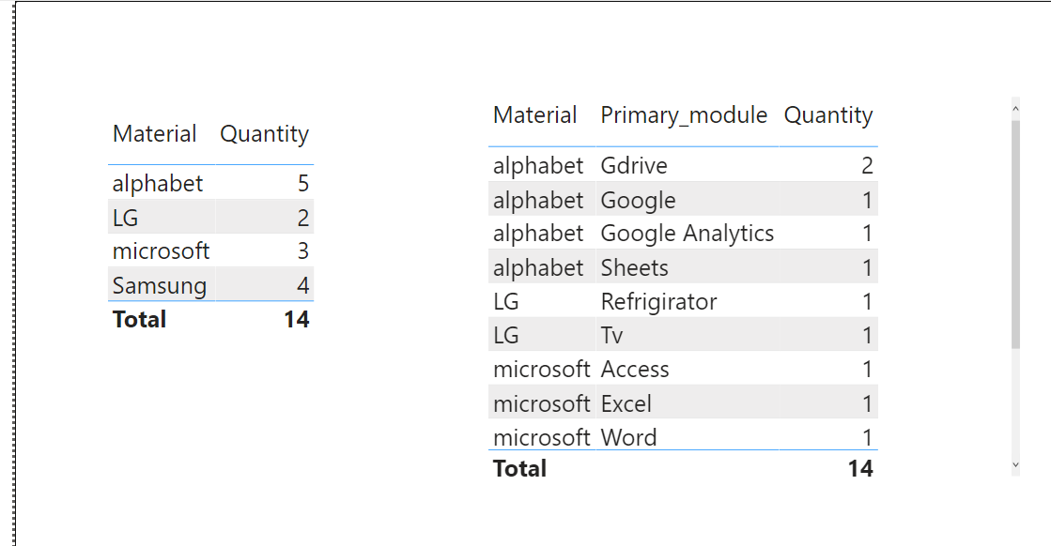  
  
and tried to select at any row in firsttable_visual it need not to filter in second table_visual  
  
Requirement is :  
if we select “alphabet” in firsttable_visual in “second_table_visual” for all “alphabet” row in Quantity column it should show values for other it should show 0  
  
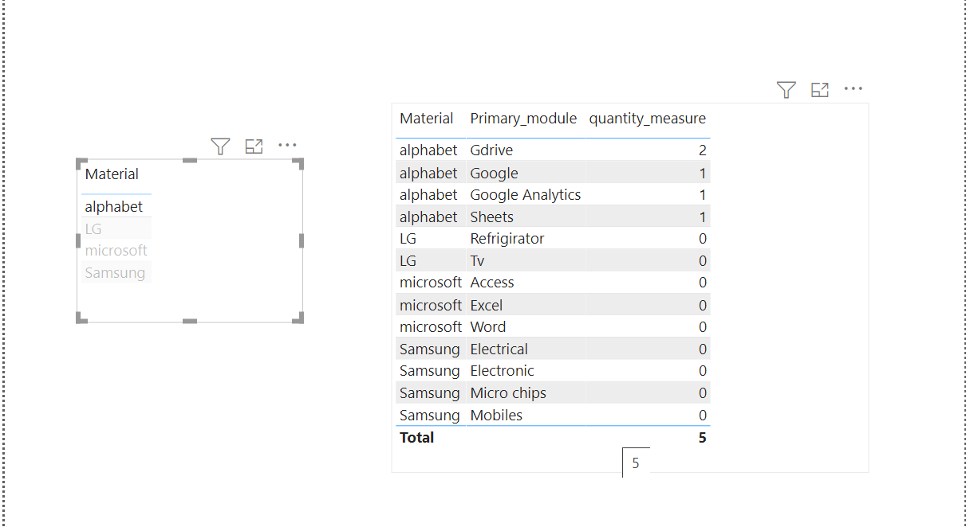  
  
  
  
  
**Not like this** below: general like this  
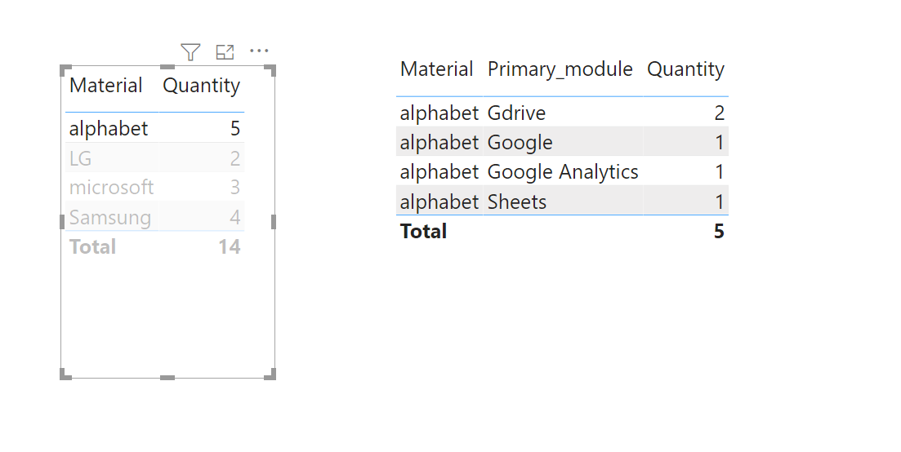  
  
steps:  
we have data like this  
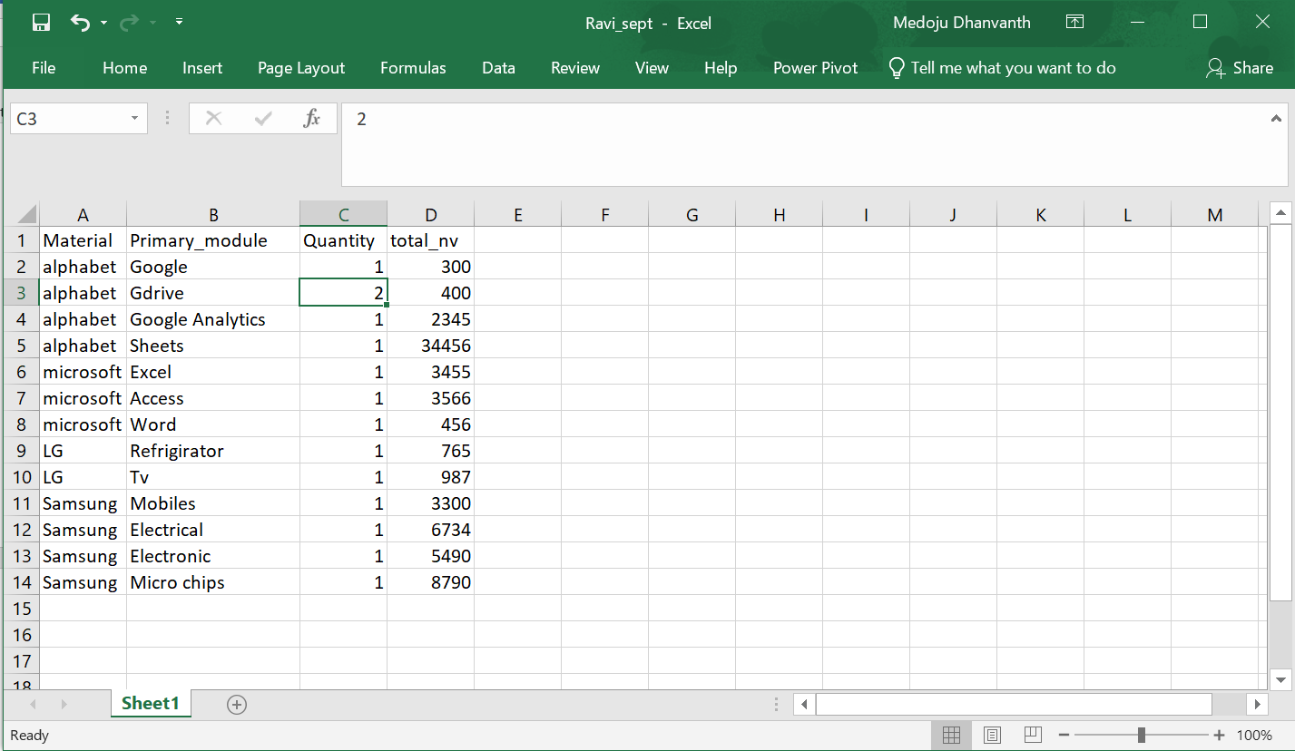  
  
connect same data to once again  
  
1.Now select “Meterial” from duplicate data in first table visual  
  
2.Create a measure in sheet1 dataset   
Selected Material = SELECTEDVALUE ( 'Sheet1 (2)'[Material])  
  
3.Create a one more measure   
Measure = CALCULATE (SUM ( 'Sheet1'[Quantity] ),FILTER ( 'Sheet1','Sheet1'[Material] = [Selected Material] ))  
  
4. Create a one more measure  
Measure2 = = IF([Measure]=BLANK(),0,[Measure])

5.create a one more measure   
quantity_measure = IF(ISFILTERED('Sheet1 (2)'[Material]),[Measure 2],SUM(Sheet1[Quantity]))

Now in Second table visual  
  
select “Material”,”Primary_module”,”Quantity_measure” columns from sheet1 data   
  
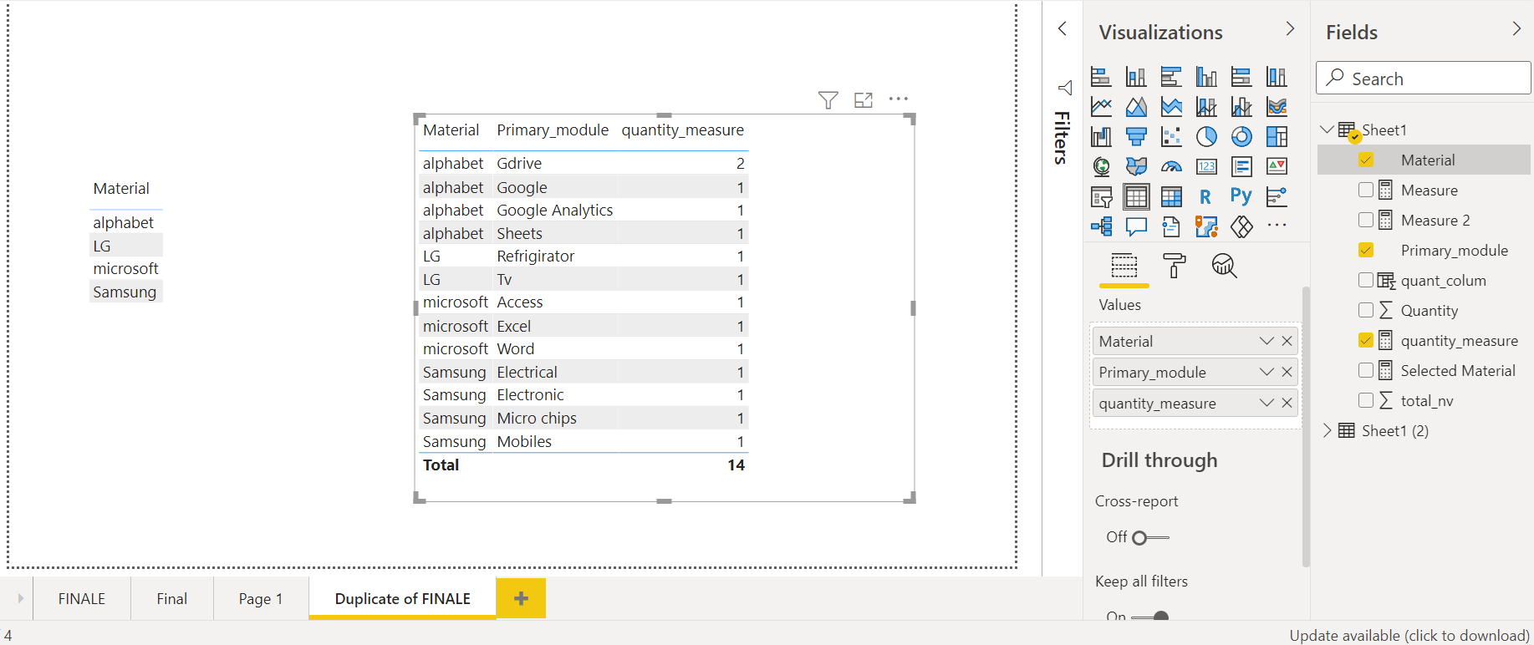

That’s it now we will get like the required format  
