CHAPTER 3
PROJECT DESCRIPTION
3.1 Introduction
This chapter presents a detailed description of the proposed AI-powered Weapon and Criminal Detection System. The project is designed as an intelligent surveillance framework that integrates deep learning-based object detection and face recognition techniques to enhance public safety. The system aims to automatically monitor live video streams, detect the presence of weapons such as guns and knives, recognize known criminals or offenders from a predefined database, and generate alerts for timely intervention.
The project combines computer vision, deep learning, and web technologies into a unified platform. It is structured as a modular system where each component performs a specific function, ensuring scalability, maintainability, and real-time performance. This chapter explains the overall system architecture, working principles, functional modules, data flow, algorithmic approach, and operational workflow in detail.
3.2 Overall System Overview
The proposed system is an AI-driven surveillance solution that processes live video input from CCTV or USB cameras. The system performs real-time frame extraction and applies two primary deep learning models: one for weapon detection and another for face recognition. The outputs from these models are analyzed by a decision module that determines whether a threat exists. If a weapon is detected or a criminal match is identified, the system generates an alert and displays the detection results through a web-based interface.
The system operates in five major stages:
- Video acquisition and preprocessing
- Weapon detection using YOLOv8
- Face detection and recognition using DeepFace
- Threat assessment and decision-making
- Alert generation and monitoring through a web interface
Each stage is interconnected to ensure seamless real-time operation.
3.3 System Architecture
The architecture of the proposed AI-powered Weapon and Criminal Detection System follows a structured pipeline-based design that enables efficient real-time processing and modular implementation. The system is designed to capture live video streams, process visual data using deep learning models, and generate alerts when potential threats are identified. The architecture ensures seamless integration between hardware components, analytical modules, and the web-based monitoring interface.
The system begins with the Video Input Module, which captures live video feeds from CCTV or USB cameras. The video stream is continuously divided into individual frames to allow frame-by-frame analysis. Frame extraction is essential for real-time object detection and facial recognition, as deep learning models operate on image data rather than continuous video streams. Preprocessing operations such as resizing, normalization, and format conversion are applied to optimize frames for model compatibility and faster inference.
After preprocessing, the frames are forwarded simultaneously to two core analytical modules:
- Weapon Detection Module (YOLOv8)
- Face Recognition Module (DeepFace)
The Weapon Detection Module uses the YOLOv8 deep learning model to identify weapons such as guns and knives. YOLOv8 performs object detection by predicting bounding boxes and classification probabilities in a single forward pass, ensuring high-speed inference suitable for real-time surveillance. When a weapon is detected, the model outputs the class label, bounding box coordinates, and confidence score.
In parallel, the Face Recognition Module detects faces within the frame and extracts facial embeddings using DeepFace. These embeddings are compared with stored embeddings in the criminal database. If the similarity score exceeds a predefined threshold, the individual is identified as a known criminal or offender. This dual-processing approach enhances the intelligence of the surveillance system by combining object detection and biometric identification.
The outputs from both modules are transmitted to the Threat Assessment Module, which acts as the decision-making unit. This module evaluates predefined logical rules to determine whether a threat condition exists. For example, detection of a weapon increases the threat level, while simultaneous weapon detection and criminal identification may trigger a high-priority alert.
Once a threat is confirmed, the Alert and Monitoring Module is activated. The system displays annotated frames with bounding boxes and identity labels on a Flask-based web interface. Additionally, alerts such as visual notifications, sound alarms, or event logs are generated to assist security personnel in rapid response.
The architecture is designed with the following considerations:
- Real-time processing capability
- Modular and scalable design
- Efficient resource utilization
- Independent upgrade of detection modules
The integration of weapon detection and face recognition within a unified architecture differentiates this system from standalone detection systems. By combining multiple analytical components into a single framework, the proposed architecture provides a comprehensive intelligent surveillance solution.
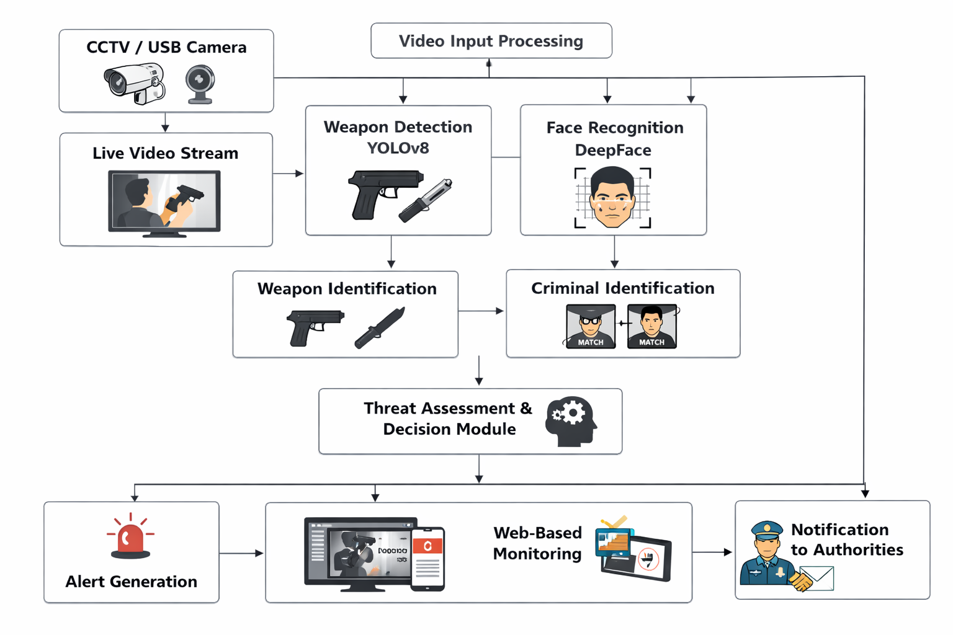
Figure 3.1: Overall System Architecture
3.4 Functional Modules Description
3.4.1 Video Acquisition Module
The video acquisition module is responsible for capturing live video from CCTV or USB cameras. OpenCV is used to access camera hardware and retrieve frames continuously. Each frame is processed sequentially to ensure real-time analysis.
Key functions of this module include:
- Capturing video stream
- Converting video into frames
- Resizing frames for model compatibility
- Passing frames to detection modules
3.4.2 Weapon Detection Module
The weapon detection module uses the YOLOv8 (You Only Look Once version 8) deep learning model. YOLOv8 is a single-stage object detection model known for its high speed and accuracy. It performs object detection by dividing the image into grids and predicting bounding boxes along with class probabilities.
In this project, the YOLOv8 model is trained or fine-tuned to detect weapons such as guns and knives. When a frame is passed to the model, it returns:
- Bounding box coordinates
- Class label (gun, knife, etc.)
- Confidence score
If the confidence score exceeds a predefined threshold, the system considers the detection valid and marks the weapon on the frame using a bounding box. This module ensures real-time detection with minimal latency.
The advantages of using YOLOv8 include:
- Faster inference speed
- High detection accuracy
- Efficient handling of small objects
- Reduced computational complexity compared to earlier models
3.4.3 Face Detection and Recognition Module
The face recognition module is implemented using the DeepFace framework. DeepFace is a lightweight facial recognition library that supports multiple deep learning backends. It performs two main tasks: face detection and face matching.
Initially, faces are detected from the video frame. The detected face is then converted into an embedding vector using a deep neural network. This embedding represents unique facial features. The embedding is compared with stored embeddings in the criminal database.
If the similarity score exceeds the defined threshold, the system identifies the individual as a known criminal or offender. The matched individual’s name or ID is displayed on the frame.
This module handles:
- Face detection
- Feature extraction
- Database comparison
- Match confirmation
The effectiveness of this module depends on the quality of the database and proper threshold tuning.
3.4.4 Criminal Database Module
The criminal database contains images of known offenders. Each image is processed beforehand to extract facial embeddings, which are stored for comparison. The database may be implemented using structured folders or a lightweight database such as SQLite.
The module supports:
- Addition of new criminal records
- Removal of outdated records
- Secure storage of facial data
- Efficient retrieval for matching
Proper database management is essential for maintaining accuracy and reliability.
3.4.5 Threat Assessment Module
The threat assessment module acts as the decision-making unit of the system. It receives inputs from both the weapon detection module and the face recognition module. Based on predefined logical conditions, it determines whether a threat is present.
For example:
- If a weapon is detected, threat level increases.
- If a criminal is recognized, threat level increases.
- If both occur simultaneously, threat level is considered critical.
This module ensures intelligent evaluation rather than isolated detection.
3.4.6 Alert Generation Module
Once a threat is identified, the alert generation module activates. Alerts may include:
- Visual notification on the web interface
- Audio alarm or buzzer
- Log entry with timestamp
- Email notification to authorities
This module ensures immediate response capability.

3.4.7 Web-Based Monitoring Module
The web interface is developed using Flask. It provides:
- Live video display
- Detection visualization
- Alert messages
- Log records
The interface allows authorized users to monitor the system efficiently. It also supports authentication for secure access.
3.5 System Workflow
The workflow of the system is sequential and real-time. The camera captures live video, which is converted into frames. Each frame undergoes object detection for weapons and facial recognition simultaneously. The outputs are evaluated by the decision module. If a threat is detected, alerts are triggered and displayed on the web interface.
The workflow ensures continuous monitoring without manual intervention.
3.6 Algorithmic Approach
The system follows the algorithm below:
- Start video capture.
- Read frame from camera.
- Preprocess frame.
- Apply YOLOv8 for weapon detection.
- Apply DeepFace for face recognition.
- Compare outputs with thresholds.
- If weapon detected OR criminal matched, generate alert.
- Display annotated frame.
- Repeat until system stops.
This algorithm ensures systematic operation.
3.7 Data Flow Description
The data flow begins with raw video input. Frames are extracted and forwarded to detection modules. Detection results are passed to the threat module. The final output is visualized and logged. This structured data flow ensures clarity in processing stages.
3.8 Advantages of Proposed System
The proposed system offers:
- Integrated weapon and criminal detection
- Real-time monitoring capability
- Automated alert generation
- Reduced human dependency
- Modular architecture for future expansion

