SmartSortingTransferLearningforIdentifyingRottenFruitsandVegetables

Track: Artificial Intelligence and Machine learning Team Lead: Meduru Dilip
Mail Id : dilipmeduru971gmail.com

Team Members:

Nakkala Dora Babu

K Keerthi Sudha

Submitted By:
- Meduru Dilip
- Annamacharya Institute of Technology & Sciences
- Electronics and Communication Engineering
- Roll No: 23AK5A0407

Abstract:
This project introduces Smart Sorting, a computer vision solution that utilizes Transfer Learning to detect and classify spoiled fruits and vegetables. The main goal is to streamline the quality control process in the agricultural sector by minimizing manual errors and enhancing operational efficiency. The system is built using a Convolutional Neural Network (CNN) architecture based on the VGG16 model.

Introduction:
Sorting perishable items such as fruits and vegetables by hand is often slow, inconsistent, and error-prone. This project proposes an automated approach using deep learning techniques, specifically transfer learning with pre-trained models, to deliver a more accurate, scalable, and cost-efficient solution forquality assessment in the agricultural sector.
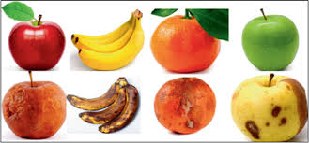

Problem Statement:
Quality control with in the food supply chain presents not able challenges.

  - The in efficiency and inconsistency of manual sorting methods
  - Increased waste resulting from delayed identification of spoilage
  - The demand for real-time, on-the-spot sorting solutions in households and localmarkets

ARCHITECTURE:
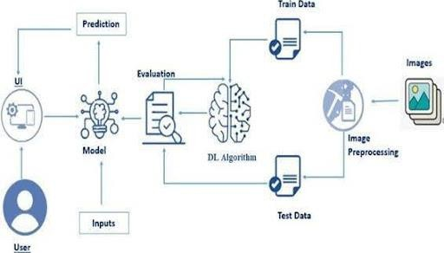

PREREQUISITES:
  - To complete this project, you must require the following software, concepts, and packages
    - Anaconda Navigator:
    - Refer to the link below to download Anaconda Navigator
    - Python packages:
    - Open anaconda prompt as administrator
    - Type“ pip install numpy ” and click enter.
    - Type“ pip install pandas” and click enter.
    - Type“ pip install scikit-learn” and click enter.
    - Type” pip install matplotlib” and click enter.
    - Type” pip install scipy” and click enter.
    - Type” pip install seaborn” and click enter.
    - Type” pip install tenser flow” and click enter.
    - Type“ pip install Flask” and click enter.

PRIOR KNOWLEDGE
  - DL Concepts
    - NeuralNetworks::https://www.analyticsvidhya.com/blog/2020/02/cnn-vs-rnn-vs-mlp-analyzing-3-types-of-neural-networks-in-deep-learning/
    - DeepLearningFrameworks::https://www.knowledgehut.com/blog/data-science/pytorch-vs-tensorflow
    - TransferLearning:https://towardsdatascience.com/a-demonstration-of-transfer-learning-of-vgg-convolutional-neural-network-pre-trained-model-with-c9f5b8b1ab0a

    - VGG16: https://www.geeksforgeeks.org/vgg-16-cnn-model/
    - Convolutional Neural Networks
(CNNs):https://www.analyticsvidhya.com/blog/2021/05/convolutional-neural-networks-cnn/s://www.javatpoint.com/k-nearest-neighbor-algorithm-for-machine-learning
    - OverfittingandRegularization:https://www.analyticsvidhya.com/blog/2021/07/prevent-overfitting-using-regularization-techniques/
    - Optimizers:https://www.analyticsvidhya.com/blog/2021/10/a-comprehensive-guide-on-deep-learning-optimizers/
  - Flask Basics: https://www.youtube.com/watch?v=lj4I_CvBnt0

PROJECT OBJECTIVES
By the end of this project, you will:
  - Know fundamental concepts and techniques used for Deep Learning.
  - Gain a broad understanding of data.
  - Haveknowledgeofpre-processingthedata/transformationtechniquesonoutliersandsome visualization concepts.

Project Structure
Create the Project folder which contains files as shown below
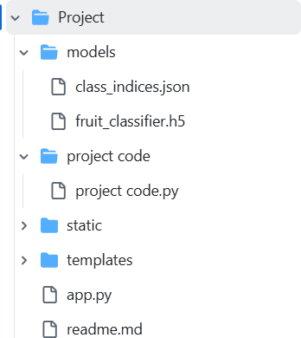

DATA COLLECTION AND PREPARATION
MachineLearningreliessignificantlyondata,asitformsthefoundationfortrainingeffectivealgorithms.In this section, users can access and download the necessary dataset required for model development and evaluation.

COLLECTING THE DATASET

Activity1:Download the dataset

There are several open-source platforms available for accessing datasets, such as Kaggle, the UCI Machine Learning Repository, and others. For this project, we utilize a dataset consisting of 28 classes of fruits and vegetables, which can be downloaded directly from Kaggle or accessed via the Kaggle API.
Link: Dataset

Data Visualization
The given Python code begins by importing essential libraries for image handling and manipulation. It then selects a random image file from a designated directory and displays it using the Image module from python. This functionality is particularly useful for tasks such as exploring image datasets or testing image processing workflows by visualizing random samples from the data.

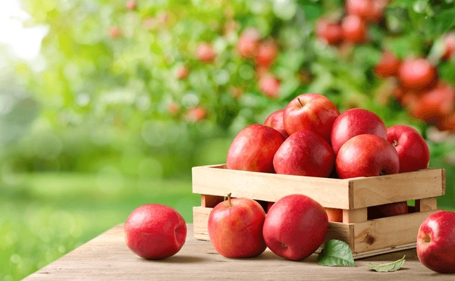

DATA AUGMENTATION
Data augmentation is a widely used technique in machine learning, especially in computer vision tasks like image classification. In projects such as distinguishing between healthy and rotten fruits and vegetables, augmentation helps improve model performance by artificially expanding the training dataset. This is achieved by applying various transformations—such as rotation, flipping, scaling, and adjustments in brightness or contrast—to existing images. These modifications enhance the diversity of the data and help the model become more robust to real-world variations.

For the 28-class classification task in this project, data augmentation typically boosts the model’s ability to generalize by simulating the different ways objects may appear in actual scenarios. However, in this specific implementation, the dataset used was already preprocessed and cropped from an augmented dataset. Therefore, data augmentation was intentionally skipped. While this slightly increased the training time, it had minimal impact on the model's accuracy.

SPLIT DATA AND MODEL BUILDING

Train-Test Split:

In this project, the dataset has been pre-divided into separate training and testing sets, eliminating the need for manual data splitting.
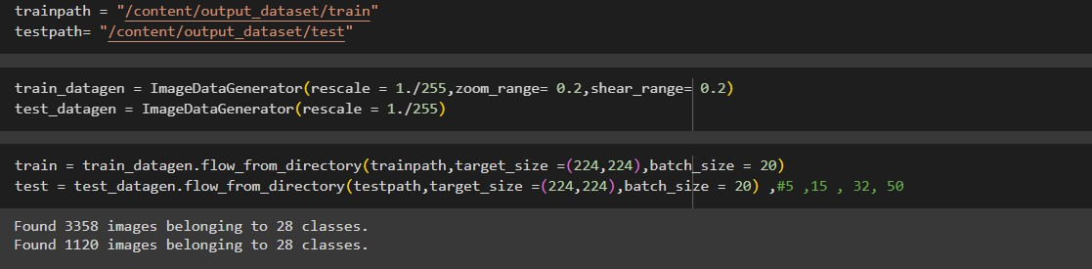

Model Building:

VGG16 Transfer Learning Model

The model in this project leverages the pre-trained VGG16 architecture with its convolutional base layers frozen to retain previously learned features. Built using a sequential structure, the model includes the VGG16 base, followed by a flattening layer, a dropout layer for regularization, and a dense output layer with Soft Max activation to classify images into five categories.

The model is compiled with the Adam optimizer and sparse categorical cross-entropy as the loss function. Training is carried out over 10 epochs using a data generator for the training set. To improve performance and avoid over fitting, Model Checkpoint and Early Stopping callbacks are implemented. The best version of the trained model is saved as fruit_classifier.h5 for future use.

A model summary is provided post-compilation, displaying the complete architecture, including the number of layers and trainable parameters.

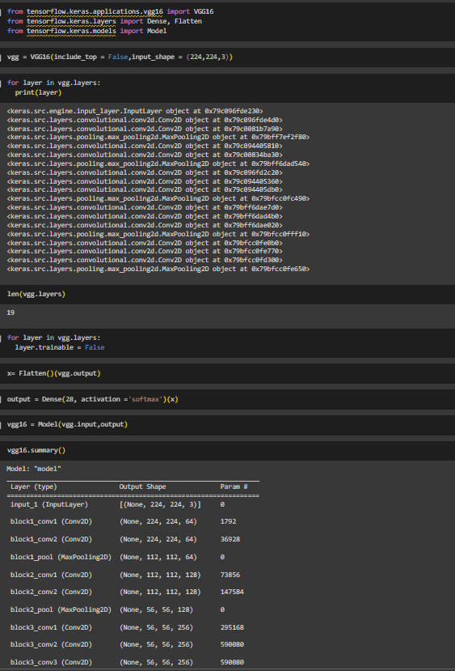

TESTING MODEL & DATA PREDICTION
The trained VGG16 model is evaluated using the predict () function to generate prediction seen data. This step helps verify the model’s performance and its ability to correctly classify images based on the learned features.
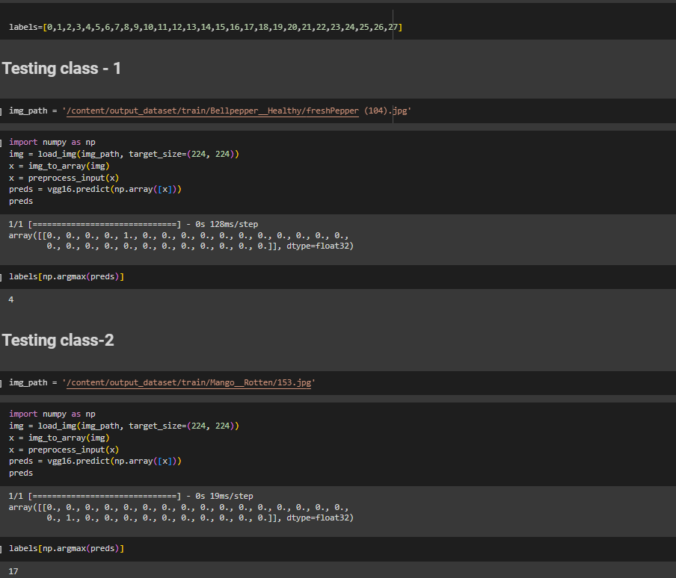

SAVING THE MODEL
Finally, we have chosen the best model now saving that model
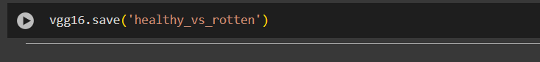

Objective:
- Build a Machine Learning Model to classify fruits and vegetables as healthy or rotten using image data.
- DevelopaWeb-BasedApplicationforuserstoeasilyuploadandclassifyproduceimages in real-time.
- MinimizeFoodWasteandHumanEffortbyautomatingthequalitycontrolprocessand reducing manual inspection.

Scenarios of Application:
- Food Processing Plants
- Supermarkets
- Smart Home

Tools and Technologies Used:
- Anaconda, Python, Flask
- Libraries: NumPy, Pandas, Scikit-learn, Tensor Flow, Matplotlib

Concepts and Prerequisites:
- Deep Learning & CNN
- Transfer Learning using VGG16
- Flask for web deployment

Methodology:
- Dataset:28-classfruit/vegetable images from Kaggle
- Preprocessing: Normalization, Augmentation
- Model:VGG16withSoftMax,trainedover10epochs
- Accuracy validated via prediction samples

System Architecture:
  - UI Input
  - Flask API
  - Model Prediction
  - Output Displayed

Application Building
In this section, we develop a web application integrated with the trained machine learning model. A user- friendly interface (UI) is provided, allowing users to upload images for prediction. The input is passed to the saved model, and the classification result is displayed directly on the interface.

Key Steps Involved:
  - Creating HTML Pages: Designing the front- for image upload and result display.
  - Developing Server-Side Script: Implementing the back end logic to handle image input.

Results and Observations:
The model accurately classified various test same such as:
  - Rotten Apple
  - Healthy Apple
It supports classification across 28 categories of fruits and vegetables, including examples like Apples (chopped), Banana, Capsicum, Cucumber, Okra (Lady Finger), Oranges, Potato, and Tomato—in both fresh and rotten conditions. The predictions were consistently accurate, show casing the models stability to generalize across diverse inputs and confirming its effectiveness for real-time freshness detection.
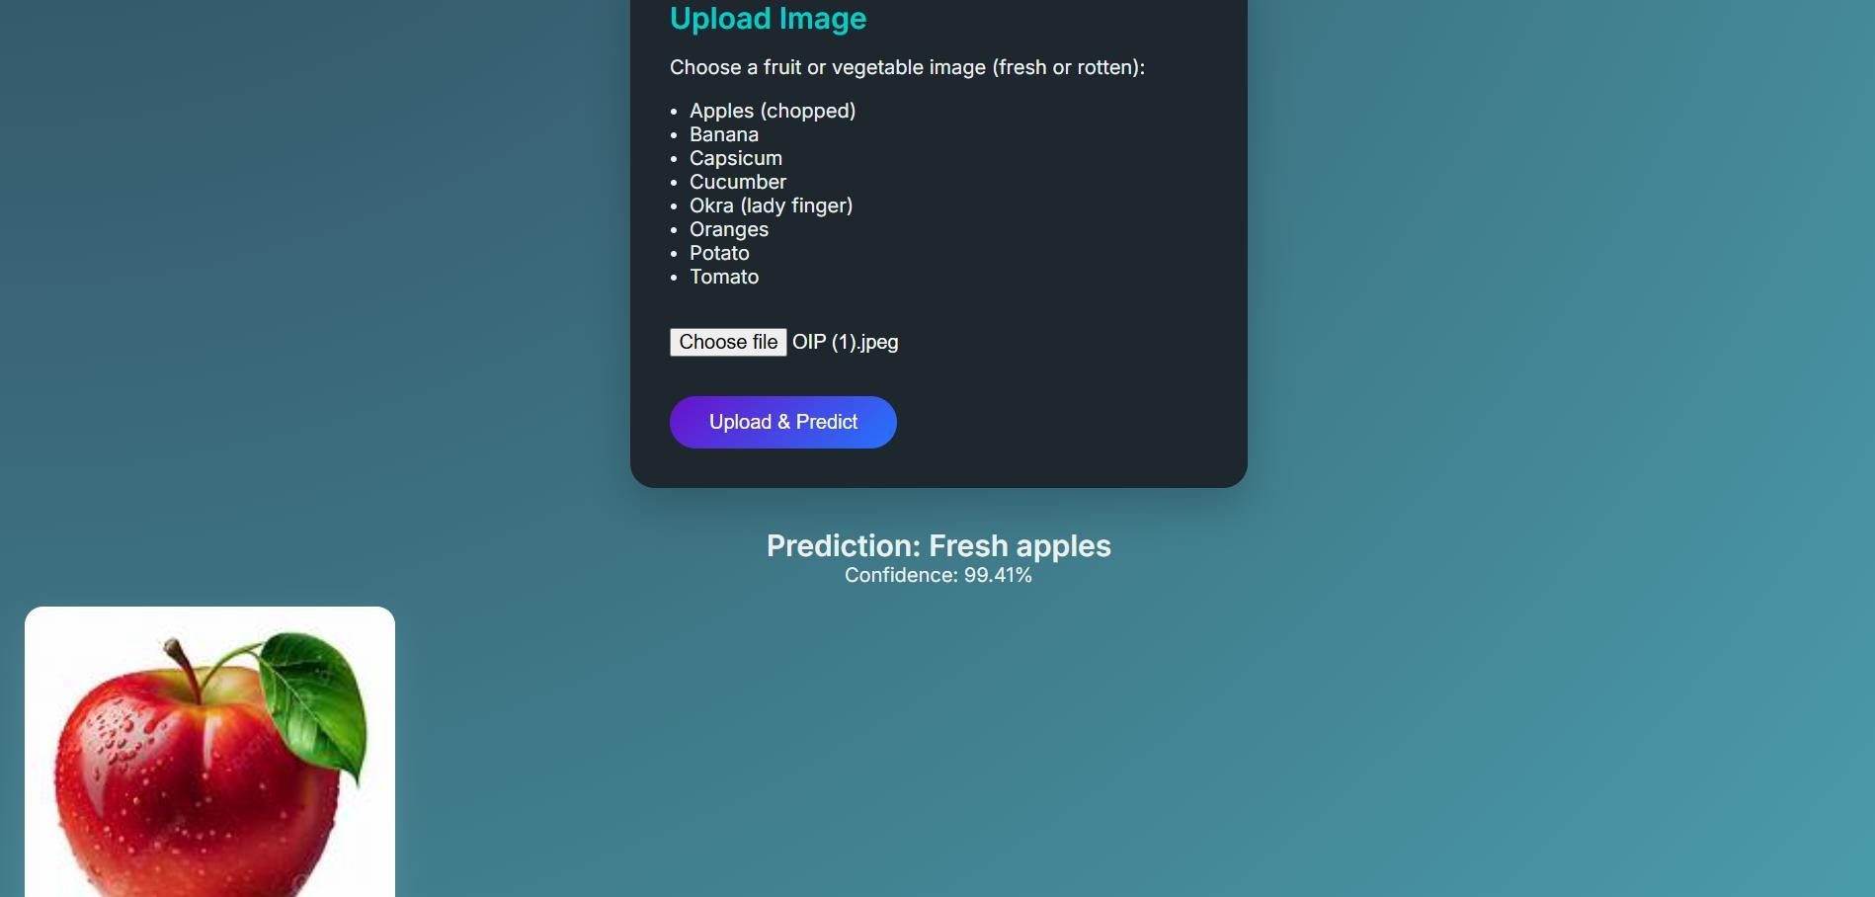
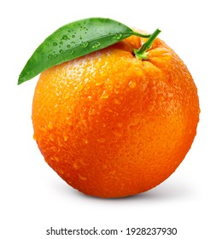

Conclusion:
This project demonstrate show transfer learning can enable efficient image-based classification and automation in the agricultural sector, significantly reducing both food waste and reliance on manual lab.
3. Applications:
  - Broader spoilage detection
  - IoT integration
  - Mobile app support

