Exp2 7th/8th aug

**Principles of web designing**

**Websites that are not well designed tend to perform poorly and have sub-optimal Google Analytics metrics (e.g. high bounce rates, low time on site, low pages per visit and low conversions).**

**The top 10 web design principles that will make your website aesthetically pleasing, easy to use, engaging, and effective.**

1. Purpose: Good web design always caters to the needs of the user. Are your web visitors looking for information, entertainment, some type of interaction, or to transact with your business? Each page of your website needs to have a clear purpose, and to fulfill a specific need for your website users in the most effective way possible.

2. Communication: People on the web tend to want information quickly, so it is important to communicate clearly, and make your information easy to read and digest. Some effective tactics to include in your web design include: organising information using headlines and sub headlines, using bullet points instead of long windy sentences, and cutting the waffle.

3. Typefaces: In general, Sans Serif fonts such as Arial and Verdana are easier to read online (Sans Serif fonts are contemporary looking fonts without decorative finishes). The ideal font size for reading easily online is 16px and stick to a maximum of 3 typefaces in a maximum of 3 point sizes to keep your design streamlined. Principles of effective web design_Serif vs Sans Serif Typography

4. Colours: A well thought out colour palette can go a long way to enhance the user experience. Complementary colours create balance and harmony. Using contrasting colours for the text and background will make reading easier on the eye. Vibrant colours create emotion and should be used sparingly (e.g. for buttons and call to actions). Last but not least, white space/ negative space is very effective at giving your website a modern and uncluttered look.

5. Images: A picture can speak a thousand words, and choosing the right images for your website can help with brand positioning and connecting with your target audience. If you don’t have high quality professional photos on hand, consider purchasing stock photos to lift the look of your website. Also consider using infographics, videos and graphics as these can be much more effective at communicating than even the most well written piece of text.

6. Navigation:Navigation is about how easy it is for people to take action and move around your website. Some tactics for effective navigation include a logical page hierarchy, using bread crumbs, designing clickable buttons, and following the ‘three click rule’ which means users will be able to find the information they are looking for within three clicks.

7. Grid based layouts: Placing content randomly on your web page can end up with a haphazard appearance that is messy. Grid based layouts arrange content into sections, columns and boxes that line up and feel balanced, which leads to a better looking website design.

8. “F” Pattern design: Eye tracking studies have identified that people scan computer screens in an “F” pattern. Most of what people see is in the top and left of the screen and the right side of the screen is rarely seen. Rather than trying to force the viewer’s visual flow, effectively designed websites will work with a reader’s natural behaviour and display information in order of importance (left to right, and top to bottom). Principles of effective web design_F Layout

9. Load time: Everybody hates a website that takes ages to load. Tips to make page load times more effective include optimising image sizes (size and scale), combining code into a central CSS or JavaScript file (this reduces HTTP requests) and minify HTML, CSS, JavaScript (compressed to speed up their load time).

1. 10: Mobile friendly: It is now commonplace to access websites from multiple devices with multiple screen sizes, so it is important to consider if your website is mobile friendly. If your website is not mobile friendly, you can either rebuild it in a responsive layout (this means your website will adjust to different screen widths) or you can build a dedicated mobile site (a separate website optimised specifically for mobile users). Mobile Friendly Web Design It is easy to create a beautiful and functional website, simply by keeping these design elements in mind. Have you got a website design that needs reviewing or optimising? Or perhaps, you are planning a website and you are looking to get the design right from the ground up. Either way, these principles of effective web design can help your website be more engaging, useful, and memorable for visitors.

**Steps in the Process of web Designing**

* Figure out what the focus of the website will be.

For example:

A web store.

Information hub for established clients.

Branding website.

* What specific features do you want in the website.

A shopping cart for an online store

A password protected section of the website

* Create a list of sections for your website and give them a hierarchy of importance.
* Write out your content and finalize it.
* Find a style / look that meets your website’s and your industry’s requirements.

Hire a graphic designer / web designer

Come up with our own design

Buy ourselves a website template and save time and money.

* Build the website.
* Evaluate the website and make the required changes / updates.

some of the things we should be looking for:

Clean easy to update design/structure.

Fast loading 'light' pages.

Intelligent use of technology

The website’s ability to convey the meaning/message of the website quickly if not instantly.

* Go live – register a domain, find a host, upload the website.

Register a domain

Find a hosting company

Upload the website

**Rules of Web Design**

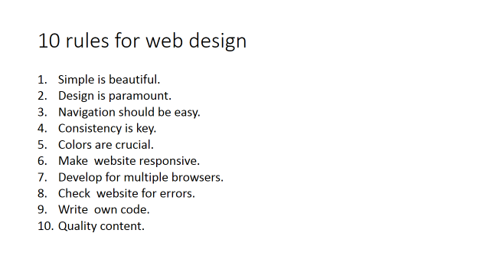

**Simple is beautiful.**

Cramming too much into each page creates confusion. Visitors get frustrated when they have to scan through rows of links and images to find what they are looking for. By keeping your pages simple, your website will be easier to use.

**Design is paramount.**

When you meet someone for the first time, you want to make a good first impression. The same should be true for your website. The overall look and feel of your site is the first thing your visitors will notice.

**Navigation should be intuitive.**

There are few things more frustrating than not being able to find what you want on a website. Pages should be well-organized with a top-down design so that visitors can easily browse through the different sections of your site.

**Consistency is key.**

Visitors shouldn't feel like they are visiting a new website each time they open a new page on your site. Consistent design across the pages within your site makes navigation a much easier task.

**Colors are crucial.**

Color selection can make or break a website. Most of us have visited websites that are simply painful to look at. When choosing colors, use a consistent palette of colors that don't clash and make sure there is a strong contrast between the text and the background.

**Make your website responsive.**

People will access your website using a wide variety of devices – from smartphones to desktop computers. Therefore, it is important that your website displays correctly on different screen sizes. CSS media queries are a great way to implement responsive web design.

**Develop for multiple browsers.**

Browsers are supposed to render webpages the same way, but they don't. Therefore, make sure to check your website in multiple browsers to make sure everything appears correctly. It is best to catch problems ahead of time instead of relying on complaints from your visitors.

**Check your website for errors.**

As any experienced editor will tell you, a great piece of work can be tarnished by a small error. If you're a webmaster, check your websites on a regular basis for typos, broken links, and images that do not load correctly.

**Write your own code.**

Whether it's HTML or PHP, nothing beats writing your code from scratch. If you build your site from templates and pre-written scripts, you will be clueless when something goes wrong. When you code your own pages, you have full control over how they look and act.

**Don't forget the content.**

Even if your site is beautifully designed, it is only an empty shell without content. A good website has both great design and great content. Therefore, make sure your pages have unique, original content that makes them worth visiting.