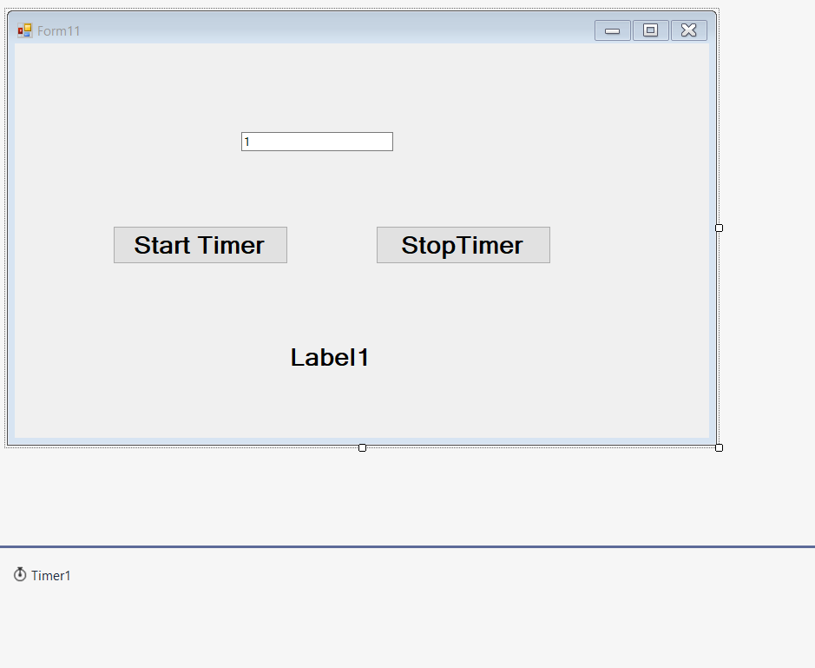

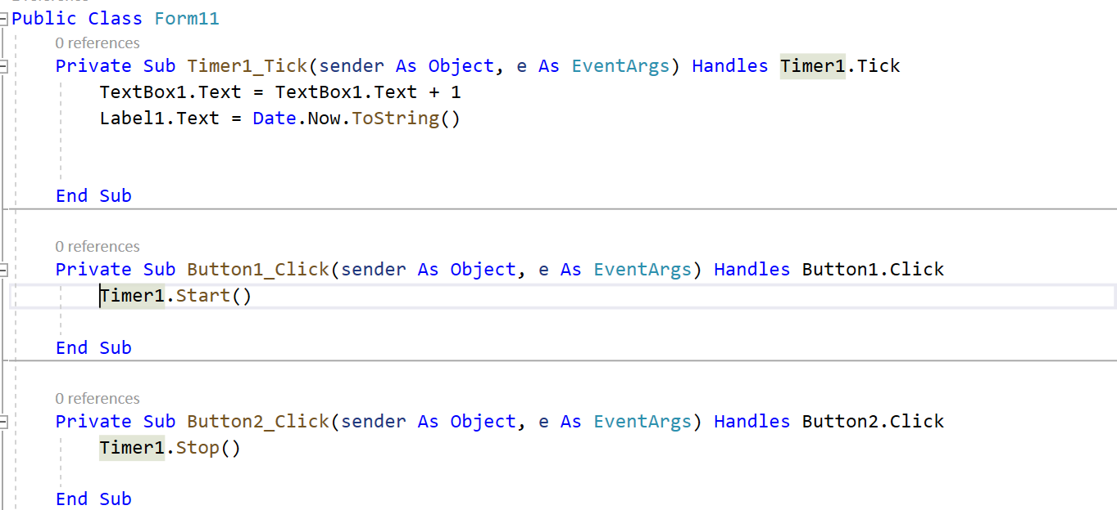

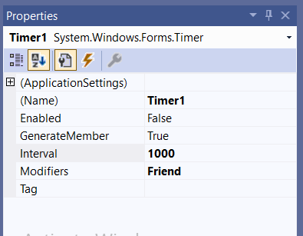

2)  
**MDI Form Example**

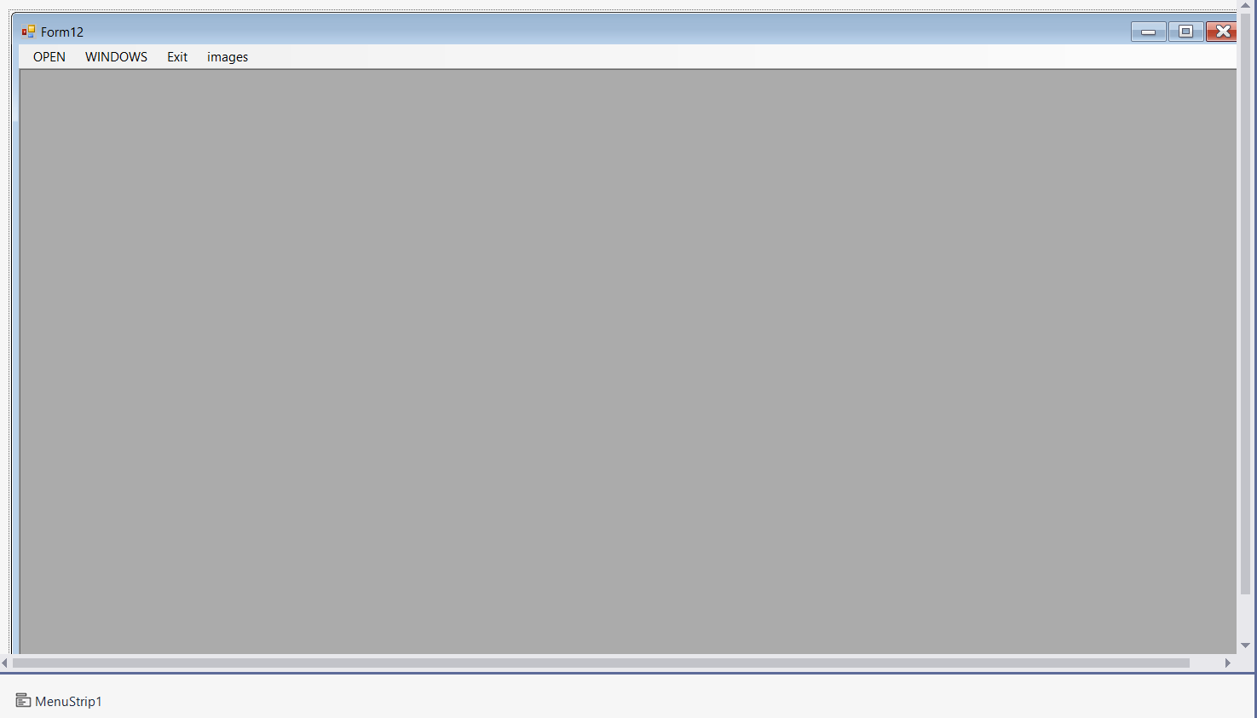

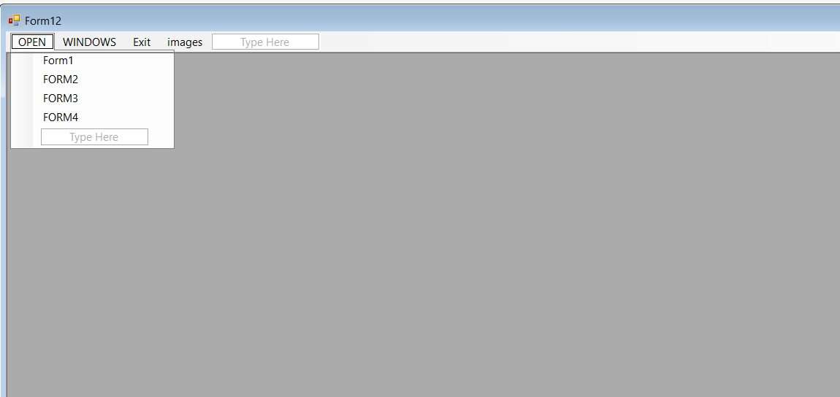

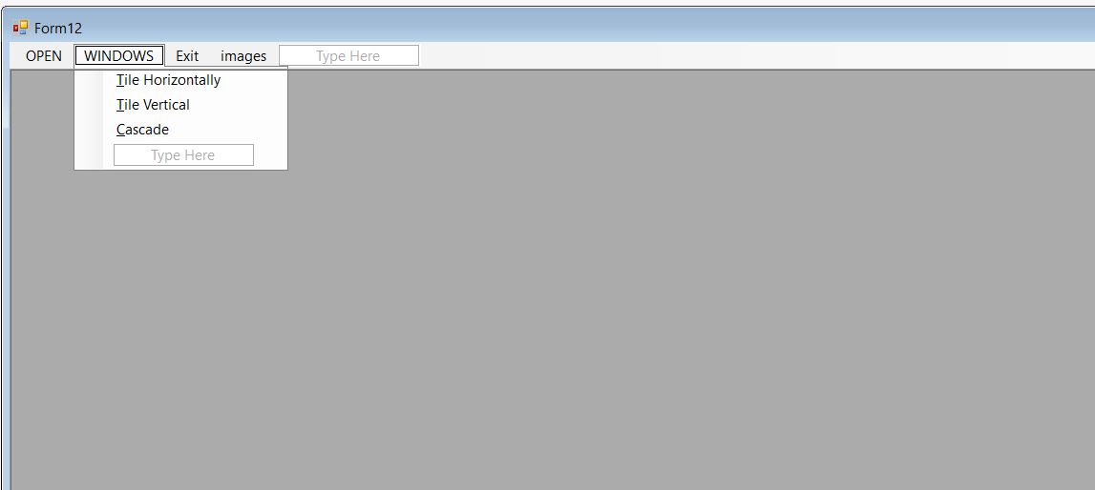

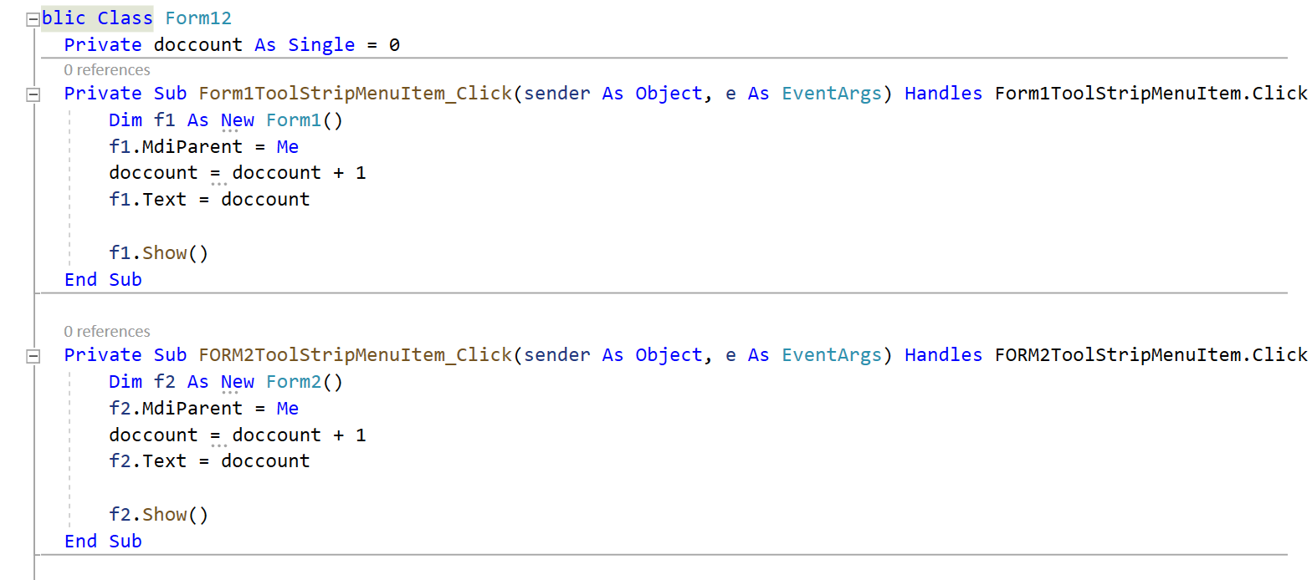

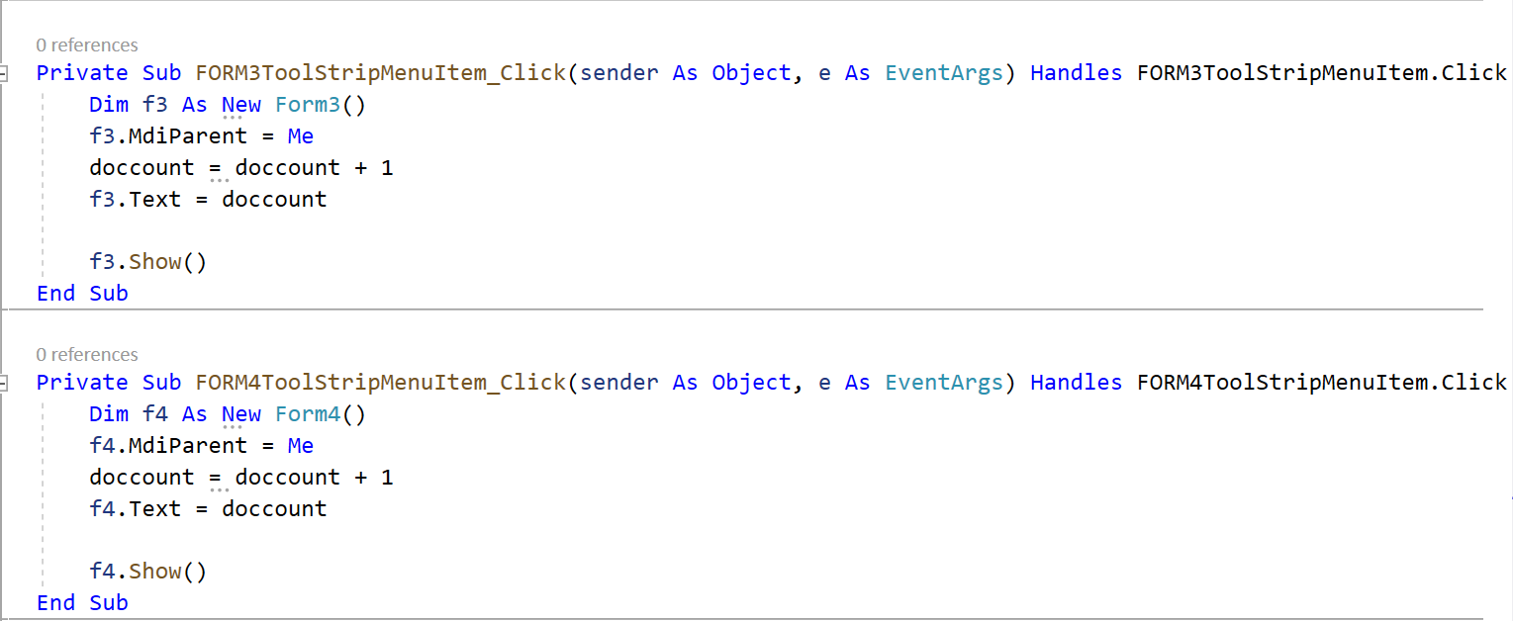

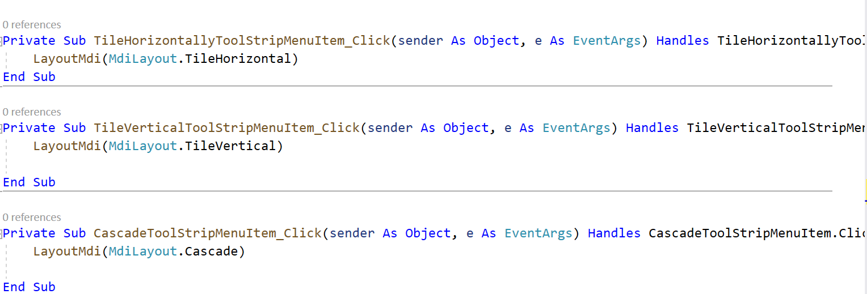

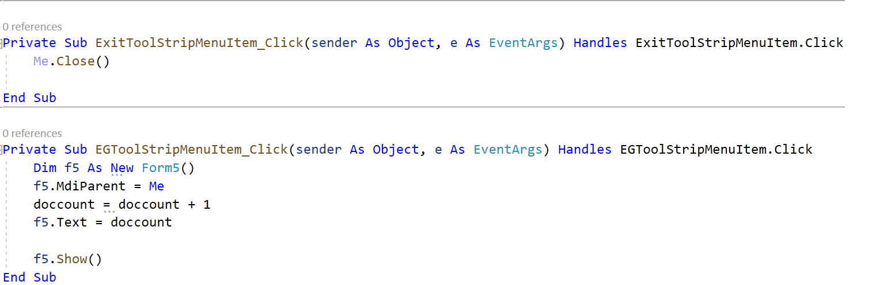

3)Panel Control

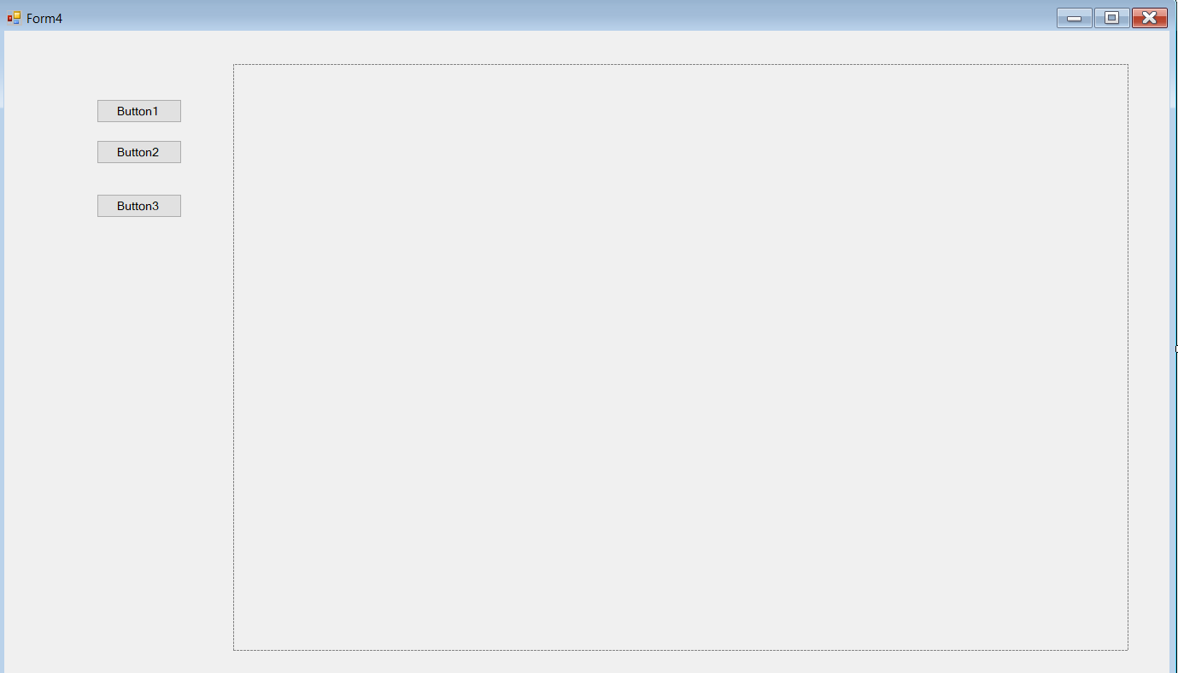



Private Sub Button1_Click(sender As Object, e As EventArgs) Handles Button1.Click

Form1.Show()

End Sub

Private Sub Button2_Click(sender As Object, e As EventArgs) Handles Button2.Click

Panel1.Controls.Clear()

Form2.TopLevel = False

Panel1.Controls.Add(Form2)

Panel1.Show()

Form2.Show()

End Sub

Private Sub Button3_Click(sender As Object, e As EventArgs) Handles Button3.Click

'switchpanel(Form3)

Panel1.Controls.Clear()

Form3.TopLevel = False

Panel1.Controls.Add(Form3)

Panel1.Show()

Form3.Show()

End Sub

4) **Tab Control example**

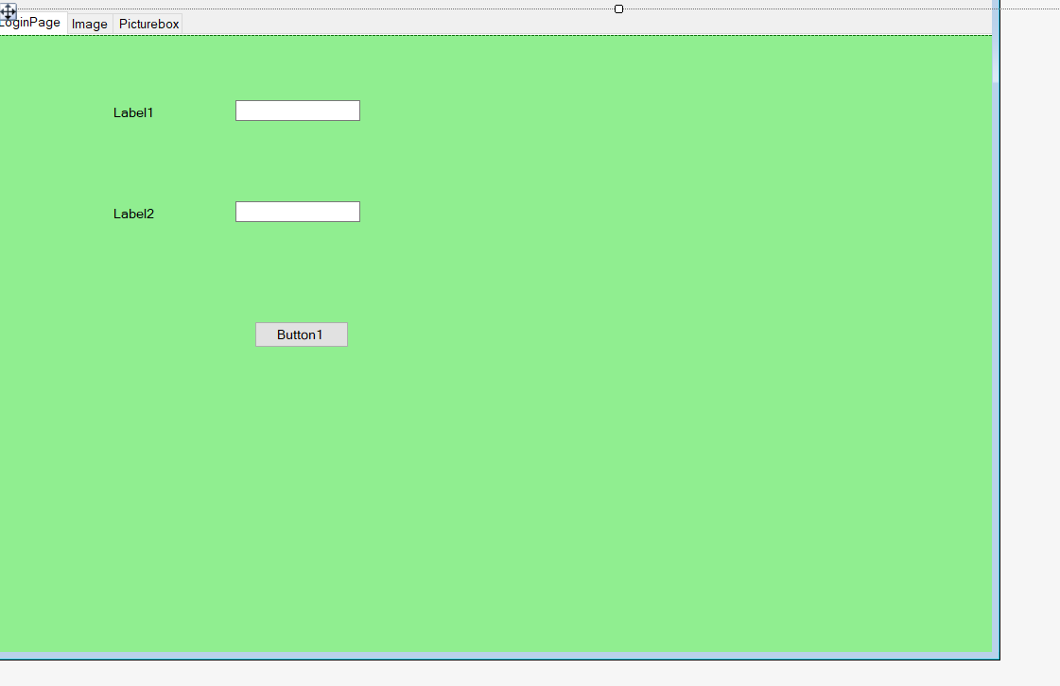

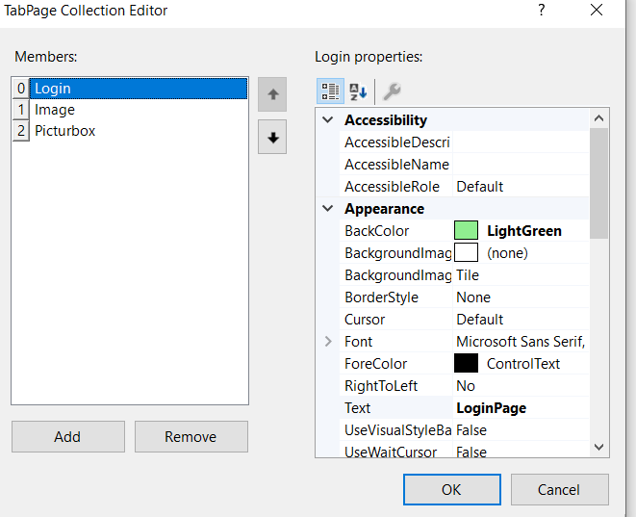

**5) User Control Example**

