# **Task 2**

# **Number Plate detection**

1. In this task we were given dataset of https://www.kaggle.com/datasets/dataturks/ vehicle-number-plate-detection On which I got Jason and performed some operations and separated images and its dimension in csv, But while separating images error encounter of access denied.
2. After this issue, we were given new dataset and then we have to perform annotation on it, I am new to annotation I tried to annotate dataset manually from labelbox here is the link of my project: <https://app.labelbox.com/catalog/dataset/clknpy7dt000g07244ijsaax7?search.query=NoXSA&search.sorting=NobwRAZglgpgNgEzALnNeTlgQQwC44BKA9gO4DCATjPjAgIJ5gA0YAbjJQEbEDOMAORwBbGCjBUaeOgAJGYAL6sEUagGM8UYgDtxAEQCiAZXIswogrgJG1ACxjCcASUzaArnDgKAukA>

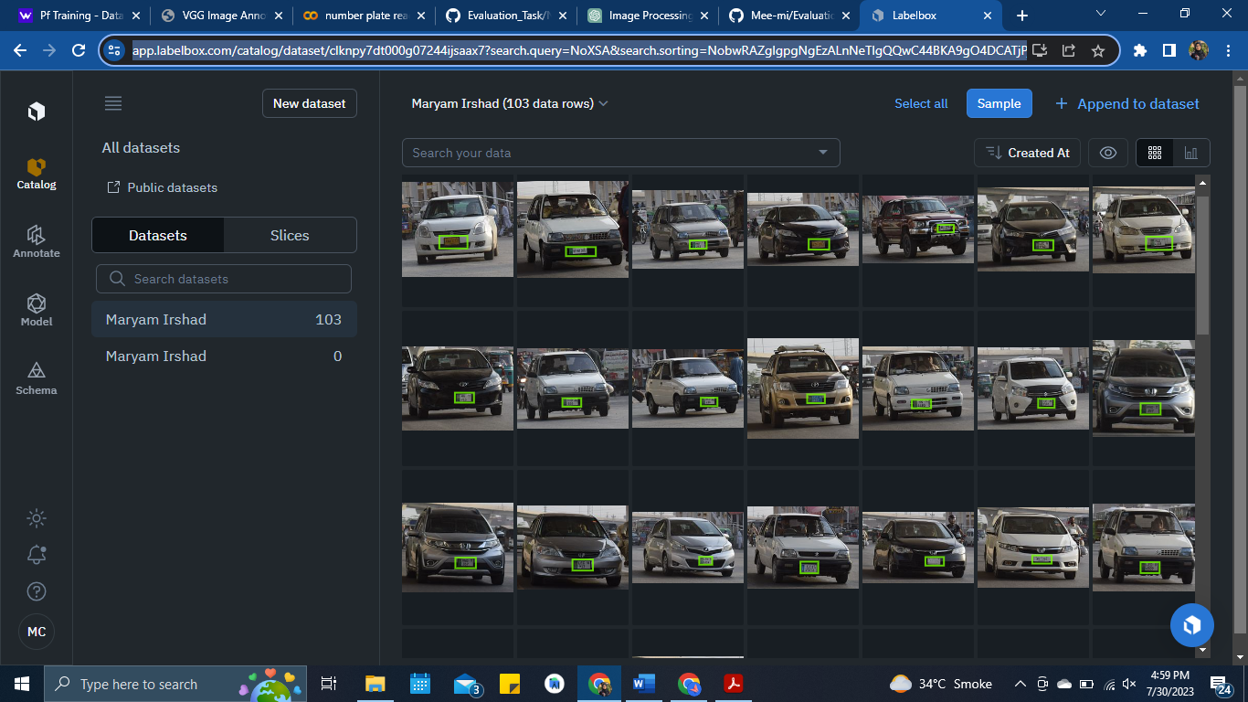

But unfortunately I couldn’t download the data is Jason, xml, or .txt file

1. After that I go for second approach to use only ROI method and try to do this, but able to got only number plates not the images. File is in my repository named ”numberplate”
2. I try next technique but couldn’t able to match it with plates: <https://colab.research.google.com/drive/1bNyzkUxEayxfw8IT6i2_mrC6Mwyt4kvG?usp=sharing>

Here is a notebook of attempt

1. I extracted the folder of zip then I loaded the images and extracted the images from the plate and then show it with car images.
2. This is final from myself right now, but I am not giving up I am learning and will make it work after discussing and learning from my leaders and seniors