PROJECT REPORT

ON

Account Management System

Submitted To

Danny Obidas

DECLARATION

We hereby declare this submission of a project is our own work and have basis conducting this system, To the best of our knowledge and skills, it contains no material previously published or created by another person or groups nor material which to a substantial extent has been accepted for the award of any other degree or diploma of the university or other institute of higher learning, except where due acknowledgment has been made in the text.

**ABSTRACT**

**CHAPTER 1**

**INTRODUCTION**

**1.1 Overview**

Account Management System formally having three modules in terms of proper functioning and working through the system.

Admin: In this account has the right to manage the role of the user. It can also manage the user status to enable or disable the account.

Teacher: This account can log in to the website and will go the his/her specific page just for the user to see the table of registered users.

Student: This account can log in to the website and will go the his/her specific page just for the student.

**1.2 Objective:**

We will Creating a new system to make handling User accounts easier and better. This system will help us keep User information correct, make things faster for our User, and help us make smarter decisions. We want to make sure managing accounts is smooth, build better relationships with the User, and use data to make good choices.

**CHAPTER 2**

**PROBLEM STATEMENT**

Right now, handling User accounts is a bit messy. We do things manually, which leads to mistakes, slow responses to User, and missed chances to make their experience better. We don't have a good system to keep track of everything, so it's a bit chaotic. Plus, we can't easily figure out what's working well and what needs improvement. We need a better way to manage accounts to make things smoother for us and our customers.

**2.1 Proposed system**

We're planning to introduce a new and improved system to manage Student and teacher accounts. This system will do a lot of things automatically, so we can avoid mistakes and serve our user faster. It will be like a helpful assistant, keeping all customer information in one organized place. The goal is to make managing accounts easy, build strong connections with the users, and use smart tools to make better decisions for everyone.

**CHAPTER 3**

**SYSTEM ANALYSIS**

3.1. Current Challenges:

* Manual processes lead to errors and delays in managing customer accounts.
* Lack of a centralized system causes confusion and difficulty in tracking customer information.
* Absence of automated tools for analytics hinders decision-making.

3.2. Proposed System Features:

* Automated Processes: Implement automation to reduce manual tasks, minimizing errors, and speeding up customer service.
* Centralized Data Management: Create a unified platform to organize and store user information for easy access and updates.

3.3. Benefits:

* Efficiency: Automation reduces workload, streamlining account management processes.
* Accuracy: Centralized data ensures information consistency and minimizes errors.

3.4. User-Friendly Interface:

* Develop an intuitive interface for easy navigation, ensuring that users can quickly adapt to and utilize the system effectively.

3.5. Security Measures:

* Implement robust security protocols to safeguard customer data and maintain the trust of clients.

**CHAPTER 4**

**4.1 SYSTEM REQUIREMENTS**

**4.1.1 Hardware Requirements:**

* **Processor: Quad-core processor, 3.2 GHz or equivalent**
* **Memory (RAM): 8 GB**
* **Storage: 250 GB available space**
* **Display: 1280x800 resolution**

**4.1.2 Software Requirements:**

* **Operating System: Windows 10 (64-bit)**
* **Web Browser: Latest versions of Chrome**
* **Database: MySQL 8.2.0**
* **Server: Apache Tomcat version 10.1.16**

**4.1.3 Network Requirements:**

* **Internet Connection any kind of broadband connection**

**4.2 USE CASE DIAGRAM**

**4.2.1 Admin Use Case:**

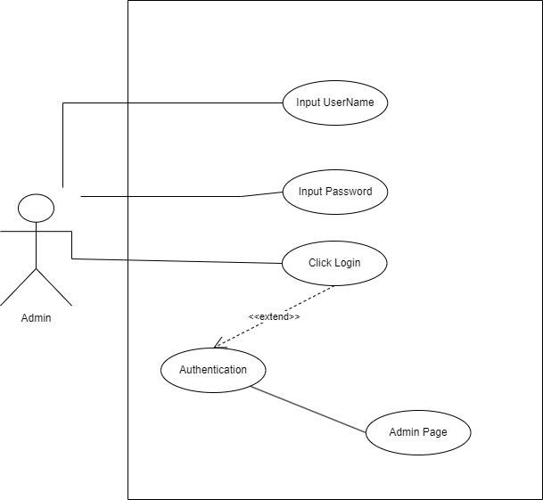

**4.2.2 Student and Teacher Use Case:**

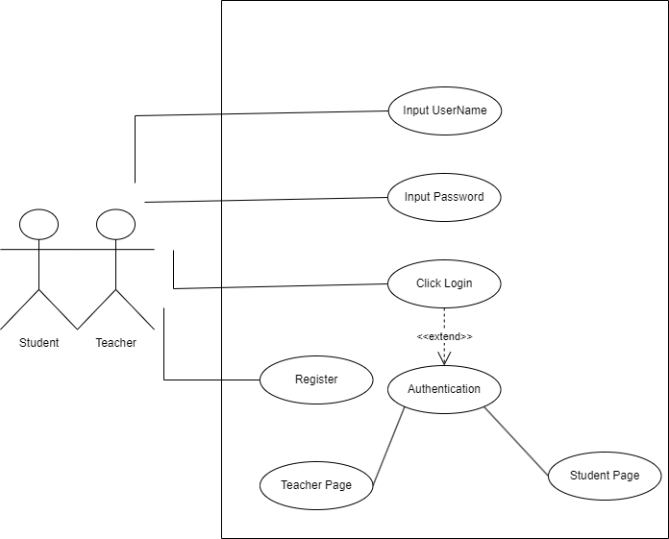

**4.2.3 admin-dash UseCase:**

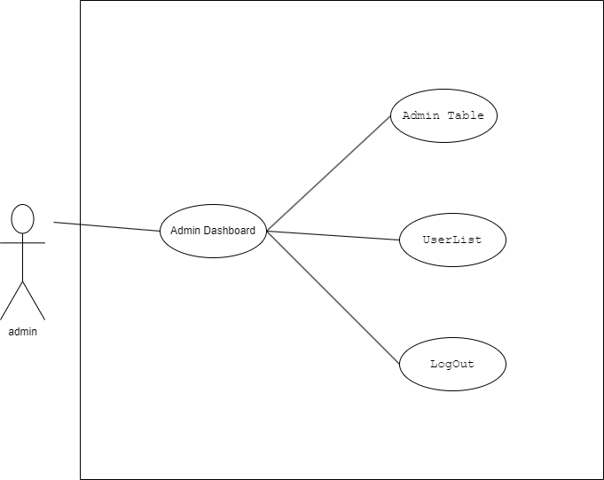

**4.2.4 User-Register UseCase:**

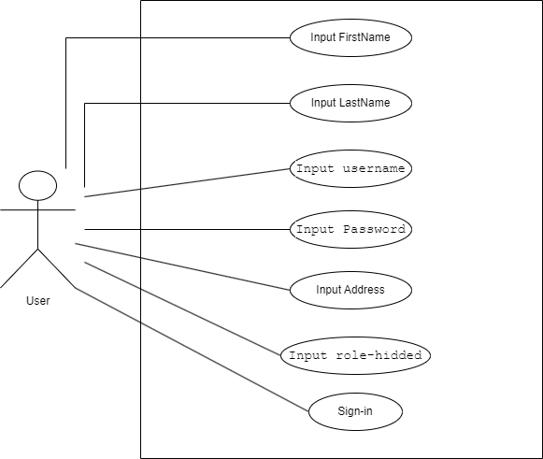

**4.3 ENTITY RELATIONSHIP DIAGRAM(ERD)**

