### **Very Short Answer Questions**

**A. What is the significance of a retrospect meeting?**

A retrospective meeting is held at the end of a project or sprint in Agile methodologies. Its significance lies in providing a dedicated time for the team to reflect on what went well, what didn’t, and how processes can be improved in the future. The goal is continuous improvement by learning from past experiences.

**B. What is the full form of PMBOK?**

The full form of PMBOK is **Project Management Body of Knowledge**.

**C. What are the triple constraints of project management?**

The triple constraints of project management are:

1. **Scope**: The work required to complete the project.
2. **Time**: The schedule or timeline for the project.
3. **Cost**: The budget allocated for the project.

These constraints are often represented in a triangle, where any change in one element affects the other two.

**D. Explain Learning Curve Theory.**

The Learning Curve Theory suggests that as people or teams repeat a task, they become more efficient at it, reducing the time and cost required to complete the task. This theory is often used in manufacturing and production to predict improvements in performance as experience with the process increases.

**E. What is Kanban?**

Kanban is a visual workflow management method used in project management to visualize work, limit work in progress, and maximize efficiency. It involves using boards with columns representing different stages of work, allowing teams to see the progress of tasks at a glance.

**F. What are three types of cost estimates?**

The three types of cost estimates are:

1. **Rough Order of Magnitude (ROM) Estimate**: An initial estimate with a broad range, often used in the early stages of a project.
2. **Budget Estimate**: A more detailed estimate used to allocate resources and set budgets.
3. **Definitive Estimate**: The most precise estimate, developed later in the project lifecycle, often with a narrow range of accuracy.

**G. What is benchmarking?**

Benchmarking is the process of comparing an organization’s processes, performance metrics, and practices against those of leading companies or industry best practices. The purpose is to identify areas for improvement and implement strategies to enhance performance.

SECTION B

Short Answer Questions

Attempt only seven (7) questions out of eight (9) questions [7 × 8 = 56]

Q. 1 Short Answer Question (Chapter 1 Introduction to Project Management)

List out and explain briefly any four advantages of formal project management.

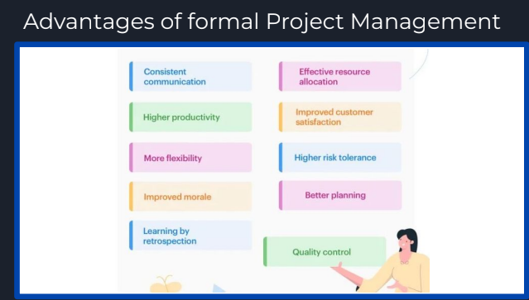

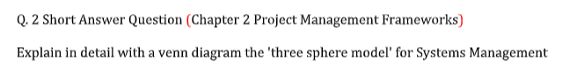

The Three Sphere Model for Systems Management is a framework that emphasizes the holistic approach required to successfully manage and implement systems in an organization. The model highlights three primary spheres or areas that must be considered:

1. **Business Sphere**
2. **Organization Sphere**
3. **Technology Sphere**

These spheres are interrelated and must be aligned for the successful implementation of a system. Here’s a detailed explanation of each sphere:

#### **1. Business Sphere**

* **Focus**: This sphere is concerned with the business aspects of a system, including its goals, objectives, and the value it brings to the organization.
* **Key Considerations**:
  + **Business Goals**: How does the system align with the organization's strategic objectives?
  + **Cost-Benefit Analysis**: What is the expected return on investment (ROI)?
  + **Market Demand**: Does the system meet the needs of customers or stakeholders?
  + **Competitive Advantage**: How does the system provide a competitive edge?

#### **2. Organization Sphere**

* **Focus**: This sphere addresses the people and process-related aspects of the system.
* **Key Considerations**:
  + **Organizational Structure**: How does the system fit within the current organizational hierarchy?
  + **Human Resources**: What are the staffing needs and how will the system affect job roles?
  + **Change Management**: What strategies will be used to manage the transition to the new system?
  + **Culture**: Does the system align with the organization's culture, and how will it impact morale?

#### **3. Technology Sphere**

* **Focus**: This sphere covers the technological components of the system.
* **Key Considerations**:
  + **Technical Requirements**: What hardware, software, and network resources are required?
  + **System Architecture**: How will the system be designed and integrated with existing systems?
  + **Security**: What measures will be implemented to ensure data integrity and confidentiality?
  + **Scalability and Flexibility**: How adaptable is the system to future changes and growth?

Q. 3 Short Answer Question (Chapter 3 Project Management Process Groups)

Discuss the signifcance of WBS for preparing a Gantt Chart. Also list out the advantages of plotting a Gantt chart over simply preparing a WBS.

### **Significance of WBS for Preparing a Gantt Chart**

A **Work Breakdown Structure (WBS)** is a hierarchical decomposition of a project into smaller, manageable components or tasks. It organizes the work to be done in a structured way, ensuring that all aspects of the project are accounted for.

**Significance for Gantt Chart Preparation:**

1. **Task Identification:** WBS helps in identifying all the tasks and sub-tasks necessary for the completion of the project. This detailed breakdown is the foundation for a Gantt chart, which visually represents these tasks along a timeline.
2. **Task Sequencing:** WBS provides a clear understanding of the relationships between different tasks, including dependencies and prerequisites. This sequencing is crucial when plotting tasks on a Gantt chart, as it ensures tasks are arranged logically and efficiently.
3. **Resource Allocation:** WBS helps in assigning resources to specific tasks. When these tasks are placed on a Gantt chart, it becomes easier to visualize resource allocation and ensure that resources are available when needed.
4. **Milestones Identification:** WBS helps in identifying key milestones in the project. These milestones can be highlighted in the Gantt chart, providing clear indicators of progress.
5. **Scope Management:** WBS ensures that all aspects of the project scope are covered. When creating a Gantt chart, this helps in avoiding scope creep by ensuring that all tasks are aligned with the project’s objectives.

### **Advantages of Plotting a Gantt Chart Over Simply Preparing a WBS**

1. **Visual Representation:** A Gantt chart provides a visual timeline of the project, making it easier to see the overall project plan at a glance, including task durations, start and end dates, and overlaps.
2. **Time Management:** Unlike WBS, which focuses on task breakdown, a Gantt chart emphasizes the timing and sequence of tasks. It helps in managing time more effectively by showing when each task should start and finish, ensuring that the project stays on schedule.
3. **Tracking Progress:** A Gantt chart allows for real-time tracking of project progress. As tasks are completed, they can be marked on the chart, providing a clear visual indicator of how much work has been done and how much remains.
4. **Identifying Critical Path:** Gantt charts help in identifying the critical path of the project—the sequence of tasks that determines the minimum project duration. This is essential for managing potential delays and ensuring that key tasks are prioritized.
5. **Resource Management:** By plotting tasks on a timeline, a Gantt chart helps in managing resource allocation more efficiently, ensuring that resources are available when needed and preventing overallocation.
6. **Communication:** Gantt charts are effective communication tools. They can be easily shared with stakeholders, providing a clear overview of the project’s status and facilitating better decision-making.
7. **Dependency Management:** Gantt charts make it easier to visualize task dependencies and adjust schedules accordingly. This ensures that tasks are completed in the correct order, avoiding bottlenecks and delays.

Q. 4 Short Answer Question (Chapter 4 Project Integration Management)

A marketing agency hosted an ad campaign and generated 123 sales earning them a revenue of $4500. During the campaign preparation they initially spent $1100 on designs and also incurred logistics expenditure of $1400. Based on this, calculate the Return on Investment (ROI) for this campaign and derive if it was a good or bad investment for the agency.

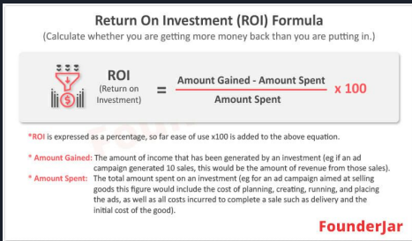

Q. 5 Short Answer Question (Chapter 5 Project Scope Management)

Prepare a sample RTM (Requirements Traceability Matrix) and explain its importance in formal

project management.

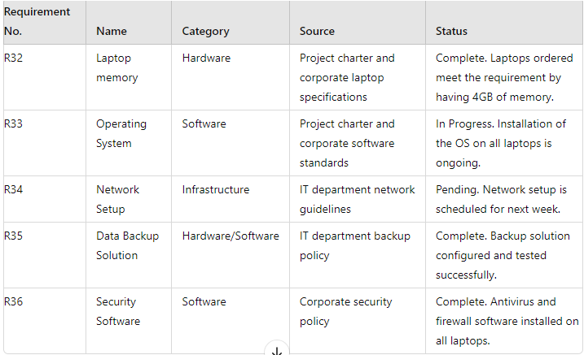

### **Explanation of the RTM**

**Requirements Traceability Matrix (RTM)** is a document used in formal project management to ensure that all project requirements are covered, tested, and validated throughout the project lifecycle.

#### **Importance in Formal Project Management:**

1. **Requirements Coverage:** RTM ensures that all business requirements are captured and linked to corresponding functional specifications and test cases. This helps in confirming that every requirement is being addressed.
2. **Scope Management:** By mapping requirements to specific features and test cases, the RTM helps in controlling scope creep by ensuring that only approved and documented requirements are implemented.
3. **Change Management:** RTM helps in managing changes by allowing project teams to trace the impact of requirement changes across the project, ensuring that all related documentation and tests are updated accordingly.
4. **Verification and Validation:** RTM plays a crucial role in the verification and validation process by ensuring that every requirement has been tested (linked to test cases) and meets the acceptance criteria.
5. **Project Status Monitoring:** It provides a clear view of the current status of each requirement, whether it is implemented, tested, or pending. This helps in monitoring project progress and identifying any areas that need attention.
6. **Facilitates Communication:** RTM serves as a communication tool between stakeholders, developers, and testers. It ensures that everyone is aligned on the project requirements and their current status.
7. **Risk Management:** By providing traceability, the RTM helps in identifying potential risks early in the project lifecycle. This enables proactive management of risks related to unmet or changing requirements.
8. **Compliance and Auditing:** In projects that require adherence to regulatory standards, RTM provides a documented trail of how requirements have been implemented and tested, supporting compliance and facilitating audits.
9. **Quality Assurance:** RTM ensures that all requirements are tested and validated, which contributes to the overall quality of the project deliverables.

Q.6 Short Answer Question (Chapter 6 Project Time Management)

Discuss in detail the three major types of activity dependencies - mandatory, discretionary and

external with elaborate/contextual examples for each.

### **Three Major Types of Activity Dependencies**

1. **Mandatory Dependencies (Hard Logic)**
   * **Description:** These are dependencies that are legally or contractually required, or they are inherent in the nature of the work being performed. Mandatory dependencies are unavoidable and are typically dictated by the physical constraints of the work.
   * **Example:** In a construction project, the foundation of a building must be laid before the walls can be erected. This is a mandatory dependency because the walls cannot be constructed without a foundation in place. Similarly, in software development, the system architecture must be designed before coding begins, as coding without a design would lead to confusion and inefficiency.
2. **Discretionary Dependencies (Soft Logic)**
   * **Description:** These are dependencies that are defined by the project team based on best practices, convenience, or preferences. Discretionary dependencies are not always required but are set to optimize the project flow. They can be changed or adjusted if needed.
   * **Example:** In a software project, a project manager might decide that the user interface (UI) design should be completed before the database design, even though both could technically be developed concurrently. This decision might be based on a preference to have the UI guide the database schema. If necessary, this order can be changed without affecting the project fundamentally.
3. **External Dependencies**
   * **Description:** External dependencies are those that involve relationships between project activities and factors or events outside the project's control. These dependencies often involve interactions with external stakeholders, suppliers, regulatory bodies, or other projects.
   * **Example:** Consider a project to develop a new mobile application that requires integration with an external payment gateway service. The project cannot complete the payment integration until the payment gateway provider delivers the necessary API. This is an external dependency because the project team has no control over when the payment gateway provider will deliver the API.

Q. 7 Short Answer Question (Chapter 7 Project Cost Management)

If the AC for a WBS item is $5500 and its EV is $4500, what is its CV ? Is it under or over budget ? If the SPI of the same item is 110% when it is halfway completed, is it ahead or behind schedule ?

### **Cost Variance (CV) and Schedule Performance Index (SPI) Calculation**

Given:

* **Actual Cost (AC) = $5,500**
* **Earned Value (EV) = $4,500**

#### **1. Cost Variance (CV):**

* **Formula:** CV = EV - AC
* **Calculation:** CV = $4,500 - $5,500 = -$1,000
* **Interpretation:** The Cost Variance is **-1,000**, which means the project is over budget. A negative CV indicates that the actual costs are higher than the earned value, meaning the project is spending more than what was planned for the work completed.

#### **2. Schedule Performance Index (SPI):**

* **Given:** SPI = 110% (or 1.10)
* **Interpretation:** The Schedule Performance Index (SPI) is **1.10**, which indicates that the project is ahead of schedule. An SPI greater than 1 means that the project is completing more work than planned within the given time, which suggests good time management.

### **Summary:**

* The project is **over budget** because the CV is negative (-$1,000).
* The project is **ahead of schedule** because the SPI is 1.10, meaning the project is progressing faster than planned.

Q. 8 Short Answer Question (Chapter 8 Project Quality Management)

What is the purpose of a scatter diagram ? Present an arbitrary statistical example of a scatter

diagram that demonstrates a high degree of negative correlation.

A scatter diagram (also known as a scatter plot or scatter graph) is a graphical representation used to display the relationship between two quantitative variables. The primary purposes of a scatter diagram include:

1. **Identifying Relationships:** It helps in visualizing the correlation or relationship between two variables, determining whether the relationship is positive, negative, or non-existent.
2. **Detecting Patterns:** Scatter diagrams can reveal patterns, trends, or clusters in the data that may not be evident through simple analysis.
3. **Outlier Detection:** By plotting individual data points, scatter diagrams can highlight outliers or anomalies that deviate significantly from the general trend.
4. **Predictive Analysis:** Scatter diagrams can assist in predictive analysis by showing how changes in one variable might be associated with changes in another.

### **Example of a Scatter Diagram Demonstrating Negative Correlation**

Let's consider an arbitrary example where we plot the number of hours spent studying and the number of errors made on a test. The assumption is that as the number of study hours increases, the number of errors on the test decreases.

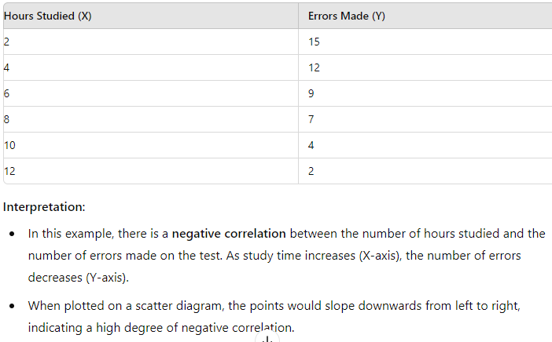

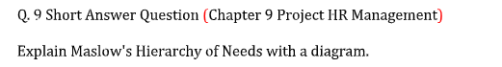

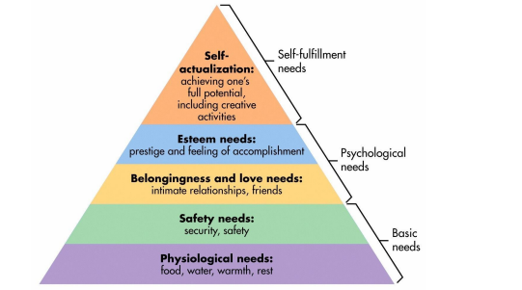

Group C

Long Analytical or Case Question

Attempt any two (2) questions out of three (3) questions [2 × 15 = 30]

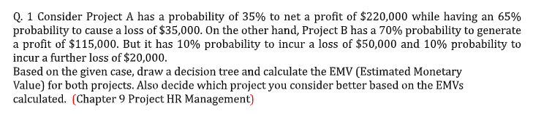

Q. 2 Identify the critical path for the activities in the given table and the expected duration of the project.

Also identify the slack times for each activity (10 + 5) (Chapter 6 Project Time Management)

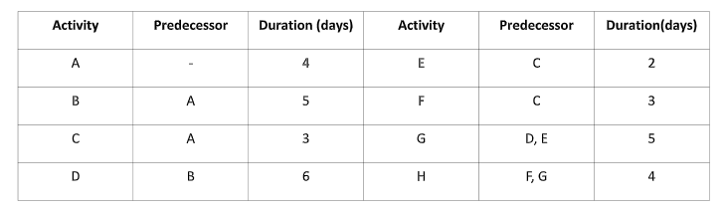

Q. 3. Draw a detailed diagram of the SCRUM methodology in software development. Also discuss the key elements of SCRUM roles, events and artifacts. (5 + 5 + 5 + 5)

(Chapter 3 Project Management Process Groups)

