**DUPE CHECK AND DELETE**

Dupe Check is a Proc that provides the information regarding the tables which do have dupe keys setup or not including the number of the duplicates in the tables if any.

In order to Setup this Procedure, you need to follow the following Steps.

1. Create View [dbo].[Vw_Tracking_Tables] on the container Database (Database with only Audit Name).

"Y:\Data\Retail\WalmartMX\Development\Pikesh.Maharjan\DupeOut\TrackingtablesVw.sql" Execute this script on your container DB by replacing the database with correct audit name.

1. Create View dbo. AllTblVw on the container Database (Database with only Audit Name).

"Y:\Data\Retail\WalmartMX\Development\Pikesh.Maharjan\DupeOut\AllTblVw.sql"

Execute this script on your container DB.

1. Create a Store Proc [dbo].[ DupProc] on the container Database that will return the information about the tables if the dup keys are setup or not along with the duplicates values in thetables.

"Y:\Data\Retail\WalmartMX\Development\Pikesh.Maharjan\DupeOut\DupProc.sql"

After these five steps, We are ready to execute the Proc [dbo].[ DupProc] that will generate the actual Results. While executing this Procedure you will need to pass some variable which will define how our Result is going to look. We will Look onto how to pass these variable in the below points:

1. This is how you will be executing this stored procedure :

DECLARE @return_value int

EXEC @return_value = [dbo].[CheckDupsV2]

@AuditName = N'RiteAid',

@DATASETNAME = N'1010data',

@DatabaseName = N'ALL',

@TableName = N'ALL',

@CheckDupKeySetupONly = 0

1. @AuditName variable is used to pass your respective AuditName
2. @DATASETNAME will define the DatasetName you want to check dupkeys for. Default Value is ALL for this variable.
3. @DatabaseName will define the DatabaseName you want to check dupkeys for. It will check all duplicate values for all the table in specified database. Default Value is ALL for this variable.
4. @TableName will define the TableName you want to check dupkeys for. If you just want to check duplicates for only on table, you can input the tablename in this field. Default Value is ALL for this variable.
5. @CheckDupKeySetupONly is the variable through which you are able to setup whether you want you want to check only if dupkeys are setup or if the duplicates values are present in the table. 0 will check for the duplicates values as well while 1 will check only if dup keys are setup for the table.

Let us review the results we get after executing the procedures :

1. First Grid will return the list which don’t have dup keys setup.

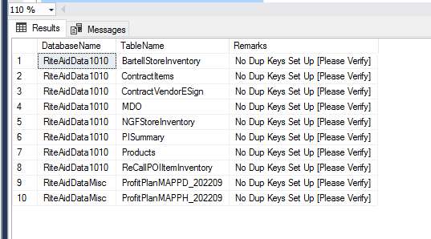

1. Second Grid will return the list which have dup keys setup.

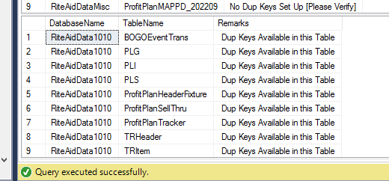

1. Third grid will show if any dupe are present or not along with the duplicates values if any. It also shows the numbers of duplicates due to the null counts of dup keys.

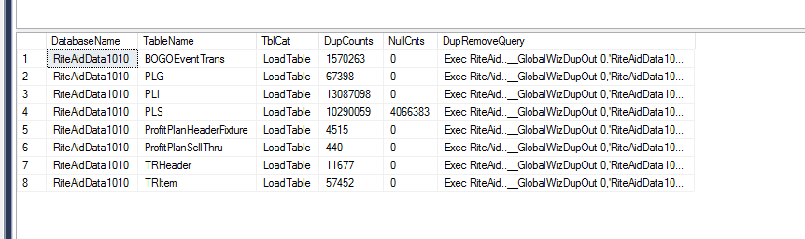

1. Fourth Grid will show the tables which do have dup keys Setup and have no duplicate Values.

