CSE523: Machine Learning

Project Report Week- 5

# Team name.: **Tech_mak**

# Name & Roll no.:

Meet Pedhadiya AU1841056

Ayush Kaneria AU1841062

Mihir Chauhan AU1841065

Krunal Pagdar AU1841066

# Tasks Performed in the week

* Data filters on datasets
* In the dataset fields of deaths, recovered and confirm cases of covid-19 contains total data since that date
* Add columns from the respective fields’ total value
  + Daily recovered
  + Daily Deaths
  + Daily confirm cases
* Perform **Linear Regression** using in-built library(**sk-learn**) on the datasets of different states and for India as well
* Perform **Polynomial Regression** using in-built library(**sk-learn**) library on the datasets of different states and for India

# Outcomes of the tasks performed

* Datasets having more useful columns like
  + Daily recovered
  + Daily Deaths
  + Daily confirm cases

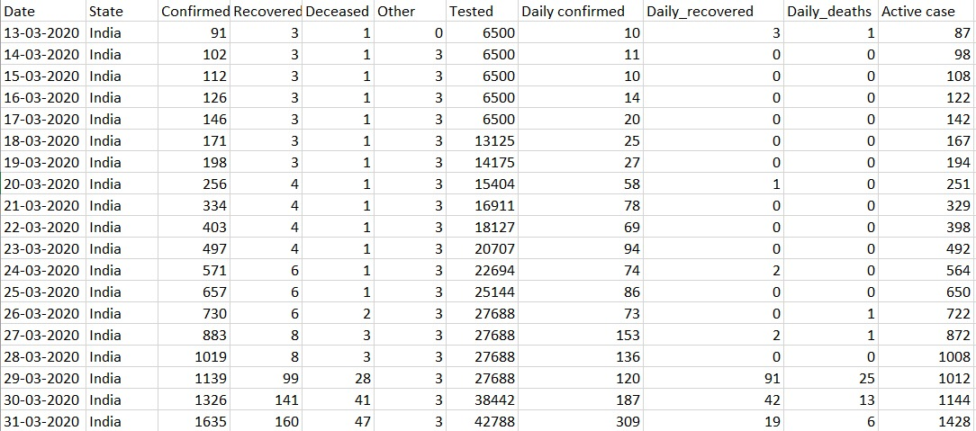

* **Linear Regression** on the data using sk-learn library
  + Independent variable 🡪 Daily tested
  + Dependent variable 🡪 Daily confirm cases
* India

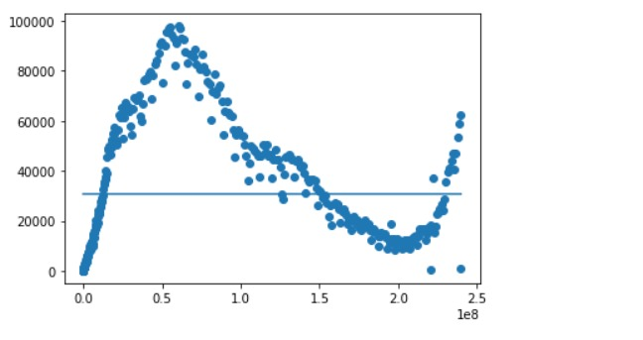

* Gujarat

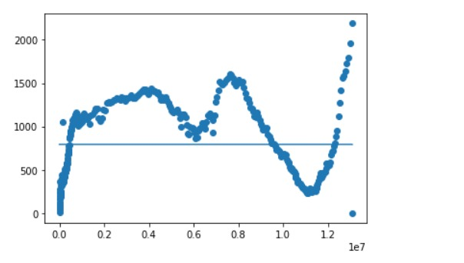

* Polynomial Regression on the data using sk-learn library
  + Independent variable 🡪 Daily tested
  + Dependent variable 🡪 Daily confirm cases
  + Data of India - Degree-4

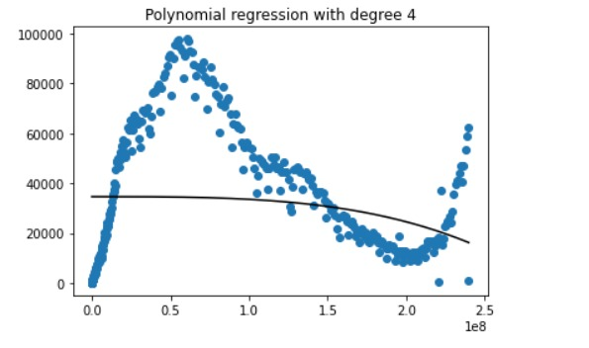

* + Data of India - Degree-10

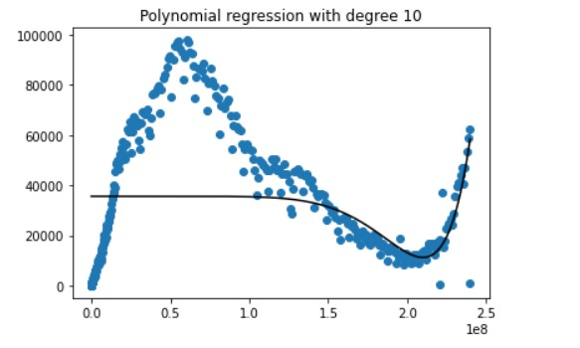

* + Degree-4

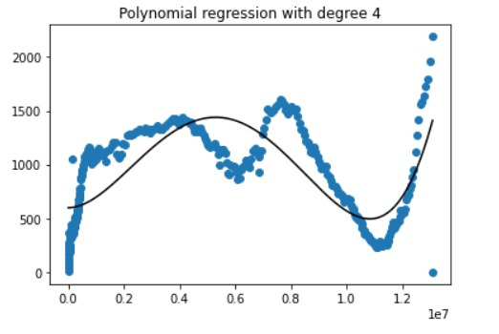

* + Data of Gujarat – Degree – 9

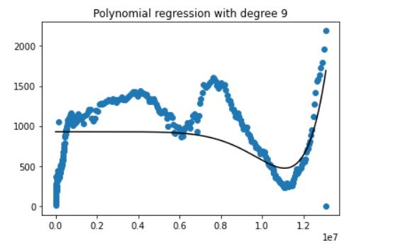

* We have performed linear and polynomial regression but we don’t get efficient output because of the lack of the independent features on that covid-19 daily cases.

# Tasks to be performed in the upcoming week

* We didn’t get efficient initial output from the linear and polynomial regression.
* So, we will try to use autoregressive and time series analysis.
* Find algorithms for autoregression and time analysis
* Add one more column to the dataset – Active cases