CSE523: Machine Learning

Project Report Week- 6

# Team name.: **Tech_mak**

# Name & Roll no.:

Meet Pedhadiya AU1841056

Ayush Kaneria AU1841062

Mihir Chauhan AU1841065

Krunal Pagdar AU1841066

# Tasks Performed in the week

* Add columns
  + **Active cases** from daily confirm cases, daily deaths and daily recoveries
* Explore autoregressive and time series algorithms
  + Auto regressive (AR)
  + Moving Average (MA)
  + Auto Regressive Integrative Moving Average (ARIMA)
  + Auto Regressive Moving Average (ARMA)
  + Exponential Smoothing (ES)
* Perform Moving Average (MA) in the datasets on the following columns
  + Daily confirm
  + Daily recovered
  + Daily Deaths
* Data filters on datasets

# Outcomes of the tasks performed

* One new column in the dataset 🡪 Daily Active cases
  + India

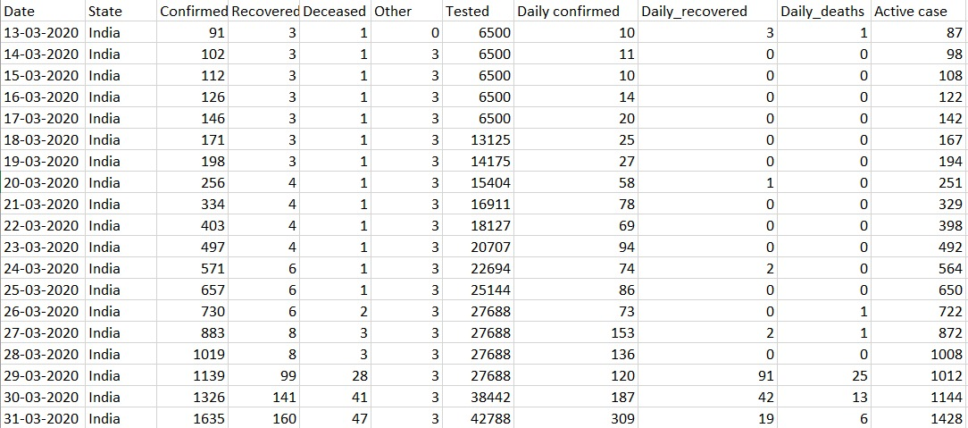

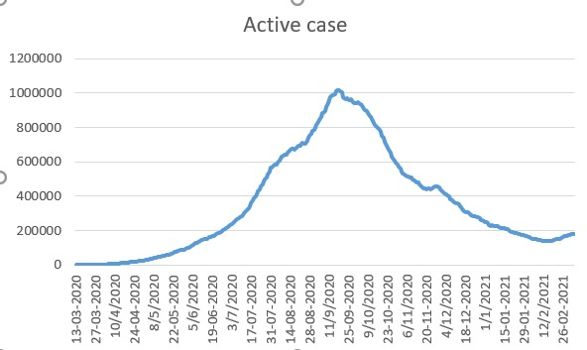

* Moving Average of Daily confirm cases

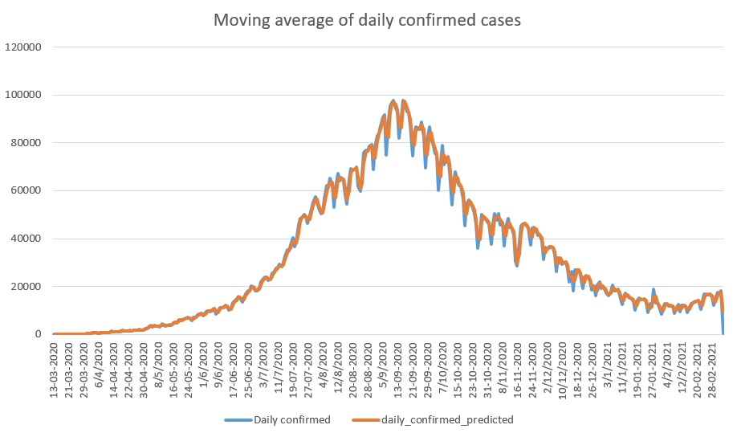

* Moving Average of Daily recovered cases

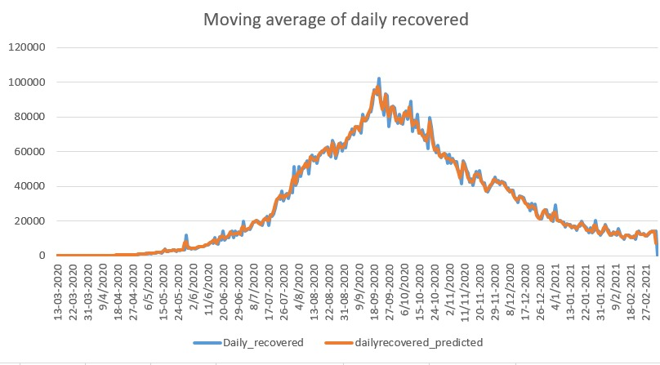

* Moving Average of Daily Deaths

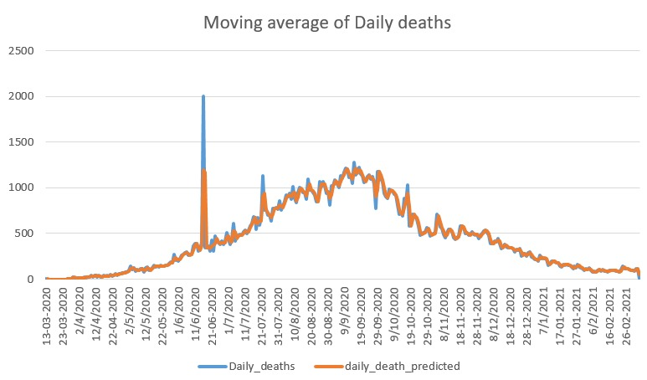

* **Got good efficiency of Moving Average (MA) for all the columns(features)**

# Tasks to be performed in the upcoming week

* Explore following algorithms in-depth
  + Auto Regression (AR)
  + ARIMA
  + ARMA
* Will Try to implement algorithms to the datasets