CSE523: Machine Learning

Project Report Week- 7

# Team name.: **Tech_mak**

# Name & Roll no.:

Meet Pedhadiya AU1841056

Ayush Kaneria AU1841062

Mihir Chauhan AU1841065

Krunal Pagdar AU1841066

# Tasks Performed in the week

* Worked on time series analysis and auto regressive algorithms
* Perform Auto regression in excel on column of **Daily confirm cases**, **Daily recovered cases** and **Daily deaths**
  + Predict the current value using previous values of the same column(feature)
  + Perform auto regression by taking window as 3,4 and 5 days as previous independent variables
* Try to plot moving average in python using **pandas** library

# Outcomes of the tasks performed

* Autoregression (AR) outputs for **Daily confirmed cases** of India by taking window as 3 days

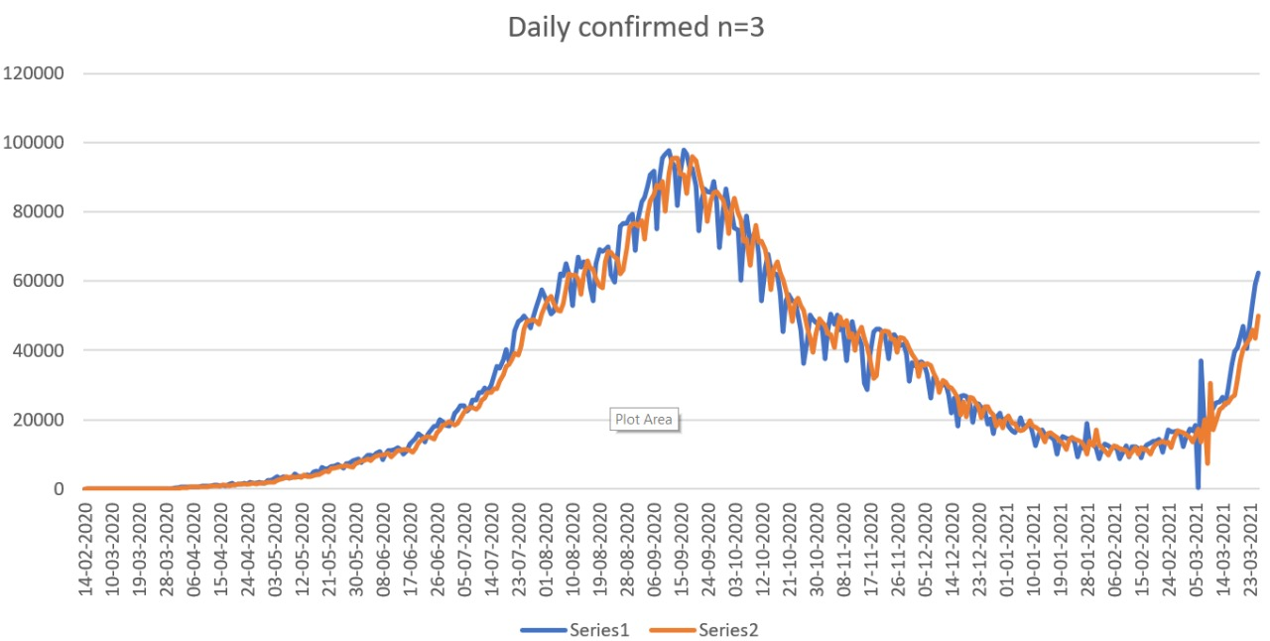

For this we got $97.49\%$ accuracy

* Autoregression (AR) outputs for **Daily confirmed cases** of India by taking window as 4 days

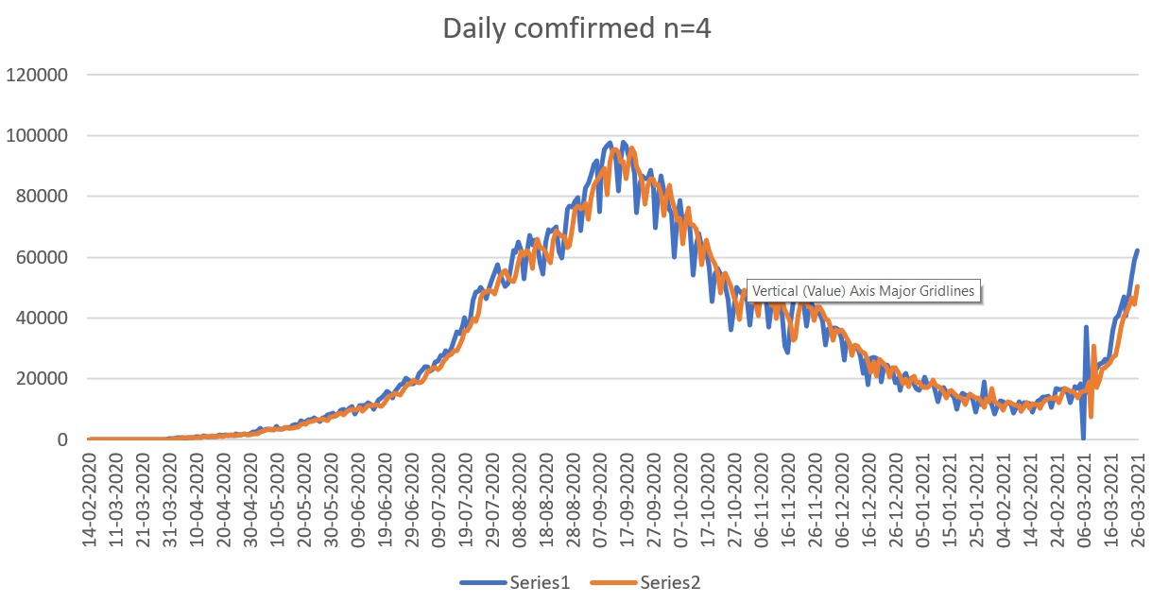

For this we got $97.50\%$ accuracy

* Autoregression (AR) outputs for **Daily confirmed cases** of India by taking window as 5 days

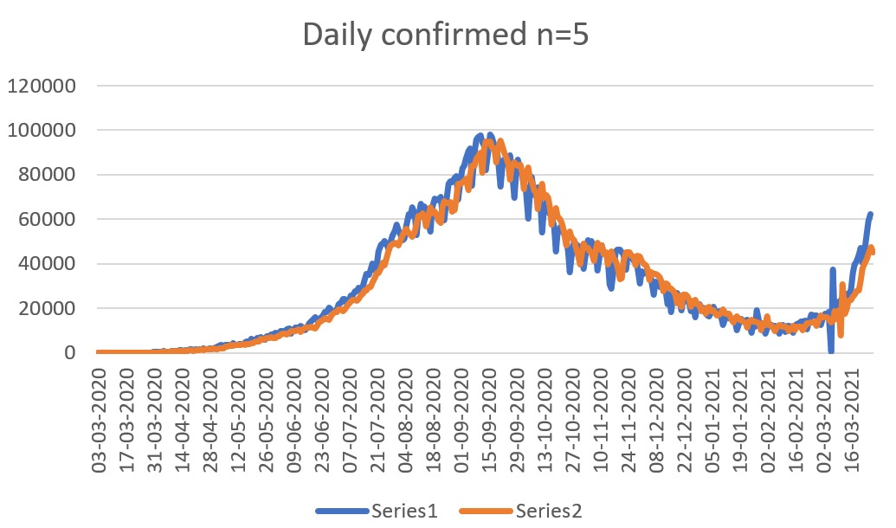

For this we got 97.51% accuracy

* Autoregression (AR) outputs for **Daily Deaths** of India by taking window as 4 days

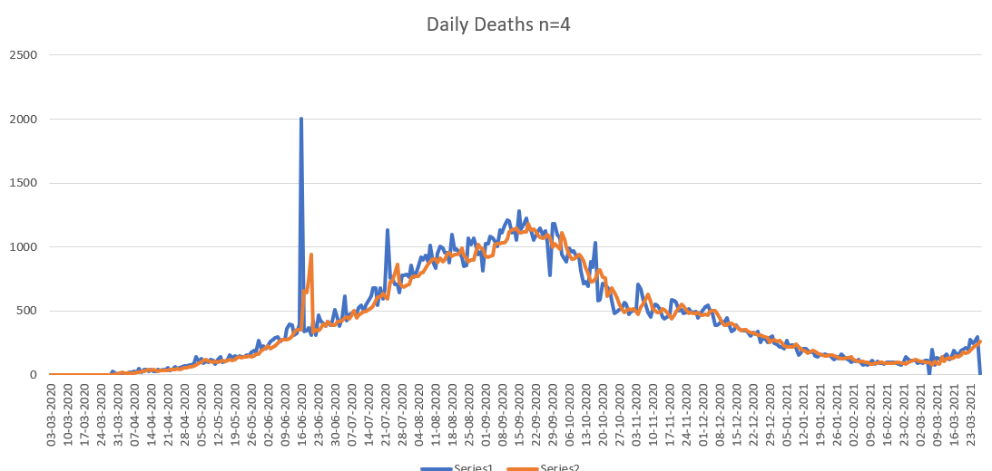

For this we got 89.98% accuracy

* Autoregression (AR) outputs for **Daily Deaths** of India by taking window as 5 days

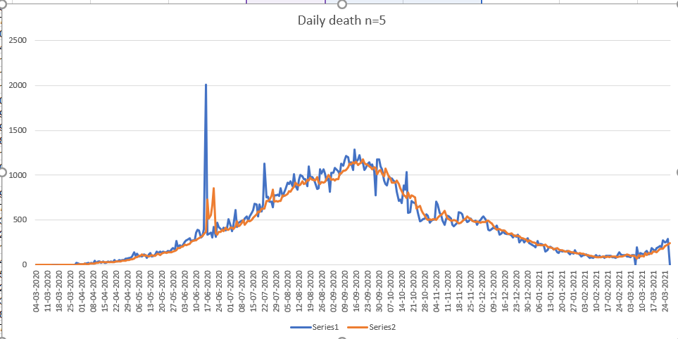

For this we got 90.46% accuracy

* Autoregression (AR) outputs for **Daily Recoveries** of India by taking window as 3 days

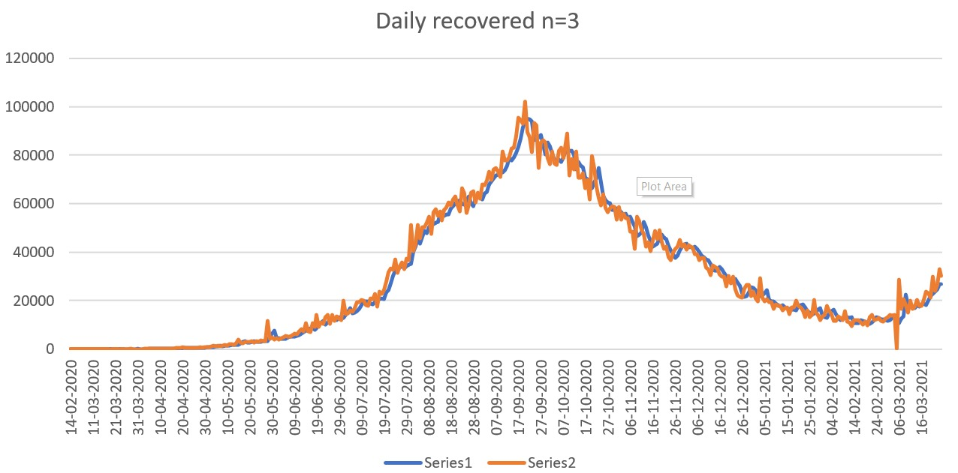

For this we got 98.24% accuracy

* **Got good efficiency of Moving Average (MA) for all the columns(features) except Daily Deaths**

# Tasks to be performed in the upcoming week

* Implement moving average (MA) and autoregression (AR) using python for our dataset
* ARIMA and ARMA will be the combination of moving average (MA) and auto regression (AR)
* Will Try to implement algorithms to the datasets