CSE523: Machine Learning

Project Report Week- 8

# Team name.: **Tech_mak**

# Name & Roll no.:

Meet Pedhadiya AU1841056

Ayush Kaneria AU1841062

Mihir Chauhan AU1841065

Krunal Pagdar AU1841066

# Tasks Performed in the week

* Update dataset with the new data of covid-19 cases of India
* Implement Autoregression algorithm (AR) using python library
* Implement Auto Regressive Moving Average (ARMA) algorithm using python library and plot the predicted value for the following columns
  + Daily Confirm Cases
  + Daily Deaths
* Implement Auto Regressive Integrated Moving Average (ARIMA) algorithm using python library and plot the predicted value of the following columns
  + Daily Confirm Cases
  + Daily Deaths
* Get the summary of the both algorithms Auto Regressive Moving Average (ARMA) and Auto Regressive Moving Average (ARMA)
* Get the difference between accuracy of ARIMA and ARMA for the Daily Confirm cases of the India

# Outcomes of the tasks performed

* Updated dataset with the latest values of Daily Cases

## Auto Regressive Moving Average (ARMA)

* Output Summary of the ARMA model on Daily Confirm Cases

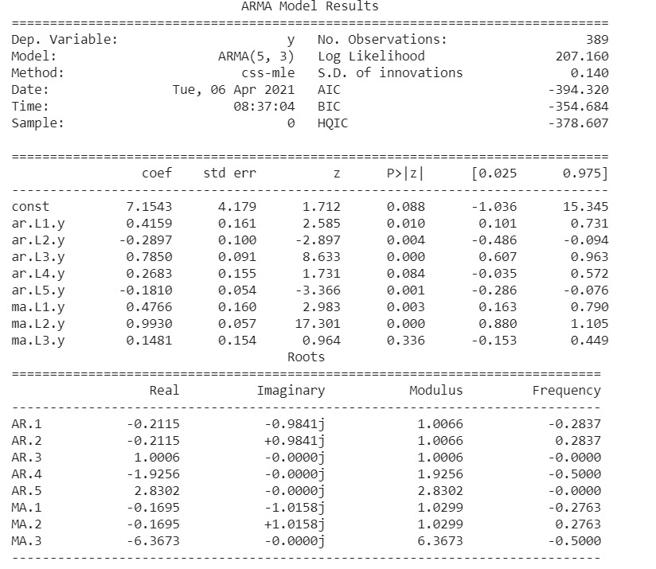

* Output Summary of the ARMA model on Daily Deaths

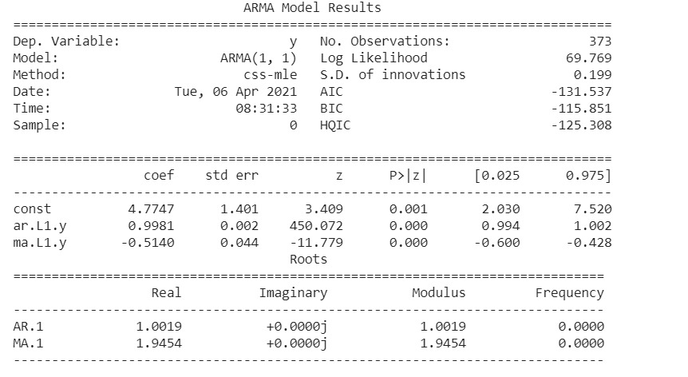

* Implement ARMA on log value Daily confirm cases

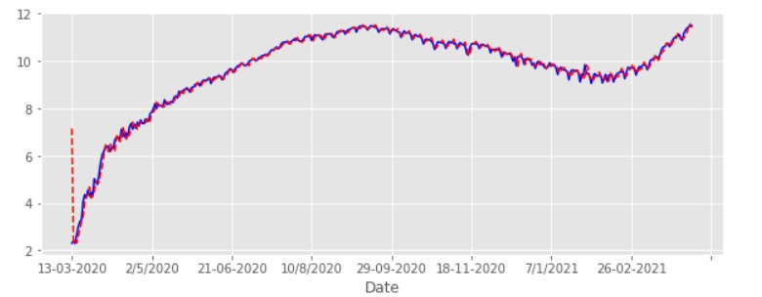

* Output of ARMA algorithm on Daily confirm cases (After converting from the log values)

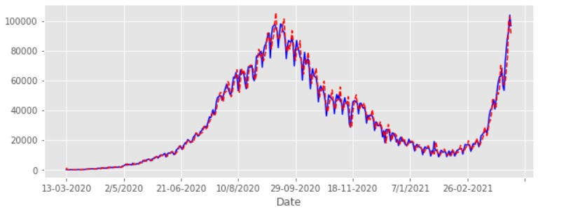

* Implement ARMA on log value Daily deaths

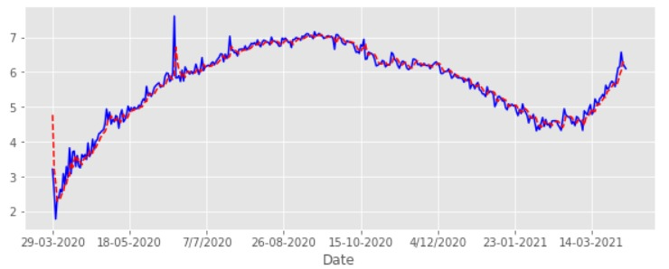

* Output of ARMA algorithm on Daily confirm cases (After converting form the log values)

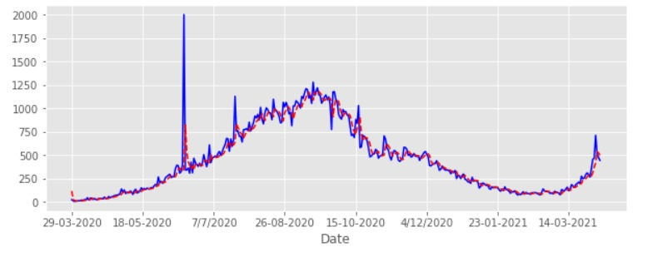

## Auto Regressive Integrated Moving Average (ARIMA)

* Output Summary of the ARMA model on Daily Confirm Cases

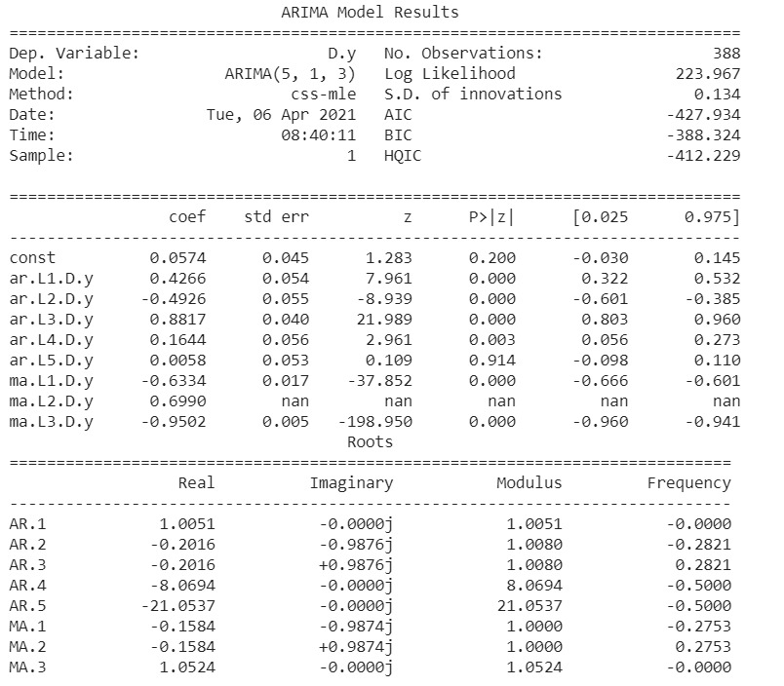

* Output Summary of the ARIMA model on Daily Deaths

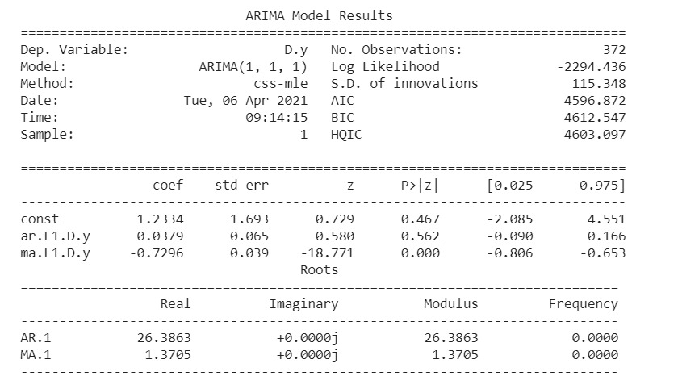

* Output of ARIMA algorithm on Daily confirm cases

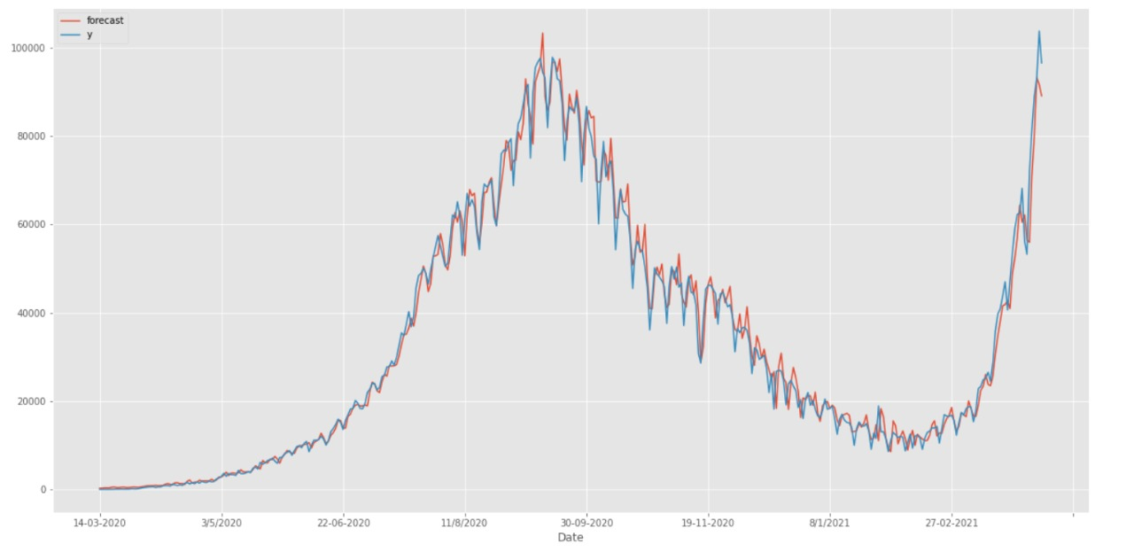

* Output of ARIMA algorithm on Daily confirm cases

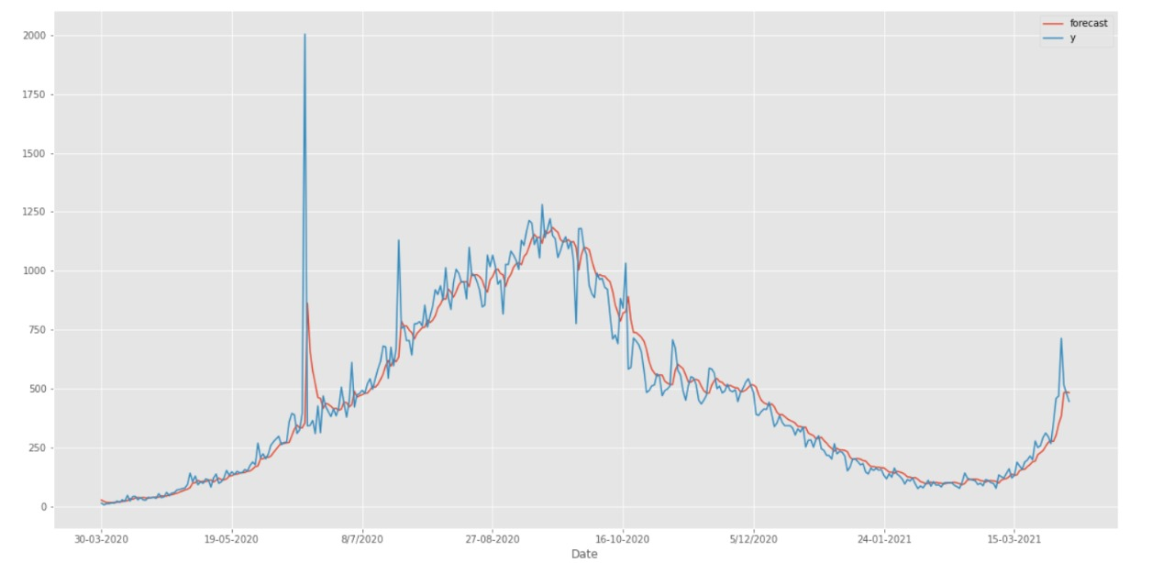

# Tasks to be performed in the upcoming week

* Prepare Final report
* Commit codes and output on Git-hub repository
* Prepare End-semester Presentation