University Network Topology Project Documentation
Course: Computer Networks
Project Title: University Campus Network Design and Implementation
Tool Used: Cisco Packet Tracer

1. Project Overview
This project demonstrates the design and implementation of a university campus network using Cisco Packet Tracer. The network consists of a hierarchical topology with a core router (R1) connected to four departmental routers, each serving a specific area of the university. The design incorporates three different routing protocols — Static Routing, RIP (Routing Information Protocol), and OSPF (Open Shortest Path First) — along with a DHCP service, to demonstrate the integration of mixed routing environments in a real-world university network scenario.

2. Network Topology Diagram
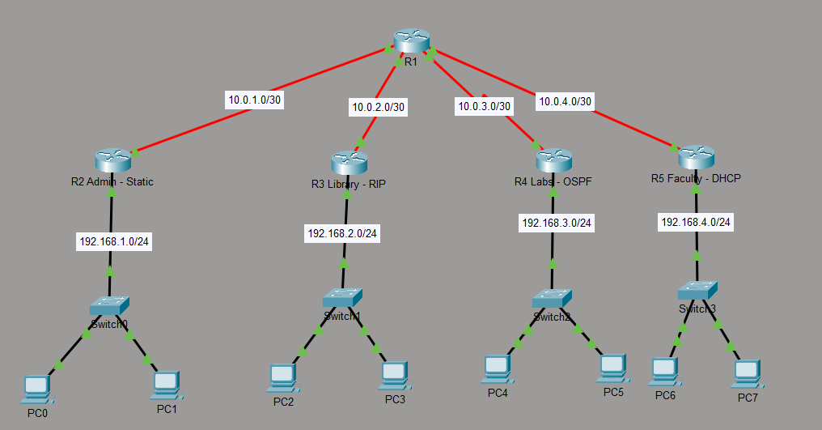
3. Network Design Overview
The topology follows a hierarchical star design:
- Core Layer: Router R1 acts as the backbone, connecting all departments and the internet.
- Distribution Layer: Routers R2, R3, R4, and R5 serve individual university departments.
- Access Layer: Switches (Switch0–Switch3) and end-user PCs (PC0–PC7) in each department.
Department | Router | Routing Protocol | LAN Subnet
Admin | R2 | Static Routing | 192.168.1.0/24
Library | R3 | RIP v2 | 192.168.2.0/24
Labs | R4 | OSPF Area 0 | 192.168.3.0/24
Faculty | R5 | DHCP Server | 192.168.4.0/24

4. IP Addressing Table
Router-to-Router Links (Serial Interfaces)
Device | Interface | IP Address | Subnet Mask | Default Gateway
R1 | Se0/0/0 (to R2) | 10.0.1.1 | 255.255.255.252 | N/A
R1 | Se0/0/1 (to R3) | 10.0.2.1 | 255.255.255.252 | N/A
R1 | Se0/1/0 (to R4) | 10.0.3.1 | 255.255.255.252 | N/A
R1 | Se0/1/1 (to R5) | 10.0.4.1 | 255.255.255.252 | N/A
R2 | Se0/1/0 (to R1) | 10.0.1.2 | 255.255.255.252 | N/A
R3 | Se0/1/0 (to R1) | 10.0.2.2 | 255.255.255.252 | N/A
R4 | Se0/1/0 (to R1) | 10.0.3.2 | 255.255.255.252 | N/A
R5 | Se0/1/0 (to R1) | 10.0.4.2 | 255.255.255.252 | N/A

LAN Interfaces
Device | Interface | IP Address | Subnet Mask | Default Gateway
R2 | Gig0/1 | 192.168.1.1 | 255.255.255.0 | N/A
R3 | Gig0/1 | 192.168.2.1 | 255.255.255.0 | N/A
R4 | Gig0/1 | 192.168.3.1 | 255.255.255.0 | N/A
R5 | Gig0/1 | 192.168.4.1 | 255.255.255.0 | N/A

End Devices
Device | IP Address | Subnet Mask | Default Gateway
PC0 | 192.168.1.2 | 255.255.255.0 | 192.168.1.1
PC1 | 192.168.1.3 | 255.255.255.0 | 192.168.1.1
PC2 | 192.168.2.2 | 255.255.255.0 | 192.168.2.1
PC3 | 192.168.2.3 | 255.255.255.0 | 192.168.2.1
PC4 | 192.168.3.2 | 255.255.255.0 | 192.168.3.1
PC5 | 192.168.3.3 | 255.255.255.0 | 192.168.3.1
PC6 | 192.168.4.2 (DHCP) | 255.255.255.0 | 192.168.4.1
PC7 | 192.168.4.3 (DHCP) | 255.255.255.0 | 192.168.4.1

Note: PC6 and PC7 receive their IP addresses automatically via DHCP from Router R5.

5. Routing Protocols Explanation
5.1 Static Routing (R2 – Admin Department)
Static Routing is the simplest form of routing, where a network administrator manually configures the path that packets should take to reach a specific destination network. Unlike dynamic routing protocols, Static Routing does not automatically adapt to network changes — if a link goes down, the administrator must manually update the route.
Why it was used on R2 (Admin):
The Admin department is a small, stable network with a single fixed path to the rest of the campus. Since there are no alternative paths or complex routing decisions to be made, Static Routing is the most efficient and lightweight choice for this department.
Configuration applied on R2:
ip route 0.0.0.0 0.0.0.0 10.0.1.1
This tells R2 to send all outbound traffic to R1 at 10.0.1.1.
Configuration applied on R1 (for the Admin network):
ip route 192.168.1.0 255.255.255.0 10.0.1.2

5.2 RIP Version 2 (R3 – Library Department)
RIP (Routing Information Protocol) is a dynamic distance-vector routing protocol. It automatically discovers and shares routes with neighboring routers by periodically broadcasting updates every 30 seconds. RIP uses hop count as its metric — the path with the fewest router hops is chosen as the best route. RIP Version 2 adds support for classless routing (CIDR) and subnet mask information in its updates.
Key characteristics:
- Maximum hop count: 15 (16 = unreachable)
- Update interval: 30 seconds
- Metric: Hop count
- Supports VLSM (Variable Length Subnet Masking) in version 2
Why it was used on R3 (Library):
The Library department demonstrates how a small dynamic routing protocol can automatically share its network information with the core router without manual configuration. RIP is ideal here as the network is small and the simplicity of its configuration makes it easy to manage.
Configuration applied on R3:
router rip
version 2
network 192.168.2.0
network 10.0.2.0

5.3 OSPF (R4 – Labs Department)
OSPF (Open Shortest Path First) is a link-state dynamic routing protocol. Unlike RIP, which simply counts hops, OSPF builds a complete map of the network topology and uses the Dijkstra algorithm to calculate the shortest and most efficient path to each destination. OSPF is an open standard, meaning it works across different router brands, and is widely used in enterprise and campus networks.
Key characteristics:
- Metric: Cost (based on bandwidth)
- Convergence: Fast (updates immediately when a change occurs)
- Scalable: Suitable for large, complex networks
- Uses "Areas" to organize routers (Area 0 = backbone)
Why it was used on R4 (Labs):
The Labs department is a high-performance environment that benefits from OSPF's fast convergence and efficient path selection. OSPF is the most professional and scalable protocol in this topology, representing best practices for a university network.
Configuration applied on R4:
router ospf 1
network 192.168.3.0 0.0.0.255 area 0
network 10.0.3.0 0.0.0.3 area 0

5.4 DHCP (R5 – Faculty Department)
DHCPv4 (Dynamic Host Configuration Protocol version 4) is not a routing protocol — it is a network service that automatically assigns IP addresses and network configuration to client devices. When a device connects to the network, it goes through the DORA process (Discover, Offer, Request, Acknowledge) to obtain an IP address, subnet mask, and default gateway from the DHCP server.
Why it was used on R5 (Faculty):
The Faculty department has end-user devices (PCs) that benefit from automatic IP address management. Instead of manually configuring each PC, R5 acts as a DHCP server, handing out addresses from the 192.168.4.0/24 pool automatically.
Configuration applied on R5:
ip dhcp excluded-address 192.168.4.1
ip dhcp pool FACULTY_POOL
network 192.168.4.0 255.255.255.0
default-router 192.168.4.1

5.5 Route Redistribution on R1 (Core Router)
Since the network uses three different routing protocols, the core router R1 must be configured with Route Redistribution to allow routes learned by one protocol to be shared into another. Without redistribution, the OSPF routers would be unaware of the RIP routes and vice versa.
Configuration applied on R1:
! Static route to Admin
ip route 192.168.1.0 255.255.255.0 10.0.1.2
! RIP configuration with redistribution
router rip
version 2
network 10.0.2.0
redistribute ospf 1 metric 5
redistribute static metric 5
! OSPF configuration with redistribution
router ospf 1
network 10.0.3.0 0.0.0.3 area 0
network 10.0.4.0 0.0.0.3 area 0
redistribute rip subnets
redistribute static subnets
default-information originate

6. Routing Tables
6.1 R1 (Core Router) – Routing Table
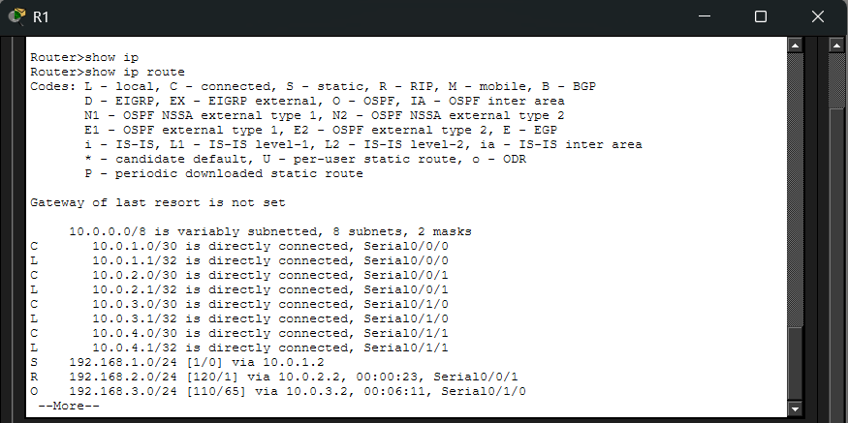
6.2 R2 (Admin – Static) – Routing Table
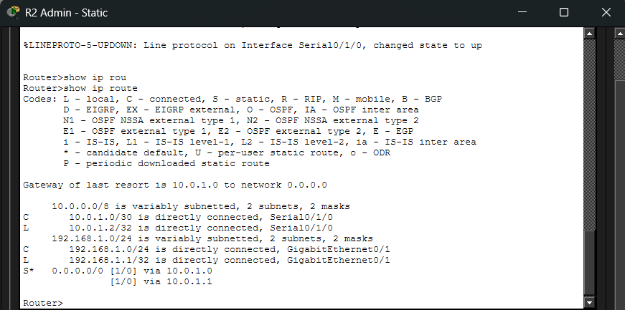
6.3 R3 (Library – RIP) – Routing Table
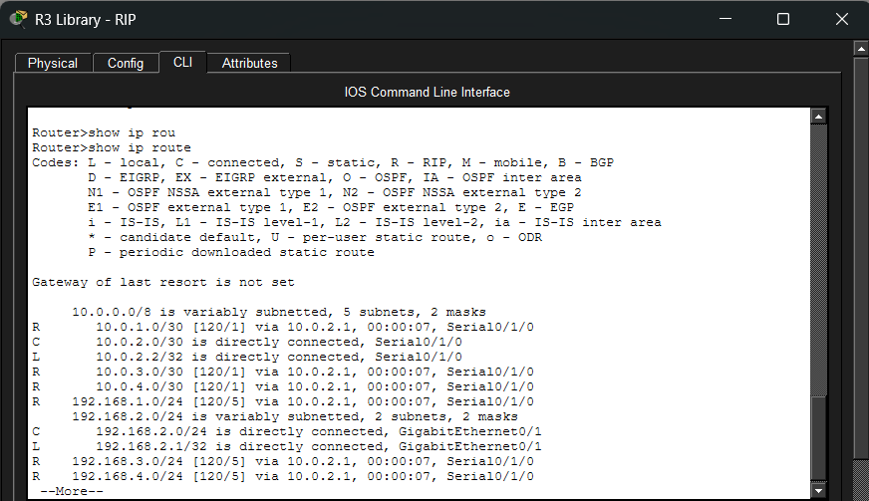
6.4 R4 (Labs – OSPF) – Routing Table
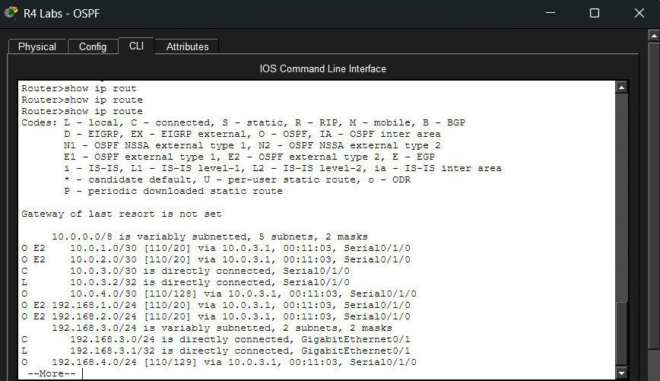

6.5 R5 (Faculty – DHCP) – Routing Table
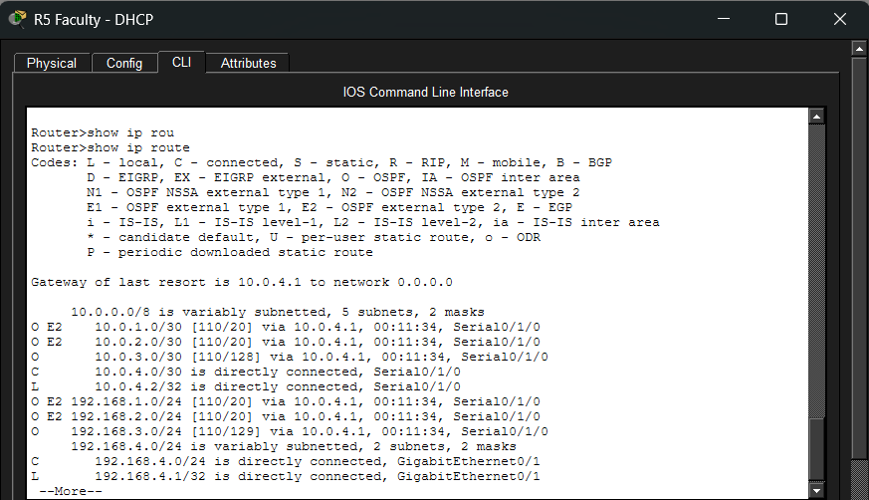
7. Connectivity Tests (Ping)
All ping tests were performed from the end-user PCs to verify end-to-end connectivity across the university campus network.
7.1 Admin Department (PC0 and PC1 – under R2)
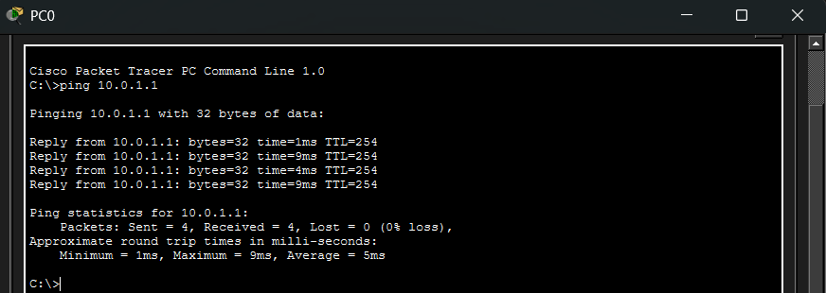

7.2 Library Department (PC2 and PC3 – under R3)
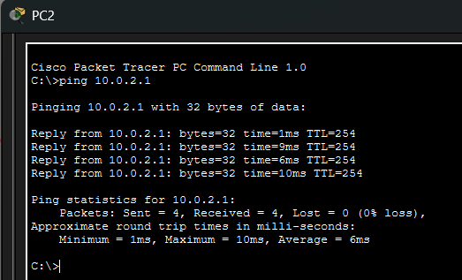
7.3 Labs Department (PC4 and PC5 – under R4)
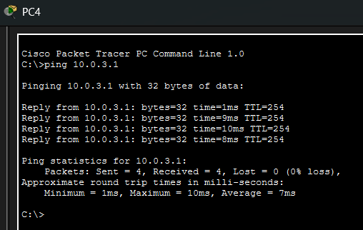
7.4 Faculty Department (PC6 and PC7 – under R5)
