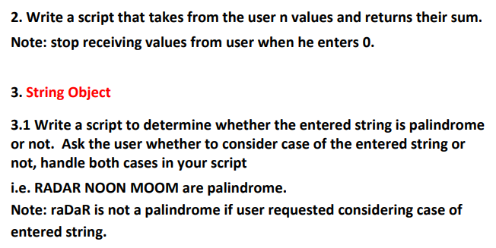

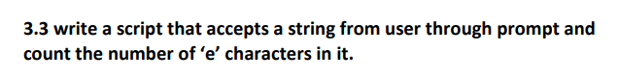

# 3.2 Write a function to Check if a Number is Odd or Even