1. achivements or achievements ?

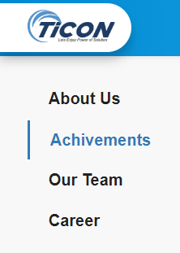

1. I don’t know why I took this :/

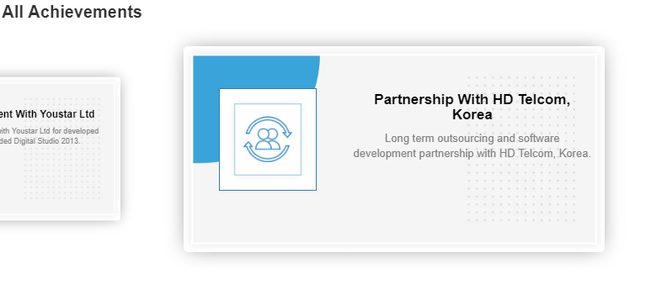

3. Spelling of provider in second line of description

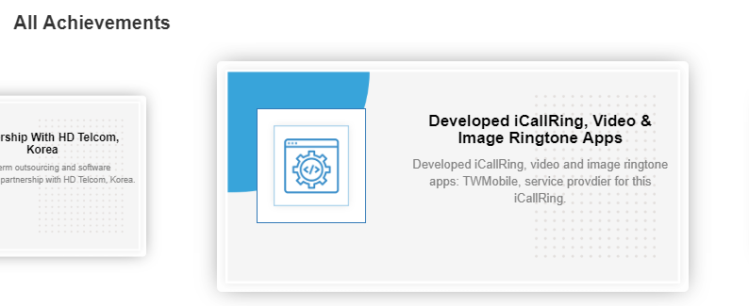

4. Spelling of python

<http://ticonsys.com/index.php/service/page/Web%20Development>

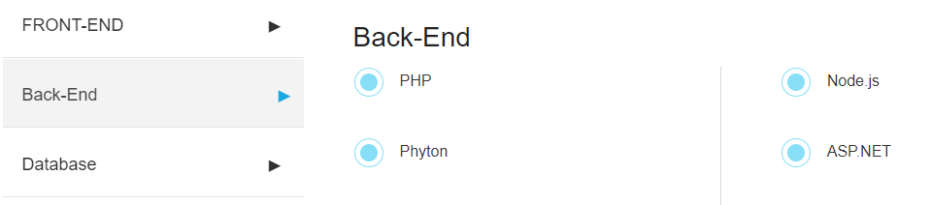

5. Spelling of Shopify  
<http://ticonsys.com/index.php/service/page/Web%20Development>  
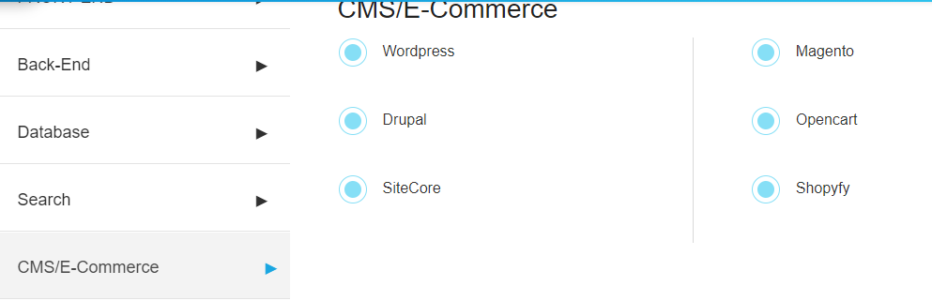

6.

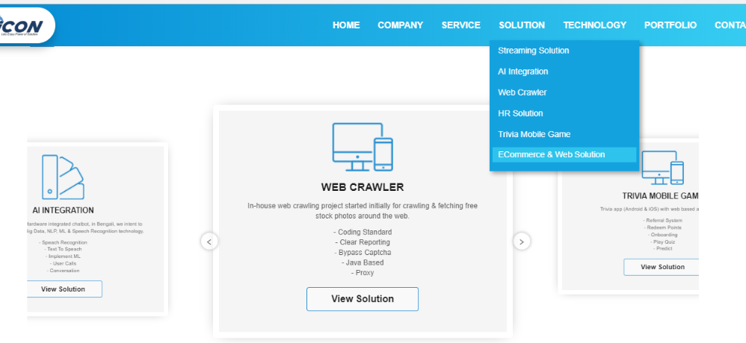

7. Dead Link!

Is View more a dead link or what?  
It just through user to a new tab and it seems same as previous page

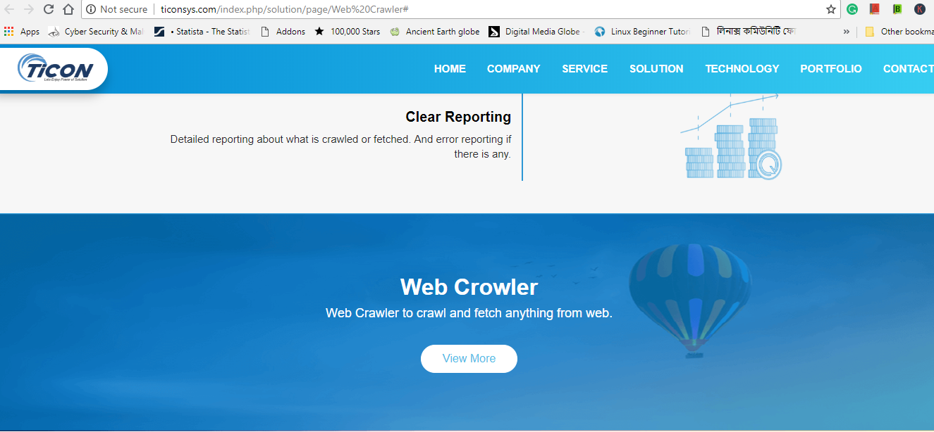

8. When user go to this url : <http://ticonsys.com/index.php/solution/page/ECommerce%20and%20Web%20Solution>

It shows only plain text. When try to scrolled down, an img appears from nowhere :P  
No js effect

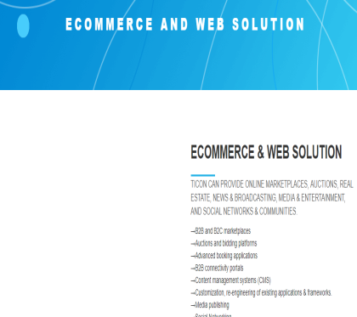 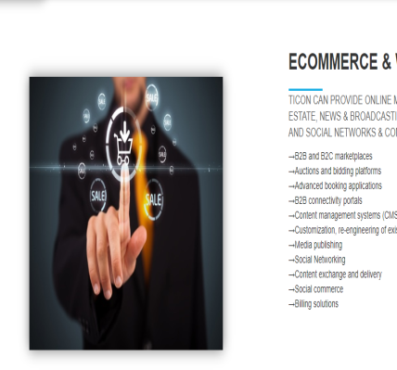

9. When try to submit via mail from this http://ticonsys.com/Streaming/index.html?email=fahimsultan4%40gmail.com#  
it shows no flash data/popup/messages

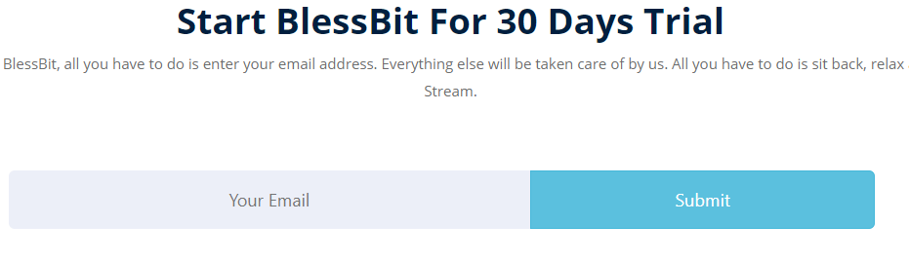

10. Another spelling mistake of the word python

<http://ticonsys.com/index.php/technology/page/Web%20Development>

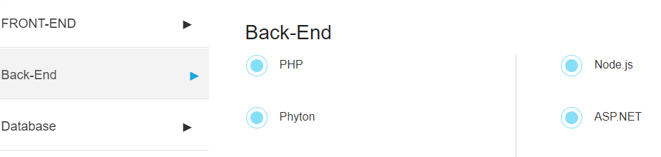

11. isn’t it shopify?

http://ticonsys.com/index.php/technology/page/Web%20Development

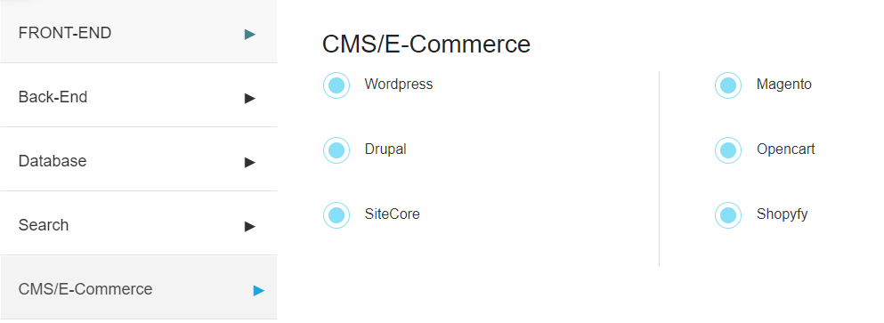

12. Speech or Speech?  
I don’t know the correct spelling

<http://ticonsys.com/index.php/technology/page/Artificial%20Intelligence>

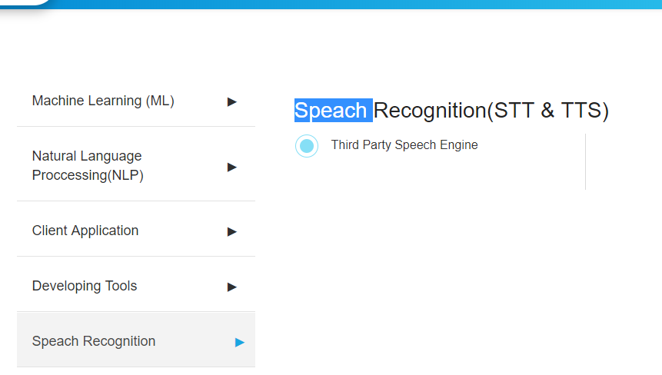

13. dimensional or dimentional ?  
<http://206.81.15.98/ticonsys.com/index.php/portfolio>

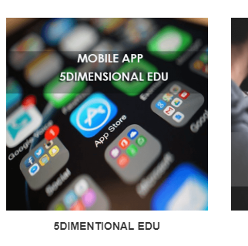

14. When I tried contact us option it gave me a error message

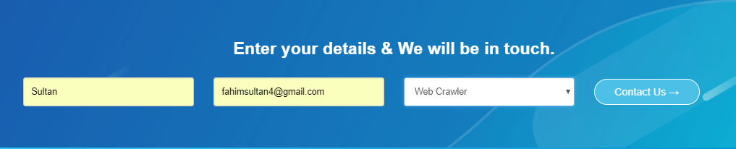



If there are any mistakes from me

Sorry ☺