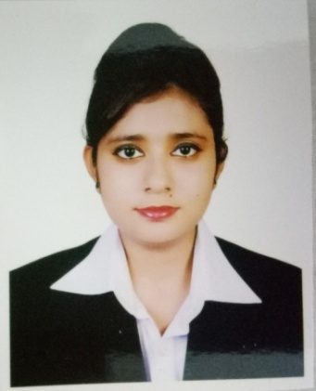Rakiba Nasrin Ratri

[ratri.rakiba@gmail.com](mailto:ratri.rakiba@gmail.com) Address: **Address: #179 Hazi Yunus Ali Sarkar Road, House#25, Tongi Modhumita, Gazipur.**

 01318533979.

 [linkedin.com/in/rakiba-ratri-5a2b32130](https://www.linkedin.com/in/rakiba-ratri-5a2b32130)

**Career Objectives** Seeking for a position for a learning opportunity where I can implement my practical, theoretical knowledge as well as use my interpersonal skills, creativity.

# Profile

Excellent internal and external communication skill to take on any challenging target. Enjoy working in a group. Self-driven and focused on meeting organization’s goal. I have ability to rapidly build relationship & set up trust. Well organized and highly motivated.

# Educational Details

|  |  |  |  |  |  |
| --- | --- | --- | --- | --- | --- |
| **Title** | **Major** | **Institution** | **Location** | **Result** | **Passing year** |
| **BSC** | Computer Science & Engineering | International University of Business, Agriculture &  Technology | Uttara, Sector- 10 | CGPA: 3.00/4 | 2015-2018  (Continuing) |
| **HSC** | Science | Milestone College | Uttara, Sector- 11 | GPA:  5/5 | 2014 |
| **SSC** | Science | Nawab Habibullah Model School & College | Uttara, Sector- 4 | GPA:  5/5 | 2012 |

**Technical Skills**

**Language skills**- English, Bengali, Hindi.( both written and verbal), Microsoft office & Prezi

**Basics of Programming** C, C++, Assembly language, HTML, CSS, PHP, Java, C#.Net, ASP.Net, MVC

**Database:** MySql, SQL

**Operating system:** Windows, Linux , **Package:** MS.Word,MS.Excel & MS.PowerPoint.

# Projects

## Employee Management System

* + Language: Php, HTML, CSS, Mysql

## 2D Computer Graphics

* + Language: C++, Glut Library

## Account Management System

* + Language: C# (Dot Net Framework), Mysql

## Autometic Result Management System

* + Language: Java, Mysql

# Related Coursework

LICT- Top Up Training Program On WEB DEVLOPMENT.

# Certificate and Awards

* Got Awards for achieving GPA 5.00 at HSC board examination from Milestone College.
* Got the LICT- Top Up Training certificate on web Devlopement.
* Certificate from British Council for book reading competition
* Got hundred percent scholarship from IUBAT.

# Academic Activities

* Experience of participating for the project showcasing on IT Fest
* Participated on NASSCOM examination

# Interest

* Web Developing
* Learning and creating new things

Signature

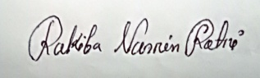

Rakiba Nasrin Ratri