Machine Learning-Based Network Intrusion Detection and Analytics System
Project Report
Author: Meemansa
Dataset: UNSW-NB15 (official predefined train/test split)

1. Problem Statement and Objectives
Network intrusion detection systems (IDS) protect computer networks by identifying malicious traffic. This project builds an offline, reproducible, educational prototype that applies machine learning to the UNSW-NB15 benchmark dataset. The primary objective is binary classification: given a network-flow record, predict whether it represents normal traffic (label=0) or an attack (label=1).
Key objectives:
1. Load and validate the official UNSW-NB15 train/test split without leakage.
2. Design a reproducible, leakage-safe preprocessing pipeline.
3. Train and compare three models: a Dummy baseline, Logistic Regression, and Random Forest.
4. Evaluate models on the held-out test set using precision, recall, F1, and confusion matrices.
5. Analyse feature importance and error patterns.
6. Document all findings and limitations honestly.
7. Build an interactive Streamlit web dashboard that presents all saved results and enables batch prediction using the pre-trained pipeline.
This is an offline benchmark evaluation, NOT a live network monitoring system. Results reflect performance on UNSW-NB15 and cannot be directly generalised to real-world network environments.

2. Dataset Source and Description
Dataset: UNSW-NB15
Source: https://research.unsw.edu.au/projects/unsw-nb15-dataset
Citation: Moustafa, N., & Slay, J. (2015). UNSW-NB15: A comprehensive data set for network intrusion detection systems (UNSW-NB15 network data set). 2015 Military Communications and Information Systems Conference (MilCIS), 1-6. https://doi.org/10.1109/MilCIS.2015.7348942
The dataset was created by the Australian Centre for Cyber Security at UNSW Canberra. It contains network flow records with 45 features extracted from real and synthetic network traffic, labelled as normal or one of nine attack categories.
Split | Rows | Normal (0) | Attack (1) | Attack %
Training | 175,341 | 56,000 | 119,341 | 68.1%
Testing | 82,332 | 37,000 | 45,332 | 55.1%

Notable characteristics:
- 45 columns: 39 numeric, 3 categorical (proto, service, state), attack_cat, label, id.
- attack_cat encodes the attack type for attack rows; NaN for normal rows (by design).
- No missing values found in either split.
- No duplicate rows.
- Class balance is inverted vs real networks: attacks dominate training (68%).
- The id column is a sequential row identifier that overlaps between splits and was excluded.

3. Preprocessing and Leakage Prevention
All preprocessing is implemented as a scikit-learn Pipeline containing a ColumnTransformer. The pipeline is fitted exclusively on training data and applied to the test set without refitting.
Excluded columns (never used as model features):
Column | Reason for exclusion
label | Binary prediction target.
attack_cat | Encodes attack category derived from the outcome — direct leakage.
id | Sequential row identifier; overlapping ranges; no traffic-flow meaning.

Numeric pipeline (39 features):
SimpleImputer(strategy='median') to handle unexpected missing values, followed by StandardScaler (zero mean, unit variance). Median imputation is used because numeric features (byte counts, timing values) are heavily right-skewed.

Categorical pipeline (proto, service, state):
SimpleImputer(strategy='most_frequent'), followed by OneHotEncoder(handle_unknown='ignore'). The handle_unknown='ignore' setting is required because EDA confirmed that 'state' has two values in the test set ('ACC', 'CLO') not present in training.
High-cardinality handling (proto):
proto has 133 unique training values; the top-10 values cover 92.9% of rows. OneHotEncoder(max_categories=20) bundles rare protocols into an infrequent bucket, keeping the output dimension manageable. service (13 values) and state (9 values) are encoded without a cap. Total output feature dimension: 81 columns.
Train-only fitting prevents data leakage: imputer medians, scaler mean/variance, and OHE category lists are computed from training data only. The test set is kept completely untouched until final evaluation.

4. Models Compared and Evaluation Methodology
Three models were trained and compared. Each model is saved as a complete scikit-learn Pipeline (preprocessor + classifier) to ensure preprocessing parameters are always aligned with the fitted classifier.
Model | Role | Key settings
DummyClassifier | Baseline | strategy='most_frequent' — always predicts attack
Logistic Regression | Linear model | solver=lbfgs, max_iter=1000, C=1.0, random_state=42
Random Forest | Ensemble model | n_estimators=100, max_depth=None, random_state=42

Evaluation methodology:
All models were trained on the official UNSW-NB15 training split (175,341 rows). Final evaluation used the official held-out test split (82,332 rows), which was not used during training or model selection. No cross-validation or hyperparameter tuning was performed in this phase.
Metrics reported:
- Accuracy (with caveats about class imbalance)
- Per-class precision, recall, and F1 (labels 0 and 1)
- Macro F1 (unweighted mean across classes)
- ROC-AUC where prediction scores are available
- Confusion matrix (TN, FP, FN, TP)
- Training time and prediction time
Intrusion-detection interpretation:
- False Negatives (FN) = attacks predicted as normal = MISSED ATTACKS. This is the more dangerous failure — a missed attack goes undetected.
- False Positives (FP) = normal predicted as attack = FALSE ALARMS. Too many FPs cause alert fatigue and reduce analyst trust.

5. Measured Results
All metrics below were measured on the official UNSW-NB15 test split (82,332 rows). Values are loaded from results/metrics/model_comparison.json — they were not manually edited.
Model | Accuracy | Attack Recall | Attack Precision | Macro F1 | ROC-AUC | Train (s)
DummyClassifier | 0.5506 | 1.0000 | 0.5506 | 0.3551 | 0.5 | 1.805
LogisticRegression | 0.8089 | 0.9724 | 0.7527 | 0.7948 | 0.9551 | 9.475
RandomForest | 0.8726 | 0.9858 | 0.8194 | 0.8665 | 0.9789 | 8.744

5.1 Confusion Matrices
Model | TN | FP | FN | TP
DummyClassifier | 0 | 37,000 | 0 | 45,332
LogisticRegression | 22,519 | 14,481 | 1,253 | 44,079
RandomForest | 27,150 | 9,850 | 642 | 44,690

Key findings:
- The Dummy baseline (FN=0, FP=37,000) confirms that always predicting 'attack' catches every attack but floods analysts with false alarms — completely impractical.
- Logistic Regression reduces FP to 14,481 and FN to 1,253 with a ROC-AUC of 0.9551.
- Random Forest achieves the best balance: only 642 missed attacks (FN) and 9,850 false alarms (FP), with ROC-AUC 0.9789 and Macro F1 0.8665.
- The test set has 55% attacks vs 68% in training — both real classifiers generalise reasonably well to the shifted class balance.
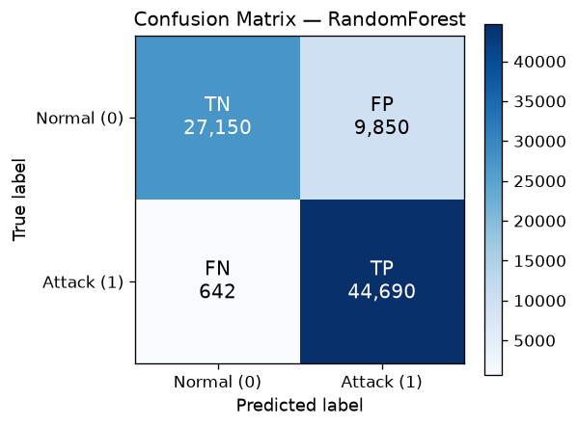
Figure 1: Confusion Matrix — Random Forest (best model)

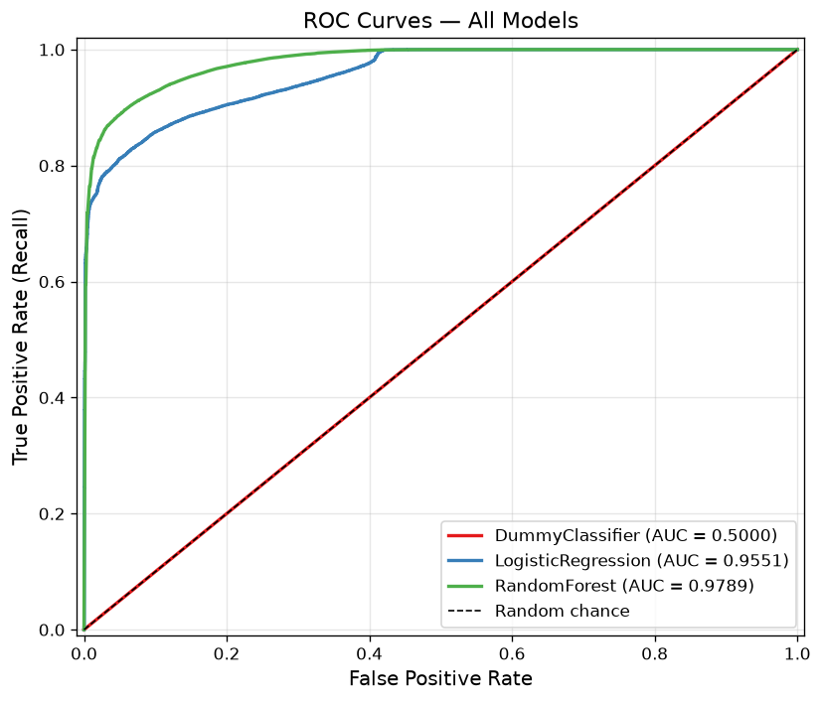
Figure 2: ROC Curves — All Models

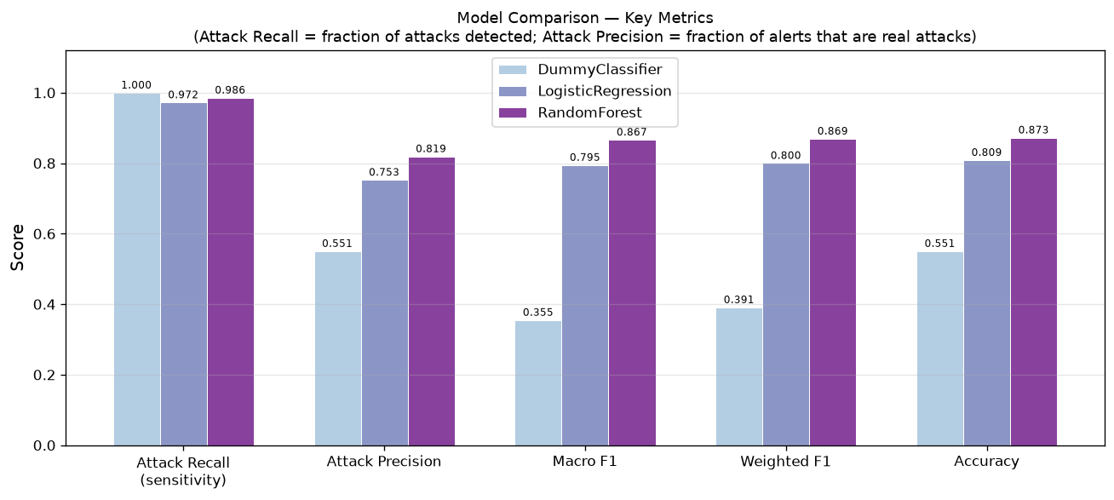
Figure 3: Model Comparison — Key Metrics

6. Feature Importance Analysis
Feature importances were extracted from the fitted Random Forest using mean decrease in impurity (MDI). The top 10 features by importance are:
Rank | Feature | Importance
1 | sttl | 0.14052
2 | ct_state_ttl | 0.09465
3 | dload | 0.06754
4 | dttl | 0.05510
5 | tcprtt | 0.04461
6 | sbytes | 0.03622
7 | ackdat | 0.03602
8 | dur | 0.03181
9 | rate | 0.03169
10 | synack | 0.02953

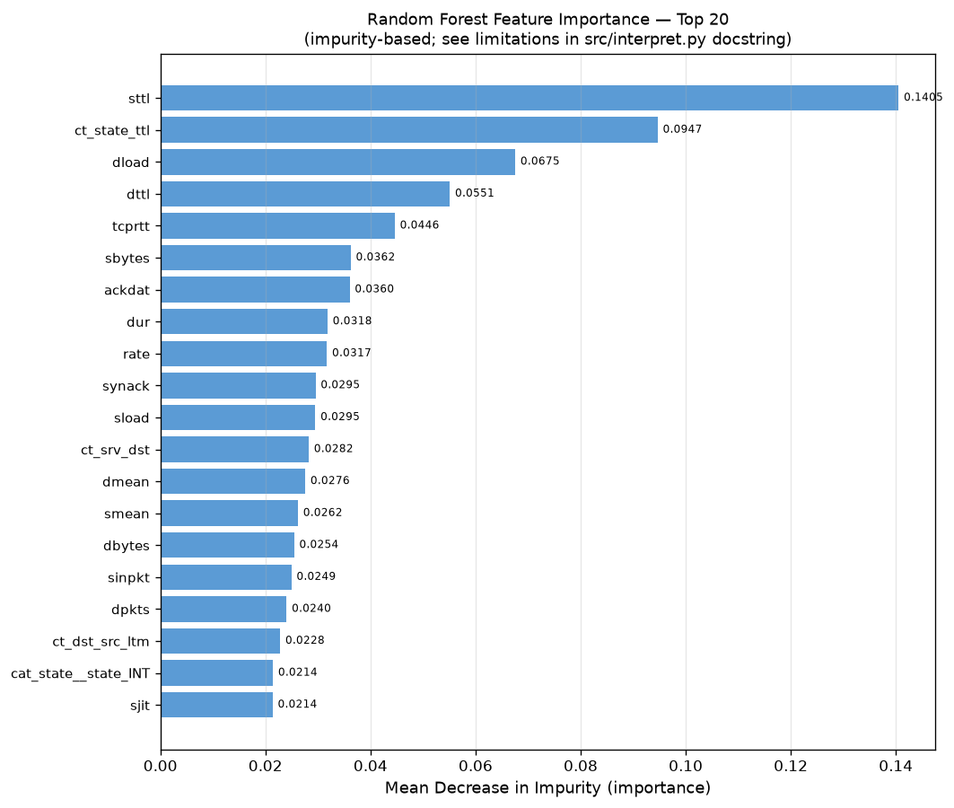
Figure 4: Random Forest Feature Importance — Top 20 Features

Interpretation and limitations:
The top feature 'sttl' (source TTL) makes network sense: different operating systems and attack tools set characteristic TTL values. The pair sttl/ct_state_ttl likely captures OS fingerprinting signals.
Important limitations of MDI importance:
1. MDI can overvalue high-cardinality features (e.g. stcpb, dtcpb).
2. Correlated features share importance — sttl and ct_state_ttl may appear less important individually than their combined effect warrants.
3. These values describe how the model makes splits, not causal relationships between features and attack behaviour.
4. Permutation importance (not computed in this project) would provide a less biased alternative.

7. Error Analysis
The Random Forest produced 9,850 false positives and 642 false negatives on the test set.
Top protocols in false positives: tcp: 7,137, udp: 2,709, igmp: 4
Top protocols in false negatives (missed attacks): tcp: 485, udp: 157
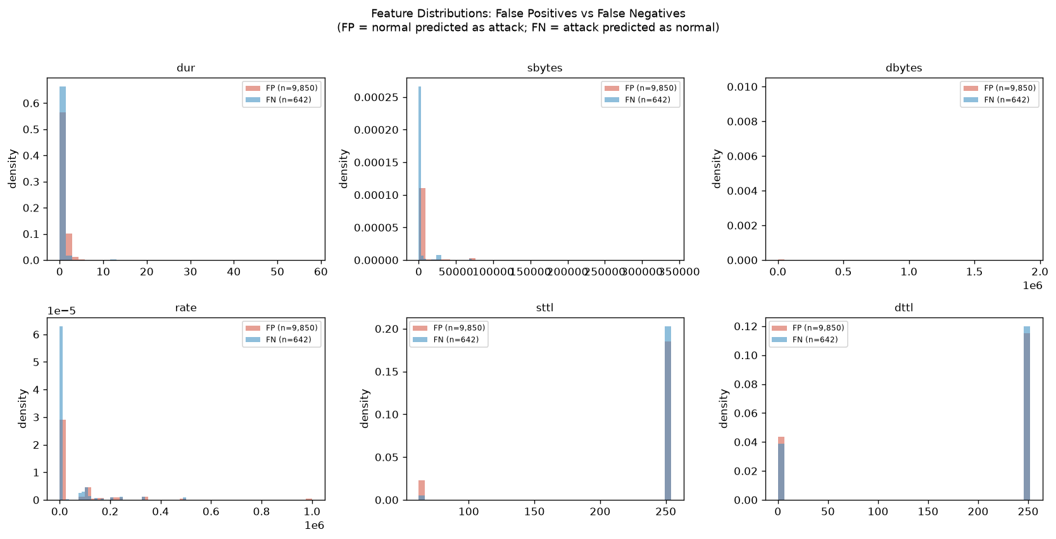
Figure 5: Feature Distributions — False Positives vs False Negatives

The error analysis shows that both false positives and false negatives are concentrated in the high-volume TCP and UDP protocols, which dominate the dataset. Attacks being missed tend to have feature distributions that overlap closely with normal traffic — these are the inherently ambiguous cases for a binary classifier.

8. Limitations and Future Work
Limitations:
1. Offline benchmark only: results are specific to UNSW-NB15 and cannot be generalised to real network environments without independent validation.
2. Inverted class balance: 68% attacks in training is unrealistic — real networks are dominated by normal traffic, which would change the operational FP/FN trade-off.
3. No hyperparameter tuning: Logistic Regression and Random Forest settings were chosen based on documented guidance, not cross-validated search.
4. MDI feature importance is biased: high-cardinality and correlated features are mis-valued; permutation importance would be more reliable.
5. Single train/test split: no confidence intervals or multiple-run variance estimates are provided.
6. Binary classification only: multiclass attack-category prediction was out of scope.
Future work:
- Threshold optimisation: adjust the decision boundary to prioritise FN reduction (fewer missed attacks) at the cost of more FP, or vice versa.
- Permutation importance: replace MDI with a less biased importance measure.
- Multiclass classification: use attack_cat to train a multiclass model and assess per-category detection rates.
- Ensemble methods: XGBoost or stacking to improve on Random Forest.
- Independent evaluation: apply the pipeline to a different network dataset.

9. Streamlit Web Dashboard
A Streamlit-based interactive web dashboard (app.py) was developed as the project's frontend layer. It reads all pre-computed results — saved model pipelines, JSON/CSV metrics, and PNG figures — and presents them through a clean, dark-themed cybersecurity interface. No model training or fitting takes place within the dashboard.

9.1 Design and Technology
The dashboard is built with Streamlit 1.66 and Matplotlib, using the existing .venv environment. It applies a dark navy/charcoal theme with blue/cyan accents to match the cybersecurity context. Metric cards, interactive tables, and embedded PNG charts are used throughout. The app is launched locally via: .venv\Scripts\python.exe -m streamlit run app.py (accessible at http://localhost:8501). No external APIs, cloud services, or internet access are required at runtime.

9.2 Dashboard Pages
The dashboard is structured into six pages accessible from a sidebar navigation panel:
Overview: Project summary, dataset record counts (train: 175,341; test: 82,332), best-model metric cards (Random Forest accuracy 87.3%, ROC-AUC 0.9789, attack recall 98.6%), and the class-distribution, model-comparison, and ROC-curve figures. A clear explanation of the Normal (label=0) vs Attack (label=1) distinction is provided.
Model Comparison: Full metrics table loaded from results/metrics/model_comparison.csv and model_comparison.json, including accuracy, precision, recall, F1, ROC-AUC, and prediction time for all three models. Per-model confusion matrices are displayed side by side. A metric glossary explains each measure in plain language.
Dataset Explorer: Class and attack-category distribution tables (from results/metrics/eda_summary.json), all six EDA figures, and a 500-row preview of the training CSV. The excluded columns (label, attack_cat, id) and their rationale are explained.
Feature Importance and Errors: An interactive horizontal bar chart of the top 20 Random Forest features (rendered with Matplotlib), a top-10 table, the saved feature-importance and error-distribution PNG figures, protocol-level error breakdowns, and a plain-language explanation of Gini importance and its limitations.
Prediction Lab: Users upload a CSV of network-flow records. The dashboard validates the schema against the 42 required feature columns, then calls pipeline.predict() and pipeline.predict_proba() on the saved RandomForest.joblib pipeline. Predictions are displayed as Normal or Attack with confidence scores, and results can be downloaded as a CSV. A synthetic demo option is also available. No .fit() call is made anywhere in the dashboard.
Project Information: Background on NIDS and the UNSW-NB15 dataset, model descriptions, metric definitions in plain language, dashboard usage instructions, project limitations, and an explanation of how saved pipelines are reused without retraining.

9.3 Prediction Pipeline Reuse
Each saved .joblib file contains the complete scikit-learn Pipeline — the fitted ColumnTransformer preprocessor (scaler statistics, one-hot encoder category lists) and the fitted classifier. The dashboard loads the pipeline once using joblib.load(), caches it with st.cache_resource, and calls only .predict() and .predict_proba(). Label convention is preserved: 0 maps to Normal, 1 maps to Attack, consistent with the training target definition in src/features.py. Unseen categorical values in uploaded data are handled gracefully by the pipeline's OneHotEncoder(handle_unknown='ignore') setting.

9.4 Limitations of the Dashboard
The dashboard is an offline educational tool, not a production security system. Predictions are only as reliable as the underlying model on UNSW-NB15; they do not reflect performance on real or modern network traffic. Uploaded CSVs must match the UNSW-NB15 feature schema exactly. The 101 MB Random Forest model requires sufficient memory on the host machine. The interface includes a clear disclaimer on every page that this is not connected to live network traffic.

10. References
Moustafa, N., & Slay, J. (2015). UNSW-NB15: A comprehensive data set for network intrusion detection systems (UNSW-NB15 network data set). 2015 Military Communications and Information Systems Conference (MilCIS), 1-6. https://doi.org/10.1109/MilCIS.2015.7348942
Pedregosa, F. et al. (2011). Scikit-learn: Machine Learning in Python. Journal of Machine Learning Research, 12, 2825-2830.
McKinney, W. (2010). Data Structures for Statistical Computing in Python. Proceedings of the 9th Python in Science Conference, 51-56.

