**Food Stall system in Java**

**ABSTRACT**

Now a day’s many applications are used for food management system but with some issues. The issues may be time management, stock management etc., which will leads to broken the customer satisfactions and quality problems. For avoiding this we implement a fool stall system which will overcome the above declared statement. We maintain our system with admin and user panel which provides better understandable for both user and management .Result show our proposed system minimize the manpower and delay between the food orders. The aim of this project is to create a food stall management system that can incorporate the benefits of all the existing solutions but without any of the drawbacks as well as including many new features.

**INTRODUCTION**

A Java project contains source code and related files for building a Java program. It has an associated Java builder that can incrementally compile Java source files as they are changed.

A Java project also maintains a model of its contents. This model includes information about the type hierarchy, references and declarations of Java elements. This information is constantly updated as the user changes the Java source code. The updating of the internal Java project model is independent of the Java builder; in particular, when performing code modifications, if auto-build is turned off, the model will still reflect the present project contents.

You can organize Java projects in two different ways are Using the project as the source container. This is the recommended organization for simple projects. Using source folders inside the project as the source container. This is the recommended organization for more complex projects. It allows you to subdivide packages into groups. When the code is run by the user, it is processed by something called the Java Virtual Machine (JVM). The JVM is essentially an interpreter for the byte code. It goes through the byte code and runs it. There are different versions of the JVM that are compatible with each OS and can run the same code. There is virtually no difference for the end-user, but this makes it a lot easier for programmers doing software development.

It was based on C and C++ syntax to make it easy for programmers from those communities to learn. Since then, it has earned a prominent place in the world of computer programming.

Java source code files (files with a .java extension) are compiled into a format called byte code (files with a .class extension), which can then be executed by a Java interpreter. Compiled Java code can run on most computers because Java interpreters and runtime environments, known as Java Virtual Machines (VMs). Byte code can also be converted directly into machine language instructions by a just-in-time compiler (JIT).

**EXISTING SYSTEM**

* In Existing system, they use man power related food serving system.
* Which may leads to following problems
* Unmanageable order logging.
* Inefficient restaurant-kitchen communication.
* Difficult order tracking and time management.
* Difficult stock management.
* Limited statistical output**.**

**DISADVANTAGES**

* Time delay
* Need high man power

**PROPOSED SYSTEM**

* Propose a food stall management system for both use and admin.
* The aim of this project is to create a food stall management system that can incorporate the benefits of all the existing solutions but without any of the drawbacks as well as including many new features.

**ADVANTAGES**

* User friendly
* Quick delivery
* Less Man power

**SYSTEM ARCHITECTURE**

Admin

Admin Login

Food Added

View the food

Order message send to the user

Order message receive the user

Delete the food

Order Placed

User

Food added to the cart

User Login

Order send to the admin

**FLOW DIAGRAM**

User

User Login

View the food

Order Placed

Food added to the cart

Admin Login

Admin

Food Added

Delete the Food

Order message send to the user

Order Message receive the user.

Order send to the admin

**USE CASE DIAGRAM**

**CLASS DIARGAM**

User

Food added to the cart

Admin

User Login

Order Placed

Admin Login

View the Food

Order send to the admin

Food Added

Delete the food

Order message send to the user.

Order message receive the user.

**SEQUENCE DIAGRAM**

User

Admin

Order

User Login

View the Food

Food added to the cart

Admin Login

Food Added

Order Placed

Order send to the admin.

Order message passes to the user

Order message receive the user

**E-R DIAGRAM**

User

Order

Admin

User Login

View the food

Food added to the cart

Admin Login

Food Added

Order placed

Order send to admin

Order message send to the user

Order message receive the user

**TESTING OF PRODUCT**

**Testing of Product:**

System testing is the stage of implementation, which aimed at ensuring that system works accurately and efficiently before the live operation commence. Testing is the process of executing a program with the intent of finding an error. A good test case is one that has a high probability of finding an error. A successful test is one that answers a yet undiscovered error.

Testing is vital to the success of the system.  System testing makes a logical assumption that if all parts of the system are correct, the goal will be successfully achieved.  The candidate system is subject to variety of tests-on-line response, Volume Street, recovery and security and usability test.  A series of tests are performed before the system is ready for the user acceptance testing.  Any engineered product can be tested in one of the following ways.  Knowing the specified function that a product has been designed to from, test can be conducted to demonstrate each function is fully operational.  Knowing the internal working of a product, tests can be conducted to ensure that “al gears mesh”, that is the internal operation of the product performs according to the specification and all internal components have been adequately exercised.

**UNIT TESTING:**

Unit testing is the testing of each module and the integration of the overall system is done.  Unit testing becomes verification efforts on the smallest unit of software design in the module.  This is also known as ‘module testing’.  The modules of the system are tested separately.  This testing is carried out during the programming itself.  In this testing step, each model is found to be working satisfactorily as regard to the expected output from the module.  There are some validation checks for the fields.  For example, the validation check is done for verifying the data given by the user where both format and validity of the data entered is included.  It is very easy to find error and debug the system.

**INTEGRATION TESTING:**

Data can be lost across an interface, one module can have an adverse effect on the other sub function, when combined, may not produce the desired major function.  Integrated testing is systematic testing that can be done with sample data.  The need for the integrated test is to find the overall system performance. There are two types of integration testing. They are:

1. Top-down integration testing.
2. Bottom-up integration testing.

**WHITE BOX TESTING:**

White Box testing is a test case design method that uses the control structure of the procedural design to drive cases.  Using the white box testing methods, we derived test cases that guarantee that all independent paths within a module have been exercised at least once.

**BLACK BOX TESTING:**

* + Black box testing is done to find incorrect or missing function
  + Interface error
  + Errors in external database access
  + Performance errors
  + Initialization and termination errors

In ‘functional testing’, is performed to validate an application conforms to its specifications of correctly performs all its required functions. So this testing is also called ‘black box testing’.  It tests the external behavior of the system.  Here the engineered product can be tested knowing the specified function that a product has been designed to perform, tests can be conducted to demonstrate that each function is fully operational.

**VALIDATION TESTING:**

After the culmination of black box testing, software is completed assembly as a package, interfacing errors have been uncovered and corrected and final series of software validation tests begin validation testing can be defined as many, but a single definition is that validation succeeds when the software functions in a manner that can be reasonably expected by the customer.

# USER ACCEPTANCE TESTING:

User acceptance of the system is the key factor for the success of the system.  The system under consideration is tested for user acceptance by constantly keeping in touch with prospective system at the time of developing changes whenever required.

# OUTPUT TESTING:

After performing the validation testing, the next step is output asking the user about the format required testing of the proposed system, since no system could be useful if it does not produce the required output in the specific format.  The output displayed or generated by the system under consideration.  Here the output format is considered in two ways.  One is screen and the other is printed format.  The output format on the screen is found to be correct as the format was designed in the system phase according to the user needs.  For the hard copy also output comes out as the specified requirements by the user. Hence the output testing does not result in any connection in the system.

**System Implementation:**

Implementation of software refers to the final installation of the package in its real environment, to the satisfaction of the intended users and the operation of the system. The people are not sure that the software is meant to make their job easier.

* The active user must be aware of the benefits of using the system
* Their confidence in the software built up
* Proper guidance is impaired to the user so that he is comfortable in using the application

Before going ahead and viewing the system, the user must know that for viewing the result, the server program should be running in the server. If the server object is not running on the server, the actual processes will not take place.

**User Training:**

To achieve the objectives and benefits expected from the proposed system it is essential for the people who will be involved to be confident of their role in the new system. As system becomes more complex, the need for education and training is more and more important.

Education is complementary to training. It brings life to formal training by explaining the background to the resources for them. Education involves creating the right atmosphere and motivating user staff. Education information can make training more interesting and more understandable.

**Training on the Application Software:**

After providing the necessary basic training on the computer awareness, the users will have to be trained on the new application software. This will give the underlying philosophy of the use of the new system such as the screen flow, screen design, type of help on the screen, type of errors while entering the data, the corresponding validation check at each entry and the ways to correct the data entered. This training may be different across different user groups and across different levels of hierarchy.

**Operational Documentation:**

Once the implementation plan is decided, it is essential that the user of the system is made familiar and comfortable with the environment. A documentation providing the whole operations of the system is being developed. Useful tips and guidance is given inside the application itself to the user. The system is developed user friendly so that the user can work the system from the tips given in the application itself.

**System Maintenance:**

The maintenance phase of the software cycle is the time in which software performs useful work. After a system is successfully implemented, it should be maintained in a proper manner. System maintenance is an important aspect in the software development life cycle. The need for system maintenance is to make adaptable to the changes in the system environment. There may be social, technical and other environmental changes, which affect a system which is being implemented. Software product enhancements may involve providing new functional capabilities, improving user displays and mode of interaction, upgrading the performance characteristics of the system. So only thru proper system maintenance procedures, the system can be adapted to cope up with these changes. Software maintenance is of course, far more than “finding mistakes”.

**Corrective Maintenance:**

The first maintenance activity occurs because it is unreasonable to assume that software testing will uncover all latent errors in a large software system. During the use of any large program, errors will occur and be reported to the developer. The process that includes the diagnosis and correction of one or more errors is called Corrective Maintenance.

**Adaptive Maintenance:**

The second activity that contributes to a definition of maintenance occurs because of the rapid change that is encountered in every aspect of computing. Therefore Adaptive maintenance termed as an activity that modifies software to properly interfere with a changing environment is both necessary and commonplace.

**Perceptive Maintenance:**

The third activity that may be applied to a definition of maintenance occurs when a software package is successful. As the software is used, recommendations for new capabilities, modifications to existing functions, and general enhancement are received from users. To satisfy requests in this category, Perceptive maintenance is performed. This activity accounts for the majority of all efforts expended on software maintenance.

**Preventive Maintenance:**

The fourth maintenance activity occurs when software is changed to improve future maintainability or reliability, or to provide a better basis for future enhancements. Often called preventive maintenance, this activity is characterized by reverse engineering and re-engineering techniques.

**MODULES:**

* Admin Stock Management
* User Authentication
* Cart items
* Delivery status

**MODULE DESCRIPTION**

Admin Stock Management:

The admin stock management manages the food list and adding the food by the user. The user select the food it will also handle by the admin side. If the food is not wanted means, it will deleted by the process of admin side. The admin have three field are add, delete and view orders. View all the customer order using the view orders.

User Authentication:

User authentication is a process that allows a device to verify the identity of someone. The user authentication is to register their data to the admin. The user login into the food stall want the food to add on cart. The cart will manage by admin side.

Cart Items:

The cart items have veg and non-veg. If we select the non-veg part. It have a many sub menus like a chicken biryani, chicken tikka like that. It is also handle by admin side. The user will only login and select the food and purchase it.

Delivery Status:

The user add the food to the cart. If select the food by the user. That food added to the cart and the food is to place on admin side. The order message send to the user side. The order is placed is to be a delivery status. The delivery status is some alert to the confirmation of the user side.

**SYSTEM REQUIREMENTS**

**Software Requirements:**

* O/S : Windows XP.
* Language : Java.
* IDE : Net Beans 6.9.1
* Data Base : MySQL

**Hardware Requirements:**

* System : Pentium IV 2.4 GHz
* Hard Disk : 160 GB
* Monitor : 15 VGA color
* Mouse : Logitech.
* Keyboard : 110 keys enhanced
* Ram : 2GB

**SOFTWARE DESCRIPTION**

**Java**

Java is a programming language originally developed by James Gosling at Sun Microsystems (now a subsidiary of Oracle Corporation) and released in 1995 as a core component of Sun Microsystems' Java platform. The language derives much of its syntax from C and C++ but has a simpler object model and fewer low-level facilities. Java applications are typically compiled to byte code (class file) that can run on any Java Virtual Machine (JVM) regardless of computer architecture. Java is a general-purpose, concurrent, class-based, object-oriented language that is specifically designed to have as few implementation dependencies as possible. It is intended to let application developers "write once, run anywhere." Java is currently one of the most popular programming languages in use, particularly for client-server web applications.

**Java Platform:**

One characteristic of Java is portability, which means that computer programs written in the Java language must run similarly on any hardware/operating-system platform. This is achieved by compiling the Java language code to an intermediate representation called Java byte code, instead of directly to platform-specific machine code. Java byte code instructions are analogous to machine code, but are intended to be interpreted by a virtual machine (VM) written specifically for the host hardware.

End-users commonly use a Java Runtime Environment (JRE) installed on their own machine for standalone Java applications, or in a Web browser for Java applets. Standardized libraries provide a generic way to access host-specific features such as graphics, threading, and networking.

A major benefit of using byte code is porting. However, the overhead of interpretation means that interpreted programs almost always run more slowly than programs compiled to native executables would. Just-in-Time compilers were introduced from an early stage that compiles byte codes to machine code during runtime.

Just as application servers such as Glass Fish provide lifecycle services to web applications, the Net Beans runtime container provides them to Swing applications. All new shortcuts should be registered in "Key maps/Net Beans" folder. Shortcuts installed INS Shortcuts folder will be added to all key maps, if there is no conflict. It means that if the same shortcut is mapped to different actions in Shortcut folder and current key map folder (like Key map/Net Beans), the Shortcuts folder mapping will be ignored.

* Database Explorer Layer API in Database Explorer

* Loaders-text-dB schema-Actions in Database Explorer

* Loaders-text-sql-Actions in Database Explorer

* Plug-in Registration in Java EE Server Registry

The keyword public denotes that a method can be called from code in other classes, or that a class may be used by classes outside the class hierarchy. The class hierarchy is related to the name of the directory in which the .java file is located.

The keyword static in front of a method indicates a static method, which is associated only with the class and not with any specific instance of that class. Only static methods can be invoked without a reference to an object. Static methods cannot access any class members that are not also static. The keyword void indicates that the main method does not return any value to the caller. If a Java program is to exit with an error code, it must call System. Exit () explicitly.

The method name "main" is not a keyword in the Java language. It is simply the name of the method the Java launcher calls to pass control to the program. Java classes that run in managed environments such as applets and Enterprise JavaBeans do not use or need a main () method. A Java program may contain multiple classes that have main methods, which means that the VM needs to be explicitly told which class to launch from.

The Java launcher launches Java by loading a given class (specified on the command line or as an attribute in a JAR) and starting its public static void main(String[]) method. Stand-alone programs must declare this method explicitly. The String [] args parameter is an array of String objects containing any arguments passed to the class. The parameters to main are often passed by means of a command line.

**Java a High-level Language:**

A high-level programming language developed by Sun Microsystems. Java was originally called OAK, and was designed for handheld devices and set-top boxes. Oak was unsuccessful so in 1995 Sun changed the name to Java and modified the language to take advantage of the burgeoning World Wide Web.

Java source code files (files with a .java extension) are compiled into a format called byte code (files with a .class extension), which can then be executed by a Java interpreter. Compiled Java code can run on most computers because Java interpreters and runtime environments, known as Java Virtual Machines (VMs). Byte code can also be converted directly into machine language instructions by a just-in-time compiler (JIT).

Java is a general purpose programming language with a number of features that make the language well suited for use on the World Wide Web. Small Java applications are called Java applets and can be downloaded from a Web server and run on your computer by a Java-compatible Web browser, such as Netscape Navigator or Microsoft Internet Explorer.

Object-Oriented Software Development using Java: Principles, Patterns, and Frameworks contain a much applied focus that develops skills in designing software-particularly in writing well-designed, medium-sized object-oriented programs. It provides a broad and coherent coverage of object-oriented technology, including object-oriented modeling using the Unified Modeling Language (UML) object-oriented design using Design Patterns, and object-oriented programming using Java.

**Net Beans**

The **Net Beans Platform** is a reusable framework for simplifying the development of Java Swing desktop applications. The Net Beans IDE bundle for Java SE contains what is needed to start developing Net Beans plug-in and Net Beans Platform based applications; no additional SDK is required.

Applications can install modules dynamically. Any application can include the Update Center module to allow users of the application to download digitally-signed upgrades and new features directly into the running application.

The platform offers reusable services common to desktop applications, allowing developers to focus on the logic specific to their application. Among the features of the platform are:

* User interface management (e.g. menus and toolbars)
* User settings management
* Storage management (saving and loading any kind of data)
* Window management
* Wizard framework (supports step-by-step dialogs)
* Net Beans Visual Library
* Integrated Development Tools

**J2EE**

A **Java EE application** or a **Java Platform, Enterprise Edition application** is any deployable unit of Java EE functionality. This can be a single Java EE module or a group of modules packaged into an EAR file along with a Java EE application deployment descriptor.

Enterprise applications can consist of the following:

* EJB modules (packaged in JAR files);
* Web modules (packaged in WAR files);
* connector modules or resource adapters (packaged in RAR files);
* Session Initiation Protocol (SIP) modules (packaged in SAR files);
* application client modules
* Additional JAR files containing dependent classes or other components required by the application;

**Wamp Server**

**WAMP**s are packages of independently-created programs installed on computers that use a Microsoft Windows operating system.

Apache is a web server. MySQL is an open-source database. PHP is a scripting language that can manipulate information held in a database and generate web pages dynamically each time content is requested by a browser. Other programs may also be included in a package, such as phpMyAdmin which provides a graphical user interface for the MySQL database manager, or the alternative scripting languages Python or Perl.

**MySQL**

The MySQL development project has made its source code available under the terms of the GNU General Public License, as well as under a variety of proprietary agreements. MySQL was owned and sponsored by a single for-profit firm, the Swedish company MySQL AB, now owned by Oracle Corporation.

Free-software-open source projects that require a full-featured database management system often use MySQL. Applications which use MySQL databases include: TYPO3, Joomla, WordPress, phpBB, Drupal and other software built on the LAMP software stack.

**Platforms and interfaces**

Many programming languages with language-specific APIs include libraries for accessing MySQL databases. These include MySQL Connector/Net for integration with Microsoft's Visual Studio (languages such as C# and VB are most commonly used) and the JDBC driver for Java. In addition, an ODBC interface called MyODBC allows additional programming languages that support the ODBC interface to communicate with a MySQL database, such as ASP or ColdFusion. The MySQL server and official libraries are mostly implemented in ANSI C/ANSI C++.

**FEASIBILITY STUDY**

The feasibility study is carried out to test whether the proposed system is worth being implemented. The proposed system will be selected if it is best enough in meeting the performance requirements.

The feasibility carried out mainly in three sections namely.

**•** Economic Feasibility

• Technical Feasibility

• Behavioral Feasibility

**Economic Feasibility**

Economic analysis is the most frequently used method for evaluating effectiveness of the proposed system. More commonly known as cost benefit analysis. This procedure determines the benefits and saving that are expected from the system of the proposed system. The hardware in system department if sufficient for system development.

**Technical Feasibility**

This study center around the system’s department hardware, software and to what extend it can support the proposed system department is having the required hardware and software there is no question of increasing the cost of implementing the proposed system. The criteria, the proposed system is technically feasible and the proposed system can be developed with the existing facility.

**Behavioral Feasibility**

People are inherently resistant to change and need sufficient amount of training, which would result in lot of expenditure for the organization. The proposed system can generate reports with day-to-day information immediately at the user’s request, instead of getting a report, which doesn’t contain much detail.

**System Implementation**

Implementation of software refers to the final installation of the package in its real environment, to the satisfaction of the intended users and the operation of the system. The people are not sure that the software is meant to make their job easier.

* The active user must be aware of the benefits of using the system
* Their confidence in the software built up
* Proper guidance is impaired to the user so that he is comfortable in using the application

Before going ahead and viewing the system, the user must know that for viewing the result, the server program should be running in the server. If the server object is not running on the server, the actual processes will not take place.

**User Training**

To achieve the objectives and benefits expected from the proposed system it is essential for the people who will be involved to be confident of their role in the new system. As system becomes more complex, the need for education and training is more and more important. Education is complementary to training. It brings life to formal training by explaining the background to the resources for them. Education involves creating the right atmosphere and motivating user staff. Education information can make training more interesting and more understandable.

**Training on the Application Software**

After providing the necessary basic training on the computer awareness, the users will have to be trained on the new application software. This will give the underlying philosophy of the use of the new system such as the screen flow, screen design, type of help on the screen, type of errors while entering the data, the corresponding validation check at each entry and the ways to correct the data entered. This training may be different across different user groups and across different levels of hierarchy.

**Operational Documentation**

Once the implementation plan is decided, it is essential that the user of the system is made familiar and comfortable with the environment. A documentation providing the whole operations of the system is being developed. Useful tips and guidance is given inside the application itself to the user. The system is developed user friendly so that the user can work the system from the tips given in the application itself.

**System Maintenance**

The maintenance phase of the software cycle is the time in which software performs useful work. After a system is successfully implemented, it should be maintained in a proper manner. System maintenance is an important aspect in the software development life cycle. The need for system maintenance is to make adaptable to the changes in the system environment. There may be social, technical and other environmental changes, which affect a system which is being implemented. Software product enhancements may involve providing new functional capabilities, improving user displays and mode of interaction, upgrading the performance characteristics of the system. So only thru proper system maintenance procedures, the system can be adapted to cope up with these changes. Software maintenance is of course, far more than “finding mistakes”.

**Corrective Maintenance**

The first maintenance activity occurs because it is unreasonable to assume that software testing will uncover all latent errors in a large software system. During the use of any large program, errors will occur and be reported to the developer. The process that includes the diagnosis and correction of one or more errors is called Corrective Maintenance.

**Adaptive Maintenance**

The second activity that contributes to a definition of maintenance occurs because of the rapid change that is encountered in every aspect of computing. Therefore Adaptive maintenance termed as an activity that modifies software to properly interfere with a changing environment is both necessary and commonplace.

**Perceptive Maintenance**

The third activity that may be applied to a definition of maintenance occurs when a software package is successful. As the software is used, recommendations for new capabilities, modifications to existing functions, and general enhancement are received from users. To satisfy requests in this category, Perceptive maintenance is performed. This activity accounts for the majority of all efforts expended on software maintenance.

**Preventive Maintenance**

The fourth maintenance activity occurs when software is changed to improve future maintainability or reliability, or to provide a better basis for future enhancements. Often called preventive maintenance, this activity is characterized by reverse engineering and re-engineering techniques

**SCREENSHOT**

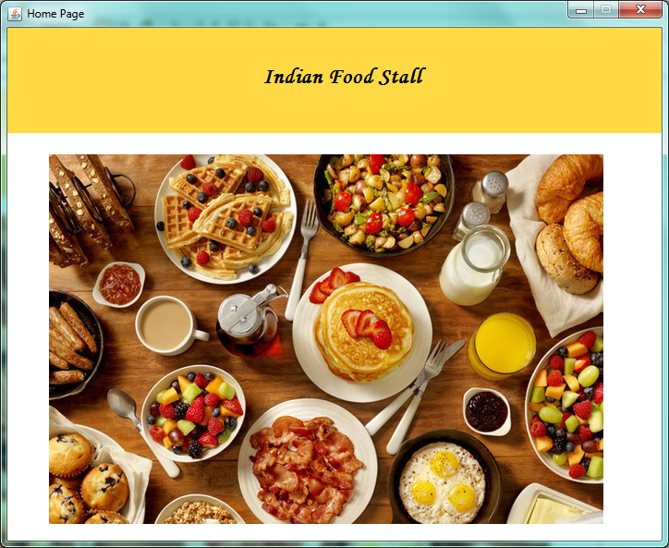

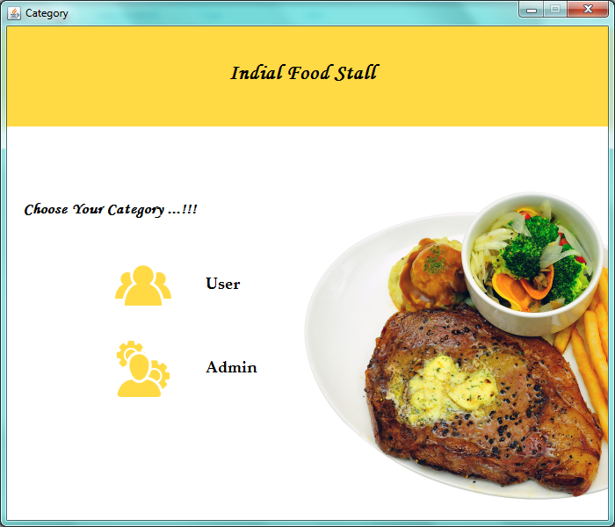

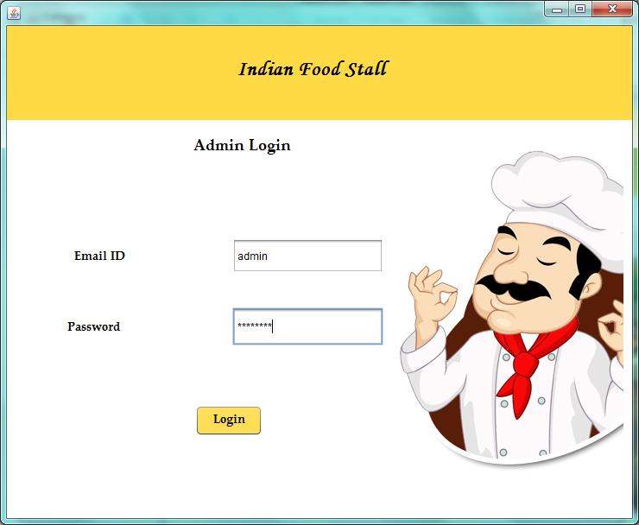

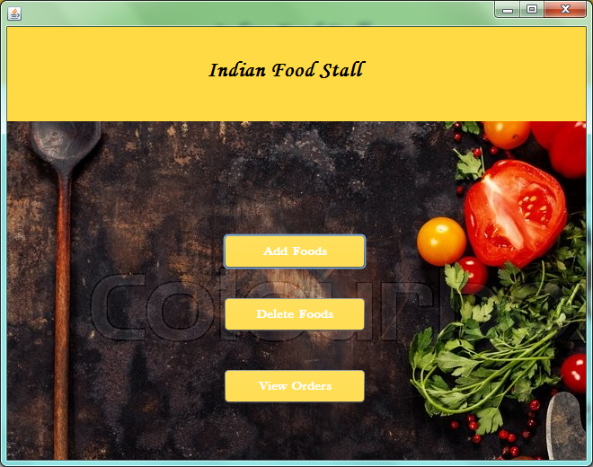

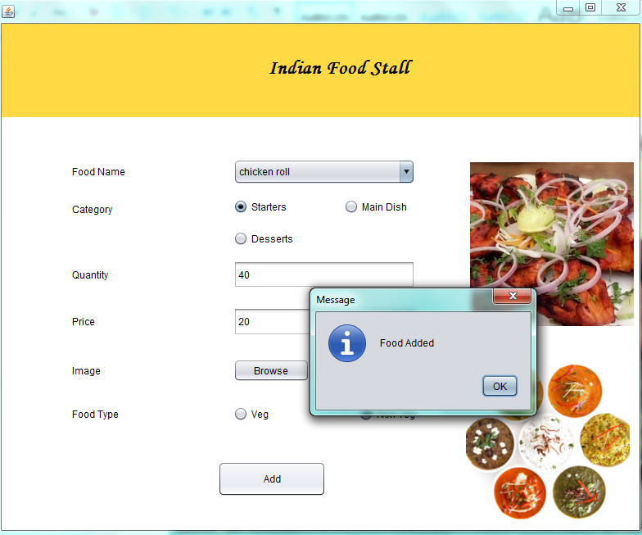

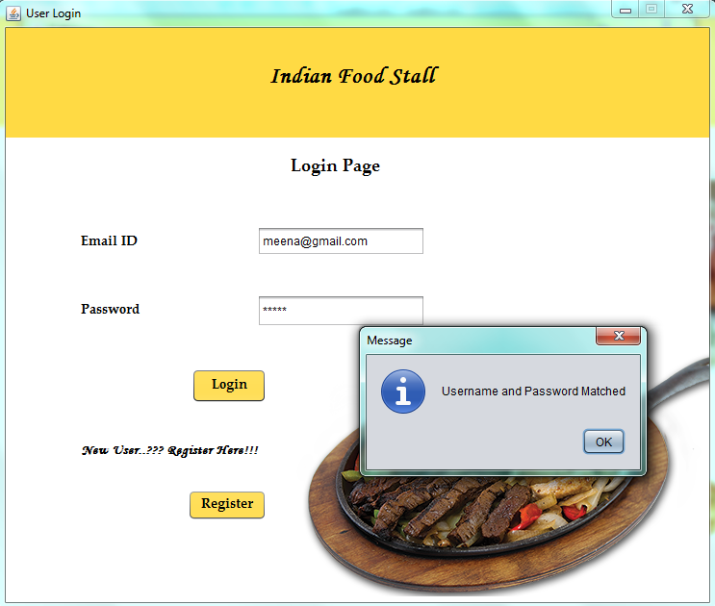

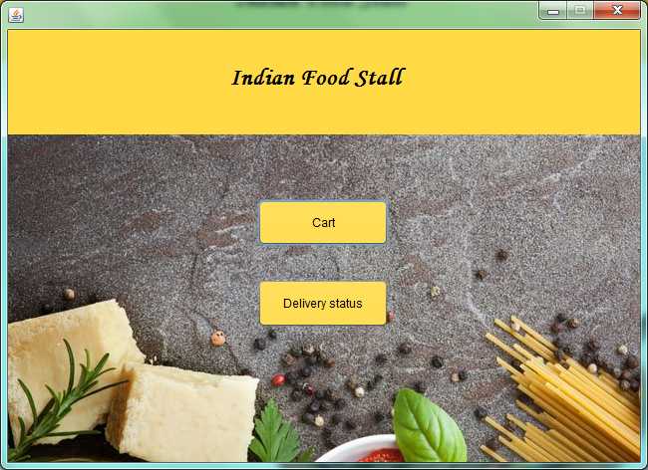

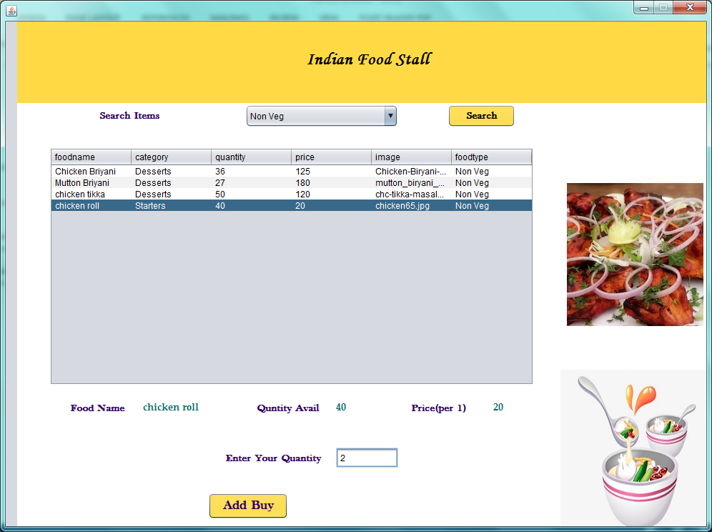

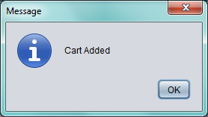

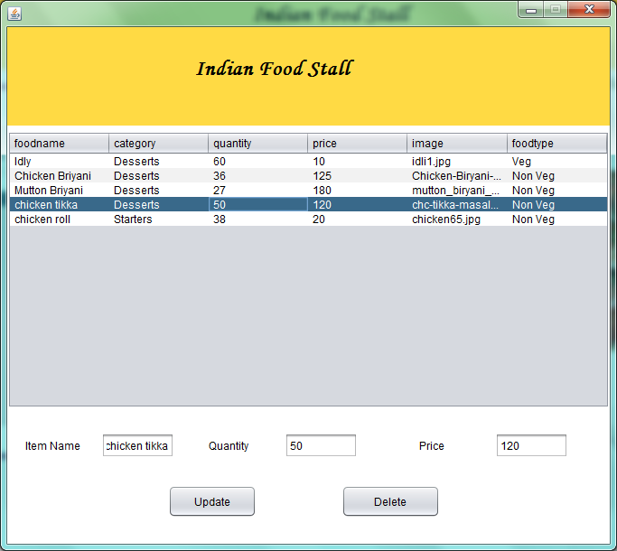

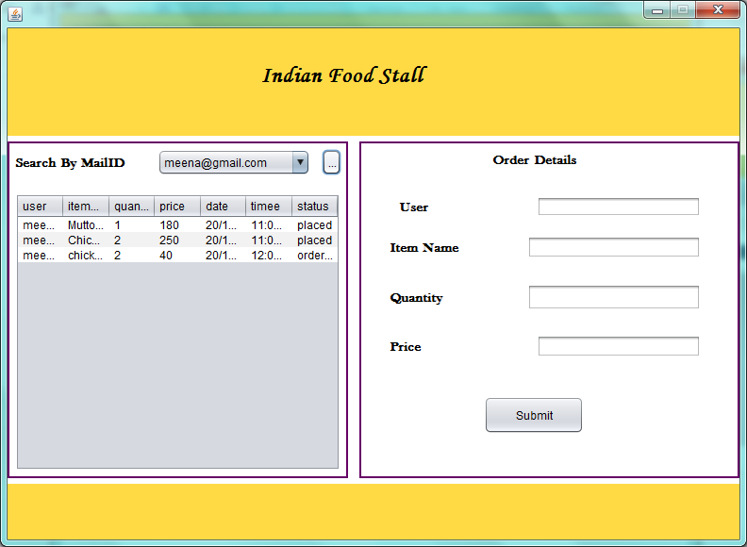

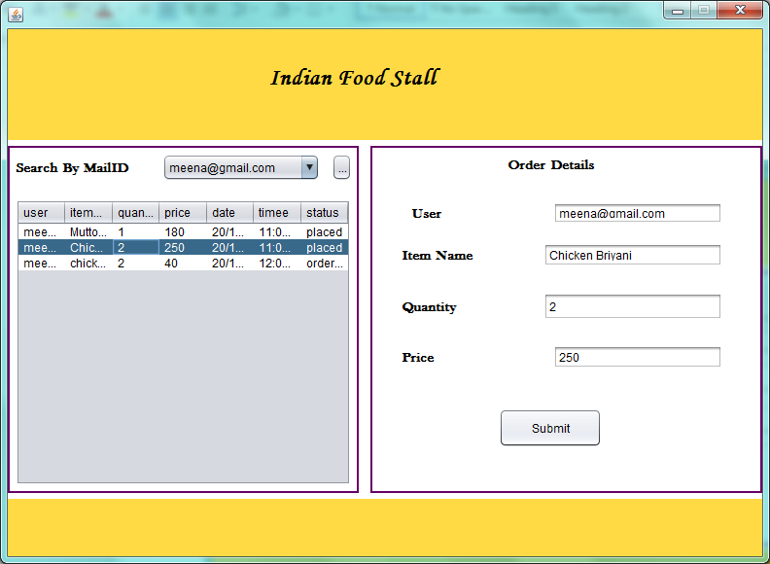

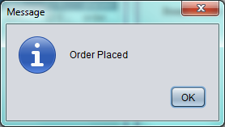

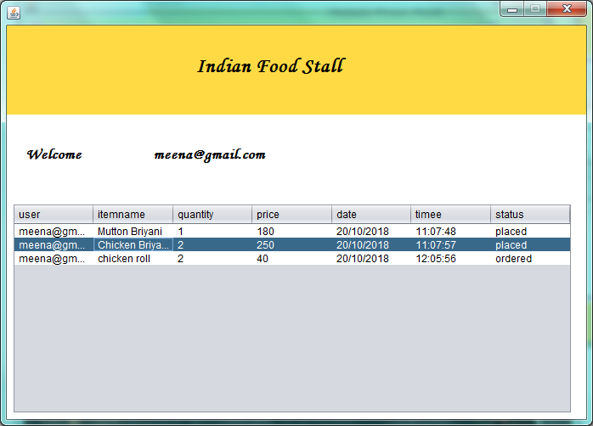

Coding:

//AddItem.java

/*

* To change this license header, choose License Headers in Project Properties.

* To change this template file, choose Tools | Templates

* and open the template in the editor.

*/

package foodstall;

import java.awt.Dimension;

import java.awt.Toolkit;

import java.io.File;

import java.sql.Connection;

import java.sql.DriverManager;

import java.sql.PreparedStatement;

import java.sql.SQLException;

import java.util.logging.Level;

import java.util.logging.Logger;

import javax.swing.ImageIcon;

import javax.swing.JFileChooser;

import javax.swing.JOptionPane;

/**

*

* @author EGC

*/

public class AddFoods extends javax.swing.JFrame {

File ff;

String combo;

/**

* Creates new form AddFoods

*/

public AddFoods() {

initComponents();

Dimension dim = Toolkit.getDefaultToolkit().getScreenSize();

this.setLocation(dim.width/2-this.getSize().width/2, dim.height/2-this.getSize().height/2);

buttonGroup1.add(jRadioButton1);

buttonGroup1.add(jRadioButton2);

buttonGroup1.add(jRadioButton3);

jRadioButton1.setActionCommand("Starters");

jRadioButton2.setActionCommand("Main Dish");

jRadioButton2.setActionCommand("Desserts");

buttonGroup2.add(jRadioButton4);

buttonGroup2.add(jRadioButton5);

jRadioButton4.setActionCommand("Veg");

jRadioButton5.setActionCommand("Non Veg");

}

/**

* This method is called from within the constructor to initialize the form.

* WARNING: Do NOT modify this code. The content of this method is always

* regenerated by the Form Editor.

*/

@SuppressWarnings("unchecked")

// <editor-fold defaultstate="collapsed" desc="Generated Code">//GEN-BEGIN:initComponents

private void initComponents() {

buttonGroup1 = new javax.swing.ButtonGroup();

buttonGroup2 = new javax.swing.ButtonGroup();

jPanel1 = new javax.swing.JPanel();

jPanel2 = new javax.swing.JPanel();

jLabel6 = new javax.swing.JLabel();

jLabel2 = new javax.swing.JLabel();

jLabel3 = new javax.swing.JLabel();

jLabel4 = new javax.swing.JLabel();

jLabel5 = new javax.swing.JLabel();

jLabel7 = new javax.swing.JLabel();

jLabel8 = new javax.swing.JLabel();

jComboBox1 = new javax.swing.JComboBox<>();

jTextField1 = new javax.swing.JTextField();

jTextField2 = new javax.swing.JTextField();

jLabel1 = new javax.swing.JLabel();

jLabel9 = new javax.swing.JLabel();

jRadioButton1 = new javax.swing.JRadioButton();

jRadioButton2 = new javax.swing.JRadioButton();

jRadioButton3 = new javax.swing.JRadioButton();

jRadioButton4 = new javax.swing.JRadioButton();

jRadioButton5 = new javax.swing.JRadioButton();

jButton1 = new javax.swing.JButton();

jTextField3 = new javax.swing.JTextField();

jButton2 = new javax.swing.JButton();

setDefaultCloseOperation(javax.swing.WindowConstants.EXIT_ON_CLOSE);

jPanel1.setBackground(new java.awt.Color(255, 255, 255));

jPanel2.setBackground(new java.awt.Color(255, 218, 68));

jLabel6.setFont(new java.awt.Font("Monotype Corsiva", 1, 24)); // NOI18N

jLabel6.setText("Indian Food Stall");

javax.swing.GroupLayout jPanel2Layout = new javax.swing.GroupLayout(jPanel2);

jPanel2.setLayout(jPanel2Layout);

jPanel2Layout.setHorizontalGroup(

jPanel2Layout.createParallelGroup(javax.swing.GroupLayout.Alignment.LEADING)

.addGroup(javax.swing.GroupLayout.Alignment.TRAILING, jPanel2Layout.createSequentialGroup()

.addContainerGap(javax.swing.GroupLayout.DEFAULT_SIZE, Short.MAX_VALUE)

.addComponent(jLabel6, javax.swing.GroupLayout.PREFERRED_SIZE, 189, javax.swing.GroupLayout.PREFERRED_SIZE)

.addGap(265, 265, 265))

);

jPanel2Layout.setVerticalGroup(

jPanel2Layout.createParallelGroup(javax.swing.GroupLayout.Alignment.LEADING)

.addGroup(jPanel2Layout.createSequentialGroup()

.addGap(41, 41, 41)

.addComponent(jLabel6)

.addContainerGap(45, Short.MAX_VALUE))

);

jLabel2.setText("Category");

jLabel3.setText("Food Name");

jLabel4.setText("Quantity");

jLabel5.setText("Image");

jLabel7.setText("Price");

jLabel8.setText("Food Type");

jComboBox1.setModel(new javax.swing.DefaultComboBoxModel<>(new String[] { "Idly", "Ponga", "Poori", "Dosa", "Veg Briyani", "Chicken Briyani", "Mutton Briyani", "masroom biriyani", "Chicken fried rice", "Egg Fried rice", "Veg Fried rice", "salad", "icecream", "apple juice", "orange juice", "chicken 65", "chicken tikka", "chicken roll", "katli" }));

jLabel1.setIcon(new javax.swing.ImageIcon(getClass().getResource("/images/k2.png"))); // NOI18N

jLabel9.setIcon(new javax.swing.ImageIcon(getClass().getResource("/images/no-cover.png"))); // NOI18N

jRadioButton1.setText("Starters");

jRadioButton2.setText("Main Dish");

jRadioButton3.setText("Desserts");

jRadioButton3.addActionListener(new java.awt.event.ActionListener() {

public void actionPerformed(java.awt.event.ActionEvent evt) {

jRadioButton3ActionPerformed(evt);

}

});

jRadioButton4.setText("Veg");

jRadioButton5.setText("Non Veg");

jButton1.setText("Browse");

jButton1.addActionListener(new java.awt.event.ActionListener() {

public void actionPerformed(java.awt.event.ActionEvent evt) {

jButton1ActionPerformed(evt);

}

});

jButton2.setText("Add");

jButton2.addActionListener(new java.awt.event.ActionListener() {

public void actionPerformed(java.awt.event.ActionEvent evt) {

jButton2ActionPerformed(evt);

}

});

javax.swing.GroupLayout jPanel1Layout = new javax.swing.GroupLayout(jPanel1);

jPanel1.setLayout(jPanel1Layout);

jPanel1Layout.setHorizontalGroup(

jPanel1Layout.createParallelGroup(javax.swing.GroupLayout.Alignment.LEADING)

.addComponent(jPanel2, javax.swing.GroupLayout.DEFAULT_SIZE, javax.swing.GroupLayout.DEFAULT_SIZE, Short.MAX_VALUE)

.addGroup(jPanel1Layout.createSequentialGroup()

.addGroup(jPanel1Layout.createParallelGroup(javax.swing.GroupLayout.Alignment.LEADING)

.addGroup(jPanel1Layout.createSequentialGroup()

.addGap(86, 86, 86)

.addGroup(jPanel1Layout.createParallelGroup(javax.swing.GroupLayout.Alignment.LEADING)

.addComponent(jLabel3, javax.swing.GroupLayout.PREFERRED_SIZE, 140, javax.swing.GroupLayout.PREFERRED_SIZE)

.addComponent(jLabel2, javax.swing.GroupLayout.PREFERRED_SIZE, 140, javax.swing.GroupLayout.PREFERRED_SIZE)

.addComponent(jLabel7, javax.swing.GroupLayout.PREFERRED_SIZE, 140, javax.swing.GroupLayout.PREFERRED_SIZE)

.addComponent(jLabel4, javax.swing.GroupLayout.PREFERRED_SIZE, 140, javax.swing.GroupLayout.PREFERRED_SIZE)

.addComponent(jLabel5, javax.swing.GroupLayout.PREFERRED_SIZE, 140, javax.swing.GroupLayout.PREFERRED_SIZE)

.addComponent(jLabel8, javax.swing.GroupLayout.PREFERRED_SIZE, 140, javax.swing.GroupLayout.PREFERRED_SIZE))

.addGap(57, 57, 57)

.addGroup(jPanel1Layout.createParallelGroup(javax.swing.GroupLayout.Alignment.LEADING, false)

.addGroup(jPanel1Layout.createSequentialGroup()

.addComponent(jRadioButton4)

.addPreferredGap(javax.swing.LayoutStyle.ComponentPlacement.RELATED, javax.swing.GroupLayout.DEFAULT_SIZE, Short.MAX_VALUE)

.addComponent(jRadioButton5))

.addComponent(jTextField1, javax.swing.GroupLayout.PREFERRED_SIZE, 222, javax.swing.GroupLayout.PREFERRED_SIZE)

.addGroup(jPanel1Layout.createSequentialGroup()

.addComponent(jRadioButton1)

.addPreferredGap(javax.swing.LayoutStyle.ComponentPlacement.RELATED, javax.swing.GroupLayout.DEFAULT_SIZE, Short.MAX_VALUE)

.addComponent(jRadioButton2)

.addGap(10, 10, 10))

.addComponent(jRadioButton3)

.addComponent(jComboBox1, 0, javax.swing.GroupLayout.DEFAULT_SIZE, Short.MAX_VALUE)

.addComponent(jTextField2)

.addGroup(jPanel1Layout.createSequentialGroup()

.addComponent(jButton1, javax.swing.GroupLayout.PREFERRED_SIZE, 93, javax.swing.GroupLayout.PREFERRED_SIZE)

.addGap(27, 27, 27)

.addComponent(jTextField3)))

.addPreferredGap(javax.swing.LayoutStyle.ComponentPlacement.RELATED, 52, Short.MAX_VALUE))

.addGroup(javax.swing.GroupLayout.Alignment.TRAILING, jPanel1Layout.createSequentialGroup()

.addContainerGap(javax.swing.GroupLayout.DEFAULT_SIZE, Short.MAX_VALUE)

.addComponent(jButton2, javax.swing.GroupLayout.PREFERRED_SIZE, 132, javax.swing.GroupLayout.PREFERRED_SIZE)

.addGap(161, 161, 161)))

.addGroup(jPanel1Layout.createParallelGroup(javax.swing.GroupLayout.Alignment.LEADING)

.addGroup(jPanel1Layout.createSequentialGroup()

.addGap(10, 10, 10)

.addComponent(jLabel1, javax.swing.GroupLayout.PREFERRED_SIZE, 212, javax.swing.GroupLayout.PREFERRED_SIZE))

.addGroup(javax.swing.GroupLayout.Alignment.TRAILING, jPanel1Layout.createSequentialGroup()

.addComponent(jLabel9, javax.swing.GroupLayout.PREFERRED_SIZE, 201, javax.swing.GroupLayout.PREFERRED_SIZE)

.addContainerGap())))

);

jPanel1Layout.setVerticalGroup(

jPanel1Layout.createParallelGroup(javax.swing.GroupLayout.Alignment.LEADING)

.addGroup(jPanel1Layout.createSequentialGroup()

.addComponent(jPanel2, javax.swing.GroupLayout.PREFERRED_SIZE, javax.swing.GroupLayout.DEFAULT_SIZE, javax.swing.GroupLayout.PREFERRED_SIZE)

.addGap(51, 51, 51)

.addGroup(jPanel1Layout.createParallelGroup(javax.swing.GroupLayout.Alignment.LEADING)

.addGroup(jPanel1Layout.createSequentialGroup()

.addComponent(jLabel9, javax.swing.GroupLayout.PREFERRED_SIZE, 208, javax.swing.GroupLayout.PREFERRED_SIZE)

.addPreferredGap(javax.swing.LayoutStyle.ComponentPlacement.RELATED, 40, Short.MAX_VALUE)

.addComponent(jLabel1, javax.swing.GroupLayout.PREFERRED_SIZE, 199, javax.swing.GroupLayout.PREFERRED_SIZE)

.addContainerGap())

.addGroup(jPanel1Layout.createSequentialGroup()

.addGroup(jPanel1Layout.createParallelGroup(javax.swing.GroupLayout.Alignment.BASELINE)

.addComponent(jLabel3, javax.swing.GroupLayout.PREFERRED_SIZE, 25, javax.swing.GroupLayout.PREFERRED_SIZE)

.addComponent(jComboBox1, javax.swing.GroupLayout.PREFERRED_SIZE, 31, javax.swing.GroupLayout.PREFERRED_SIZE))

.addGap(18, 18, 18)

.addGroup(jPanel1Layout.createParallelGroup(javax.swing.GroupLayout.Alignment.LEADING)

.addComponent(jLabel2, javax.swing.GroupLayout.PREFERRED_SIZE, 25, javax.swing.GroupLayout.PREFERRED_SIZE)

.addGroup(jPanel1Layout.createParallelGroup(javax.swing.GroupLayout.Alignment.BASELINE)

.addComponent(jRadioButton1)

.addComponent(jRadioButton2)))

.addGap(14, 14, 14)

.addComponent(jRadioButton3)

.addGap(18, 18, 18)

.addGroup(jPanel1Layout.createParallelGroup(javax.swing.GroupLayout.Alignment.BASELINE)

.addComponent(jLabel4, javax.swing.GroupLayout.PREFERRED_SIZE, 25, javax.swing.GroupLayout.PREFERRED_SIZE)

.addComponent(jTextField1, javax.swing.GroupLayout.PREFERRED_SIZE, 34, javax.swing.GroupLayout.PREFERRED_SIZE))

.addGap(23, 23, 23)

.addGroup(jPanel1Layout.createParallelGroup(javax.swing.GroupLayout.Alignment.BASELINE)

.addComponent(jLabel7, javax.swing.GroupLayout.PREFERRED_SIZE, 25, javax.swing.GroupLayout.PREFERRED_SIZE)

.addComponent(jTextField2, javax.swing.GroupLayout.PREFERRED_SIZE, 35, javax.swing.GroupLayout.PREFERRED_SIZE))

.addGap(28, 28, 28)

.addGroup(jPanel1Layout.createParallelGroup(javax.swing.GroupLayout.Alignment.BASELINE)

.addComponent(jLabel5, javax.swing.GroupLayout.PREFERRED_SIZE, 25, javax.swing.GroupLayout.PREFERRED_SIZE)

.addComponent(jButton1)

.addComponent(jTextField3, javax.swing.GroupLayout.PREFERRED_SIZE, javax.swing.GroupLayout.DEFAULT_SIZE, javax.swing.GroupLayout.PREFERRED_SIZE))

.addGap(27, 27, 27)

.addGroup(jPanel1Layout.createParallelGroup(javax.swing.GroupLayout.Alignment.BASELINE)

.addComponent(jLabel8, javax.swing.GroupLayout.PREFERRED_SIZE, 25, javax.swing.GroupLayout.PREFERRED_SIZE)

.addComponent(jRadioButton4)

.addComponent(jRadioButton5))

.addPreferredGap(javax.swing.LayoutStyle.ComponentPlacement.RELATED, javax.swing.GroupLayout.DEFAULT_SIZE, Short.MAX_VALUE)

.addComponent(jButton2, javax.swing.GroupLayout.PREFERRED_SIZE, 43, javax.swing.GroupLayout.PREFERRED_SIZE)

.addGap(41, 41, 41))))

);

javax.swing.GroupLayout layout = new javax.swing.GroupLayout(getContentPane());

getContentPane().setLayout(layout);

layout.setHorizontalGroup(

layout.createParallelGroup(javax.swing.GroupLayout.Alignment.LEADING)

.addComponent(jPanel1, javax.swing.GroupLayout.DEFAULT_SIZE, javax.swing.GroupLayout.DEFAULT_SIZE, Short.MAX_VALUE)

);

layout.setVerticalGroup(

layout.createParallelGroup(javax.swing.GroupLayout.Alignment.LEADING)

.addComponent(jPanel1, javax.swing.GroupLayout.DEFAULT_SIZE, javax.swing.GroupLayout.DEFAULT_SIZE, Short.MAX_VALUE)

);

pack();

}// </editor-fold>//GEN-END:initComponents

private void jButton1ActionPerformed(java.awt.event.ActionEvent evt) {//GEN-FIRST:event_jButton1ActionPerformed

try {

JFileChooser chooser = new JFileChooser("./Food");

chooser.setMultiSelectionEnabled(true);

chooser.showOpenDialog(this);

ff = chooser.getSelectedFile();

String location = ff.getPath();

jTextField3.setText(ff.getName());

} catch (Exception e) {

e.printStackTrace();

}

jLabel9.setIcon(new ImageIcon("./Food/"+ff.getName()));

}//GEN-LAST:event_jButton1ActionPerformed

private void jRadioButton3ActionPerformed(java.awt.event.ActionEvent evt) {//GEN-FIRST:event_jRadioButton3ActionPerformed

// TODO add your handling code here:

}//GEN-LAST:event_jRadioButton3ActionPerformed

private void jButton2ActionPerformed(java.awt.event.ActionEvent evt) {//GEN-FIRST:event_jButton2ActionPerformed

if(jTextField1.getText().toString().equals("")

&&jTextField2.getText().toString().equals("")&&jTextField3.getText().toString().equals("")){

JOptionPane.showMessageDialog(this, "Fill All Fields");

}

else{

try{

combo=jComboBox1.getSelectedItem().toString();

Connection connection=DriverManager.getConnection

("jdbc:mysql://localhost:3306/foodstall","root","");

//Preapared Statement

PreparedStatement pst=connection.prepareStatement("insert into foods values(?,?,?,?,?,?)");

// String sql="insert into register values(?,?,?)";

// pst=con.prepareStatement(sql);

pst.setString(1, combo);

pst.setString(2,buttonGroup1.getSelection().getActionCommand());

pst.setString(3,jTextField1.getText().toString());

pst.setString(4, jTextField2.getText().toString());

pst.setString(5, jTextField3.getText().toString());

pst.setString(6, buttonGroup2.getSelection().getActionCommand());

pst.executeUpdate();

JOptionPane.showMessageDialog(this, "Food Added");

}

catch (SQLException ex) {

Logger.getLogger(UserRegister.class.getName()).log(Level.SEVERE, null, ex);

}

}

jTextField1.setText("");

jTextField2.setText("");

jTextField3.setText("");

}//GEN-LAST:event_jButton2ActionPerformed

/**

* @param args the command line arguments

*/

public static void main(String args[]) {

/* Set the Nimbus look and feel */

//<editor-fold defaultstate="collapsed" desc=" Look and feel setting code (optional) ">

/* If Nimbus (introduced in Java SE 6) is not available, stay with the default look and feel.

* For details see http://download.oracle.com/javase/tutorial/uiswing/lookandfeel/plaf.html

*/

try {

for (javax.swing.UIManager.LookAndFeelInfo info : javax.swing.UIManager.getInstalledLookAndFeels()) {

if ("Nimbus".equals(info.getName())) {

javax.swing.UIManager.setLookAndFeel(info.getClassName());

break;

}

}

} catch (ClassNotFoundException ex) {

java.util.logging.Logger.getLogger(AddFoods.class.getName()).log(java.util.logging.Level.SEVERE, null, ex);

} catch (InstantiationException ex) {

java.util.logging.Logger.getLogger(AddFoods.class.getName()).log(java.util.logging.Level.SEVERE, null, ex);

} catch (IllegalAccessException ex) {

java.util.logging.Logger.getLogger(AddFoods.class.getName()).log(java.util.logging.Level.SEVERE, null, ex);

} catch (javax.swing.UnsupportedLookAndFeelException ex) {

java.util.logging.Logger.getLogger(AddFoods.class.getName()).log(java.util.logging.Level.SEVERE, null, ex);

}

//</editor-fold>

/* Create and display the form */

java.awt.EventQueue.invokeLater(new Runnable() {

public void run() {

new AddFoods().setVisible(true);

}

});

}

// Variables declaration - do not modify//GEN-BEGIN:variables

private javax.swing.ButtonGroup buttonGroup1;

private javax.swing.ButtonGroup buttonGroup2;

private javax.swing.JButton jButton1;

private javax.swing.JButton jButton2;

private javax.swing.JComboBox<String> jComboBox1;

private javax.swing.JLabel jLabel1;

private javax.swing.JLabel jLabel2;

private javax.swing.JLabel jLabel3;

private javax.swing.JLabel jLabel4;

private javax.swing.JLabel jLabel5;

private javax.swing.JLabel jLabel6;

private javax.swing.JLabel jLabel7;

private javax.swing.JLabel jLabel8;

private javax.swing.JLabel jLabel9;

private javax.swing.JPanel jPanel1;

private javax.swing.JPanel jPanel2;

private javax.swing.JRadioButton jRadioButton1;

private javax.swing.JRadioButton jRadioButton2;

private javax.swing.JRadioButton jRadioButton3;

private javax.swing.JRadioButton jRadioButton4;

private javax.swing.JRadioButton jRadioButton5;

private javax.swing.JTextField jTextField1;

private javax.swing.JTextField jTextField2;

private javax.swing.JTextField jTextField3;

// End of variables declaration//GEN-END:variables

}

//Userdelivery.Java

/*

* To change this license header, choose License Headers in Project Properties.

* To change this template file, choose Tools | Templates

* and open the template in the editor.

*/

package foodstall;

import java.awt.Dimension;

import java.awt.Toolkit;

import java.sql.DriverManager;

import java.sql.ResultSet;

import java.sql.ResultSetMetaData;

import java.sql.Statement;

import java.time.LocalDateTime;

import java.time.format.DateTimeFormatter;

import java.util.Vector;

import javax.swing.table.DefaultTableModel;

/**

*

* @author EGC

*/

public class UserDelivery extends javax.swing.JFrame {

Statement st;

String combo;

java.sql.Connection con;

/**

* Creates new form UserDelivery

*/

public UserDelivery() {

initComponents();

this.setResizable(false);

Dimension dim = Toolkit.getDefaultToolkit().getScreenSize();

this.setLocation(dim.width/2-this.getSize().width/2, dim.height/2-this.getSize().height/2);

try

{

Class.forName("com.mysql.jdbc.Driver");

con=DriverManager.getConnection("jdbc:mysql://localhost:3306/foodstall","root","");

st=con.createStatement();

}

catch(Exception e)

{

e.printStackTrace();

}

}

/**

* This method is called from within the constructor to initialize the form.

* WARNING: Do NOT modify this code. The content of this method is always

* regenerated by the Form Editor.

*/

@SuppressWarnings("unchecked")

// <editor-fold defaultstate="collapsed" desc="Generated Code">//GEN-BEGIN:initComponents

private void initComponents() {

jPanel1 = new javax.swing.JPanel();

jPanel2 = new javax.swing.JPanel();

jLabel6 = new javax.swing.JLabel();

jScrollPane1 = new javax.swing.JScrollPane();

jTable1 = new javax.swing.JTable();

jLabel1 = new javax.swing.JLabel();

jLabel2 = new javax.swing.JLabel();

setDefaultCloseOperation(javax.swing.WindowConstants.EXIT_ON_CLOSE);

addWindowListener(new java.awt.event.WindowAdapter() {

public void windowOpened(java.awt.event.WindowEvent evt) {

formWindowOpened(evt);

}

});

jPanel1.setBackground(new java.awt.Color(255, 255, 255));

jPanel2.setBackground(new java.awt.Color(255, 218, 68));

jLabel6.setFont(new java.awt.Font("Monotype Corsiva", 1, 24)); // NOI18N

jLabel6.setText("Indian Food Stall");

javax.swing.GroupLayout jPanel2Layout = new javax.swing.GroupLayout(jPanel2);

jPanel2.setLayout(jPanel2Layout);

jPanel2Layout.setHorizontalGroup(

jPanel2Layout.createParallelGroup(javax.swing.GroupLayout.Alignment.LEADING)

.addGroup(jPanel2Layout.createSequentialGroup()

.addGap(222, 222, 222)

.addComponent(jLabel6, javax.swing.GroupLayout.PREFERRED_SIZE, 189, javax.swing.GroupLayout.PREFERRED_SIZE)

.addContainerGap(javax.swing.GroupLayout.DEFAULT_SIZE, Short.MAX_VALUE))

);

jPanel2Layout.setVerticalGroup(

jPanel2Layout.createParallelGroup(javax.swing.GroupLayout.Alignment.LEADING)

.addGroup(jPanel2Layout.createSequentialGroup()

.addGap(35, 35, 35)

.addComponent(jLabel6)

.addContainerGap(42, Short.MAX_VALUE))

);

jTable1.setModel(new javax.swing.table.DefaultTableModel(

new Object [][] {

{null, null, null, null},

{null, null, null, null},

{null, null, null, null},

{null, null, null, null}

},

new String [] {

"Title 1", "Title 2", "Title 3", "Title 4"

}

));

jScrollPane1.setViewportView(jTable1);

jLabel1.setFont(new java.awt.Font("Monotype Corsiva", 1, 18)); // NOI18N

jLabel1.setText("Welcome");

jLabel2.setFont(new java.awt.Font("Monotype Corsiva", 1, 18)); // NOI18N

javax.swing.GroupLayout jPanel1Layout = new javax.swing.GroupLayout(jPanel1);

jPanel1.setLayout(jPanel1Layout);

jPanel1Layout.setHorizontalGroup(

jPanel1Layout.createParallelGroup(javax.swing.GroupLayout.Alignment.LEADING)

.addGroup(javax.swing.GroupLayout.Alignment.TRAILING, jPanel1Layout.createSequentialGroup()

.addGap(0, 0, Short.MAX_VALUE)

.addComponent(jLabel1, javax.swing.GroupLayout.PREFERRED_SIZE, 132, javax.swing.GroupLayout.PREFERRED_SIZE)

.addGap(18, 18, 18)

.addComponent(jLabel2, javax.swing.GroupLayout.PREFERRED_SIZE, 163, javax.swing.GroupLayout.PREFERRED_SIZE)

.addGap(347, 347, 347))

.addGroup(jPanel1Layout.createSequentialGroup()

.addContainerGap()

.addComponent(jScrollPane1, javax.swing.GroupLayout.PREFERRED_SIZE, 660, javax.swing.GroupLayout.PREFERRED_SIZE)

.addContainerGap(javax.swing.GroupLayout.DEFAULT_SIZE, Short.MAX_VALUE))

.addComponent(jPanel2, javax.swing.GroupLayout.Alignment.TRAILING, javax.swing.GroupLayout.DEFAULT_SIZE, javax.swing.GroupLayout.DEFAULT_SIZE, Short.MAX_VALUE)

);

jPanel1Layout.setVerticalGroup(

jPanel1Layout.createParallelGroup(javax.swing.GroupLayout.Alignment.LEADING)

.addGroup(jPanel1Layout.createSequentialGroup()

.addComponent(jPanel2, javax.swing.GroupLayout.PREFERRED_SIZE, javax.swing.GroupLayout.DEFAULT_SIZE, javax.swing.GroupLayout.PREFERRED_SIZE)

.addGap(33, 33, 33)

.addGroup(jPanel1Layout.createParallelGroup(javax.swing.GroupLayout.Alignment.BASELINE)

.addComponent(jLabel1, javax.swing.GroupLayout.PREFERRED_SIZE, 28, javax.swing.GroupLayout.PREFERRED_SIZE)

.addComponent(jLabel2, javax.swing.GroupLayout.PREFERRED_SIZE, 28, javax.swing.GroupLayout.PREFERRED_SIZE))

.addPreferredGap(javax.swing.LayoutStyle.ComponentPlacement.RELATED, 33, Short.MAX_VALUE)

.addComponent(jScrollPane1, javax.swing.GroupLayout.PREFERRED_SIZE, 249, javax.swing.GroupLayout.PREFERRED_SIZE)

.addContainerGap())

);

javax.swing.GroupLayout layout = new javax.swing.GroupLayout(getContentPane());

getContentPane().setLayout(layout);

layout.setHorizontalGroup(

layout.createParallelGroup(javax.swing.GroupLayout.Alignment.LEADING)

.addComponent(jPanel1, javax.swing.GroupLayout.DEFAULT_SIZE, javax.swing.GroupLayout.DEFAULT_SIZE, Short.MAX_VALUE)

);

layout.setVerticalGroup(

layout.createParallelGroup(javax.swing.GroupLayout.Alignment.LEADING)

.addComponent(jPanel1, javax.swing.GroupLayout.DEFAULT_SIZE, javax.swing.GroupLayout.DEFAULT_SIZE, Short.MAX_VALUE)

);

pack();

}// </editor-fold>//GEN-END:initComponents

private void formWindowOpened(java.awt.event.WindowEvent evt) {//GEN-FIRST:event_formWindowOpened

jLabel2.setText(UserLogin.mail);

String name=jLabel2.getText();

DateTimeFormatter dtf = DateTimeFormatter.ofPattern("dd/MM/yyyy");

LocalDateTime now = LocalDateTime.now();

String date=dtf.format(now);

try {

Vector col = new Vector();

Vector data = new Vector();

ResultSet rs = st.executeQuery("SELECT * FROM cart where user='"+name+"' and date='"+date+"'");

ResultSetMetaData md = rs.getMetaData();

int columns = md.getColumnCount();

for (int i = 1; i <= columns; i++)

{

col.addElement(md.getColumnName(i));

}

//System.out.println(i);

while (rs.next())

{

Vector row = new Vector(columns);

for (int i = 1; i <= columns; i++)

{

row.addElement(rs.getObject(i));

}

data.addElement(row);

}

DefaultTableModel model = new DefaultTableModel(data, col);

jTable1.setModel(model);

}

catch(Exception e)

{

e.printStackTrace();

}

}//GEN-LAST:event_formWindowOpened

/**

* @param args the command line arguments

*/

public static void main(String args[]) {

/* Set the Nimbus look and feel */

//<editor-fold defaultstate="collapsed" desc=" Look and feel setting code (optional) ">

/* If Nimbus (introduced in Java SE 6) is not available, stay with the default look and feel.

* For details see http://download.oracle.com/javase/tutorial/uiswing/lookandfeel/plaf.html

*/

try {

for (javax.swing.UIManager.LookAndFeelInfo info : javax.swing.UIManager.getInstalledLookAndFeels()) {

if ("Nimbus".equals(info.getName())) {

javax.swing.UIManager.setLookAndFeel(info.getClassName());

break;

}

}

} catch (ClassNotFoundException ex) {

java.util.logging.Logger.getLogger(UserDelivery.class.getName()).log(java.util.logging.Level.SEVERE, null, ex);

} catch (InstantiationException ex) {

java.util.logging.Logger.getLogger(UserDelivery.class.getName()).log(java.util.logging.Level.SEVERE, null, ex);

} catch (IllegalAccessException ex) {

java.util.logging.Logger.getLogger(UserDelivery.class.getName()).log(java.util.logging.Level.SEVERE, null, ex);

} catch (javax.swing.UnsupportedLookAndFeelException ex) {

java.util.logging.Logger.getLogger(UserDelivery.class.getName()).log(java.util.logging.Level.SEVERE, null, ex);

}

//</editor-fold>

/* Create and display the form */

java.awt.EventQueue.invokeLater(new Runnable() {

public void run() {

new UserDelivery().setVisible(true);

}

});

}

// Variables declaration - do not modify//GEN-BEGIN:variables

private javax.swing.JLabel jLabel1;

private javax.swing.JLabel jLabel2;

private javax.swing.JLabel jLabel6;

private javax.swing.JPanel jPanel1;

private javax.swing.JPanel jPanel2;

private javax.swing.JScrollPane jScrollPane1;

private javax.swing.JTable jTable1;

// End of variables declaration//GEN-END:variables

}

**CONCLUSION**

* Thus our food stall management system achieves less time consumption then existing system.
* Out food stall application also provide customer buyer relationship. The user can easily cart their foods on the place.