Chapter 1: Introduction
1.1 Introduction
With the rapid growth of digital technologies, the internet has become a major contributor to global energy consumption and carbon emissions. Every website visit, data transfer, and server request consumes energy, often generated from non-renewable sources. The Sustainable Web Tracker is designed to raise awareness and provide insights into the environmental impact of web usage. It monitors and analyzes website-related energy consumption and carbon footprint, helping developers and users make environmentally conscious decisions.

1.2 Problem Statement
Despite increasing awareness about climate change, the environmental impact of web technologies remains largely overlooked. Most website owners and users are unaware of how their digital activities contribute to carbon emissions. There is a lack of accessible tools that can measure, track, and present this data in an understandable way. This gap leads to inefficient web practices and unnecessary energy consumption.

1.3 Project Objectives & Goals
The main objectives of the Sustainable Web Tracker are:
- To estimate the carbon footprint of websites based on data usage and server interactions
- To provide real-time or near real-time tracking of energy consumption
- To raise awareness among users and developers about sustainable web practices
- To suggest optimization techniques for reducing environmental impact
- To promote greener digital habits and sustainable development in web technologies



1.4 Scope and Limitations
Scope:
- Tracks website energy usage and estimated carbon emissions
- Provides analytics and visualization of environmental impact
- Can be used by developers, organizations, and general users
- Supports integration with web browsers or platforms (if applicable)
Limitations:
- Carbon emission estimates may not be 100% accurate due to varying energy sources and infrastructure
- Limited access to real server-side data in some cases
- Depends on assumptions and models for calculation
- May not cover all types of web technologies or dynamic content accurately

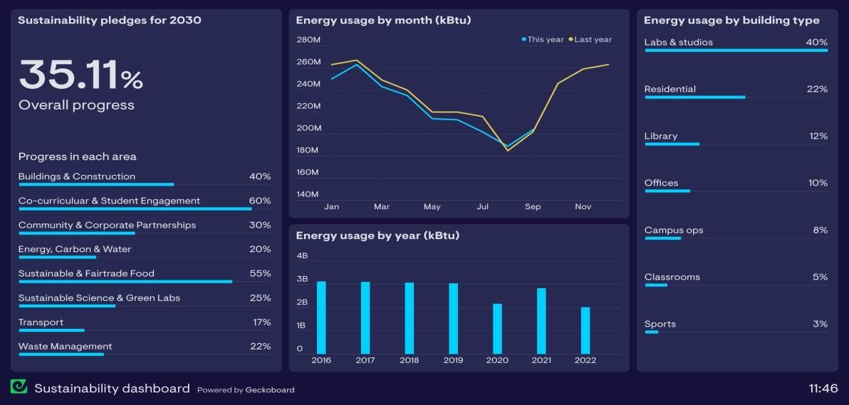

1.5 Report Outline
This report is organized into several chapters:
- Chapter 1: Introduction – Overview, problem statement, objectives, scope, and structure
- Chapter 2: Literature Review – Analysis of existing tools and related work
- Chapter 3: Methodology – System design, architecture, and implementation approach
- Chapter 4: Results and Discussion – Findings, analysis, and performance evaluation
- Chapter 5: Conclusion and Future Work – Summary and potential improvements

Chapter 2: Literature Survey
2.1 Survey and Analysis of Existing Solutions

With the growing concern over digital carbon emissions, several tools and research studies have been developed to estimate and reduce the environmental impact of websites.
One of the most widely used tools is the Website Carbon Calculator, which estimates the carbon footprint of a webpage based on data transfer, energy consumption, and hosting infrastructure. It highlights that the internet consumes massive energy, and even a single webpage contributes measurable CO₂ emissions.
Another solution, Digital Carbon Online, provides a more comprehensive analysis by assessing the full website lifecycle and offering strategies to reduce emissions and achieve carbon neutrality.

AI-based tools such as SEMIL Green Web’s calculator use machine learning models and APIs (like page speed insights) to estimate emissions based on real-time performance metrics. These tools improve accuracy by considering large datasets of websites and dynamic parameters.

Research studies have also contributed significantly. For instance, a web page carbon footprint calculator model considers factors such as server location, user traffic, and returning visits to compute emissions and suggest optimization techniques.
Additionally, studies on sustainable web design emphasize that inefficient websites with heavy media, complex scripts, and poor optimization lead to higher energy consumption and carbon emissions.
Overall, existing solutions focus on:
- Estimating carbon emissions per webpage or website
- Providing optimization suggestions (image compression, caching, green hosting)
- Raising awareness about sustainable web practices
- Using data-driven or AI-based methodologies for analysis

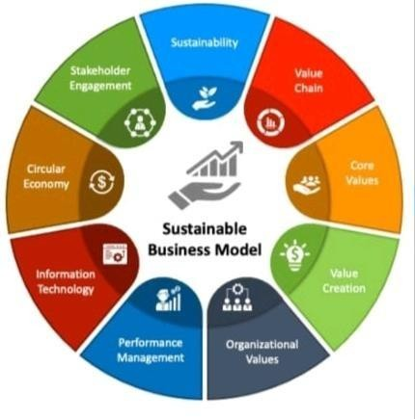

2.2 Identification of Research Gap

Despite the availability of several tools and studies, there are still notable gaps in the current solutions:
- Limited Accuracy: Most tools rely on generalized assumptions (e.g., average energy consumption per data transfer), which may not reflect real-time or location-specific variations.
- Lack of Real-Time Monitoring: Many existing solutions provide static analysis rather than continuous or real-time tracking of website emissions.
- Poor User Awareness & Accessibility: While tools exist, they are not widely integrated into everyday browsing or development workflows, limiting their practical use.
- Insufficient Personalization: Current tools do not account for user-specific behavior, device differences, or regional energy sources.
- Limited Integration: Most calculators function as standalone tools and are not integrated into browsers, developer environments, or live systems.
- Inconsistent Metrics & Methodologies: Different tools use varying formulas and datasets, leading to inconsistent results and confusion among users.

Chapter 3: Requirement Analysis and Specification

3.1 Functional Requirements
Functional requirements define what the system should do. The Sustainable Web Tracker must provide the following functionalities:
- Website Analysis:
The system should analyze a given website URL and estimate its energy consumption and carbon footprint.
- Carbon Emission Calculation:
It should calculate approximate CO₂ emissions based on data transfer, page size, number of requests, and hosting type.
- Real-Time Monitoring:
The system should track user browsing activity (if integrated as an extension) and provide real-time emission data.
- Data Visualization:
Display results using graphs, charts, or dashboards for easy understanding.
- User Input Handling:
Allow users to enter URLs manually or automatically capture browsing data.
- Suggestions for Optimization:
Provide recommendations such as image compression, caching, use of green hosting, and code optimization.
- Database Storage (Optional):
Store user data and analysis history for future reference.

3.2 Non-Functional Requirements
Non-functional requirements describe how the system performs its functions:
- Performance:
The system should provide fast and efficient analysis with minimal delay.
- Accuracy:
Carbon emission calculations should be reasonably accurate based on available models and data.
- Usability:
The interface should be simple, user-friendly, and easy to navigate.

- Scalability:
The system should handle multiple users and increasing data efficiently.
- Reliability:
The system should function consistently without crashes or data loss.
- Security:
User data and browsing information should be protected and handled securely.
- Compatibility:
Should work across different browsers and devices (desktop/mobile).
- Maintainability:
The system should be easy to update and maintain.
3.3 Software and Hardware Requirements
Software Requirements:
- Frontend: HTML, CSS, JavaScript (or frameworks like React/Angular)
- Backend: Node.js / Python / PHP (depending on implementation)
- Database: MySQL / MongoDB (optional)
- Browser Integration: Chrome Extension APIs (if applicable)
- Development Tools: VS Code, GitHub
- Operating System: Windows / Linux / macOS
Hardware Requirements:
- Processor: Minimum Intel i3 or equivalent
- RAM: Minimum 4 GB (8 GB recommended)
- Storage: At least 500 MB free space
- Internet Connection: Required for web analysis and API access

Chapter 4: System Design and Architecture
4.1 System Architecture Diagram
The Sustainable Web Tracker follows a client-server architecture that enables efficient data collection, processing, and visualization.
Architecture Components:
- User Interface (Frontend):
  - Allows users to input website URLs or track browsing activity
  - Displays carbon footprint results, analytics, and suggestions
  - Built using technologies like HTML, CSS, and JavaScript
- Application Server (Backend):
  - Processes user requests and performs calculations
  - Fetches website data such as page size, load time, and number of requests
  - Implements carbon emission estimation algorithms
- Data Processing Module:
  - Converts collected data into energy usage and CO₂ emissions
  - Applies predefined formulas and assumptions
- Database:
  - Stores user inputs, results, and historical data (if implemented)
- External APIs (Optional):
  - Used to fetch additional metrics such as page performance or hosting details.

4.2 Data Flow Diagram
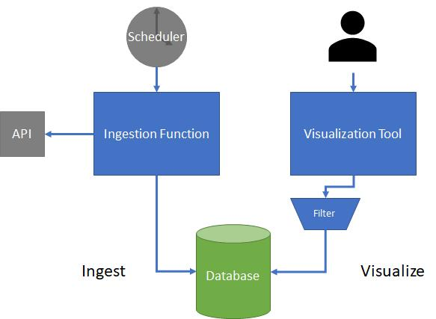

4.3 ER Diagram
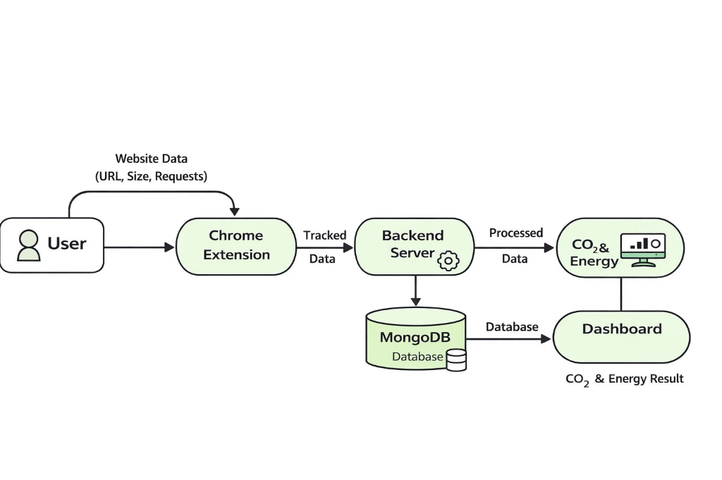

4.4 Use Case Diagram
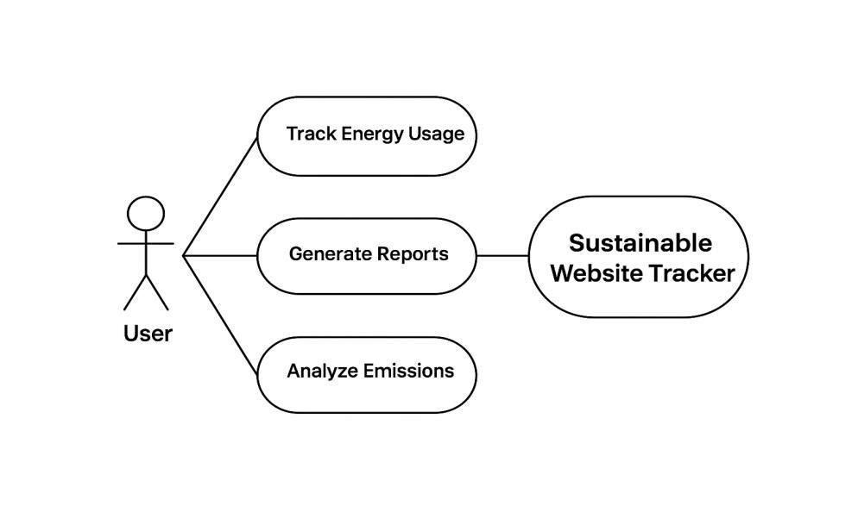

4.5 Sequence Diagram

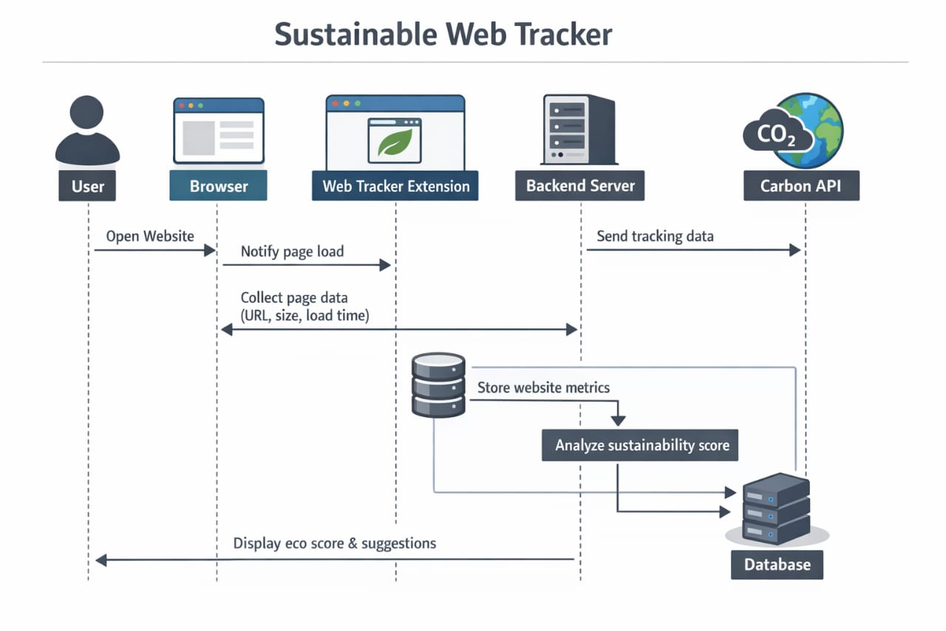

Chapter 5: Implementation, Testing, and Maintenance

5.1 Introduction to Languages, IDE’s
The development of the Sustainable Web Tracker involves modern web technologies for both frontend and backend implementation.
- Programming Languages:
  - HTML, CSS, JavaScript for frontend development
  - JavaScript (Node.js) or Python for backend processing
  - SQL for database management
- IDE (Integrated Development Environment):
  - Visual Studio Code (VS Code): Used for writing and managing code due to its lightweight nature and extensive extensions
  - Optional tools like PyCharm or WebStorm can also be used depending on the backend language

5.2 Tools and Technologies used for Implementation
The following tools and technologies are used to develop the system:
- Frontend Technologies:
  - HTML5, CSS3, JavaScript
  - Frameworks (optional): React.js / Angular
- Backend Technologies:
  - Node.js / Python (Flask or Django)
- Database:
  - MySQL / MongoDB
- APIs and Libraries:
  - Page performance APIs (e.g., Lighthouse, PageSpeed Insights)
  - Carbon estimation models and libraries
- Version Control:
  - Git and GitHub for code management and collaboration
- Browser Integration (Optional):
  - Chrome Extension APIs for real-time tracking

5.3 Coding Standards of Language used & Project Scheduling
To ensure code quality and maintainability, the following standards are followed:
- Use of meaningful variable and function names
- Proper indentation and formatting
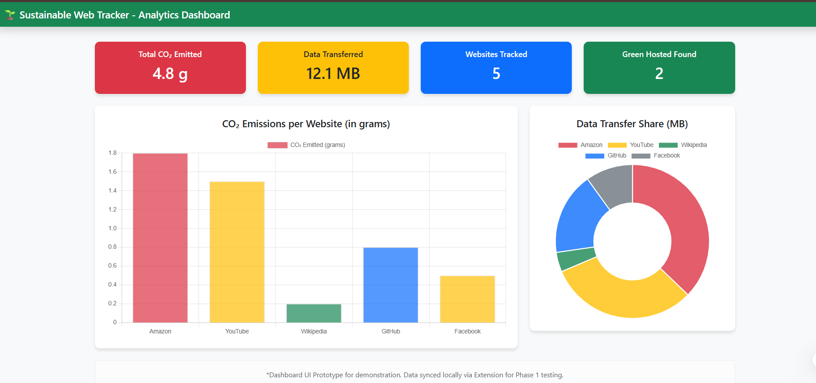

- Modular programming approach
- Commenting and documentation for better understanding
- Following best practices such as DRY (Don’t Repeat Yourself) and KISS (Keep It Simple, Stupid)
- Adherence to language-specific standards (e.g., ESLint for JavaScript, PEP 8 for Python)

Typical Project Phases:
- Requirement Analysis
- System Design
- Implementation
- Testing
- Deployment
- Maintenance

5.4 Testing Techniques and Test Plans
Testing ensures that the system works correctly and meets requirements.
Testing Techniques:
- Unit Testing:
Individual components or modules are tested separately
- Integration Testing:
Ensures that different modules work together properly
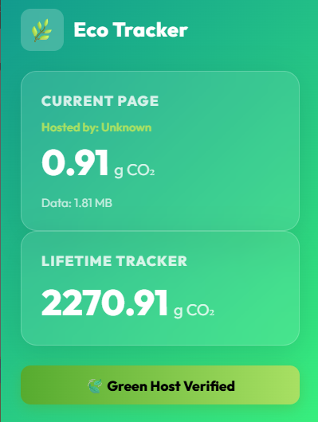

Description:
The dashboard provides a visual representation of website analysis including total CO₂ emission, data transferred, number of websites tracked, and green hosting status. Graphs and charts are used for better understanding of energy consumption and carbon footprint.

- System Testing:
Validates the complete system functionality
- User Acceptance Testing (UAT):
Ensures the system meets user expectations
- Performance Testing:
Checks system speed, responsiveness, and scalability

Test Plan:
- Objective:
To verify accuracy of carbon emission calculations and system performance
- Test Cases Include:
  - Valid and invalid URL inputs
  - Different website sizes and complexities
  - Real-time tracking functionality
  - Data visualization accuracy
- Expected Outcomes:
  - Correct emission calculations
  - Fast response time
  - Error-free user interface
  - Reliable and consistent performance

Maintenance
After deployment, the system requires continuous maintenance:
- Corrective Maintenance: Fixing bugs and errors
- Adaptive Maintenance: Updating system for new technologies or environments
- Perfective Maintenance: Enhancing features and performance
- Preventive Maintenance: Improving system reliability and preventing future issues

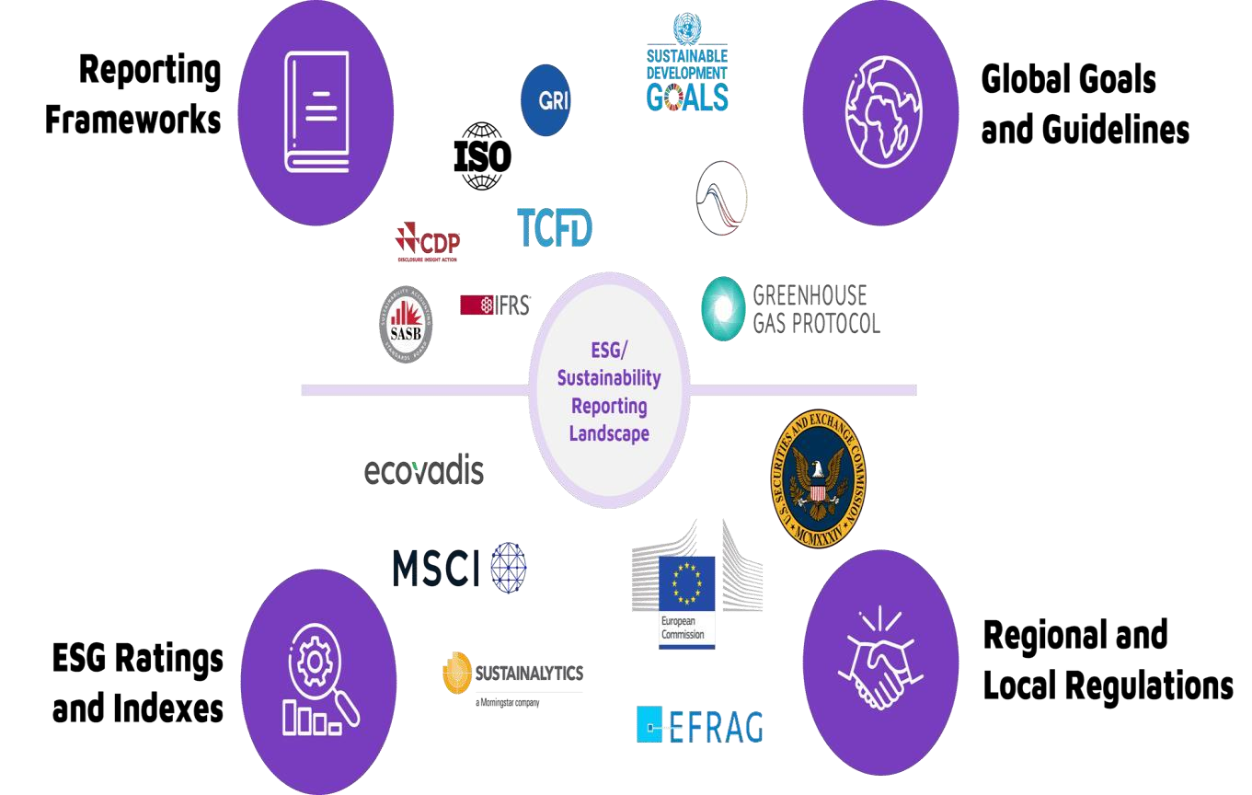

Chapter 6: Expected Results and Discussion
6.1 Expected Results and Discussion
The Sustainable Web Tracker is expected to successfully analyze websites and provide meaningful insights into their environmental impact. The system will generate estimates of carbon emissions and energy consumption based on various parameters such as page size, number of requests, and load time.
Expected Results:
- Accurate estimation of carbon footprint (CO₂ emissions) for different websites
- Identification of high-energy-consuming web elements (e.g., large images, scripts)
- Clear and interactive visualization of results using charts and dashboards
- Generation of optimization suggestions for improving sustainability
- Ability to track and compare multiple websites or browsing sessions
Discussion:
The results obtained from the system will help users and developers understand the hidden environmental cost of web usage. By analyzing different types of websites, it is expected that:
- Websites with heavy media content will show higher carbon emissions
- Optimized websites will demonstrate significantly lower energy consumption
- Small improvements (like image compression or caching) can reduce emissions noticeably
This highlights the importance of adopting sustainable web development practices and encourages users to make informed decisions.

6.2 Expected Performance Results
The system is expected to perform efficiently under normal usage conditions while maintaining accuracy and responsiveness.
Performance Expectations:
- Fast Response Time:
Website analysis results should be generated within a few seconds
- Scala

- bility:
The system should handle multiple users and concurrent requests without significant delay
- Accuracy:
Emission calculations should be consistent and based on reliable estimation models
- Low Resource Usage:
The system should not consume excessive system or network resources
- Reliability:
The system should provide stable performance with minimal downtime or errors

Chapter 7: Conclusion

7.1 Conclusion

- The Sustainable Web Tracker project highlights the growing importance of understanding and reducing the environmental impact of digital technologies. As internet usage continues to expand globally, the energy consumption associated with websites and online services contributes significantly to carbon emissions.
- This project aims to address the lack of awareness by providing a system that estimates the carbon footprint of websites and offers actionable insights for improvement. Through the integration of data analysis, visualization, and optimization suggestions, the system encourages developers and users to adopt more sustainable web practices.
- The proposed solution demonstrates how even small optimizations—such as reducing page size, minimizing HTTP requests, and using efficient coding techniques—can collectively lead to a meaningful reduction in energy consumption and environmental impact.
- In conclusion, the Sustainable Web Tracker serves as a step toward greener computing by promoting responsible web development and increasing awareness about digital sustainability. It has the potential to be further enhanced with more accurate models, real-time tracking, and wider integration across platforms.

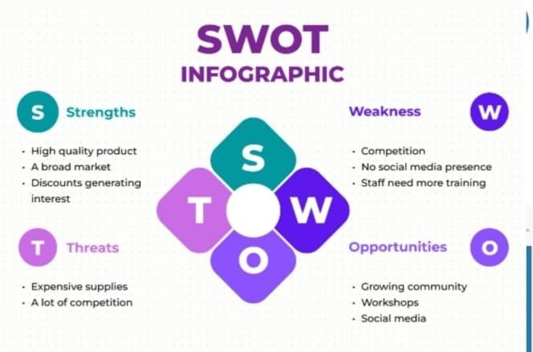

References
- Website Carbon Calculator. Website Carbon Emissions Tool. Available at: https://www.websitecarbon.com/
- Digital Carbon Online. Website Sustainability Analysis Platform. Available at: https://www.digitalcarbon.online/
- SEMIL Green Web. Website Carbon Calculator using AI. Available at: https://semilgreenweb.com/
- Research Paper: A Carbon Footprint Calculator Tool for Web Pages. Available on ResearchGate
- Google Developers. PageSpeed Insights Documentation. Available at: https://developers.google.com/speed/pagespeed/insights/
- Sustainable Web Design Guidelines. Various academic and industry sources

Chapter 8: APPENDICES

Appendix A: Source Code

The complete source code of the Sustainable Web Tracker project is maintained in a GitHub repository for version control and collaboration.
- Repository Link:
(Add your GitHub repository link here, e.g., https://github.com/Meena0119/sustainable-web-tracker)
- Contents of Repository:
  - Frontend code (HTML, CSS, JavaScript)
  - Backend code (Node.js / Python)
  - Database scripts
  - Documentation (README file with setup instructions)
- Snapshot:
Include screenshots of:
  - Project folder structure
  - Key files (main code files, configuration files)
  - Running application interface

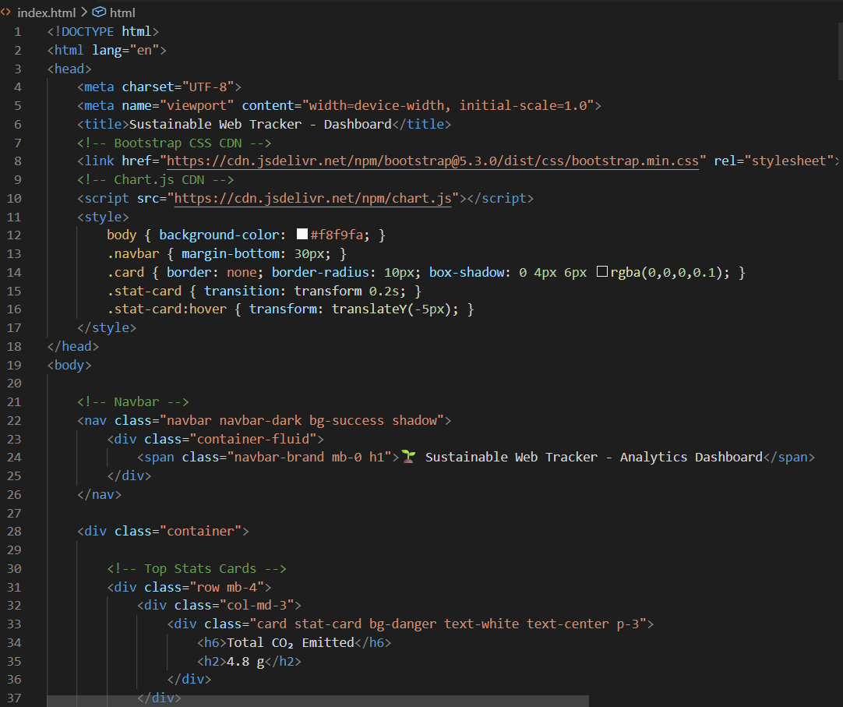

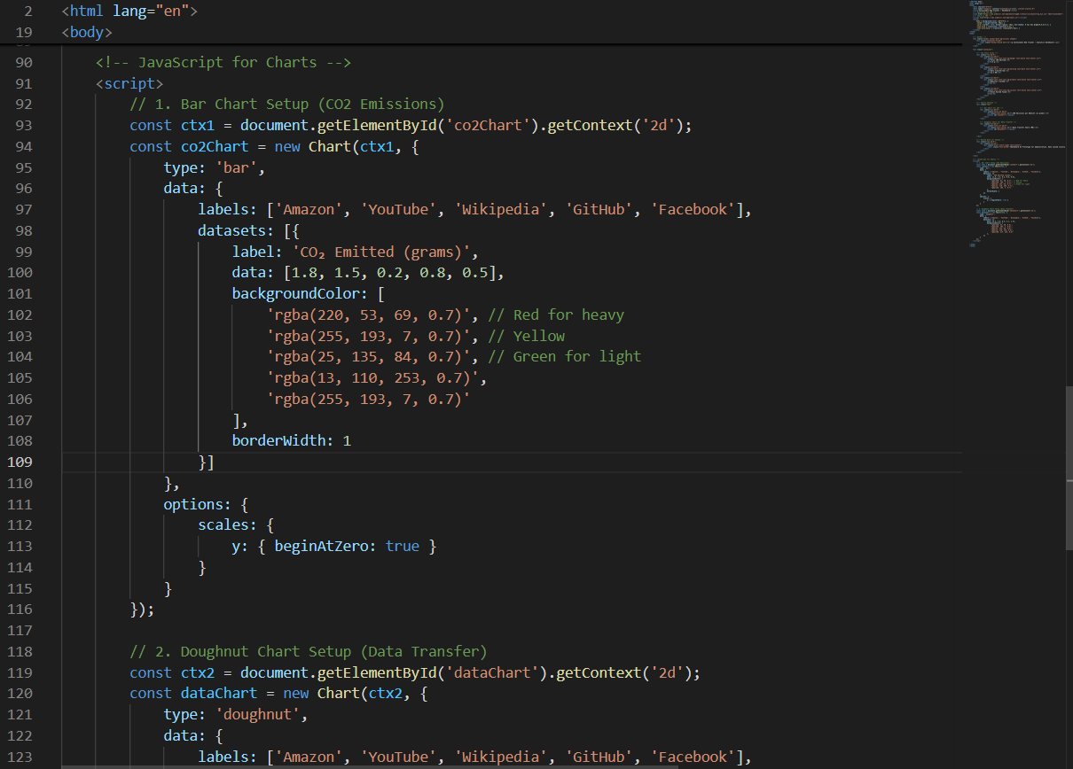

Appendix B: Comprehensive Project Timeline

The project development is planned and tracked using a Gantt chart to ensure timely completion of each phase.
Project Timeline Phases:
- Requirement Analysis
- Literature Survey
- System Design
- Implementation
- Testing
- Documentation
- Final Submission

Appendix C: Team Member Contributions

This section outlines the contributions of each team member involved in the project.
Example Format:
Team Member Name | Contribution
Archana Singh- | Requirement Analysis & Documentation
Kehkasha Ansari- | Frontend development
Meena Vishwakarma- | Backend ,API integration , testing

Appendix D: Dataset Details and Sources

The project uses various datasets and parameters for estimating carbon emissions.
Data Sources:
- Website performance metrics (page size, load time, number of requests)
- Publicly available APIs (e.g., PageSpeed Insights)
- Research-based carbon estimation models
Dataset Parameters:
- Data transfer size (in MB)
- Energy consumption per byte
- Carbon intensity of electricity

Appendix E: Relevant Published Papers

The following research papers and resources were referred to during the development of this project:
- A Carbon Footprint Calculator Tool for Web Pages – ResearchGate
- Studies on Sustainable Web Design and Green Computing
- Articles on digital carbon emissions and energy-efficient web development
- Documentation from Google PageSpeed Insights
- Industry blogs and whitepapers on green web hosting and optimization

n

