**WEBSITE FINAL CORRECTIONS**

{All ORANGE Color is to be done by us} - {Saira/Nikki}

{All RED Color is to be done by Hardy} - {Hardy}

{All GREEN Color is to be done by Sujith} -SUJITH needs to design the **MOBILE** Version of ALL Pages as well!- {Sujith}

Note: Wherever we have written INR, instead of that please write ₹

1. **HOMEPAGE** {Sujith}
   * 1. Select FIVE Pictures for the first section. The text with the First Picture will say: **Not All Indian Online Stores offer Worldwide Shipping.** The text with the second picture will say: **Send your items to your locker at our Warehouse instead.** The text with the third picture will say: **We will Deliver your items to your doorstep abroad.** The text with the fourth picture will say: **Worry not if your International Credit Card isn’t accepted!** The text with the five picture will say: **Shoppre.com is here at your service!** {Saira/Nikki}
     2. Please make SURE that the Indian Pattern (behind the banner) is put properly, as it isn’t continuous. It looks like it's patched up.
     3. Use Archana’s photo (holding a carton) for our Services {Saira/Nikki}
     4. Please add this small “Sale” banner in between the two headers (You can choose the colors and the font).

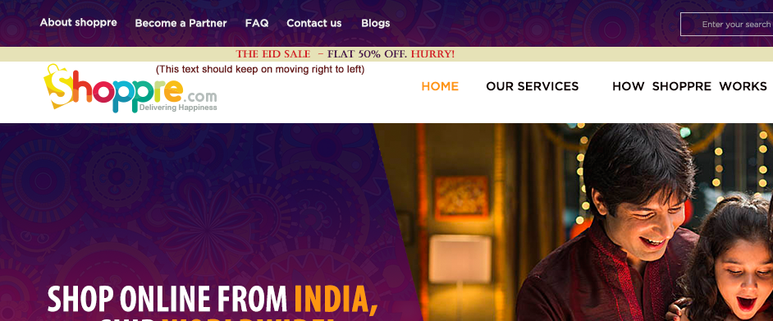

* + 1. In the footer: The Phone number is +91 80 4094 4077

The Email address is [serviceteam@shoppre.com](mailto:serviceteam@shoppre.com)

1. **ABOUT SHOPPRE** {Sujith}
   * 1. Select the Main Picture - showcasing a team{Saira/Nikki}
     2. Add ‘The Mission’ in Italics font - the entire paragraph. Also, position it in on the left side itself (as it is), but centrally align the whole text.
     3. There will be only THREE circles:
        + 1. All About Shoppre
          2. Why Choose Shoppre
          3. Our Shipping Partners (Please correct this spelling)
     4. Shoppre is the brainchild…The text is nice..but we need to make it look also nice... We need to add a photo of two ladies (cartoonic image). As of now you put some nice image for representation purpose... {Sujith}



We will find the correct image later.{Saira/Nikki}

* + 1. Why Choose Shoppre: Need to Select two images{Saira/Nikki}
    2. Our Shipping Partners: Instead of two tabs, we need to keep only one tab over there: “Become a Partner”.

1. **BECOME A PARTNER**  {Sujith}
   1. Select the Main Picture (for the banner){Saira/Nikki}
   2. STRATEGIC PARTNER PROGRAM
      1. **Are you a merchant or a reseller living outside India, seeking an Indian-based package consolidation and shipping partner?**
      2. SHOPPRE can help you grow your business.
      3. Partner with the India's #1 package consolidation company.
      4. Let both the tabs placed in the middle (Learn more and Contact us).
   3. SELLER PARTNER PROGRAM
      1. **Is your business based in India, and do your products have global appeal?**
      2. Expand your business to International customers.
      3. Partner with the India's #1 package consolidation company.
      4. Integration is FREE, simple and requires minimal IT resources.
      5. Let both the tabs placed in the middle (Learn more and Contact us).
2. **Become a Shoppre Strategic Partner** {Sujith}

*In the banner, the text will be:* PARTNER WITH INDIA’S #1 PACKAGE CONSOLIDATION COMPANY

Select the Main Picture (for the banner){Saira/Nikki}

* Also, the first point, instead of “Global companies…” we can write “For Global Companies who are looking to resell…” *(Sorry for this change again).*
* *At the end, please make the next section:*

Would like to know more?

Our dedicated business development and account management team is ready to hear from you.

CONTACT US TODAY

1. **Become a Shoppre Seller Partner** {Sujith}
   1. Select the Main Picture (for the banner){Saira/Nikki}
   2. In the main banner, we need to change the text to : PARTNER WITH INDIA’S #1 PACKAGE CONSOLIDATION COMPANY
   3. In the first section (white color background), below ‘merchandise so far’, make a tab

CONTACT US TODAY TO LEARN MORE

1. Do you own a website?

...it's so easy to ship internationally. *(please complete the sentence)*

*(Please keep the tab* Click here to receive your FREE Locker  *in the pop-up poster, with the same yellow background itself. Don't make it a white background on the bottom.)*

* *At the end, please make the next section:*

Would like to know more?

Our dedicated business development and account management team is ready to hear from you.

CONTACT US TODAY

1. **BROWSE CATEGORIES** - Select the Main Picture (for the banner){Saira/Nikki}

We will give you the details of the names of the Websites and Sellers.

1. **BLOGS** -*Done*
2. **FAQ** - *Need to do this page from scratch* - Please write the same headings for the timebeing, but simply choose the colors, and try to make slight changes in the layout. {Sujith}

Select the Main Picture (for the banner){Saira/Nikki}

We will give you the all the Q & A.{Saira/Nikki}

1. **CONTACT US**  {Sujith}
   1. Select the Main Picture (for the banner){Saira/Nikki}
   2. *Please put the “I’m not a Robot” in a similar rectangle as the above ones.*
   3. *Under hours, the timing has to be:*  9:00 am - 5:00 pm IST
   4. *Regarding the FAQ Section, we will give you the details later…* {Saira/Nikki}
   5. Instead of: After Ready to get started?, please make it So what are you waiting for...etc etc.
2. **LOG IN** {Sujith}**FINISHED UPDATION)**
   1. “I forgot my Email Address or Password. Please remind me.” <Email Address> or <Password> needs to be hyperlinked. Also, <Register> needs to be hyperlinked.
   2. Please put a cross button on the top right corner of the pop-up box.
   3. In the poster, instead of “INR 100 Cashback!”, we have to write “200 Shoppre Loyalty Points!”
3. **SIGN UP** {Sujith} **-** *Done*
4. **HOW SHOPPRE WORKS -** *Done*
5. **PRICING**  {Sujith}**FINISHED UPDATION)**

Select the Main Picture (for the banner){Saira/Nikki}

* 1. Under Get Shipping Rates,
     1. The chargeable weight…. (it need not be underlined)
     2. Under The Actual or the Volumetric weight, please write “Learn how to calculate the Volumetric Weight” (which will be hyperlinked and underlined).
     3. Please send me another image to show how the pop-up will look like (the volumetric weight poster).
  2. In the Shipping Calculator, “What is your package type?” needs to be aligned properly. We need to push it a little down.
  3. Please send me another image to show how the page would look, if someone clicks “Get Shipping Rates”. This (the image below) is what the content should be.

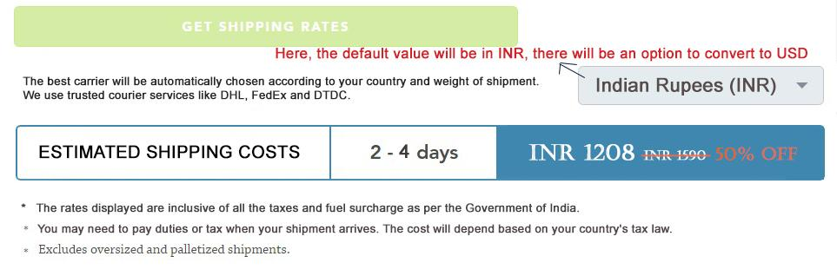

1. **COUNTRY GUIDES** <https://www.myus.com/countries/>
   1. Select the Main Picture (for the banner){Saira/Nikki}
   2. Banner text will be: Shoppre delivers to 220+ countries around the globe! {Sujith}
   3. *All the Shipping Costs, Duties and Taxes, etc. need to be hyperlinked, which will open up in new pages (which will again have all the headings - please call me if you have doubt).*
      1. *Shipping Costs - will lead to the pricing page (Shipping Calculator)*
      2. *Duties and Taxes - will lead to* [*https://www.myus.com/duties-taxes/*](https://www.myus.com/duties-taxes/) *. Don’t forget that all the text HAS to be REWRITTEN Later on. As of now, please change all US to India, and all MyUS to Shoppre.*  {Hardy}
      3. *Restricted and Prohibited Items - will lead to* [*https://www.myus.com/benefits/shipping/customs-help/restrictions/*](https://www.myus.com/benefits/shipping/customs-help/restrictions/) *. We will give you the actual list later on.*  {Hardy}
      4. *Current Exchange Rate - will lead to* [*https://www.myus.com/countries/exchange-rates/*](https://www.myus.com/countries/exchange-rates/) {Hardy}
      5. *Typical Transit Times - which is not hyperlinked.*
      6. *Country Alerts - will lead to* [*https://www.myus.com/country-alerts*/](https://www.myus.com/country-alerts/)  {Hardy}

Now, AFTER someone selects a country from the drop-down menu (For example: <https://www.myus.com/ae/>):

1. The Main Banner (as our regular layout) will have text on the left side, and image on the right side. So in short, we will have to **select images for All the Countries** - This image selection (in the right dimensions) Sujith can do. {Sujith}
2. Keep this height of this banner lesser than how it is now.
3. For the reviews (we will hand over all the review to you), do Not put a girl’s photo there. It will be very tough for us to find genuine human images. Rather, Make a nice rectangular box on the left (which has the country flag). Also, use the same background image that we usually use for reviews.
4. In the Shipping Calculator, the default country will be the country which is selected by the customer. Since you have used Australia as a representation, please write Australia here also.
5. For the exchange rate calculator, since the rectangle box height is not matching that of the Shipping Calculator, I think we will write the Country name, Capital and Currency under the exchange rate calculator.
6. Duties and Taxes:
   1. Please change all the MyUS Text to Shoppre.
   2. Please change all the United Arab Emirates to Australia.
7. Package Transit Times:
   1. Don’t write Express shipping and Economy shipping. Just write 2-4 Business Days
   2. Again, in the orange box, please change all the MyUS Text to Shoppre.
   3. Please change all the United Arab Emirates to Australia.
   4. Please change Sarasota, US to Bengaluru, India facility.
8. Products you can’t ship Internationally to Australia:
   1. Please change all the United Arab Emirates to Australia.
   2. Please change all the US to Indian.
   3. In the orange box, please change all the MyUS Text to Shoppre.
9. Partner up with Shoppre:
   1. Please change US to Indian.
10. Which Indian Stores can I buy from?
    1. Tab: Brands You Love
    2. Shoppre also offers a Personal Shopping Service where [we can buy items on your behalf](https://www.myus.com/benefits/shopping/personal-shopper/). (the underlined has to be hyperlinked) This comes in handy if an Indian website is not accepting your International credit card.
11. Items that Cannot be Exported From India
    1. Below the entire list, write “CONTACT US if you have any doubts regarding what you can ship to your country. Our team of Logistics experts will get back to you as soon as possible.”
12. **OUR SERVICES**
    1. Select the Main Picture (for the banner){Saira/Nikki}
13. **VIEW ALL SHOPPRE REVIEWS**
    1. Select the Main Picture (for the banner){Saira/Nikki}
    2. Below every review, please write the Country name in Italics. {Sujith}
14. **CUSTOMER DASHBOARD** 
    1. **Main Customer Dashboard** {Sujith}**Final correction to be done** 
       1. Sorry, there is a slight correction in the address:

**SAIRA HASSAN**

First Floor, No. 181, 2nd Cross Road, 7th Main,

Koramangala 1st Block, Locker No: A1234

Landmark (Optional): Near State Bank of India, Koramangala 1st Block

(Pincode): 560034

Bengaluru, Karnataka,

India

0091 914 835 914 3

ii) The Packages in Locker A1234, and View Queue…. The right side text and the left side text are not aligned nicely…

**Shoppre Incoming Packages** (the spacing of the below needs to be done properly):

**Final correction to be done**

PLEASE NOTE:

Documents must include individual values for each item in the package.

Is this secure? Yes, all uploaded documents are held in our secure server.

* 1. **REFER A FRIEND** {Sujith}  **(FINISHED UPDATION)**

ACTIVITY:

*(Similar to Myus)*  {Hardy}

* 1. **PERSONAL SHOPPER** {Sujith}  **(FINISHED UPDATION)**

We will provide the details for the pop-up box of the Personal Shopper Terms and Conditions.{Saira/Nikki}

* 1. **MY ACCOUNT SETTINGS** {Sujith}
     1. On the left side, we need to keep a list (similar to MyUS):
        1. Membership Profile
           1. Contact Information **(PAGE DESIGNED)**
           2. My Password **PAGE DESIGNED)**
        2. Address Book**PAGE DESIGNED)**
        3. Payment Method **PAGE DESIGNED)**
        4. Shipping Preferences (please put a question mark in the circle wherever necessary, and keep check boxes wherever required).
           1. Default Shipping Address: (Then put an address in a box)
           2. Log in options:

Additional email address (optional)

Take photos of item at login*

* + - * 1. Shipping Schedule Preference: (Two options:)

HOLD (Store your items in your locker, and get them delivered as per your need.)

AUTOMATIC (Get your item delivered as soon as your item reaches your locker.)

* + - * 1. Packing Options:

Repackage your items* (for eg: Discard shoe boxes)

Fragile Stickers*

Add extra packing material*

Ship in original shipping boxes

Maximum weight per box/ Multi-piece shipment (MPS) (Add a tab to write down the weight in kilograms, and write the conversion from kg to pounds on the right side: 1 kg is about 2.20462 pounds)

* + - 1. Performa Invoice Options:

Tax ID:

Mark items for "Personal Use Only"

Please include a printed Proforma Invoice in my shipment

* + - 1. Account Documents:
         1. Please upload any documents requested by Shoppre to validate your account (For example, your photo identification, etc.). Please do not upload invoices here. Seller invoices can be uploaded to your packages in [My](https://myaccount.myus.com/) Locker.
         2. UPLOAD DOCUMENT

#### Is this secure? Yes, all uploaded documents are held in our secure server, and are only available for viewing when you are signed in to your account.

* 1. **MY SHIPMENT HISTORY** - *Need to do this page from scratch* {Hardy}

The only main difference is that under “Type”, we will have only Two options: Personal Shopper and Shipping. (Membership will not be there). Also, there will probably be a difference in the color combination (which will have to suit our web layouts).

* 1. **MY FAVORITE STORES** - *Need to do this page from scratch* {Sujith}**(PAGE DESIGNED)**

i) Please keep a tab (a drop down menu tab) which says: Category: ___________

(by Default, the category will be Apparels).

ii) Below this, we will show a few shops (like how you did in Brands You Love, and they have to be starred).

* 1. **MY LOYALTY POINTS** - *Need to do this page from scratch* {Sujith} **(PAGE DESIGNED)**

### Similar to Refer a friend page, we need to keep two tabs on the top. One is “Rewards” and the other is “History”.

REWARDS:

### Achievements

LEVEL 1 0 100

SHOPPER TOTAL POINTS POINTS TO LEVEL UP

* + 1. At Shoppre, members always come first, and nothing says "we appreciate you" more than CASH for shipping! We're excited to unveil the industry's first rewards program that allows you to easily earn shipping credits with Shoppre.
    2. Keep three circles in the next section:
       1. FREE to every Shoppre member
       2. REDEEM your points for future shipments
       3. SO EASY to earn points!
    3. Earn Shoppre Loyalty Points

There are lots of ways to earn Shoppre Loyalty Points, and they never expire!

* + - 1. SHIPPING REWARDS
         1. Earn Shoppre Loyalty Points whenever you ship a package (10% of the total amount that you paid for your shipment).
      2. SHOPPING REWARDS
         1. Earn 50 Shoppre Loyalty Points per shipment, by shopping from ANY of our Featured Sellers (the underlined will be hyperlinked).
      3. REFER A FRIEND
         1. Earn 200 Shoppre Loyalty Points for each friend you refer as soon as they do their first shipment!
      4. MISCELLANEOUS REWARDS
         1. Earn 20 Shoppre Loyalty Points for participating in social media and surveys.
    1. Turn your rewards into Cash!

For every 1,000 Shoppre Loyalty Points you earn, a INR 100 credit will automatically be applied to your next shipment. There is no limit to the number of INR 100 Credits you can collect, giving you unlimited earning potential!

* + 1. START SHIPPING TO LEVEL UP AND EARN SURPRISE LOYALTY POINTS! (This sentence should be written in a fancy way at the end).

HISTORY:

Here, we need the following column:

|  |  |  |
| --- | --- | --- |
| **LOYALTY POINTS** | **ACHIEVED ON:** | **REDEEMED INR 100 ON:** |
| 1000 | 08/05/2017 | 28/07/2017 |
| 2000 | 19/08/2017 | 02/01/2018 |

* 1. **SHIPMENT ALERTS** - *Need to do this page from scratch* {Hardy}

The only difference will probably be the color combination (which will have to suit our web layouts). The text will remain the same.

1. **TERMS AND CONDITIONS & PRIVACY POLICY** - *Need to do this page from scratch* We will hand this over to you soon. {Saira/Nikki} {Hardy}

*-------------------------------------------------------------------------------------------------------------------------------------------*