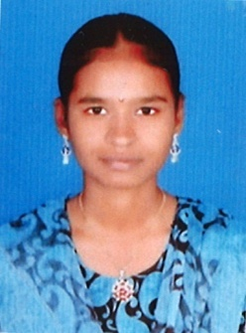 **RESUME**

**MEENA.K**

B.E Computer Science & Engineering

Mobile No: 6380059012

Email Id: [meena001999@gmail.com](mailto:meena001999@gmail.com)

LinkedIn : <http://www.linkedin.com/in/meena-k-8a3a8b18b>

**CAREER OBJECTIVE:**

Intend to build a career successfully .I involve myself Fully for the growth of organization and leading corporate of hi-tech environment.

**ACADEMIC PROFILE:**

|  |  |  |  |
| --- | --- | --- | --- |
| **Course** | **School/College** | **Duration** | **Percentage** |
| B.E Computer Science & Engineering | Panimalar Engineering College | 2017-2021 | 7.6[ upto 5th Semester] |
| H.S.C | Government Girls Higher Secondary School | 2016-2017 | 87.67 |
| SSLC | Government Girls Higher Secondary School | 2015-2016 | 94 |

**TECHNICAL SKILLS:**

**Area of Interest** : Coding , Software Testing, web Development

**Programming Language** : Basic Knowledge of Python , C, html , css , Java script

Photoshop , Blog Writing

**WORKSHOPS:**

* Attended a Workshop on " Android App Development " Conducted by Infoziant Systems Pvt Ltd.
* Attended the "Entrepreneurship development Camp" in Panimalar Engineering College.
* Attended a Workshop on " Block chain" Conducted by GUVI

**PERSONAL STRENGTH:**

* Ability to Learn new things
* Co-operation in doing Team Work

**ACHIEVEMENTS**

* Presented a paper in Ozmenta 2020 organized by Velammal Engineering College
* Presented a Poster in Science Bazaar organized by WHD.
* Participated in Photoshop, Blog Writing and Film Critic Contests conducted by Study Monk

**PERSONAL DETAILS:**

Date of Birth : 27 /12 /1999

Nationality : Indian

Father's Name : Mr. A. Krishnan

Mother's Name : Mrs. K. Rajeswari

Sex : Female

Marital Status : unmarried

Languages known : Tamil , English

Address : No:509A,Poongan Street, Perungattur , cheyyar(TK),

Hasanamapettai (post),Tiruvannamalai.

Hobbies : Drawing

**DECLARATION:**

The Information Furnished above is correct to the best of my Knowledge.

Place : Chennai Signature

Date: **(MEENA K)**