How to do execute this command line utility via a xxx.bat file:

Steps to Create a bat file

1. Open a new notepad file.
2. Type the following commands in the text file:

@echo off

cd /d D:\DevTest\bin\ServiceImageManager.exe --vrs=D:\DevTest\Projects\D1\RR1.vrs --si-file=D:\DevTest\Projects\D1\VirtualServices\Images\RR6.vsi --vsm-file=D:\DevTest\Projects\D1\VirtualServices\RR6.vsm --record –go

1. Save the text file with the extension .bat.
2. To Run the batch file, simply double-click it.

Call this from Jenkins

1. Installed Jenkins.
2. Called the .bat file from Jenkins:

call C:\Users\mn00365099\Desktop\SV\CMD\cmd.bat

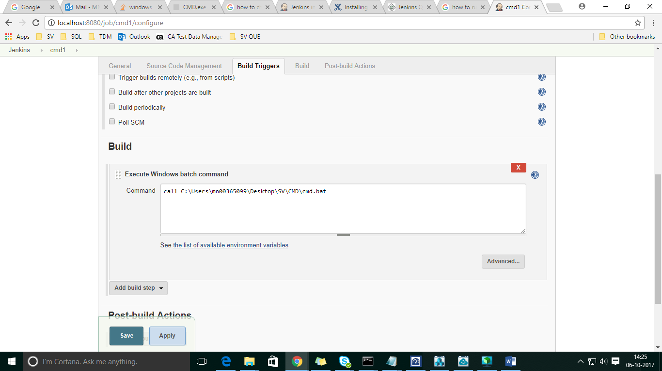

1. Build the .bat file in Jenkins.

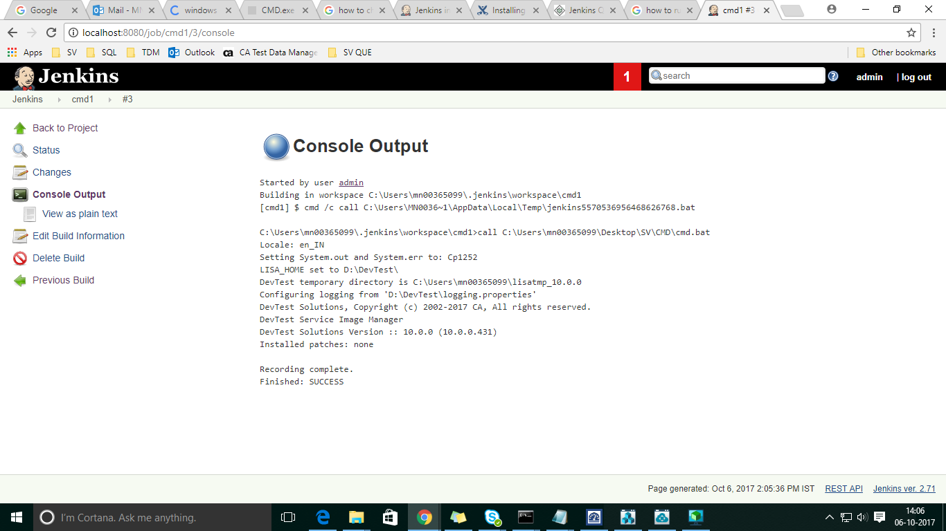

1. Go to DevTest workstation vsi and vsm is created

