1. Created a transformation on CARD_NUMBER of CREDIT_CARDS table.

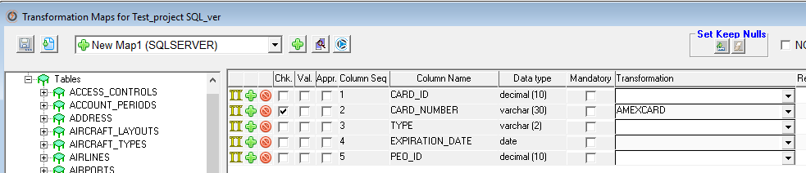

1. Saved the extract. (crd_card)

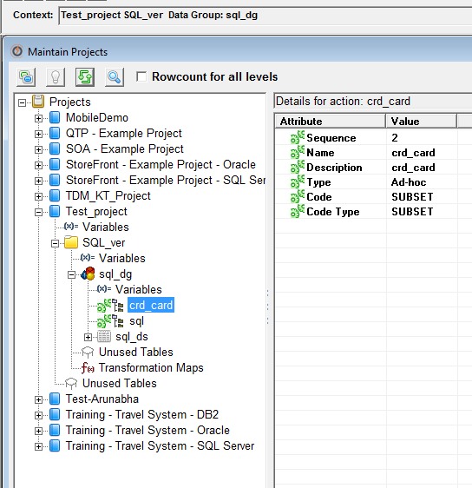

1. Generating the Scrambled extract.

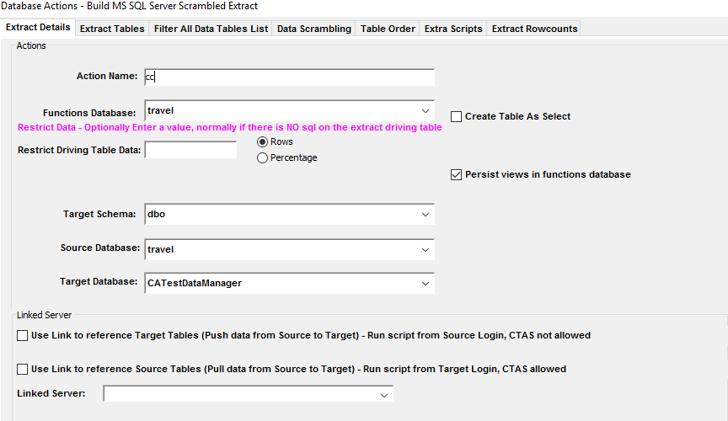

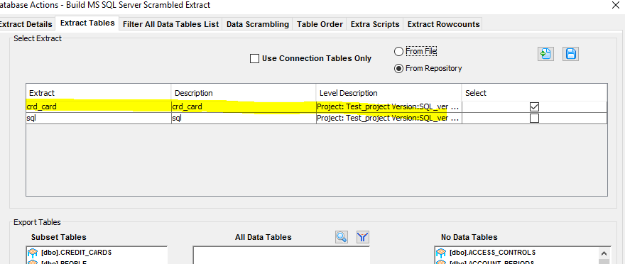

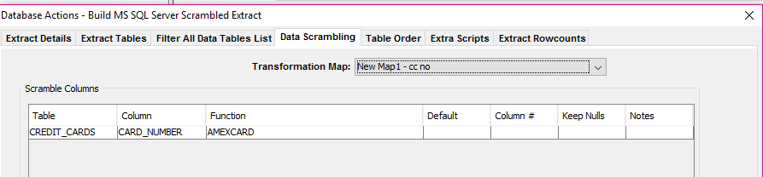

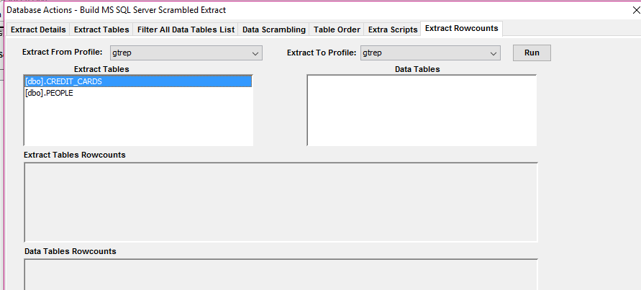

1. Tried to extract the dump file.

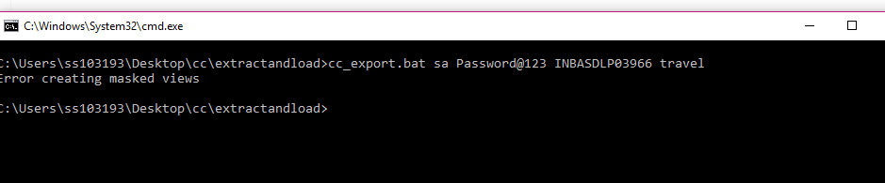

**Getting Error creating masked views.**

select * from [dbo].[gtsrc_reference_data]

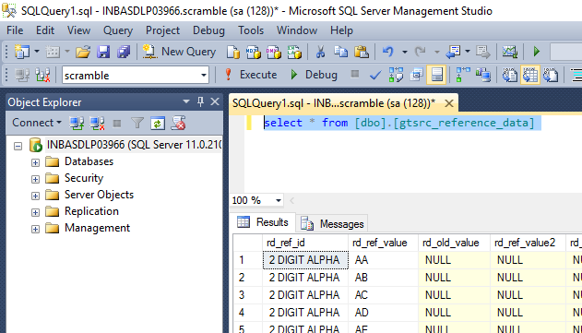

Data is available in dbo].[gtsrc_reference_data]of Scramble database.

Observation: Debug. View (cc_obfusc_schema)

IF EXISTS(SELECT 1 FROM sys.views

WHERE object_id = OBJECT_ID('[dbo].[CREDIT_CARDS]'))

BEGIN

DROP VIEW [dbo].[CREDIT_CARDS]

END

GO

CREATE VIEW [dbo].[CREDIT_CARDS] as select

[CARD_ID] [CARD_ID],

travel.dbo.AMEX([[CARD_NUMBER]], '') [CARD_NUMBER], -- This is line is giving error

[TYPE] [TYPE],

[EXPIRATION_DATE] [EXPIRATION_DATE],

[PEO_ID] [PEO_ID]

from [travel].[dbo].[CREDIT_CARDS]

GO