Activity4

Create input.txt file under /root folder and create activity4.hive to transfer input.txt file data into files table

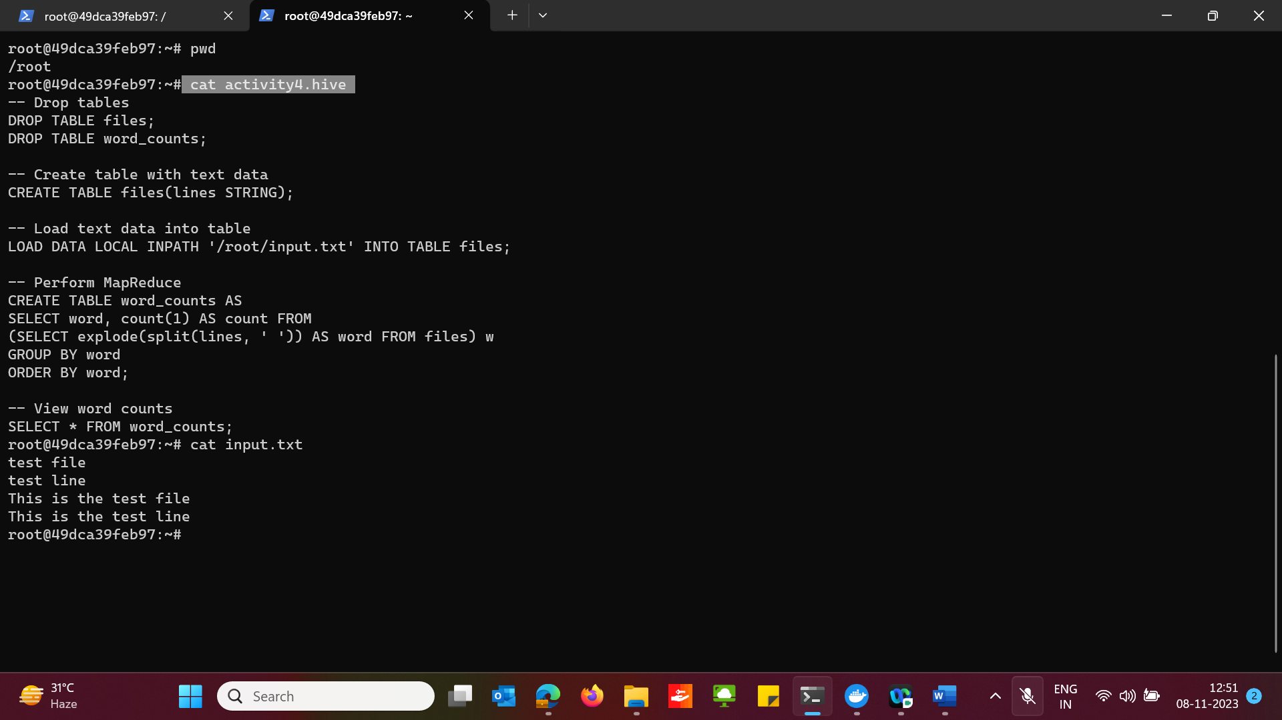

In hive, check data in files and word_counts table after executing the above activity4.hive

