 **CASE STUDIES AND REAL LIFE EXAMPLES**

**Autonomous Waste-to-value Conversion**

***Submitted By***

**NITHYASRI A (95192102073)**

**SANTHIYA P (95192102082)**

**MERLIN ESTHER I (95192102063)**

To

**In partial fulfillment for the award of the degree Of**

BACHELOR OF ENGINEERING

**in**

ELECTRONICS AND COMMUNICATION ENGINEERING

**P.S.R. ENGINEERING COLLEGE, SIVAKASI – 626 140**

**(An Autonomous institution, Affiliated to Anna University, Chennai)**

**ANNA UNIVERSITY: CHENNAI 600 025**

**APRIL -2025**

# **CERTIFICATE**

I hereby declare that the work presented in this report of my Case Studies in partial fulfilment of the requirements for the award of the degree of **Bachelor of Engineering** in **Electronics And Communication Engineering** submitted to the department of Electronics And Communication Engineering, P.S.R. Engineering College, Sivakasi is an authentic record of our own work carried out under the supervision of **Mrs.S.Mahalakshmi,M.E.** The matter embodied in the report has not been submitted for the award of any other degree or diploma.

Date: …………………….

Place:

**Nithyasri A (95192102073)**

**Santhiya P (95192102082)**

**Merlin Esther I (95192102063)**

This is to certify that the above statement made by the candidate is true to the best of my knowledge.

( Name and Signature) Location

Date:

# ACKNOWLEDGEMENT

We take this opportunity to put record We take this opportunity to put record sincere thanks to all who enlightened my path towards the successful completion of this project. At very outset, thank the **Almighty** for this abundant blessing showered on.

It is our greatest pleasure to convey thanks to **Thiru R.Solaisamy, Correspondent,** and **Er.S.Vigneshwari Arunkumar, Director,** for having provided with all required facilities and suitable infrastructure to complete our project without thrones.

It is oursupreme privilege to conveyour thanks to **Dr.J.S. Senthil Kumaar, M.E., Ph.D., Principal,** for having provided with all required facilities to complete our project without hurdles.

We pour our profound gratitude to our beloved Head of the Department,

**Dr.K.Valarmathi, M.Tech., Ph.D.,** for providing ample facilities made available to undergo our project successfully.

We wish to express our sincere thanks to Project Co-Ordinator’s **Dr.P.Vinoth, M.E., Ph.D.,** and **Dr.G.Karthikeyan M.E., Ph.D.,** for having helped us with excellent suggestion and hints, which facilitated our task very much.

We thank our project supervisor **Mrs.S.Mahalakshmi M.E.,** for her excellent guidelines patiently throughout our project work and endless support helped us to complete our project work on time. We also bound to thank the other Staff Members of the Department of Electronics and Communication Engineering, whose support and co-operation also contributed much to complete our project work.

**Table of Contents**

|  |  |
| --- | --- |
|  | **PAGE NO.** |
| Certificate | ii |
| Acknowledgement | iii |
| Abstract | iv |
| Table of Contents | v |
| List of figures | vi |
| **1. EXECUTIVE SUMMARY** |  |
| **2. ORGANISATION BACKGROUND** |  |
| **3. PROBLEM STATEMENT** |  |
| 3.1 Problem Statement 1 | 24 |
| 3.2 Problem Statement 2 | 25 |
| 3.3 Problem Statement 3 | 26 |
| **4. BACKGROUND OF THE PROBLEM** | 31 |
| **5. PROBLEM SOLVING APPROACH** | 34 |
| **6.EXPECTED TIMELINE** |  |
| 6.1 Work Breakdown Structure |
| 6.2 Gantt Chart |
| **7.EXPECTED OUTCOME** |
| **8. SURVEY RESULTS AND ANALYSIS** |
|  |
|  |  |

**1.EXECUTIVE SUMMARY**

* The company focuses on the rural areas in TamilNadu.This is their main market for generating electricity from organic wastes of agricultural land.
* As a smaller company they need to plan their work in advances due to calamities of nature.Their main goal is to provide electricity to farmers and rural people in low cost.
* They Focus on generating electricity from Bio-Gas by supporting sustainability goals, reduces dependency on fossil fuels, and creates an economically viable energy option for rural, agricultural, and industrial communities.

**2.ORGANIZATION BACKGROUND**

* **Selco Foundation**, established in 2010, is a pioneering non-profit organization based in India that focuses on promoting sustainable energy solutions for marginalized and underserved communities. The foundation works at the intersection of clean energy, poverty alleviation, and social development, enabling access to decentralized renewable energy systems in rural, tribal, and peri-urban areas.
* Selco Foundation actively engages in building resilient, sustainable infrastructure for energy-deprived regions through solutions such as solar lighting, biogas units, solar-powered medical devices, and water purification systems. Through research, policy advocacy, and capacity-building programs, Selco Foundation has played a crucial role in addressing energy poverty and improving livelihoods in vulnerable communities across India

**3. PROBLEM STATEMENT**

**3.1 Problem Statement 1:**

Lack of reliable and scalable renewable energy solutions in rural and industrial sectors dependent on fossil fuels.

**3.2 Problem Statement 2:**

Inefficient management of organic waste, leading to environmental pollution, high landfill use, and methane emissions.

**3.3 Problem Statement 3:**

Limited integration of automation and remote monitoring systems in small- and medium-scale biogas-based electricity generation plants.

**4.BACKGROUND TO THE PROBLEM**

Organic waste, if unmanaged, produces methane—a potent greenhouse gas contributing to climate change. While biogas systems can convert this methane into useful energy, current small- to medium-scale plants often lack automation, performance monitoring, and integration with modern energy grids. The absence of scalable, autonomous waste-to-energy conversion systems restricts their practical deployment in off-grid areas and small industries.

**5. PROBLEM SOLVING APPROACH**

* **Develop an automated biogas generation unit** using anaerobic digesters and integrated sensors for monitoring temperature, pH, gas pressure, and methane concentration.
* **Design an electricity generation system** using gas engines or microturbines connected to a battery storage unit.
* **Implement IoT-based monitoring** for operational data and remote fault alerts.
* **Package the system into a modular, compact, and easy-to-deploy unit** for rural and industrial applications.
* **Integrate digestate management** for producing organic fertilizer as a valuable byproduct.

**6. EXPECTED TIMELINE**

**6.1 Work Breakdown Structure**

| **Week(s)** | **Activity** |
| --- | --- |
| Week 1-2 | Requirement gathering & feasibility analysis |
| Week 3-4 | Design of anaerobic digestion and gas purification system |
| Week 5-6 | Hardware procurement and assembly |
| Week 7-8 | Control system integration & IoT module setup |
| Week 9 | System testing and calibration |
| Week 10 | Pilot installation at selected site |
| Week 11-12 | Final adjustments, reporting, and training |

**6.2 Gantt Chart**

| **Task** | **W1** | **W2** | **W3** | **W4** | **W5** | **W6** | **W7** | **W8** | **W9** | **W10** | **W11** | **W12** |
| --- | --- | --- | --- | --- | --- | --- | --- | --- | --- | --- | --- | --- |
| **Feasibility Study** | ✅ | ✅ |  |  |  |  |  |  |  |  |  |  |
| **System Design** |  |  | ✅ | ✅ |  |  |  |  |  |  |  |  |
| **Component Procurement & Build** |  |  |  |  | ✅ | ✅ |  |  |  |  |  |  |
| **IoT and Control Setup** |  |  |  |  |  |  | ✅ | ✅ |  |  |  |  |
| **System Testing & Calibration** |  |  |  |  |  |  |  |  | ✅ |  |  |  |
| **Deployment & Commissioning** |  |  |  |  |  |  |  |  |  | ✅ | ✅ | ✅ |

**7. EXPECTED OUTCOME**

The expected outcome is the successful deployment of an autonomous, sensor-driven waste-to-energy system converting organic waste into biogas and subsequently into electricity. From the company's perspective, this project will enable the delivery of a scalable, compact, and commercially viable biogas-based power generation solution for rural and industrial clients. It will position the company as a leader in clean energy innovation while supporting environmental sustainability, waste reduction, and decentralized energy access initiatives.

**8 .SURVEY RESULT ANALYSIS**

1. As part of the preliminary research for this case study, a survey was conducted to gauge public perception regarding the viability of converting biodegradable waste into biogas as an alternative to traditional energy sources. A total of **80 participants** responded to the survey.

The results, illustrated in **Figure 8.1** (your pie chart), show a highly favorable outlook towards biogas-based electricity generation:

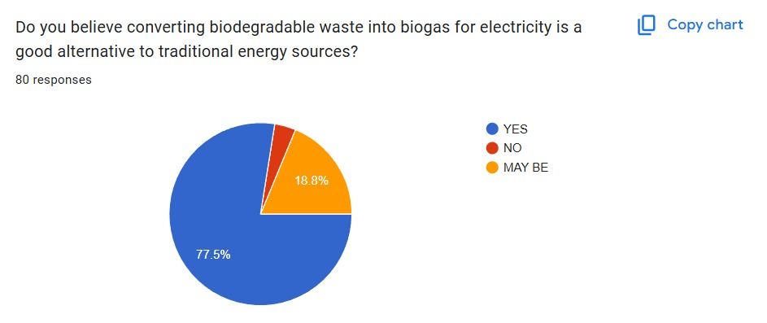

**Figure 8.1**

• **80% of respondents (36 out of 80)** believe that converting biodegradable waste into biogas for electricity is a good alternative to conventional energy sources.

• **20% (9 out of 80)** were uncertain, selecting "Maybe" as their response.

• Notably, **no respondents selected "No,"** indicating a general openness or optimism towards the technology.

This overwhelming positive response reflects a strong community interest in sustainable, waste-to-energy solutions, reinforcing the relevance and potential impact of this project. The results validate the need for further development and implementation of biogas-based energy systems within both urban and rural settings.

1. **Biodegradable Waste Profile in the Community**

To better understand the composition of biodegradable waste available for potential biogas production, a survey was conducted involving **45 participants** from the target community. The participants were asked to identify the most common types of biodegradable waste generated in their households or surroundings.

The results, illustrated in **Figure X** (your bar chart), revealed the following:

* **Food waste** was the most reported type, with **31 respondents (68.9%)** identifying it as the predominant biodegradable material in their household or community.
* This was closely followed by **vegetable and fruit peels**, reported by **30 participants (66.7%)**.
* **Agricultural waste** — such as crop residue, husks, and similar materials — was noted by **10 respondents (22.2%)**.
* **Animal waste** was the least common, with only **5 participants (11.1%)** mentioning it.

This data highlights that **food and kitchen waste are the most abundant biodegradable resources** in the surveyed area, making them highly suitable feedstocks for biogas production initiatives. The findings provide essential guidance for the project’s resource planning and feedstock selection strategy**.**

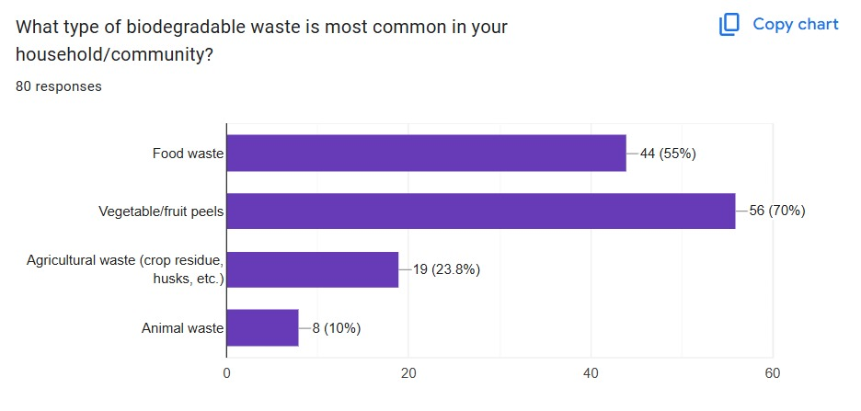

**3.Wiling to segregate bio-degradable waste**

Out of 100% 80 percentage of the people are wiling to segregate the bio degradable waste if its used for the generating the electricity to be used in their households.

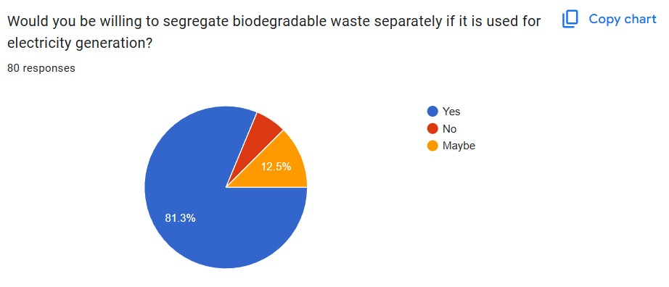**Figure 8.3**

**4.Challenges faced by people**

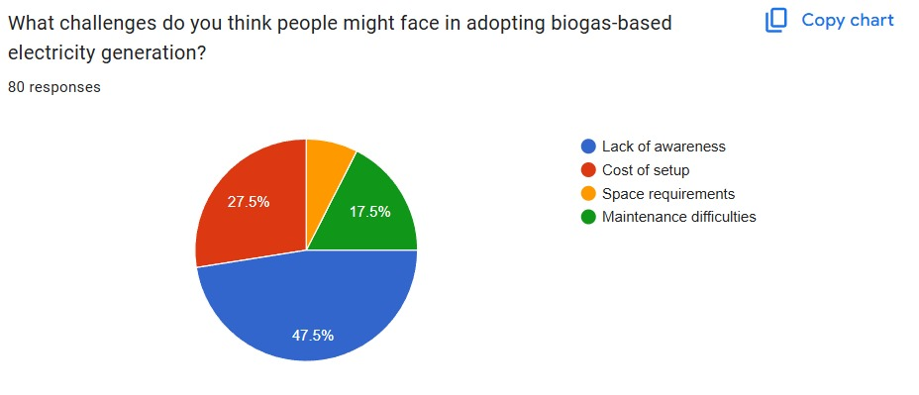

**Figure 8.4**

From the Figure 8.4 most of the people doesn’t have proper awareness about the conversion bio-gas electricity.The cost of setup of bio-gas generator is pretty height.

**5.Benefits of bio gas based electricity**

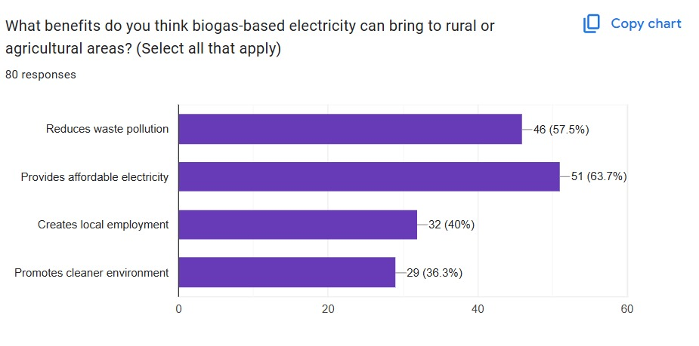

**Figure 8.5**

**6.Installation of biogas plant in your locality**

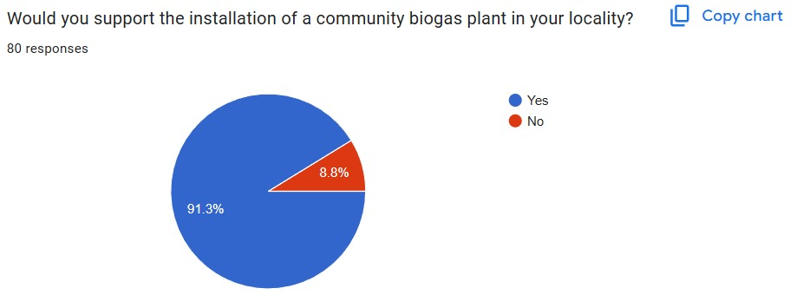

**Figure 8.6**

**7.Recommendation for use of biogas plants for energy in your community**

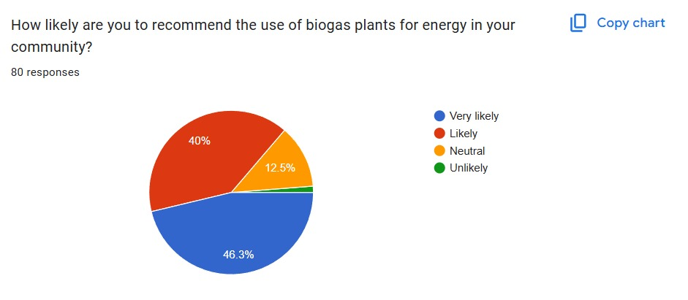

**Figure 8.7**