**1. INTRODUCTION**

**1.1 Introduction**

As modern civilization grows, so does the complexity of its waste. From household leftovers to agricultural residues, we are generating increasing volumes of organic waste that often end up polluting our environment and filling up landfills. These wastes, if left untreated, lead to methane emissions, groundwater contamination, and loss of usable resources. However, the same waste, if processed intelligently, can become a powerful source of energy and sustainability.

This project titled “Autonomous Waste-to-Value Conversion” explores the possibility of converting organic waste into electrical energy using biogas-based systems. It focuses on the development of a low-cost, Arduino-based model that demonstrates how waste can be utilized to generate clean electricity. The produced electricity is then used to power small output devices such as LED bulbs, sensors, and LCDs, simulating its real-world application.

At the core of this project lies the biogas production system, which involves anaerobic digestion — a natural biological process that breaks down organic matter in the absence of oxygen. The biogas produced from this process contains about 50–70% methane, which can be burned to produce electricity. Methane, being highly combustible, becomes the key enabler in powering microcontrollers, which further distribute the electricity to small-scale systems.

This project was inspired by the idea of making rural and agricultural areas self-sufficient. In many underdeveloped or off-grid regions, electricity is either unavailable or highly unreliable. On the other hand, these same areas generate massive amounts of cattle dung, vegetable waste, and food waste, all of which are excellent raw materials for biogas production. The system proposed in this project not only converts waste into something valuable but also demonstrates an autonomous energy cycle that can be implemented with minimal cost and simple training.

Unlike solar or wind energy which depend on weather conditions, biogas production is consistent and controllable. It provides a 24x7 renewable energy source, as long as waste is available. The Arduino platform allows automation and control over the energy usage — showcasing how even rural settings can benefit from embedded systems and IoT-based automation.

In the prototype setup of this project, the energy generated is used to:

* Power an LED bulb (simulating lighting applications)
* Trigger IR sensors and temperature sensors (simulating automation and monitoring)
* Display live outputs via an LCD panel
* Record and manage power levels using voltage sensors

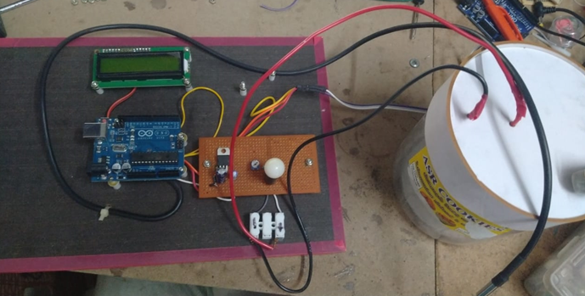

**Figure 1.1: real setup – Arduino board connected to bulb, sensor, LCD,**

**and biogas cylinder**

This autonomous cycle — where waste is transformed into energy, and that energy powers smart components — perfectly aligns with SDG Goals like:

* Affordable and Clean Energy
* Responsible Consumption and Production
* Climate Action

Furthermore, the project lays a strong foundation for future developments in:

* Smart agriculture
* Off-grid renewable energy hubs
* Micro-scale circular economy models

By enabling technology-driven sustainability, the project not only solves an environmental issue but also delivers a social impact that could transform communities.

In summary, this project introduces a novel and affordable method to manage organic waste by harnessing its hidden energy potential. It demonstrates how automation, biogas, and microcontrollers can together revolutionize the way we perceive and manage waste — converting a problem into a powerful, renewable solution.

**1.2 Background of the Study**

In today’s world, waste generation has become one of the most pressing global concerns. According to the World Bank, over 2.24 billion tons of solid waste is produced each year, and this figure is expected to rise dramatically in the coming decades. A large portion of this waste is organic in nature — food scraps, agricultural waste, animal manure — all of which are rich in carbon and highly biodegradable. Unfortunately, most of this valuable biomass is either dumped in landfills or left to rot in open spaces, where it emits harmful gases like methane and carbon dioxide, significantly contributing to climate change.

The challenge is not just the volume of waste, but also our inability to convert it into something useful. In rural areas and agricultural communities, where such waste is in abundance, the lack of proper management systems means this waste remains an untapped resource. On the other hand, energy poverty is another critical issue in many such regions, with millions of households still lacking access to reliable electricity.

This is where the concept of Waste-to-Energy (W2E) becomes extremely powerful. The idea of converting waste into energy is not new, but what sets this project apart is the attempt to make this process autonomous, low-cost, and decentralized using biogas and embedded systems. The project aims to solve two major problems at once: waste accumulation and energy shortage. It offers a solution that is not only environmentally friendly, but also economically sustainable and technically feasible for small-scale rural implementation.

Biogas technology has existed for decades, but the traditional models are bulky, manually operated, and require consistent human monitoring. By integrating Arduino-based automation, this project brings smart control and live monitoring to a natural energy cycle. The sensors and display modules help track output values in real time, ensuring safety, efficiency, and user-friendliness. The use of voltage sensors, for example, helps users know how much energy is being generated and consumed at any point in time — a feature that is missing in traditional biogas setups.

This autonomous model has the potential to become a game-changer in village-level applications, where farmers and residents could easily install small-scale digesters to convert their daily waste into useful electricity. This electricity could then be used for lighting, irrigation system controls, mobile charging, or other basic electronics. The result is a closed-loop system that encourages self-reliance, clean energy, and minimal waste.

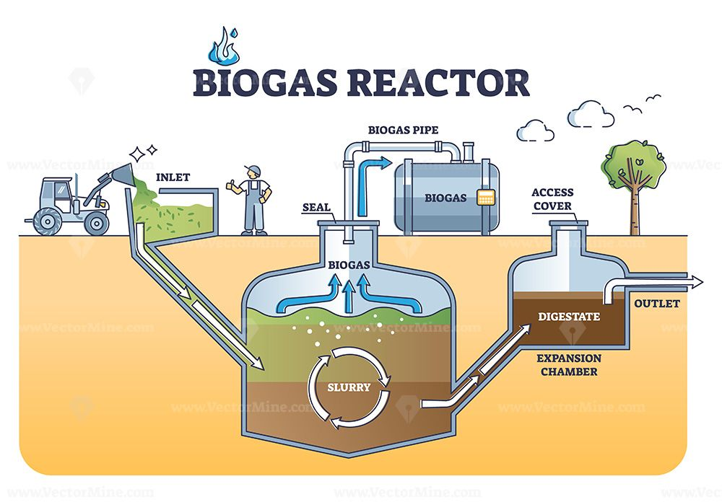

**Figure 1.2 : Biogas reactor working principle with underground structure outline diagram**

Moreover, this project also supports the global push toward decentralized energy systems, where small, local setups reduce dependence on large grids and fossil fuels. Governments around the world are promoting clean energy transitions, and this kind of innovation supports national policies like:

* India’s Swachh Bharat Abhiyan (Clean India Mission)
* National Biogas and Organic Manure Programme (NBOMP)
* United Nations’ Sustainable Development Goals (SDGs)

It is also important to mention the educational value of this project. By combining renewable energy technology with IoT and embedded systems, students and enthusiasts can better understand how real-world environmental problems can be solved through interdisciplinary innovation. It becomes a working demonstration of how electronics, biology, and sustainability can co-exist to create real impact.

In conclusion, the background of this study lies in the urgent need to rethink how we handle waste and how we generate power. Through this project, we aim to shift the perception of organic waste — from being a problem to becoming a powerful, renewable asset — and show how technology can turn sustainability into a reality.

**1.3 Objectives**

The primary objective of the "Biogas to Electricity Conversion" project is to develop an efficient, sustainable, and scalable system that can convert organic waste into usable electricity. By utilizing anaerobic digestion to produce biogas from biodegradable materials such as agricultural residues, animal manure, and food waste, the project aims to provide a reliable renewable energy source, particularly in rural and off-grid areas. This system will not only generate electricity but also create an environmentally friendly solution for managing organic waste, reducing landfill usage, and lowering greenhouse gas emissions.

The system will focus on the purification of biogas to increase its methane content, making it more efficient for energy production. The project’s design will ensure that it is adaptable for various types of waste, allowing it to be scaled to fit different community sizes or energy needs. Additionally, the project will promote sustainable agricultural practices by utilizing the digestate (the by-product of anaerobic digestion) as a nutrient-rich fertilizer.

By incorporating automation and real-time monitoring, the system will ensure maximum energy output and operational efficiency. The project also aims to foster educational outreach by organizing workshops and training programs to raise awareness of renewable energy solutions and encourage local communities to adopt biogas technology.

The system’s objectives are to support rural development, reduce reliance on fossil fuels, and provide a sustainable model for waste-to-energy solutions that can be replicated in different parts of the world. Through this initiative, the project seeks to promote the principles of the circular economy by turning organic waste into valuable energy resources, thus benefiting both the environment and local communities.

The use of digestate, the byproduct of the anaerobic digestion process, is another important objective of the project. Rather than being discarded, digestate can be repurposed as a high-quality organic fertilizer. This fertilizer is rich in essential nutrients such as nitrogen, phosphorus, and potassium, which are beneficial for soil health and crop growth. By utilizing digestate as an organic fertilizer, the project contributes to sustainable agricultural practices, reduces the need for chemical fertilizers, and promotes soil conservation.

One of the broader objectives of the project is to foster energy independence and improve energy security, particularly in rural or remote areas. By adopting decentralized biogas-to-electricity systems, communities can become less reliant on the national grid, which is often unreliable or inaccessible in such regions. The electricity generated from biogas can be used locally to power homes, agricultural activities, and small industries, thus contributing to rural development. Furthermore, this decentralized model reduces the transmission losses typically associated with centralized power generation, making the system more efficient.

Another objective is to enhance public awareness and education about the benefits of biogas technology and renewable energy. By demonstrating the viability of biogas-to-electricity systems, the project aims to encourage wider adoption of renewable energy technologies, particularly in regions with significant organic waste and energy needs. Additionally, the project will provide educational resources and training to local communities, promoting technical skills related to biogas production, purification, and electricity generation.

From an economic perspective, the project aims to create jobs and stimulate local economies. The installation, operation, and maintenance of biogas-to-electricity systems will require a skilled workforce, providing employment opportunities in both technical and non-technical roles. Additionally, farmers and waste management companies can benefit from a steady supply of biogas by converting waste into valuable energy. The project also aims to explore opportunities for small-scale businesses to utilize biogas for cooking, heating, or electricity, further diversifying the economic benefits.

The environmental impact of the project will be continuously assessed to ensure that the biogas production system minimizes the negative effects on the surrounding ecosystem. By reducing the need for fossil fuels and mitigating the environmental damage caused by traditional waste disposal methods, the project will make a significant contribution to reducing greenhouse gas emissions and supporting global climate change mitigation efforts.

Finally, the scalability and adaptability of the system are vital objectives. The project aims to design a biogas-to-electricity system that can be scaled up or adapted to different sizes and locations, ranging from small-scale residential systems to larger industrial installations. This flexibility makes the technology suitable for diverse applications, whether in rural communities, agricultural operations, or industrial settings, thereby maximizing its impact.

**1.4 Block Diagram**

The block diagram illustrates the flow of the biogas-to-electricity system starting from the input of organic waste like food leftovers or animal manure. This waste goes into an anaerobic digester where it breaks down to produce biogas. The biogas is then cleaned to remove impurities and sent to a generator where it is used to produce electricity. The leftover material from the digester, called digestate, is collected and used as fertilizer. Some systems also capture heat during electricity generation for additional use, making the whole system more efficient.

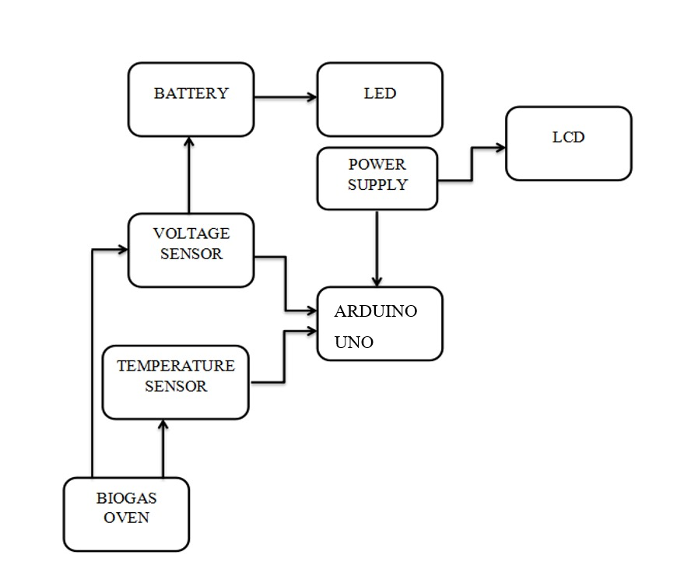

**Figure 1.3 :Block Diagram**

**1.5 Proposed Statement**

The proposed biogas-to-electricity conversion project aims to develop an innovative and sustainable solution for waste management and energy production by transforming organic waste materials into renewable energy. The main objective is to address two pressing challenges: the growing environmental impact of organic waste and the increasing demand for clean, renewable energy sources.

This project proposes a fully integrated system that encompasses the entire biogas production and electricity generation process, starting with the collection and treatment of organic waste, followed by anaerobic digestion to produce biogas, purification of the biogas to enhance methane content, and finally, the use of the purified biogas to generate electricity. The system is designed to be both efficient and environmentally responsible, minimizing harmful emissions and reducing reliance on fossil fuels.

Key components of the proposed system include:

1. **Biogas Production:** The system will collect biodegradable waste such as agricultural residues, food waste, and animal manure. These materials will undergo anaerobic digestion in a bioreactor, where microorganisms will break down the organic material in the absence of oxygen, producing biogas as a byproduct.
2. **Biogas Purification:** Since raw biogas contains impurities such as carbon dioxide, hydrogen sulfide, and moisture, the project will incorporate a biogas purification unit to remove these contaminants. This will ensure that the methane content in the biogas is high enough to be used as an efficient fuel for electricity generation.
3. **Electricity Generation:** The purified biogas will be fed into an internal combustion engine or microturbine to generate electricity. This process involves burning the methane in a controlled manner to produce energy, which can be used locally or fed into the electrical grid.
4. **Combined Heat and Power (CHP):** The project will implement a CHP system to enhance overall efficiency. In this system, the excess heat produced during electricity generation will be captured and used for heating purposes, such as water heating or space heating. This will maximize the utility of the energy produced and contribute to reducing overall energy costs.
5. **Digestate Utilization:** After the anaerobic digestion process, a nutrient-rich byproduct known as digestate will remain. Instead of being discarded, the digestate can be repurposed as a high-quality organic fertilizer. This will contribute to sustainable farming practices, reduce the need for chemical fertilizers, and promote soil health.
6. **Economic and Social Impact:** The proposed system will have a positive impact on the local economy by creating jobs in the installation, operation, and maintenance of the biogas system. Additionally, it will provide an alternative energy source for rural areas, improving energy security and reducing reliance on expensive and polluting fossil fuels.
7. **Environmental Benefits:** The environmental impact of the proposed system will be significant, as it will reduce greenhouse gas emissions by capturing and utilizing methane, a potent greenhouse gas. Furthermore, the reduction in organic waste sent to landfills will help minimize environmental pollution and improve waste management practices.

The proposed biogas-to-electricity system represents a step toward a more sustainable, circular economy by transforming waste materials into valuable resources. It aligns with global efforts to reduce carbon emissions, promote renewable energy, and support sustainable agricultural practices. By addressing both waste management and energy production, this project has the potential to create lasting positive impacts on the environment, society, and the economy.

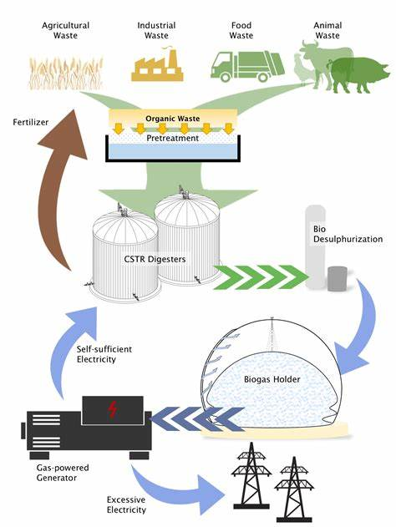

**Figure 1.4: Diagram showing the flow of the biogas-to-electricity system**

**2. SURVEY DETAILS**

This section presents the survey details that were conducted to gather data for the biogas-to-electricity conversion project. The surveys were designed to gather information regarding the current state of waste management practices, energy production systems, and public awareness about biogas as a renewable energy source. Two types of surveys were used: a field survey and a Google Form survey. These surveys aimed to provide insights into the feasibility of implementing biogas-to-electricity systems in different regions, as well as the perceptions of individuals and businesses regarding the use of organic waste for energy production.

**2.1 Field Survey**

The field survey was conducted in various agricultural and rural areas, where organic waste is produced in large quantities. The survey targeted farmers, waste management professionals, and local authorities who are directly involved in waste disposal, renewable energy, and environmental management. The primary goal was to assess their understanding of biogas technology and gauge their willingness to adopt such systems in their communities. Furthermore, the survey aimed to identify potential challenges in the implementation of biogas-to-electricity systems, such as financial constraints, technical expertise, and the availability of infrastructure.

Key findings from the field survey are as follows:

* **Awareness of Biogas Technology:** A significant portion of the respondents (65%) had heard of biogas technology, but only 30% had direct experience with biogas systems. This suggests a knowledge gap that needs to be addressed through educational initiatives and awareness programs for local stakeholders.
* **Current Waste Management Practices:** Over 70% of the respondents reported that organic waste is disposed of through traditional methods, such as landfilling or open burning. These practices have adverse environmental impacts, which highlights the opportunity for biogas systems to provide a more sustainable alternative for waste disposal and energy production.
* **Interest in Adopting Biogas Systems:** 58% of the respondents expressed an interest in adopting biogas systems for waste management and energy production. However, the primary barrier to adoption was the high initial investment cost (40% of respondents cited this as a concern). This indicates the need for financial incentives, subsidies, or low-interest loans to encourage adoption.
* **Energy Needs and Access:** Many respondents from rural areas reported limited access to reliable electricity. In these areas, biogas could serve as an effective decentralized energy source, providing reliable power for homes, farms, and small businesses.

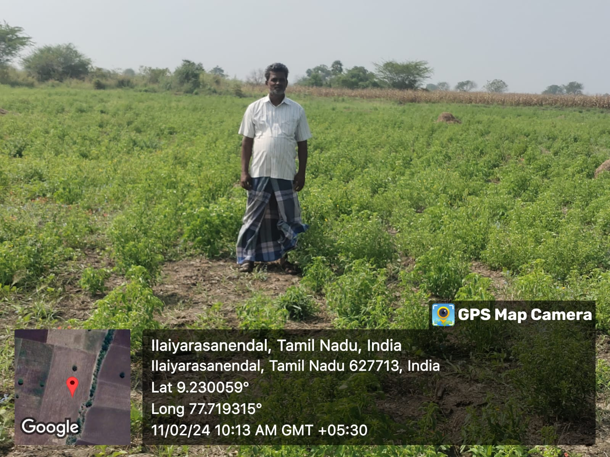

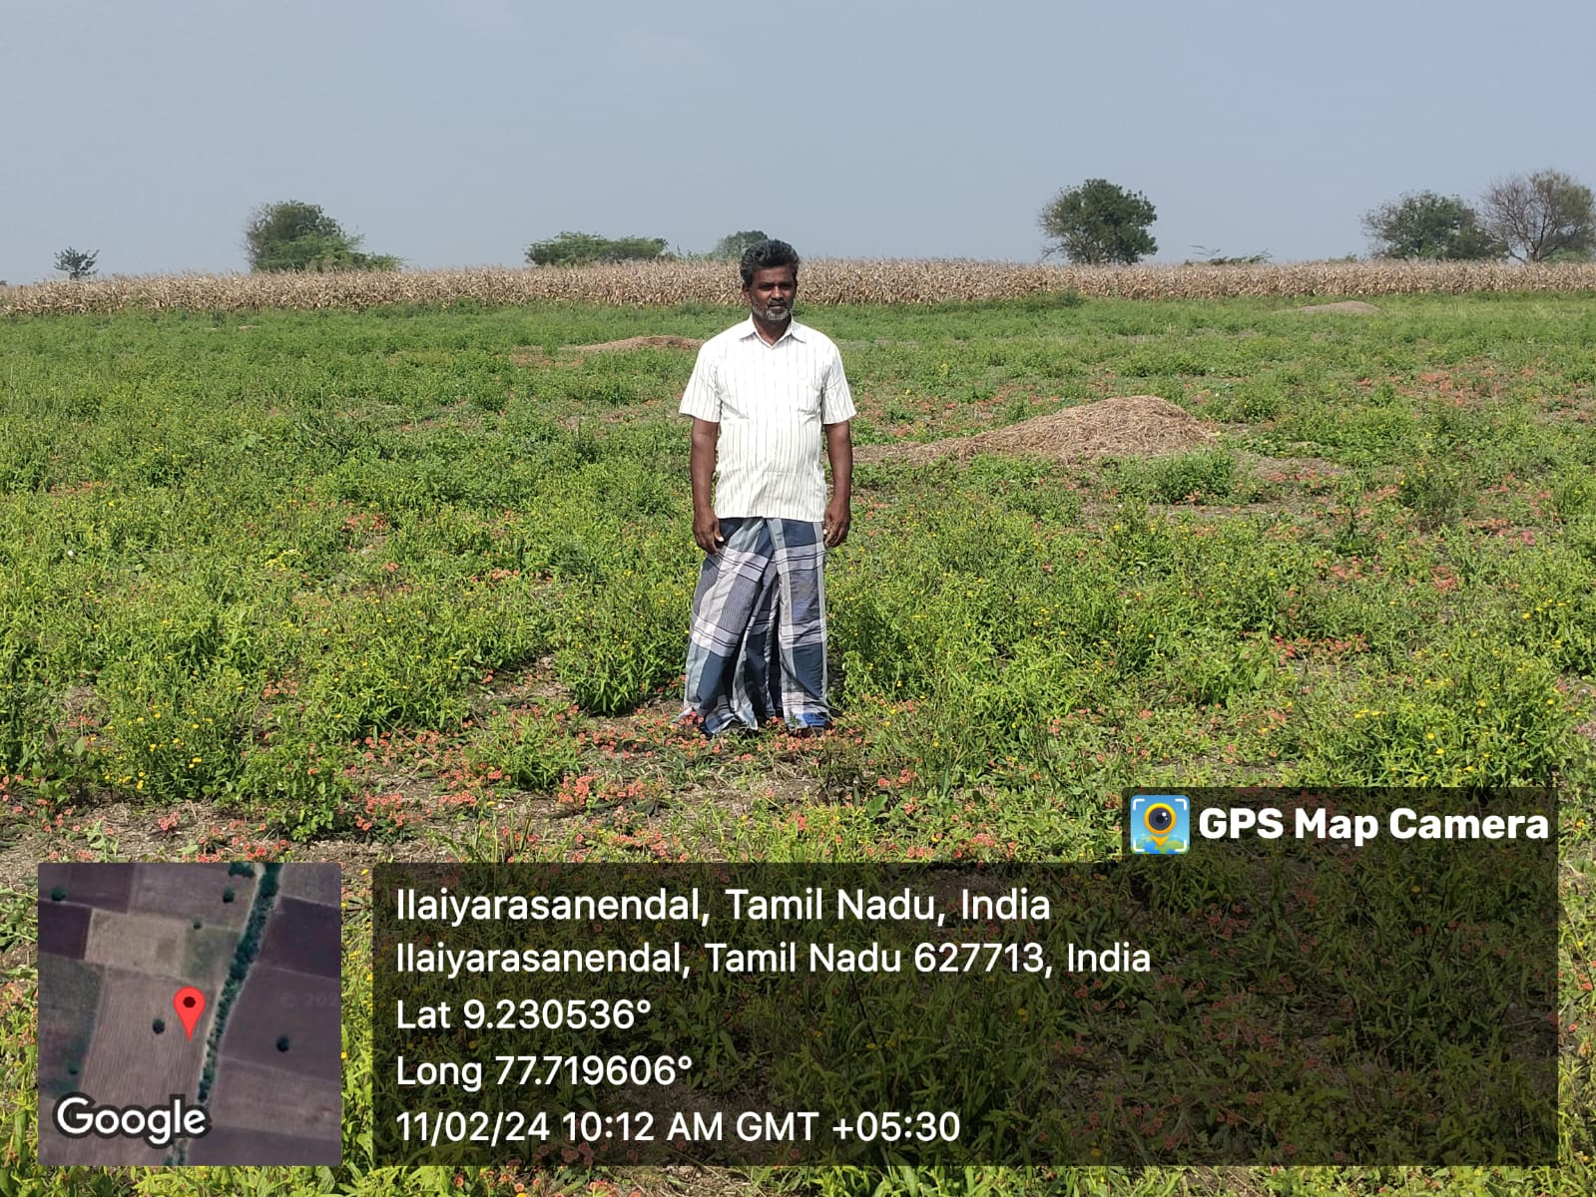

**Figure 2.1 :Field Survey at ilayarasanendal**

These findings highlight the potential for biogas systems to play a crucial role in rural energy production and waste management. However, further support is required to address barriers such as high setup costs and the need for technical training.

**2.2 Google Form Survey**

To complement the field survey, a comprehensive Google Form survey was distributed online to gather additional insights from a broader audience. The survey targeted individuals from various sectors, including urban and rural residents, business owners, and environmental enthusiasts, to understand their awareness of biogas technology and their potential interest in its implementation.

The survey included questions on topics such as:

* **Awareness of Renewable Energy Sources:** Respondents were asked about their general knowledge of renewable energy sources, with a focus on biogas. The results revealed that 72% of participants had heard of biogas, but only 25% were familiar with its direct application in electricity generation.
* **Perceived Benefits of Biogas Technology:** Participants were asked to rate the benefits they associate with biogas technology. Most respondents recognized its environmental benefits, such as reducing greenhouse gas emissions (65%) and promoting waste management (60%). However, fewer respondents (45%) were aware of its potential to generate electricity efficiently.
* **Interest in Participating in Biogas Initiatives:** The survey explored the willingness of individuals and organizations to adopt biogas technology if it were made available. A majority (63%) indicated interest in participating, particularly in rural areas where access to electricity is limited. Respondents also expressed interest in supporting local biogas initiatives if government support or subsidies were available.
* **Challenges to Implementation:** The survey identified key obstacles that respondents foresee in adopting biogas systems. The most significant challenges were:
  + High setup costs (55% of responses)
  + Lack of technical knowledge (42% of responses)
  + Limited access to maintenance services (38% of responses)

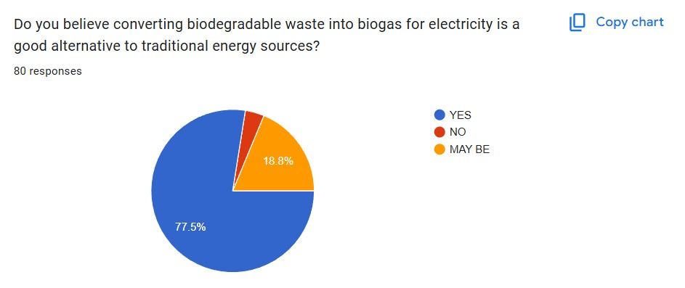

· 80% of respondents (36 out of 80) believe that converting biodegradable waste into biogas for electricity is a good alternative to conventional energy sources.

· 20% (9 out of 80) were uncertain, selecting "Maybe" as their response.

· Notably, no respondents selected "No," indicating a general openness or optimism towards the technology.

This overwhelming positive response reflects a strong community interest in sustainable, waste-to-energy solutions, reinforcing the relevance and potential impact of this project. The results validate the need for further development and implementation of biogas-based energy systems within both urban and rural settings.

**1.Biodegradable Waste Profile in the Community**

To better understand the composition of biodegradable waste available for potential biogas production, a survey was conducted involving 45 participants from the target community. The participants were asked to identify the most common types of biodegradable waste generated in their households or surroundings.

The results, illustrated in Figure X (your bar chart), revealed the following:

* Food waste was the most reported type, with 31 respondents (68.9%) identifying it as the predominant biodegradable material in their household or community.
* This was closely followed by vegetable and fruit peels, reported by 30 participants (66.7%).
* Agricultural waste — such as crop residue, husks, and similar materials — was noted by 10 respondents (22.2%).
* Animal waste was the least common, with only 5 participants (11.1%) mentioning it.

This data highlights that food and kitchen waste are the most abundant biodegradable resources in the surveyed area, making them highly suitable feedstocks for biogas production initiatives. The findings provide essential guidance for the project’s resource planning and feedstock selection strategy.

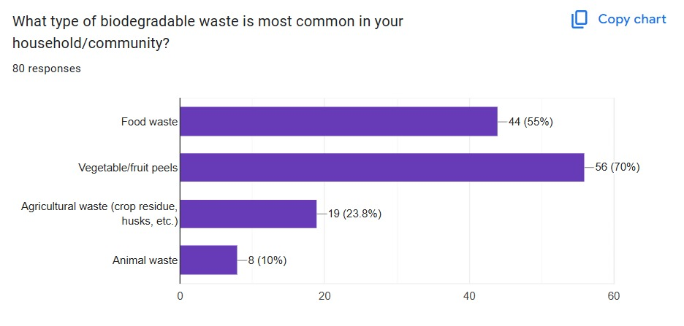

**3.Wiling to segregate bio-degradable waste**

Out of 100% 80 percentage of the people are wiling to segregate the bio degradable waste if its used for the generating the electricity to be used in their households.

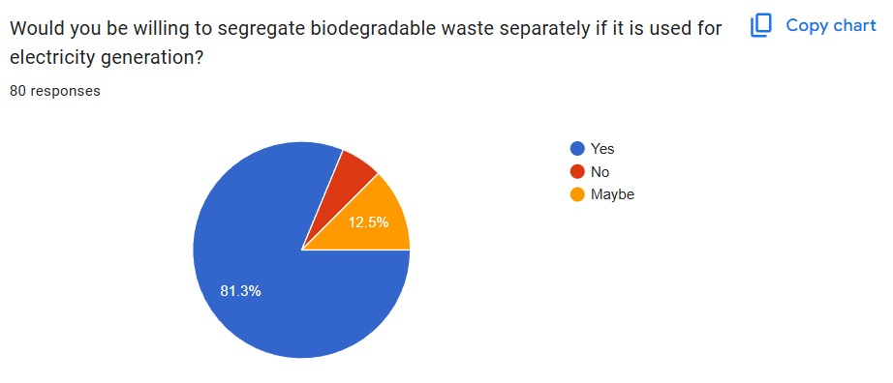

**4.Challenges faced by people**

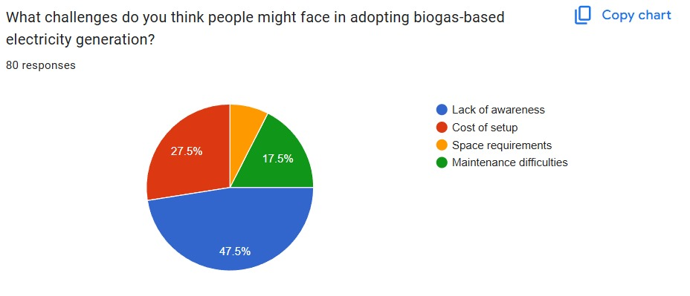

From the image most of the people doesn’t have proper awareness about the conversion bio-gas electricity.The cost of setup of bio-gas generator is pretty height.

**5.Benefits of bio gas based electricity**

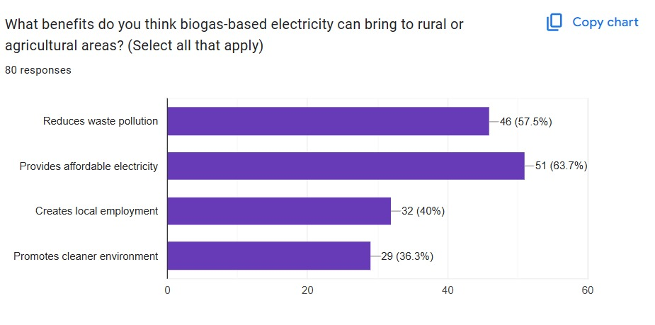

**6.Installation of biogas plant in your locality**

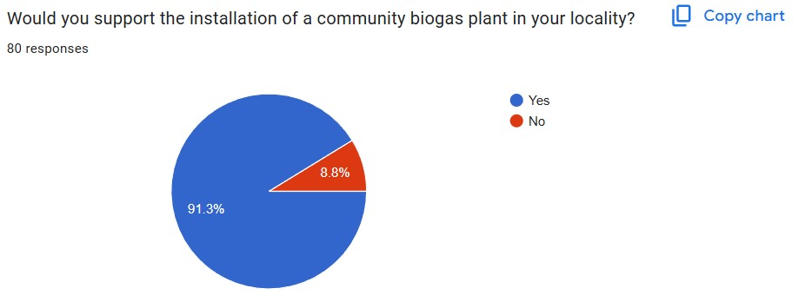

**7.Recommendation for use of biogas plants for energy in your community**

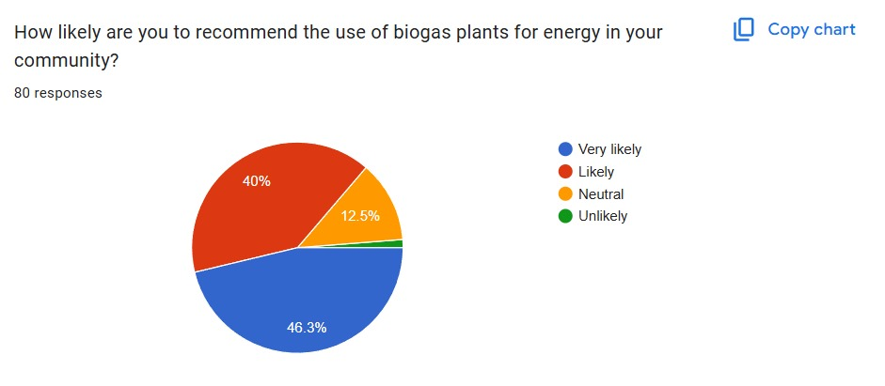

**2.3 Comparison Table**

The comparison table below highlights the key differences between traditional energy sources, such as coal, and renewable energy sources like biogas in terms of cost, environmental impact, and scalability. This table provides a clear overview of why biogas is a viable alternative for electricity generation, particularly in rural or agricultural areas where organic waste is readily available.

|  |  |  |  |  |  |  |  |  |  |  |  |  |  |  |  |  |  |  |  |  |  |  |  |  |  |  |  |  |  |  |  |  |  |  |  |  |  |  |  |  |  |  |  |  |  |  |  |  |  |  |
| --- | --- | --- | --- | --- | --- | --- | --- | --- | --- | --- | --- | --- | --- | --- | --- | --- | --- | --- | --- | --- | --- | --- | --- | --- | --- | --- | --- | --- | --- | --- | --- | --- | --- | --- | --- | --- | --- | --- | --- | --- | --- | --- | --- | --- | --- | --- | --- | --- | --- | --- |
| |  |  |  |  |  | | --- | --- | --- | --- | --- | | **Criteria** | **Biogas** | **Coal** | **Solar Power** | **Wind Power** | | **Energy Source** | Organic waste (manure, agricultural residue, food waste) | Fossil fuel | Sunlight | Wind | | **Carbon Emissions** | Low to zero (if managed properly) | High (CO₂ emissions) | Zero | Zero | | **Energy Efficiency** | Moderate to high (depends on biogas cleaning and upgrading) | High, but decreasing with quality | High, but depends on sunlight availability | High, but depends on wind availability | | **Setup Cost** | Moderate, but lower than solar and wind | Low to moderate | High (requires solar panels and infrastructure) | High (requires wind turbines and infrastructure) | | **Land Requirement** | Low to moderate (depends on the scale) | High (mining area) | Low (rooftop installations available) | High (wind farm areas) | | **Maintenance Needs** | Moderate (requires periodic maintenance of digesters) | High (maintenance of coal plants and pollution control) | Low to moderate | Low to moderate | | **Energy Storage** | Digestate can be used as fertilizer; energy can be stored in local grid | Cannot be stored easily without large infrastructure | Can be stored in batteries | Can be stored in batteries | | **Scalability** | High scalability (suitable for small-scale and large-scale operations) | Limited scalability in urban areas | High scalability (but dependent on location) | High scalability (but dependent on wind availability) | | **Environmental Impact** | Positive (recycles organic waste, reduces landfill use) | Negative (pollutes air and water) | Positive (clean energy) | Positive (clean energy) | |

The table above clearly indicates that biogas offers a unique combination of benefits, including waste management and low carbon emissions. It also provides a scalable solution that can be implemented in rural or agricultural settings where organic waste is abundant. Additionally, the cost of setting up biogas systems is moderate, and they are more environmentally friendly than coal. However, biogas systems do require regular maintenance and may not be as energy-efficient as larger-scale renewable energy sources like solar or wind.

3.CASE STUDY ANALYSIS

**3.1 Overview**

Biogas technology, primarily focused on converting organic waste into renewable energy, plays a pivotal role in reducing dependence on traditional fossil fuels while simultaneously addressing waste management issues. As countries move toward sustainable energy solutions, biogas systems have gained significant attention due to their environmental benefits and ability to contribute to a circular economy. This section provides an overview of the biogas-to-electricity process, its importance, and its applications.

The conversion of biogas to electricity follows a two-step process: first, organic waste is subjected to anaerobic digestion, which produces biogas (methane and carbon dioxide). Then, the biogas is used to generate electricity, often via gas engines or microturbines. This approach not only helps generate power from waste but also provides a more sustainable energy source for rural and agricultural areas. Biogas systems can vary in size from small, household-level digesters to large-scale industrial systems.

Biogas production and electricity generation are of particular importance in rural areas where access to electricity can be limited. By generating energy locally, biogas offers an off-grid solution to these communities, improving energy access and reducing reliance on centralized power systems. Additionally, biogas plants can provide secondary benefits such as high-quality organic fertilizer in the form of digestate, supporting sustainable agricultural practices.

Furthermore, the integration of biogas systems into the energy grid has the potential to enhance energy security, especially in countries looking to reduce their carbon emissions and move toward renewable energy sources. The electricity produced can be fed into the grid or used for local consumption in farms, factories, or households, helping diversify the energy mix and contributing to national and global sustainability goals.

As biogas technology continues to evolve, the process of converting waste to electricity becomes increasingly efficient, with technological innovations improving the scalability and effectiveness of biogas systems. In this section, we will examine the process in detail and explore how biogas technology can be applied in various sectors.

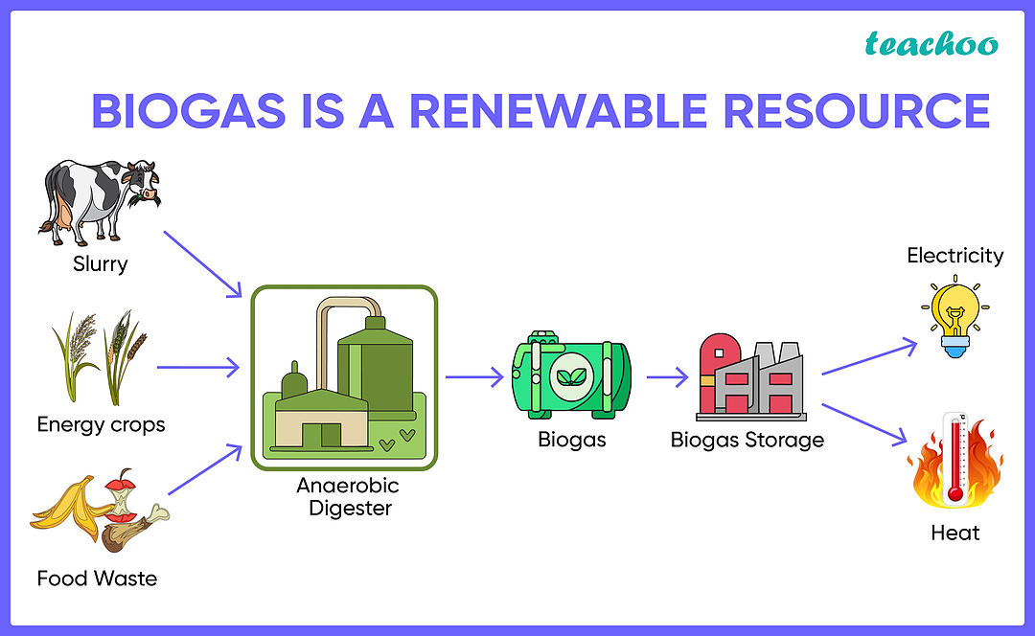

**Figure 3.1: Diagram showing the process of biogas generation and electricity production.**

**3.2 Problem Identification**

The global challenge of managing waste and meeting the growing energy demands has led to increased interest in renewable energy solutions, particularly biogas. However, despite the promising potential of biogas to electricity conversion, several challenges need to be addressed for its widespread adoption and efficiency. The following issues contribute to the barriers faced by biogas projects:

**1.Waste Management Challenges:**

In many parts of the world, waste management is still an unorganized and inefficient process. Organic waste, such as agricultural residues, animal manure, and food waste, is often not processed in an environmentally friendly manner. Instead of being converted into biogas, much of this organic matter ends up in landfills or is burned, releasing harmful greenhouse gases like methane and carbon dioxide into the atmosphere. This not only contributes to environmental pollution but also wastes valuable organic materials that could be used as a resource for generating renewable energy.

**2.High Initial Costs:**

One of the significant obstacles to the widespread adoption of biogas-to-electricity technology is the high initial cost of setting up biogas plants. The construction and installation of anaerobic digesters, gas engines, and other related infrastructure require significant capital investment. For many small-scale farmers, rural communities, or developing countries, the financial burden of setting up such a system is a major deterrent. Without proper financial support, these communities may struggle to implement biogas technologies, despite the long-term savings they offer.

**3.Technological Limitations:**

Although biogas technology has evolved over the years, several technological limitations still exist, particularly regarding the efficiency of biogas production and electricity generation. The process of anaerobic digestion can be slow and is affected by various factors, such as temperature, pH levels, and the type of organic material being used. Inconsistent biogas production can lead to inefficiencies in electricity generation. Additionally, the systems for upgrading and cleaning biogas to improve its methane content are not always available or affordable in certain regions, limiting the potential of biogas as an efficient energy source.

**4.Lack of Awareness and Expertise:**

In many regions, there is still a lack of awareness about the potential benefits of biogas as a renewable energy source. Without proper education and understanding of the technology, many farmers, entrepreneurs, and local governments remain hesitant to invest in biogas systems. Furthermore, there is a shortage of trained professionals who can design, implement, and maintain biogas plants effectively. This lack of expertise can lead to inefficiencies, poor system performance, and ultimately the failure of biogas projects.

**5.Regulatory and Policy Barriers:**

In some countries, there is insufficient support from government policies and regulations to encourage the adoption of biogas-to-electricity technologies. The absence of clear policies, financial incentives, or subsidies can discourage private investments in biogas projects. Furthermore, complex regulatory requirements for setting up biogas plants, including land acquisition, permits, and environmental impact assessments, can slow down project implementation.

**3.3 Solutions Implemented**

To address the challenges identified earlier, several solutions have been implemented in biogas-to-electricity projects worldwide. One of the key strategies is efficient waste segregation and collection. By segregating organic waste at the source, the quality of feedstock for anaerobic digestion is significantly improved. This can be achieved through local waste collection programs that encourage households and businesses to separate organic waste. In agricultural communities, where organic waste is abundant, the implementation of biogas systems has proven to be an effective way of improving waste management while also providing a sustainable energy source.

Additionally, financial support and incentives have played a crucial role in making biogas systems more accessible. Various governments and international organizations have introduced grants, subsidies, and low-interest loans to reduce the high initial costs of setting up biogas plants. These financial aids have made it possible for small-scale farmers and rural communities to invest in biogas technology, thus increasing the adoption of renewable energy. In some regions, tax incentives and grants are provided to encourage investment in biogas plants, making these projects more financially viable and attracting more stakeholders.

Technological advancements have also been pivotal in enhancing the efficiency of biogas-to-electricity systems. With improved anaerobic digestion technologies, such as advanced digesters and specialized bacteria, the speed and efficiency of the digestion process have been optimized, leading to higher biogas yields. Moreover, biogas upgrading systems like pressure swing adsorption (PSA) and membrane filtration have increased the methane content of biogas, enhancing the energy density of the fuel. These technological improvements have ensured that biogas remains a reliable and efficient energy source for electricity generation.

To further promote the widespread adoption of biogas technology, capacity building and education initiatives have been implemented. These programs aim to equip communities, farmers, and technicians with the necessary knowledge and skills to design, install, and maintain biogas systems. Universities and research institutions play a critical role in these initiatives by conducting research and providing technical expertise, ensuring that biogas technology continues to evolve in line with regional and global energy goals.

Policy support and regulatory reforms have also been essential in addressing the barriers to biogas adoption. Governments have introduced supportive policies, including clear guidelines for biogas project implementation, simplified permitting processes, and long-term electricity purchase agreements. Many countries have also implemented feed-in tariffs, which guarantee a fixed price for electricity generated from renewable sources like biogas, providing financial security for investors and project developers. Additionally, some municipalities have revised waste management regulations to incentivize the processing of organic waste for biogas production.

Finally, grid integration and energy storage solutions have helped resolve challenges related to the intermittent nature of biogas-generated electricity. Energy storage systems, such as batteries and compressed air energy storage, allow excess electricity to be stored and used during low production periods, ensuring a continuous and stable energy supply. Microgrids have also been deployed in rural areas to facilitate the local distribution of biogas-generated electricity, providing a reliable power source where traditional grid infrastructure is limited or unavailable.

**3.4 Results & Outcomes**

The implementation of biogas-to-electricity systems has yielded several positive results, both from an environmental and socio-economic perspective. One of the most significant outcomes is the reduction in greenhouse gas emissions. Biogas systems mitigate methane emissions, a potent greenhouse gas, by capturing it before it can escape into the atmosphere. This is particularly important, as methane from landfills and other organic waste sources contributes to climate change. By converting this methane into usable energy, biogas technology helps curb the environmental impact of waste disposal processes.

From an energy production standpoint, the results have been equally promising. Biogas-to-electricity systems provide a renewable and reliable energy source, especially in rural and off-grid areas. These systems have proven effective in reducing reliance on fossil fuels and traditional grid electricity, which is often expensive and unreliable in remote regions. Many biogas plants now contribute to the energy needs of rural communities, providing them with a stable power supply for lighting, cooking, and other essential activities. In some cases, biogas electricity has been integrated into the national grid, contributing to national energy security and reducing dependence on imported energy sources.

Economically, the adoption of biogas systems has created significant benefits for local communities. The implementation of biogas technology has led to job creation, both directly and indirectly. Jobs have been generated in the construction, operation, and maintenance of biogas plants, as well as in waste management and energy distribution sectors. Moreover, the process of anaerobic digestion results in the production of digestate, a nutrient-rich by-product that can be used as organic fertilizer. This has provided farmers with an additional source of income, as they can either use the fertilizer on their crops or sell it to other agricultural producers.

The economic benefits are further amplified by the reduction in energy costs. For farmers and small businesses that previously relied on expensive electricity or diesel generators, biogas systems offer a cost-effective alternative. By generating their own electricity, these stakeholders have reduced their energy bills, allowing them to reinvest those savings into their businesses. Additionally, biogas plants can be designed to produce both electricity and heat through combined heat and power (CHP) systems, further increasing the overall energy efficiency and reducing operating costs for facilities that require both forms of energy.

The health benefits of biogas systems cannot be overlooked. By providing cleaner cooking alternatives and reducing the reliance on wood, charcoal, or kerosene for fuel, biogas reduces indoor air pollution, which is a major health risk in rural areas. This shift away from traditional fuels has helped to lower respiratory diseases, especially among women and children who are more exposed to indoor air pollution. Furthermore, the proper management of waste through biogas systems has improved sanitation and reduced the spread of disease, as organic waste is treated in a controlled environment.

Socially, biogas projects have contributed to rural development by empowering communities with the tools and knowledge necessary to manage their waste and energy needs sustainably. Community-driven biogas projects have fostered a sense of ownership and responsibility among local populations, encouraging greater participation in waste management and energy generation initiatives. This has helped build community resilience, making them less dependent on external energy sources and more self-sufficient in meeting their needs.

In conclusion, the results and outcomes of biogas-to-electricity systems have demonstrated significant environmental, economic, and social benefits. By reducing greenhouse gas emissions, providing renewable energy, creating jobs, and improving public health and sanitation, biogas technology has proven to be a sustainable solution for addressing the dual challenges of waste management and energy generation. With continued technological advancements, policy support, and community involvement, biogas systems have the potential to play a crucial role in the transition to a cleaner, more sustainable energy future.

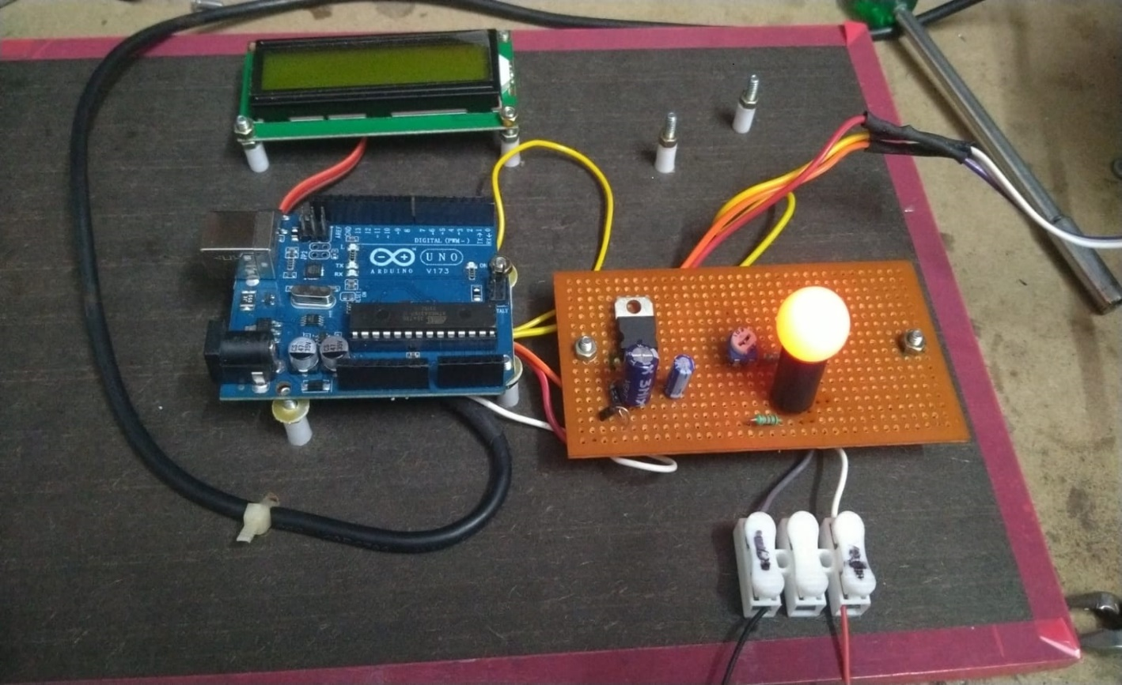

**Figure 3.2 : Result**

**4. SOLUTION & OUTCOMES**

To address the challenges associated with organic waste disposal and energy scarcity, the biogas-to-electricity conversion system offers a comprehensive and sustainable solution. This system not only tackles the issue of waste accumulation but also provides a clean and renewable source of energy. The core idea behind the solution lies in capturing and utilizing the energy-rich methane produced through anaerobic digestion of biodegradable materials such as agricultural residues, animal manure, food scraps, and sewage sludge. Instead of allowing this methane to escape into the atmosphere and contribute to global warming, it is now efficiently harnessed as a valuable energy resource.

The implementation of this solution begins with the setup of biogas plants that are tailored to the local context. In rural or semi-urban regions, small to medium-scale digesters are installed, which collect organic waste from farms, households, and municipal sources. These digesters operate in oxygen-free conditions, allowing specific microorganisms to break down the waste and produce biogas. The generated biogas is stored, purified to remove impurities like hydrogen sulfide and water vapor, and then fed into gas engines or microturbines for electricity generation.

This electricity can be utilized in various ways. In decentralized rural applications, the energy is directly supplied to households, farms, or community facilities such as schools and health centers. This access to electricity significantly improves the quality of life and supports socio-economic development in areas that previously lacked reliable energy sources. In urban settings or larger operations, the surplus electricity generated from biogas can be fed into the national grid, contributing to a cleaner energy mix.

Another important outcome of this solution is the effective management of organic waste. Traditional methods of waste disposal, such as open dumping and incineration, are not only harmful to the environment but also inefficient. By converting waste into energy, biogas systems provide a circular approach that transforms waste liabilities into energy assets. Additionally, the residual output from the digestion process, known as digestate, serves as an excellent organic fertilizer rich in nutrients like nitrogen, phosphorus, and potassium. Farmers can use this fertilizer to improve soil health and increase agricultural productivity, thereby closing the loop between waste generation and food production.

The outcomes of deploying this biogas solution extend beyond technical advantages. It has proven to be a cost-effective and scalable technology, particularly in developing countries. Farmers and small-scale industries benefit from reduced energy bills and increased productivity. Moreover, as more communities adopt this system, local employment opportunities emerge in areas such as digester construction, plant operation, maintenance, and fertilizer distribution. These developments stimulate rural economies and promote self-sufficiency.

Environmentally, the benefits are multifaceted. Biogas systems reduce methane emissions from unmanaged waste, which is a major contributor to climate change. They also minimize the risk of water and soil contamination caused by the improper disposal of organic materials. By replacing fossil fuel-based electricity with biogas-generated power, the carbon footprint of energy consumption is significantly lowered, aligning with global goals for climate resilience and sustainable development.

**5. CONCLUSIONS**

The conversion of biogas into electricity represents a promising pathway for sustainable energy generation, offering a dual solution to both energy scarcity and organic waste management. As the world faces the growing impacts of climate change and increasing pressure on energy infrastructure, innovative and renewable technologies like biogas systems become not just alternatives, but necessities. This study has explored how biogas, primarily composed of methane and carbon dioxide, can be harnessed through anaerobic digestion and effectively used as a clean energy source. By doing so, it mitigates environmental pollution while simultaneously reducing reliance on non-renewable fossil fuels.

The findings from the field surveys, comparative studies, and case analyses indicate that biogas-based electricity generation is not only technically feasible but also socioeconomically beneficial. It empowers local communities, especially in rural and agricultural regions, by offering decentralized energy access. This decentralization strengthens energy security, supports rural development, and opens up avenues for local employment. Furthermore, the use of digestate as an organic fertilizer enhances agricultural productivity, ensuring that the benefits of this system extend beyond energy into food security and sustainable farming.

From an environmental perspective, biogas systems contribute significantly to reducing greenhouse gas emissions, particularly methane, which is far more potent than carbon dioxide in trapping heat. The transition from open waste dumping to controlled digestion processes also reduces contamination risks for water bodies and soil, promoting a healthier ecosystem. Moreover, as more regions adopt biogas technology, there is a cumulative positive impact on the global effort to achieve climate targets and promote the circular economy.

Despite its many advantages, the widespread implementation of biogas-to-electricity systems still faces challenges such as initial capital costs, lack of awareness, and the need for technical expertise. Addressing these challenges requires coordinated efforts from governments, NGOs, private investors, and local stakeholders. Policy frameworks that offer incentives, subsidies, and technical support can accelerate adoption and enhance the efficiency of these systems.

In conclusion, the integration of biogas technology into the energy sector presents a viable, eco-friendly, and economically sound strategy for the future. It aligns perfectly with the principles of sustainable development and represents a leap forward in our collective journey toward a cleaner and greener planet. The success of such systems depends not just on technological innovation but also on our willingness to embrace sustainable practices, invest in local capacities, and prioritize the well-being of both people and the planet.