**PRACTICE SET – 2**

Meena Rhoshini C

Nov 11, 24

1. **0 - 1 Knapsack Problem**

class Knapsack {

public static void main(String[] args) {

int capacity = 4;

int[] val = {1, 2, 3};

int[] wt = {4, 5, 1};

System.out.println(knapsack(capacity, val, wt));

int capacity1 = 3;

int[] val1 = {1, 2, 3};

int[] wt1 = {4, 5, 6};

System.out.println(knapsack(capacity1, val1, wt1));

int capacity2 = 5;

int[] val2 = {10, 40, 30, 50};

int[] wt2 = {5, 4, 6, 3};

System.out.println(knapsack(capacity2, val2, wt2));

int capacity3 = 10;

int[] val3 = {60, 100, 120};

int[] wt3 = {10, 20, 30};

System.out.println(knapsack(capacity3, val3, wt3));

int capacity4 = 50;

int[] val4 = {60, 100, 120};

int[] wt4 = {10, 20, 30};

System.out.println(knapsack(capacity4, val4, wt4));

}

static int knapsack(int capacity, int[] val, int[] wt) {

int n = val.length;

int[][] dp = new int[n + 1][capacity + 1];

for (int i = 1; i <= n; i++) {

for (int w = 1; w <= capacity; w++) {

if (wt[i - 1] <= w)

dp[i][w] = Math.max(val[i - 1] + dp[i - 1][w - wt[i - 1]], dp[i - 1][w]);

else

dp[i][w] = dp[i - 1][w];

}

}

return dp[n][capacity];

}

}

OUTPUT:

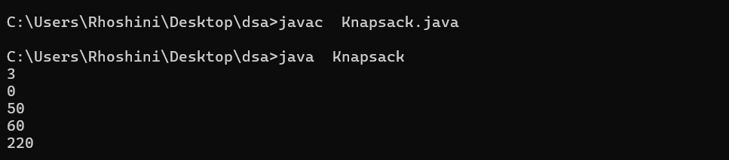

Time complexity: O(n * capacity)

Space complexity: O(n * capacity)

1. **Floor in a Sorted Array**

class FloorInSortedArray {

public static void main(String[] args) {

int[] arr = {1, 2, 8, 10, 11, 12, 19};

int k = 0;

System.out.println(floor(arr, k));

int[] arr1 = {1, 2, 8, 10, 11, 12, 19};

int k1 = 5;

System.out.println(floor(arr1, k1));

int[] arr2 = {1, 2, 8};

int k2 = 1;

System.out.println(floor(arr2, k2));

int[] arr3 = {2, 4, 6, 8, 10};

int k3 = 7;

System.out.println(floor(arr3, k3));

int[] arr4 = {5, 10, 15, 20};

int k4 = 25;

System.out.println(floor(arr4, k4));

}

static int floor(int[] arr, int k) {

int low = 0, high = arr.length - 1, result = -1;

while (low <= high) {

int mid = low + (high - low) / 2;

if (arr[mid] == k) return mid;

if (arr[mid] < k) {

result = mid;

low = mid + 1;

} else {

high = mid - 1;

}

}

return result;

}

}

OUTPUT:

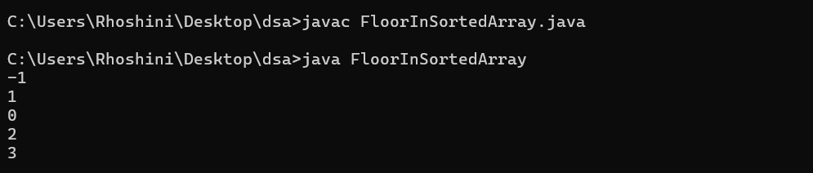

Time Complexity: O(log n)  
Space Complexity: O(1)

1. **Check Equal Arrays**

class CheckEqualArrays {

public static void main(String[] args) {

int[] arr1 = {1, 2, 5, 4, 0};

int[] arr2 = {2, 4, 5, 0, 1};

System.out.println(equal(arr1, arr2));

int[] arr3 = {1, 2, 5};

int[] arr4 = {2, 4, 15};

System.out.println(equal(arr3, arr4));

int[] arr5 = {3, 4, 2, 1};

int[] arr6 = {1, 2, 3, 4};

System.out.println(equal(arr5, arr6));

int[] arr7 = {10, 20, 30};

int[] arr8 = {20, 30, 10};

System.out.println(equal(arr7, arr8));

}

static boolean equal(int[] arr1, int[] arr2) {

if (arr1.length != arr2.length) return false;

int[] count = new int[1000000];

for (int num : arr1) count[num]++;

for (int num : arr2) {

if (count[num] == 0) return false;

count[num]--;

}

return true;

}

}

OUTPUT:

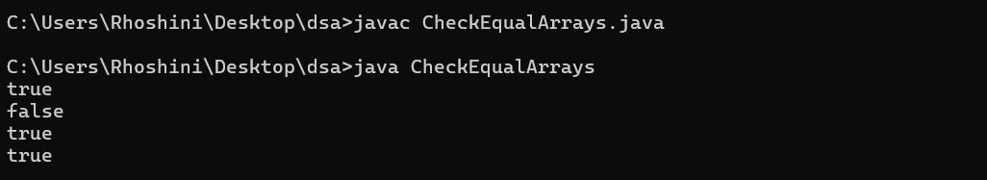

Time Complexity: O(n)  
Space Complexity: O(n)

1. **Palindrome Linked List**

class PalindromeLinkedList {

static class ListNode {

int val;

ListNode next;

ListNode(int val) {

this.val = val;

this.next = null;

}

}

public static void main(String[] args) {

ListNode head1 = new ListNode(1);

head1.next = new ListNode(2);

head1.next.next = new ListNode(1);

head1.next.next.next = new ListNode(1);

head1.next.next.next.next = new ListNode(2);

head1.next.next.next.next.next = new ListNode(1);

System.out.println(isPalindrome(head1));

ListNode head2 = new ListNode(1);

head2.next = new ListNode(2);

head2.next.next = new ListNode(3);

head2.next.next.next = new ListNode(4);

System.out.println(isPalindrome(head2));

}

static boolean isPalindrome(ListNode head) {

if (head == null || head.next == null) return true;

ListNode slow = head, fast = head;

while (fast != null && fast.next != null) {

slow = slow.next;

fast = fast.next.next;

}

slow = reverse(slow);

fast = head;

while (slow != null) {

if (slow.val != fast.val) return false;

slow = slow.next;

fast = fast.next;

}

return true;

}

static ListNode reverse(ListNode head) {

ListNode prev = null, curr = head;

while (curr != null) {

ListNode next = curr.next;

curr.next = prev;

prev = curr;

curr = next;

}

return prev;

}

}

OUTPUT:

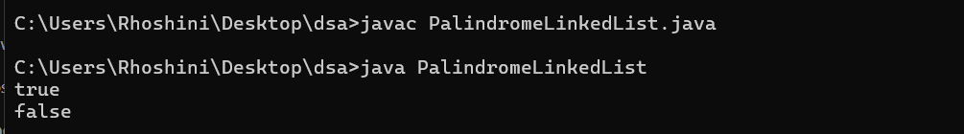

Time Complexity: O(n)  
Space Complexity: O(1)

1. **Balanced Tree Check**

class BalancedTreeCheck {

static class TreeNode {

int val;

TreeNode left, right;

TreeNode(int val) {

this.val = val;

left = right = null;

}

}

public static void main(String[] args) {

TreeNode root1 = new TreeNode(1);

root1.left = new TreeNode(2);

root1.left.right = new TreeNode(3);

System.out.println(isBalanced(root1));

TreeNode root2 = new TreeNode(10);

root2.left = new TreeNode(20);

root2.right = new TreeNode(30);

root2.left.left = new TreeNode(40);

root2.left.right = new TreeNode(60);

System.out.println(isBalanced(root2));

}

static boolean isBalanced(TreeNode root) {

return height(root) != -1;

}

static int height(TreeNode root) {

if (root == null) return 0;

int leftHeight = height(root.left);

if (leftHeight == -1) return -1;

int rightHeight = height(root.right);

if (rightHeight == -1) return -1;

if (Math.abs(leftHeight - rightHeight) > 1) return -1;

return Math.max(leftHeight, rightHeight) + 1;

}

}

OUTPUT:

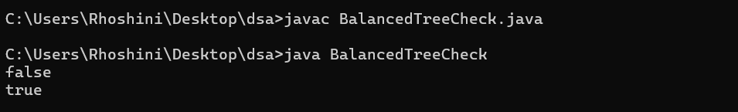

Time Complexity: O(n)  
Space Complexity: O(h)

1. **Triplet Sum in Array**

class TripletSumInArray {

public static void main(String[] args) {

int n1 = 6, x1 = 13;

int[] arr1 = {1, 4, 45, 6, 10, 8};

System.out.println(tripletSum(arr1, n1, x1));

int n2 = 6, x2 = 10;

int[] arr2 = {1, 2, 4, 3, 6, 7};

System.out.println(tripletSum(arr2, n2, x2));

int n3 = 6, x3 = 24;

int[] arr3 = {40, 20, 10, 3, 6, 7};

System.out.println(tripletSum(arr3, n3, x3));

}

static int tripletSum(int[] arr, int n, int x) {

for (int i = 0; i < n - 2; i++) {

int left = i + 1, right = n - 1;

while (left < right) {

int sum = arr[i] + arr[left] + arr[right];

if (sum == x) return 1;

else if (sum < x) left++;

else right--;

}

}

return 0;

}

}

OUTPUT:

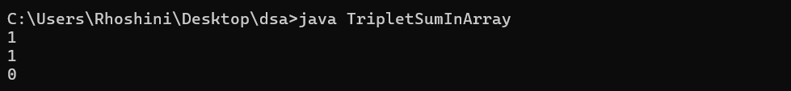

Time Complexity: O(n^2)  
Space Complexity: O(1)