## AWS Burner Account:

Event Login - <https://dashboard.eventengine.run>

* Enter the event Hash [Event Hash: **0e8a-118729b274-ee]**

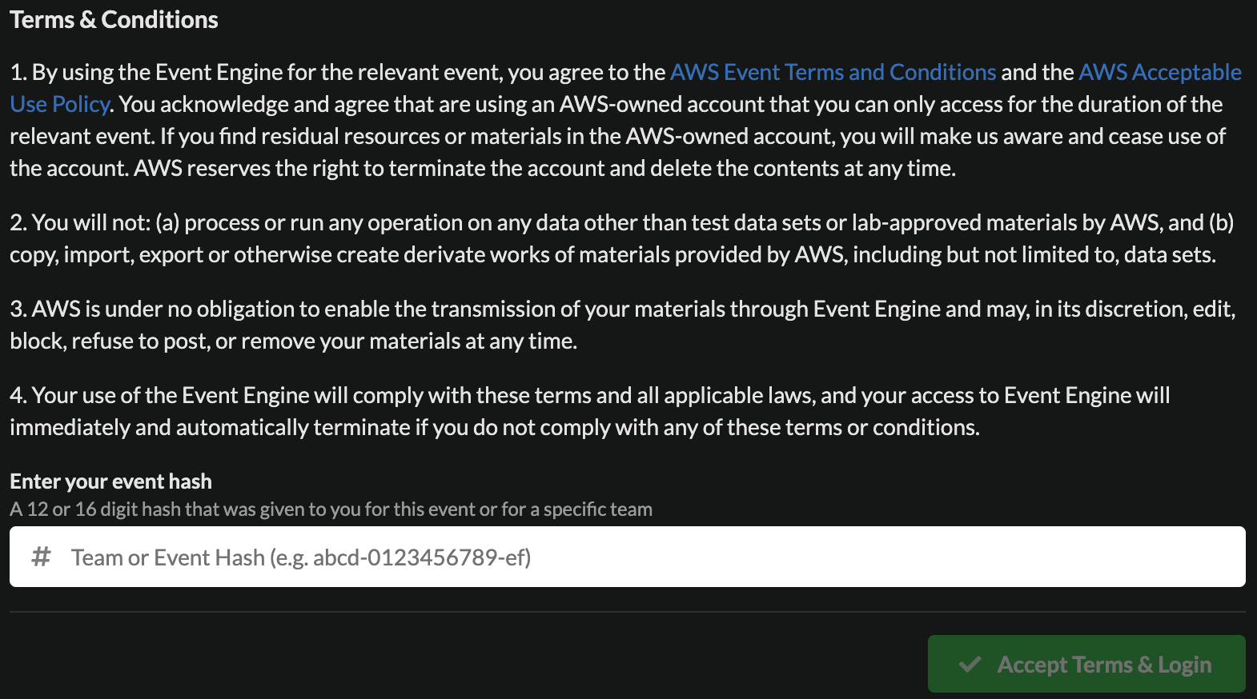

* Click on OTP and provide your

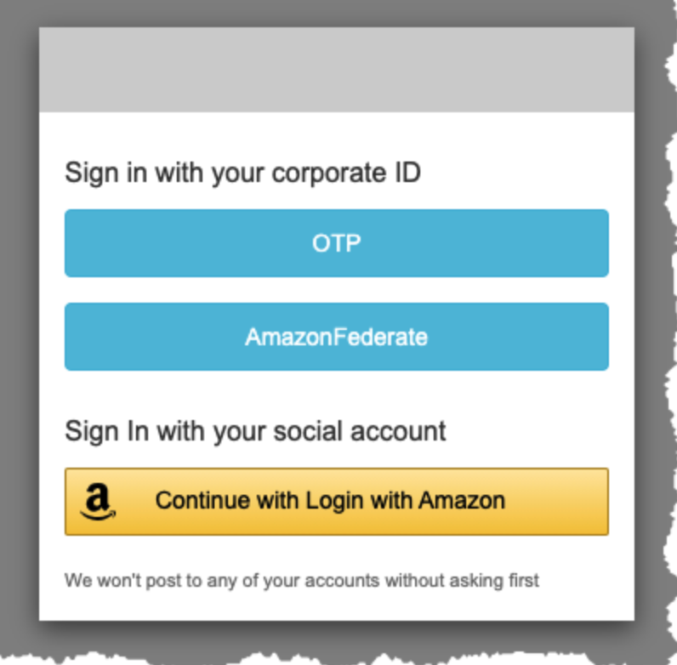

* Click on Open Console

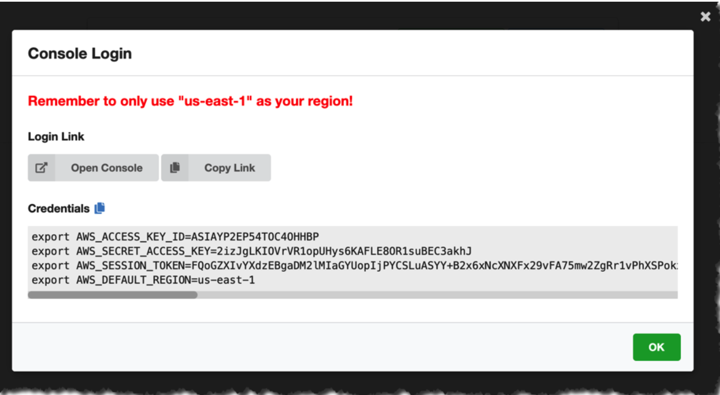

## Workshop Details –

* SageMaker Workshops: <https://catalog.us-east-1.prod.workshops.aws/workshops/63069e26-921c-4ce1-9cc7-dd882ff62575/en-US>

## SageMaker Code Repo:

Model deployment repo:

* git clone https://github.com/ MeenaSunderam/e2e_sagemaker.git
  1. Code in “98-DeploymentPatterns” folder

Model Debugger / Model Monitoring / Clarify

* git clone https://github.com/aws-samples/amazon-sagemaker-immersion-day.git