## AWS Burner Account:

Event Login - <https://dashboard.eventengine.run>

* Enter the event Hash [Event Hash: **ad53-1f50fb0294-34]**

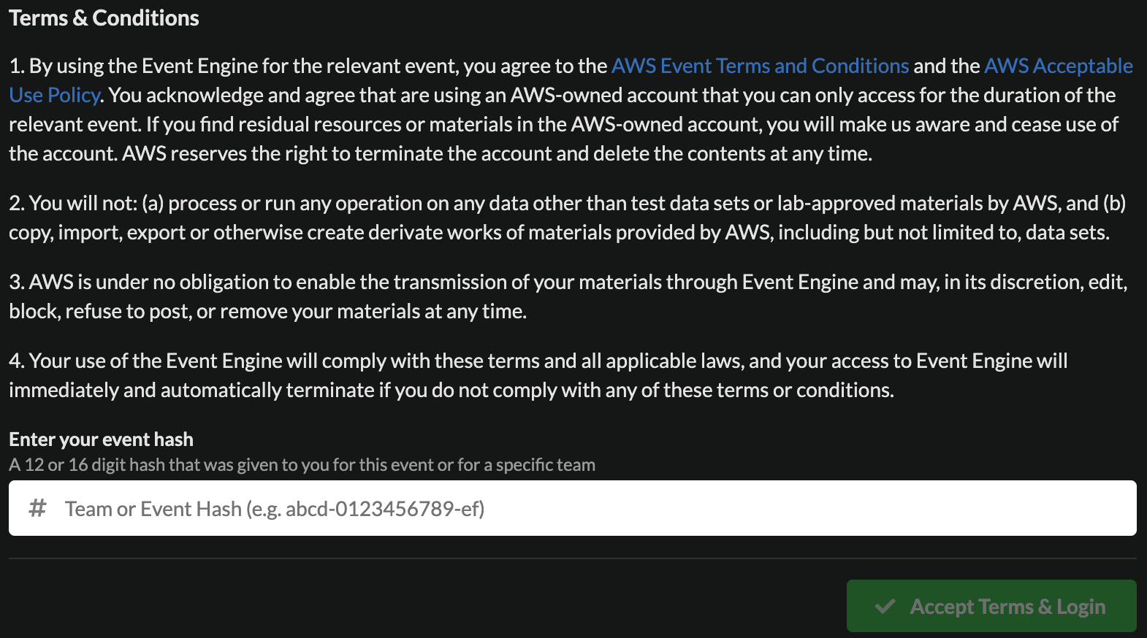

* Click on OTP and provide your

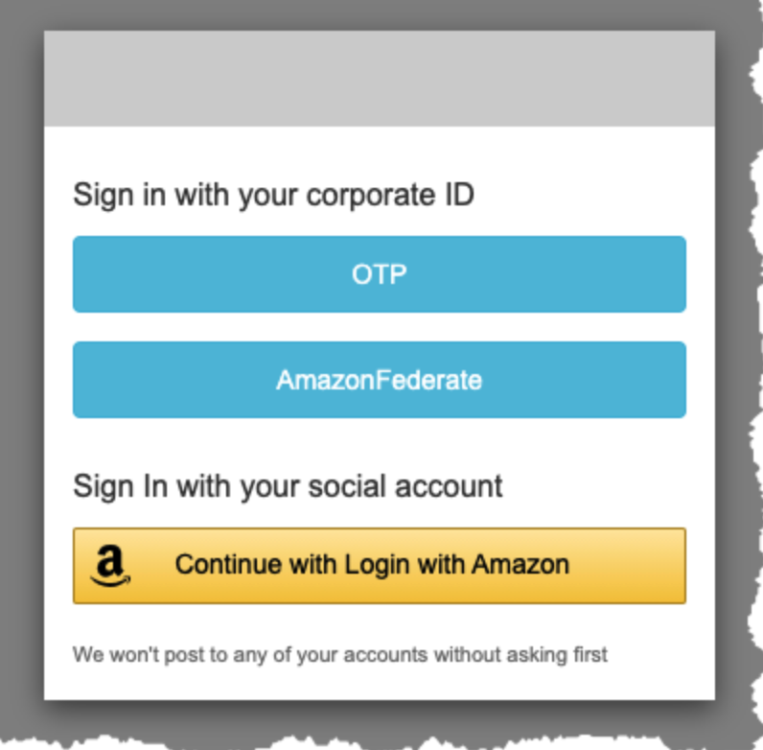

* Click on Open Console

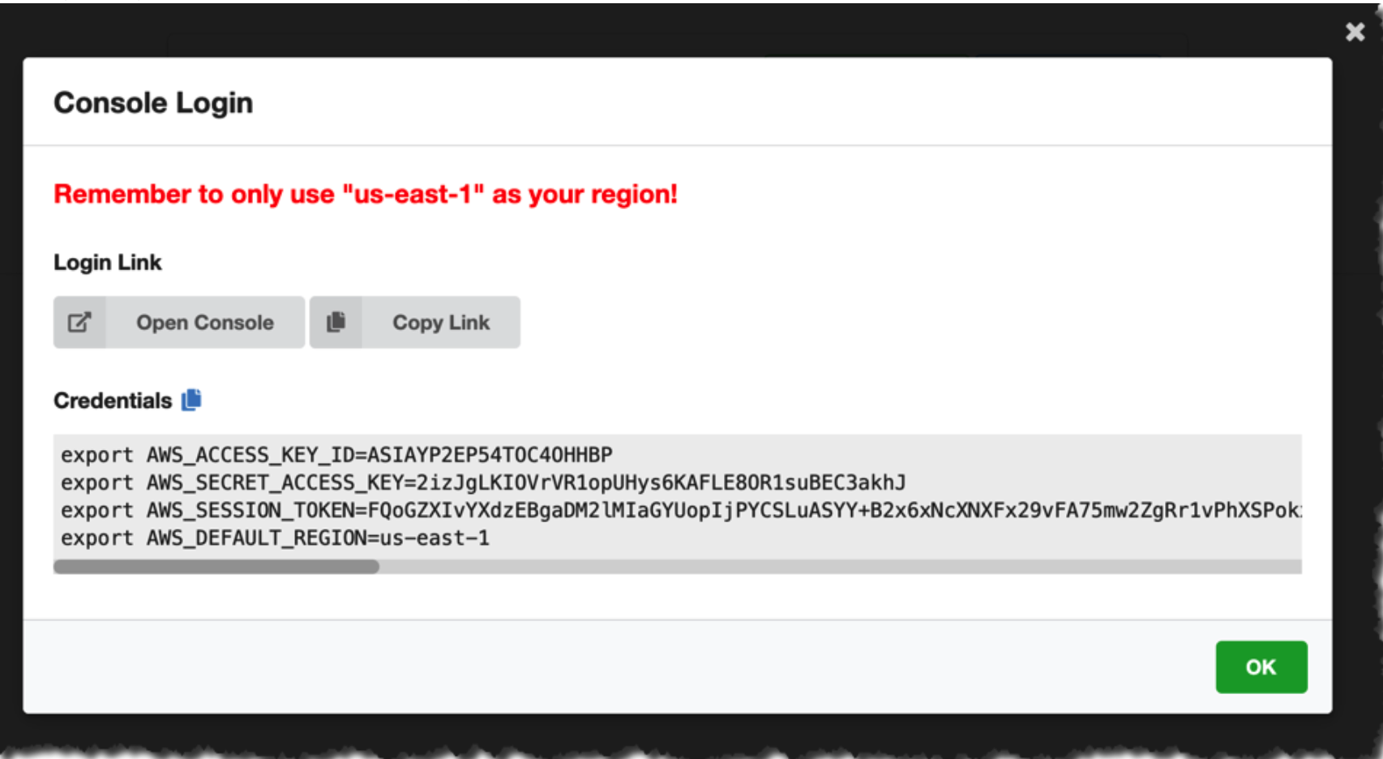

## Workshop Details –

<https://catalog.us-east-1.prod.workshops.aws/workshops/63069e26-921c-4ce1-9cc7-dd882ff62575/en-US>

## Code Repo:

git clone https://github.com/aws-samples/amazon-sagemaker-immersion-day.git