The project is build using HTML, CSS,jquery and using few functionalities of Javascript.

The project has a registration form where user enter the Username and Password. Once the values are entered, client-side validation is performed.

Username should have the format of “E00”check. If an user enters only E00< >, the input is considered valid. Password should have minimum 5 characters. Javascript function is again implemented to ensure if Username and Password are not similar. For user to know the correctness and ensuring against the validations, check buttons are kept beside certain vital user inputs.

If user is prompted with a client validation error, he is highlighted with the error input and also labels will be displayed whenever he enters wrong input.

The database had two student objects which contains details of 2 students which is displayed in HTML format. The students’ courses could be selected and their corresponding experience level are also determined through a dropdown. Javascript function is required to validate/cross-check the user input in expertise check.

The user is also asked to hover on and out of an image just for enhanced/creative application environment.

User is provided with the summary of the page which is formulated by summary and navigation tags.

When the user clicks on Submit button, after filling the form, user is re-directed to the Welcome page where he is able to view the venue locations in a map for his reference.

Obtained Google API Key and used in javascript to access the Google Maps

The locations in Map are JFK, ESB, NY and VA. The locations are provided as the Lat and Long values to a variable. Further the mapOptions and markers are also introduced in map.

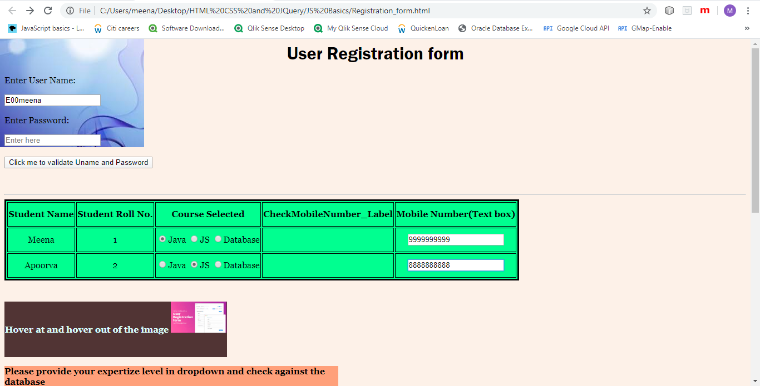

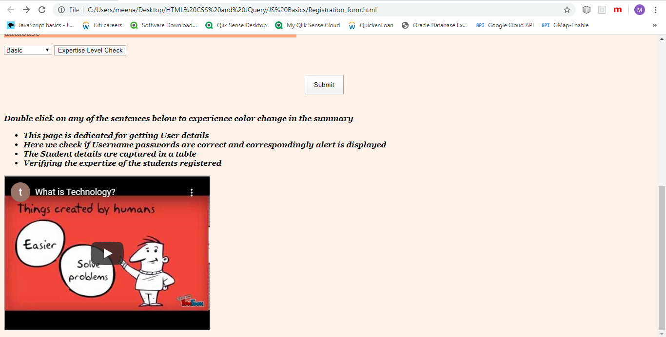

Once User, clicks on Submit, he is navigated to WelcomePage.html

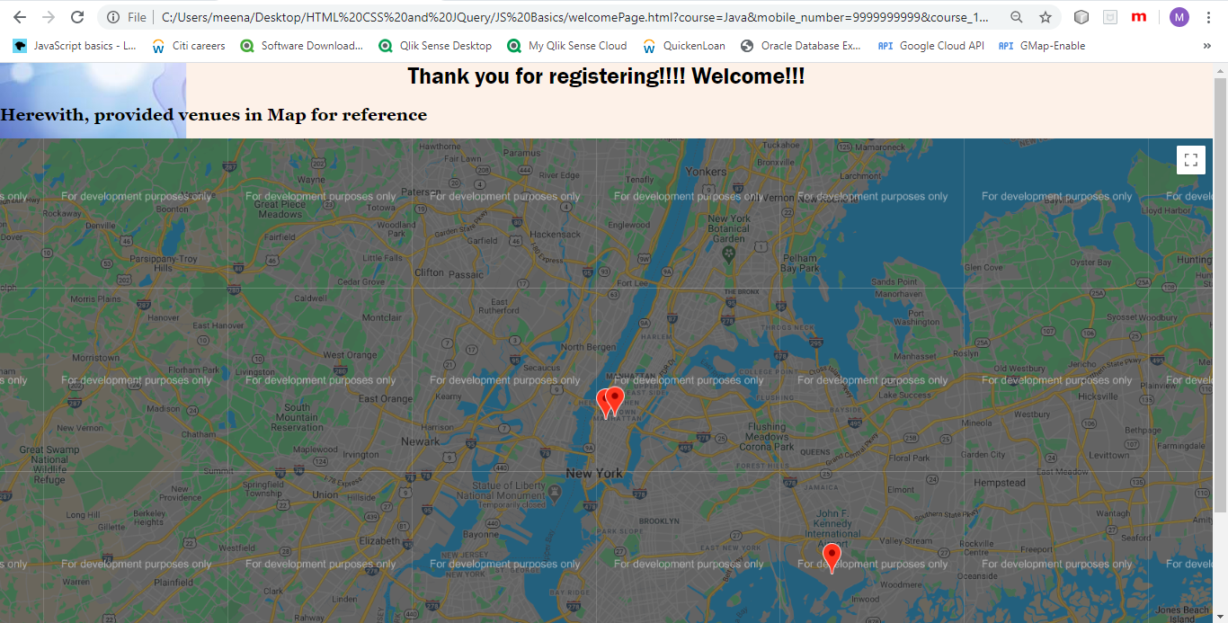

The complete view:

