Ques 1: Create a container for the below bash script(**pomodoro.sh**).

1. Create a Dockerfile

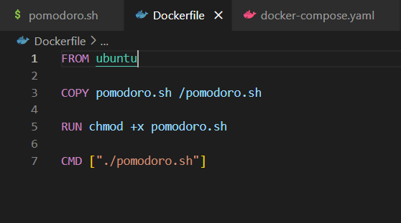

1. Create a Docker Image

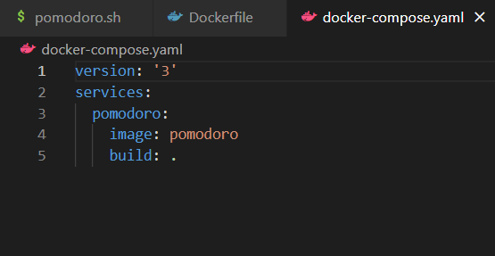

1. Push the image to the docker hub

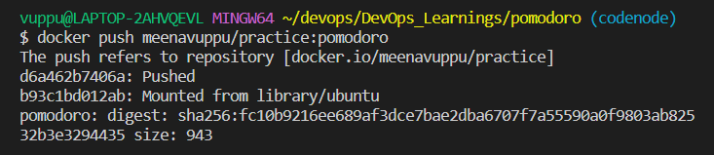

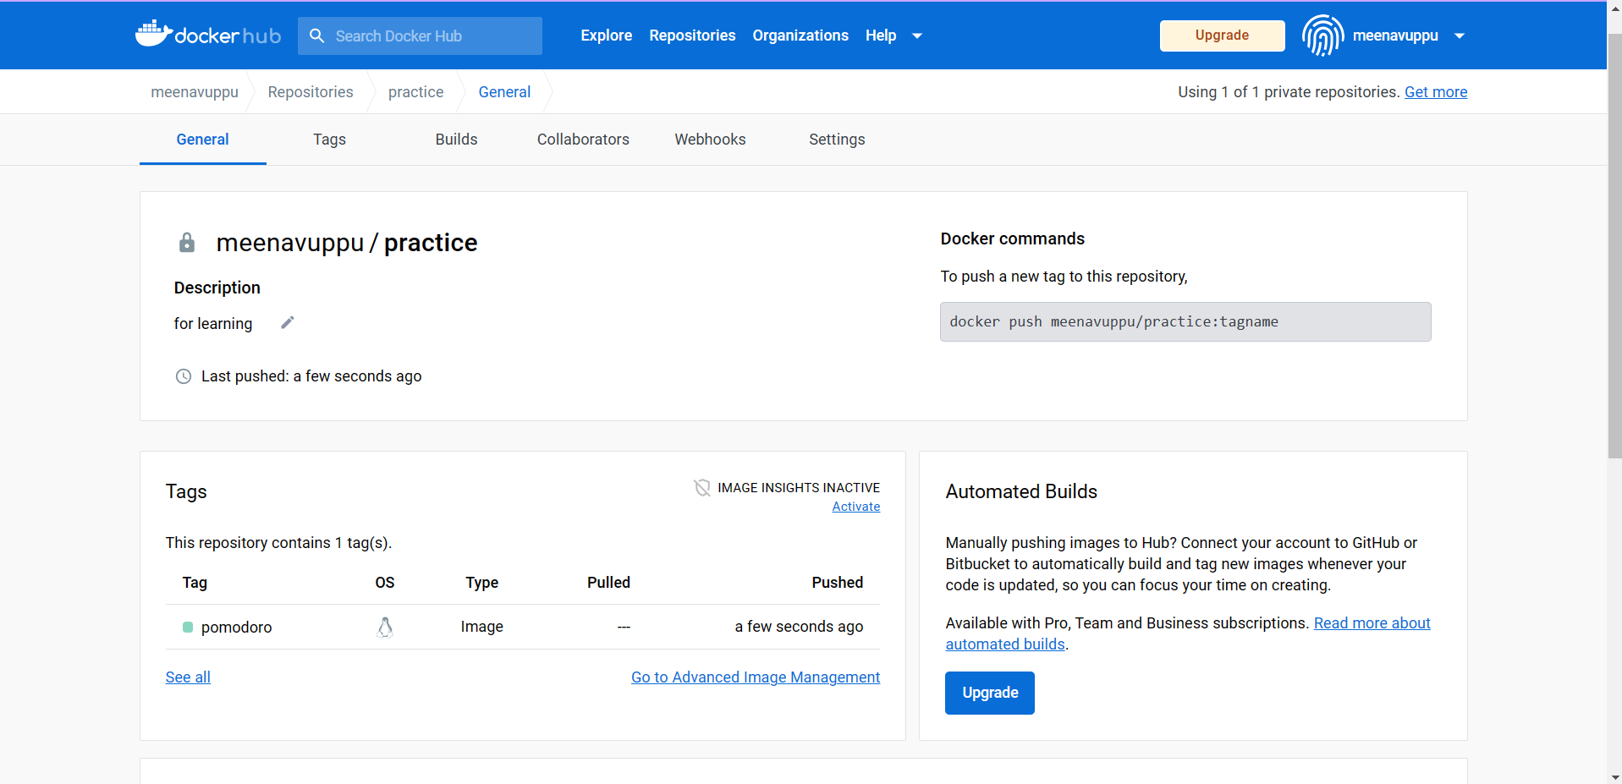

1. Pull it and test it.

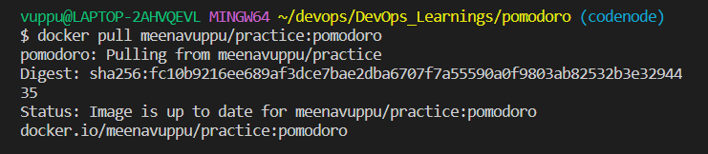



Find the script from here <https://github.com/DARK-art108/Bash-Scripts>