Ques: **Complete the below task:**

1. Explain the below AWS Architecture
2. Implement the same in the AWS(only do a proper connection between service)

**NOTE:** *Submission can be done by sharing the proper screenshots of implementation and doc for explanation!*

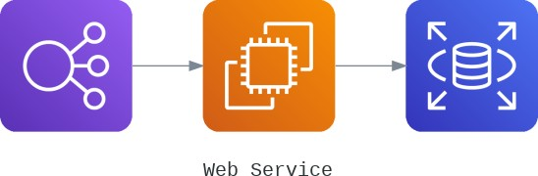

The above architecture consists of a load balancer, EC2 instances and an Amazon RDS. And we made a connection into the RDS using the EC2 which has a load balancer.

- created a load balancer with no target groups yet

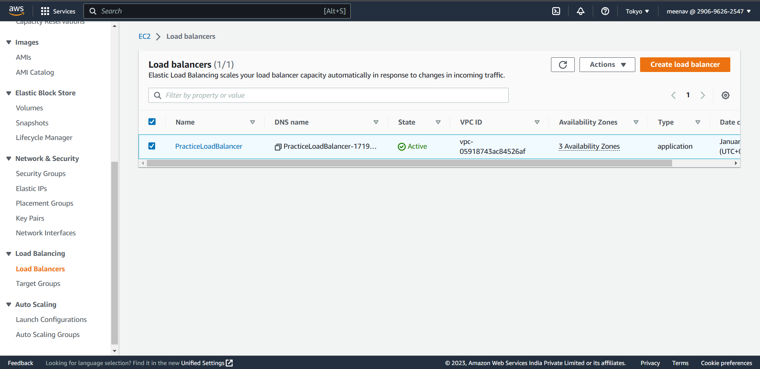

- then created two EC2 instances that has a web server

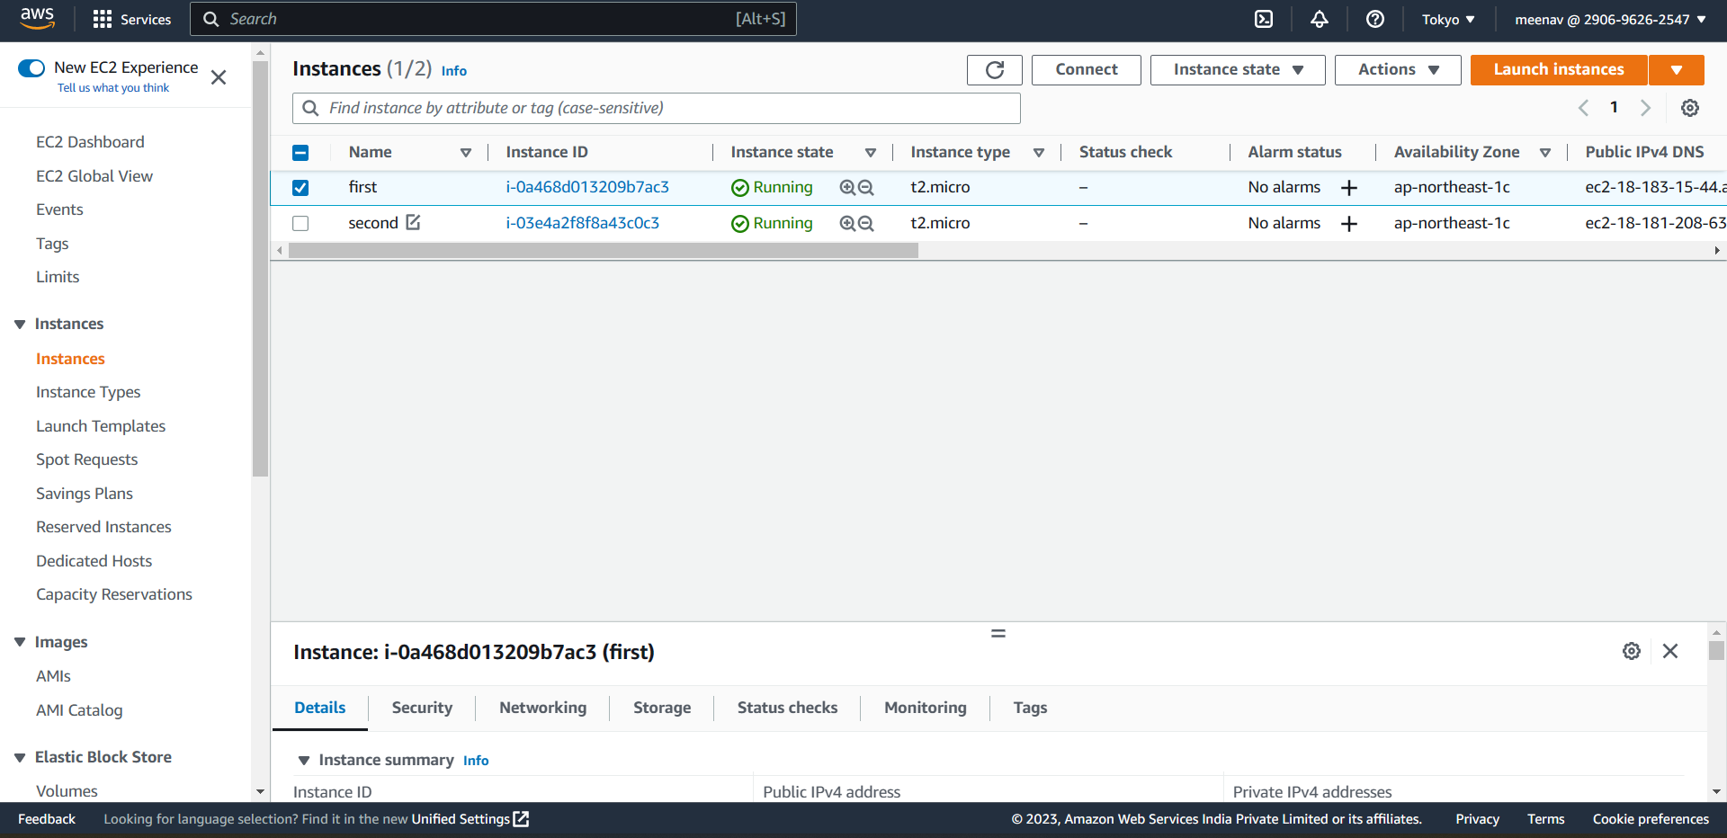

-Attached the created instances to the target group for load balancer to have them as targeted instances.

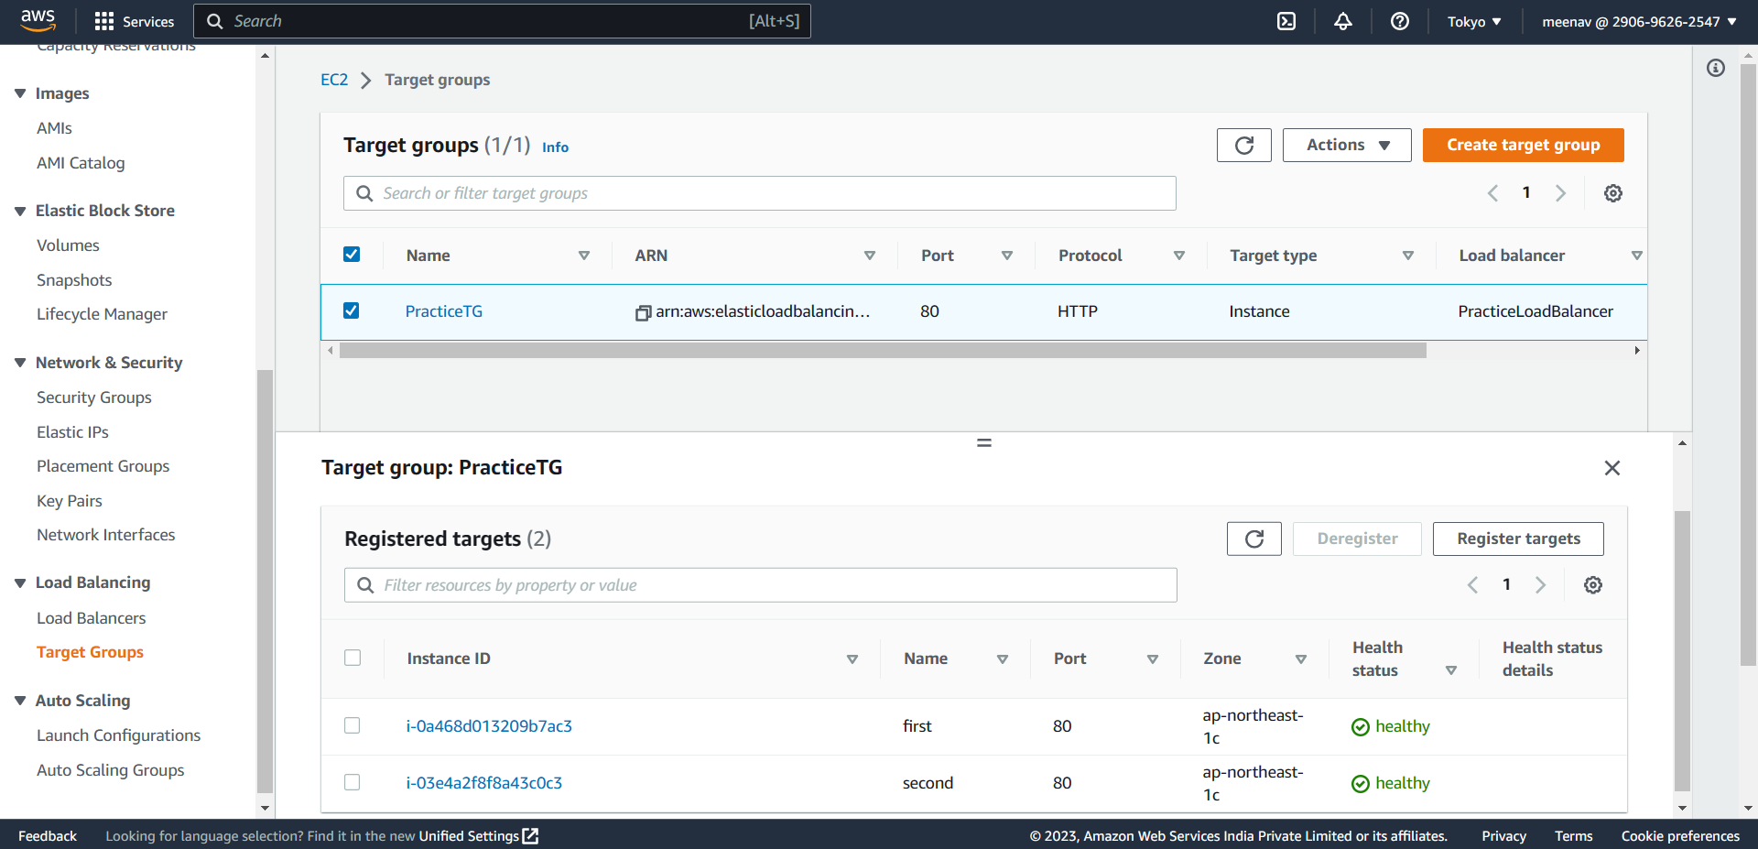

- now, for the amazon RDS from the architecture, I’ve created a subnet group first to mention in which subnet it can deploy the RDS instance

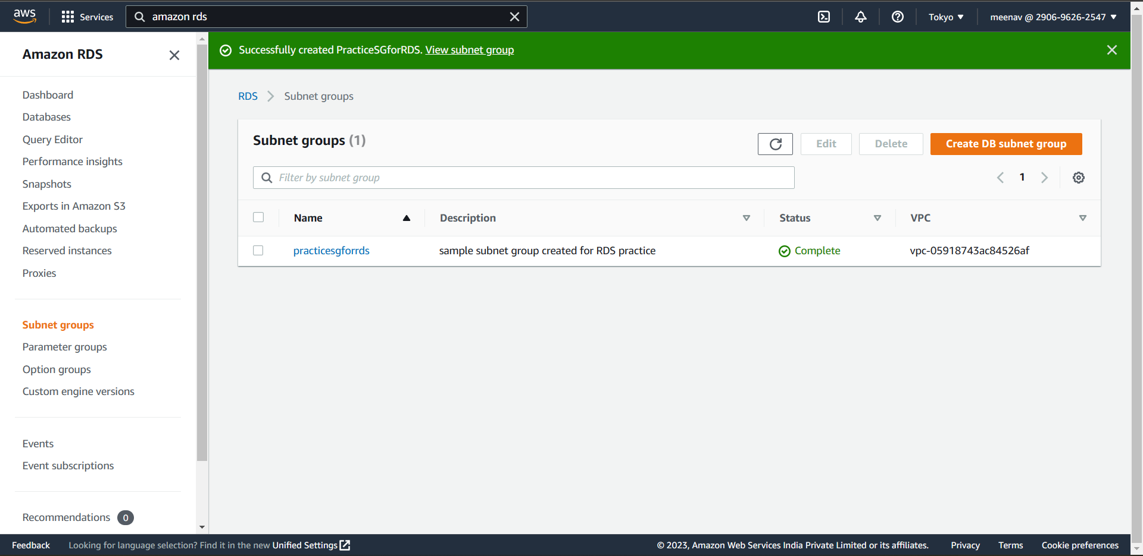

-created a sample DB instance

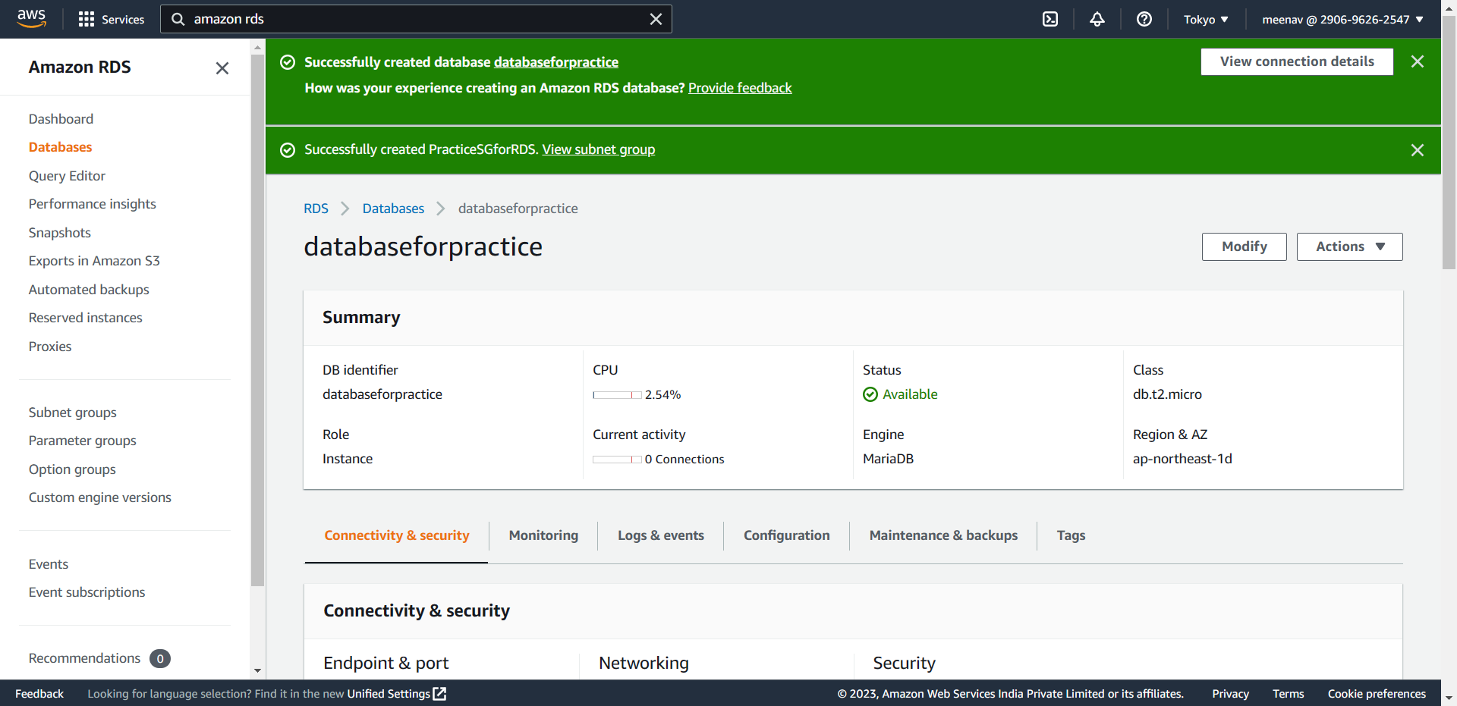

- now, I’ve logged into the maria DB from my first EC2 instance

