Ques 1: Create a container for the below bash script(**prime.sh**).

1. Create a Dockerfile
2. Create a Docker Image

Find the script from here <https://github.com/DARK-art108/Bash-Scripts>

Method-1:

- downloaded the shell script for finding prime no’s from the given repo

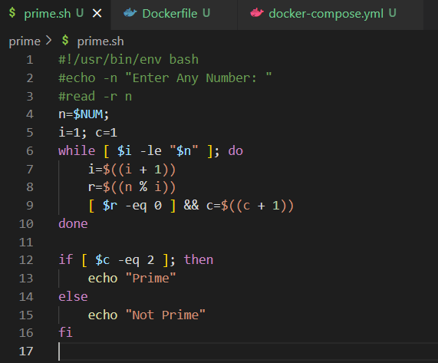

- created the docker file with Ubuntu distro for running the shell script which I copied here. Now, ran the shell script with respective command

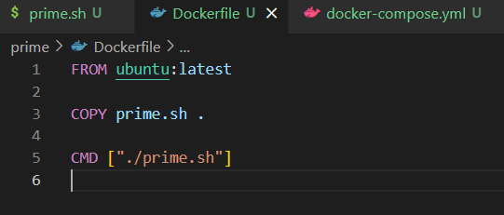

- build container named number using the below command

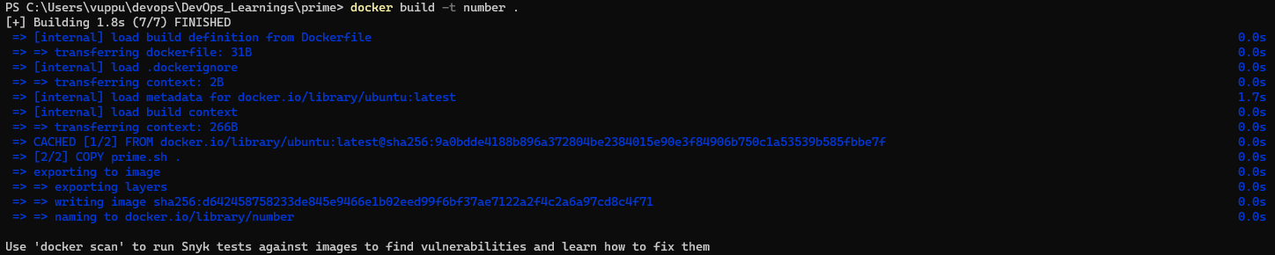

- executed the script by passing env variables directly through the command itself

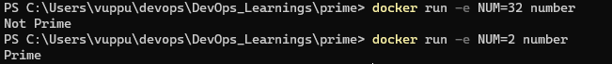

Method-2:

- downloaded the shell script for finding prime no’s from the given repo



- created the docker file with Ubuntu distro for running the shell script which I copied here. Now, ran the shell script with respective command



- created docker compose file so that the script can be an image and run it. I have also passed an environment variable which acts as an input for the prime.sh script

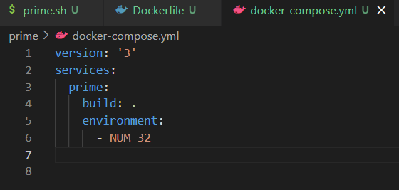

But for the above process, we need to delete images and container every time we change NUM

Output: