**Ques 1:**

Create your own new custom VPC

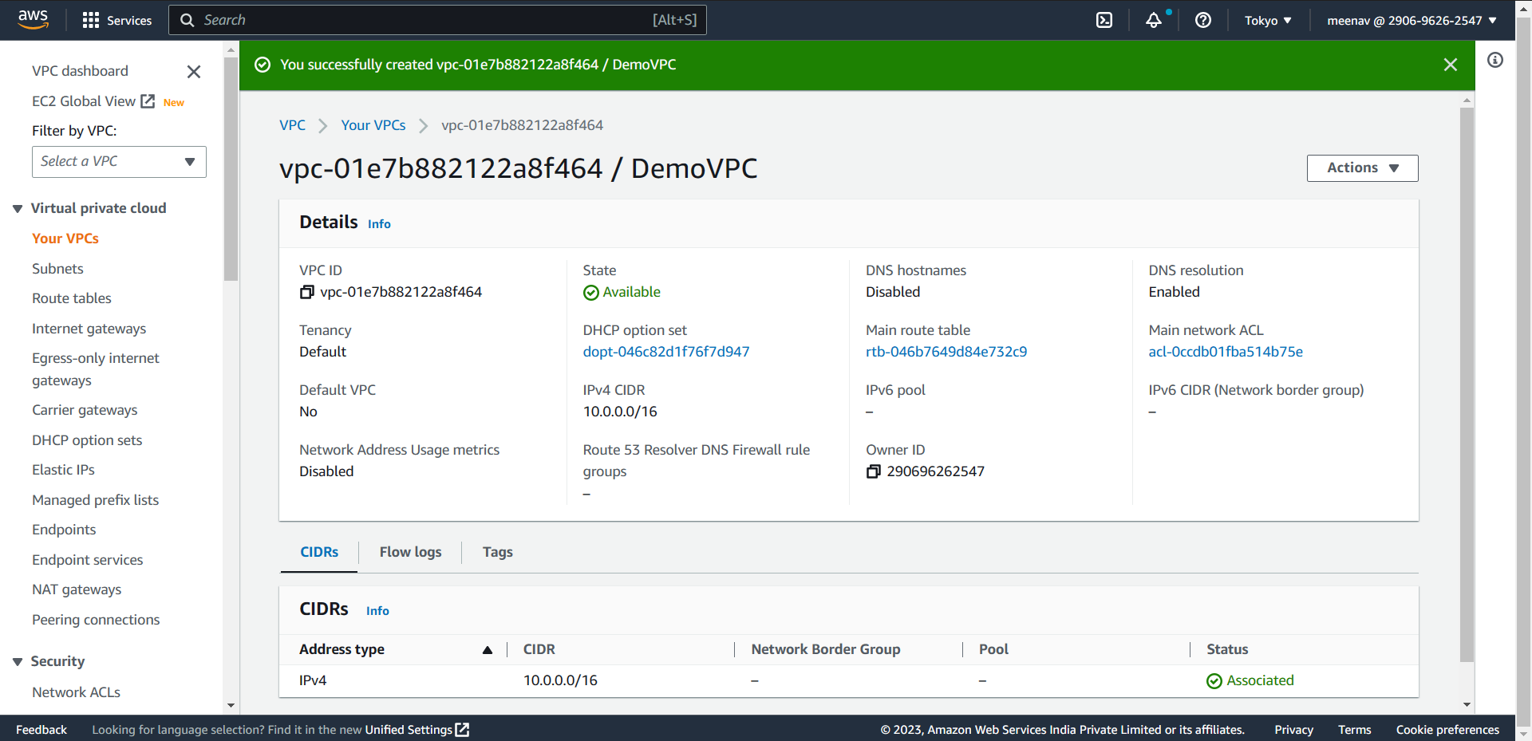

* And configure your EC2 linux instance inside your custom VPC

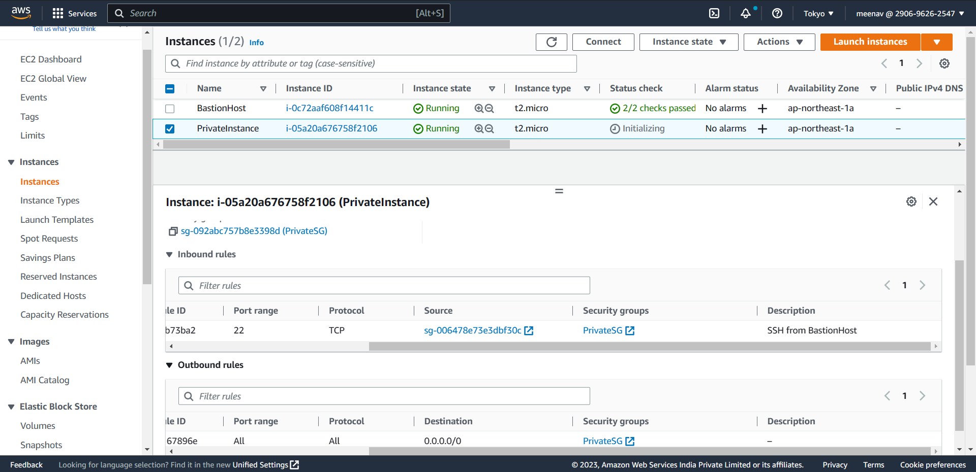

- And then create 4 subnets of that VPC

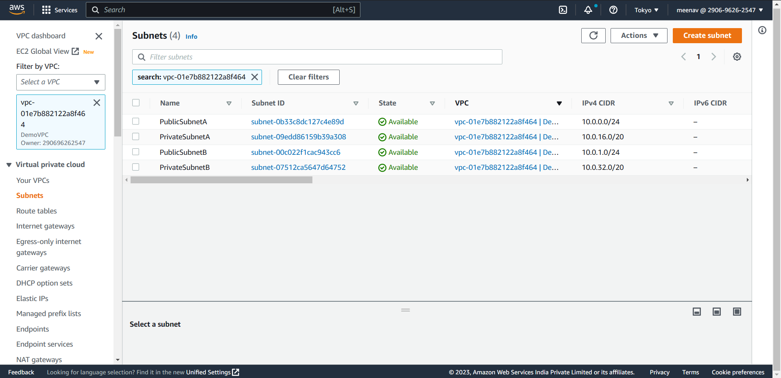

* Attach an internet gateway to your custom VPC

