Ques : Explain the below aws architecture diagram in detail, also deploy the same aws architecture.

* For this assignment you need to take a look and study the documentation for [SAM CLI](https://docs.aws.amazon.com/serverless-application-model/latest/developerguide/install-sam-cli.html), you need to deploy a ***Hello, World application*** on aws lambda.
* Make sure when you test the lambda url it will respond as **Hello, World.**

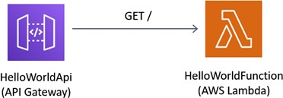

The above architecture defines how we can deploy a server-less application. In AWS, we have Lambda function which runs the code by managing all the underlying resources.

Here, we are going to call the Hello World function in the AWS using the SAM-CLI (Server-less Application Model CLI). From this, we can built and deploy the AWS function and check for the code it runs which in this case is getting a success message response from the endpoint URL generated by Lambda.

First, we need to install the SAM_CLI installer and then initiate it through the console

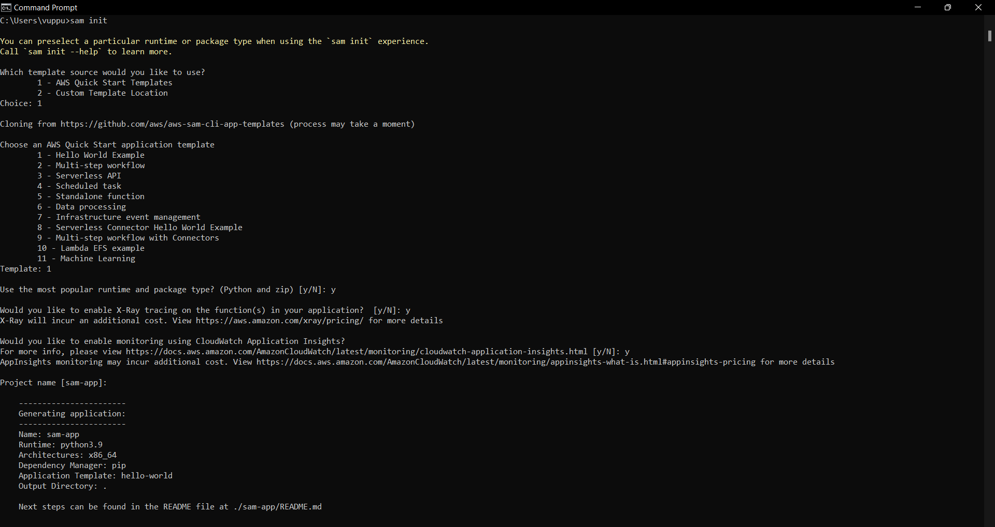

Now enter the sam-app folder and run the build command to define the requirements

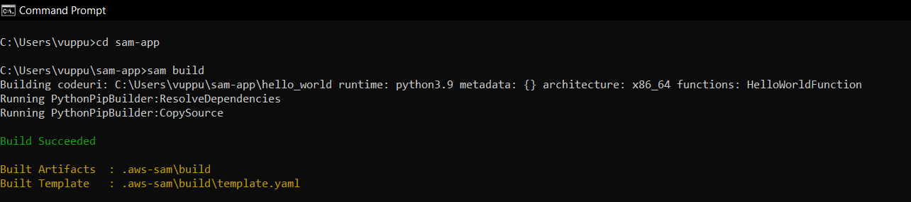

After the set up is done we need to deploy the resources into the aws

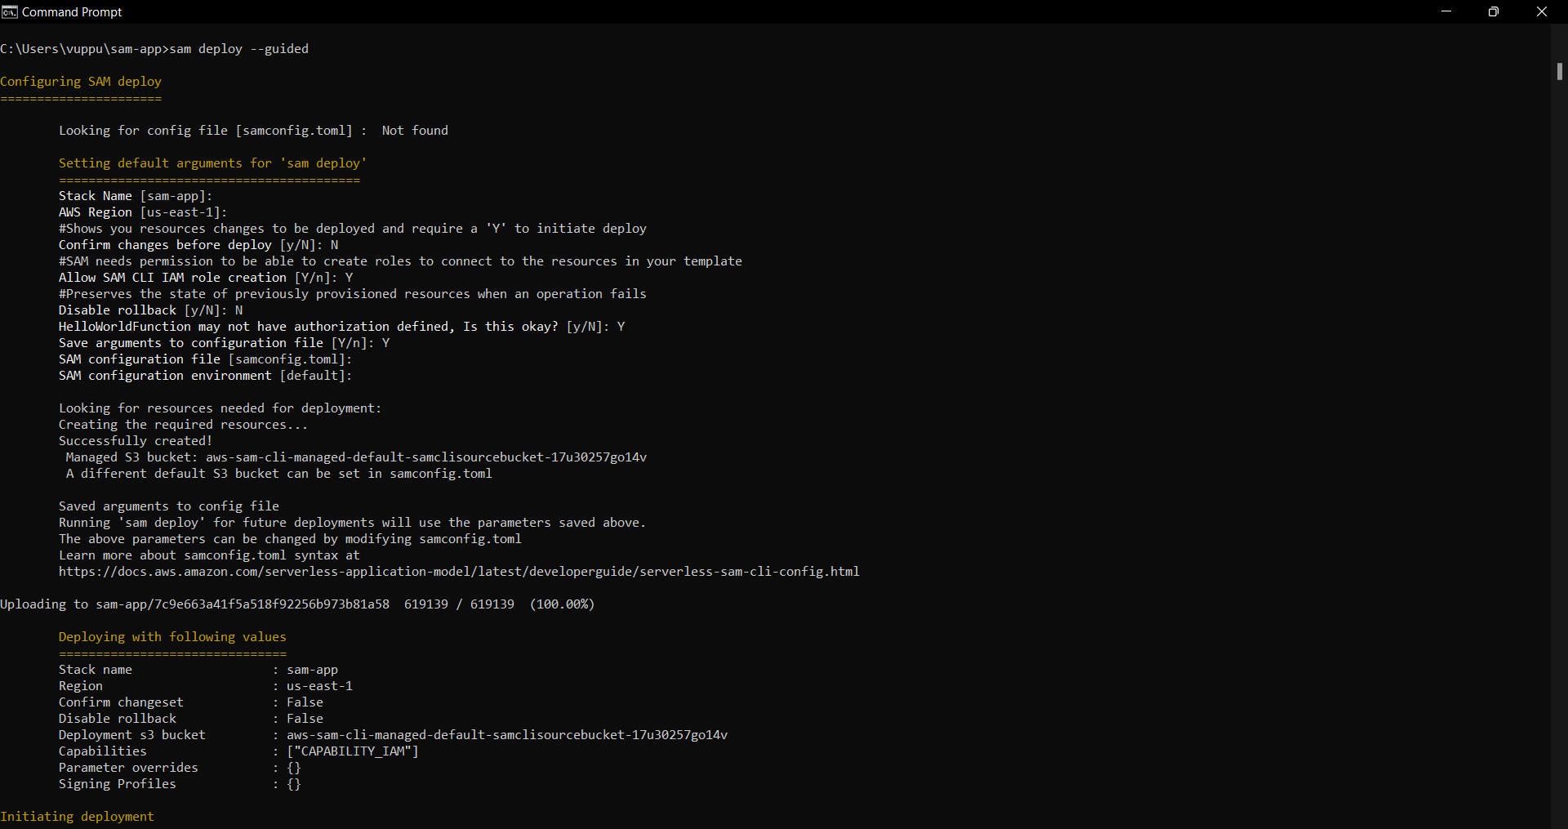

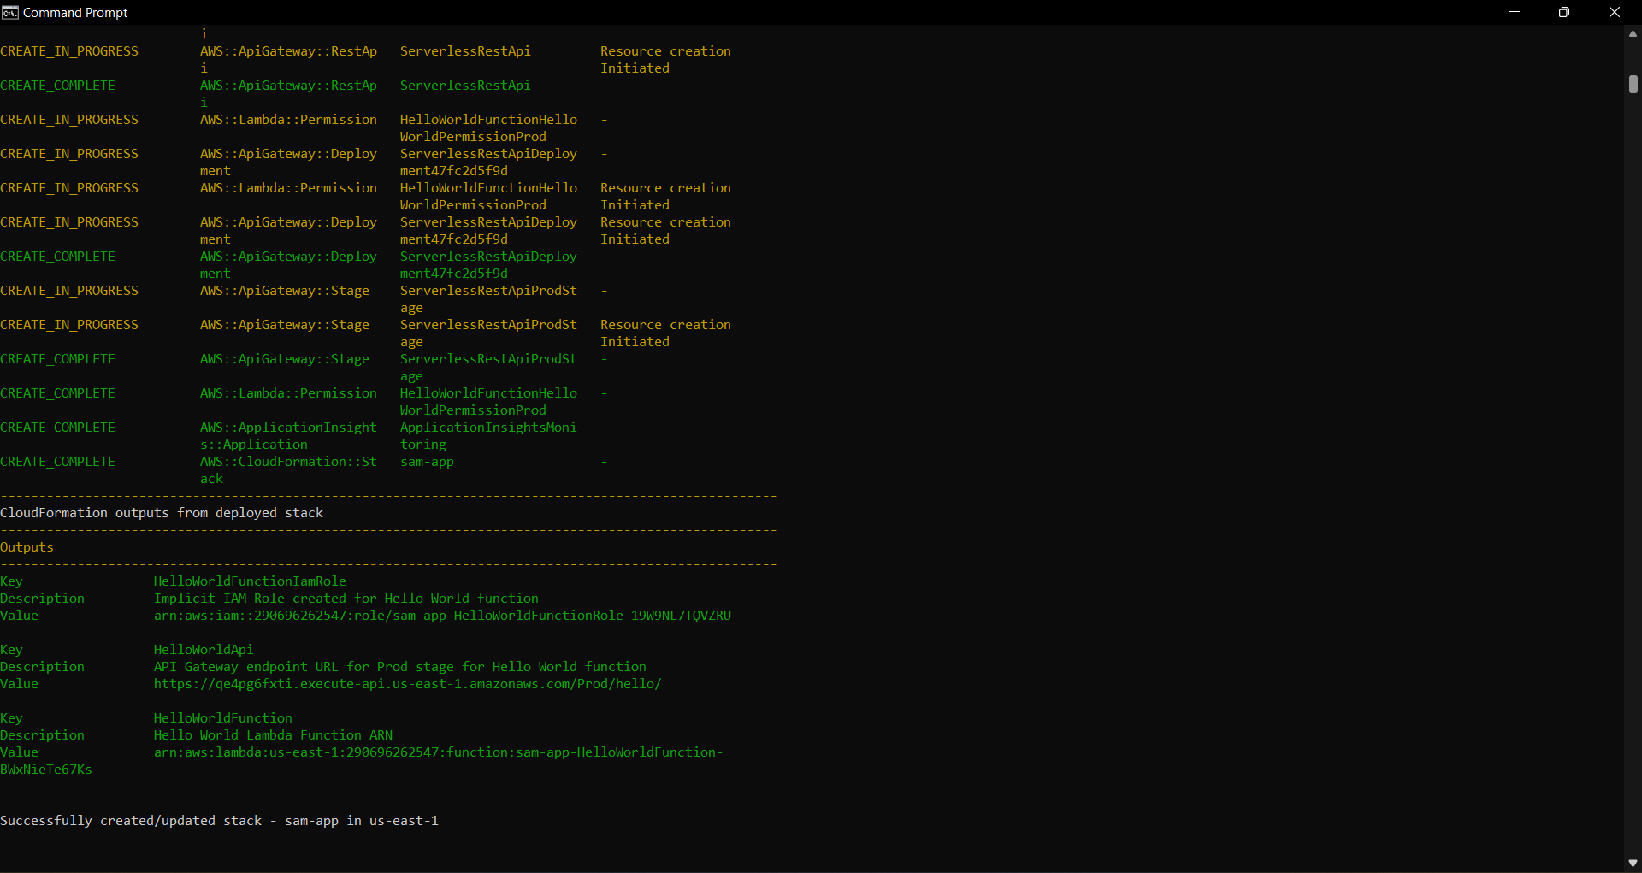

The deploy command deploys the application in the AWS lambda (cloud). It takes the deployment artifacts that you build with the sam build command, packages and uploads them to an Amazon S3 bucket that the AWS SAM CLI creates, and deploys the application using AWS Cloud Formation.

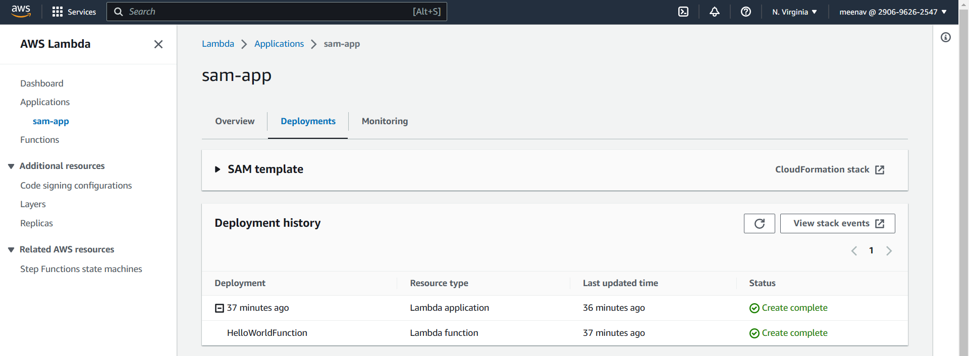

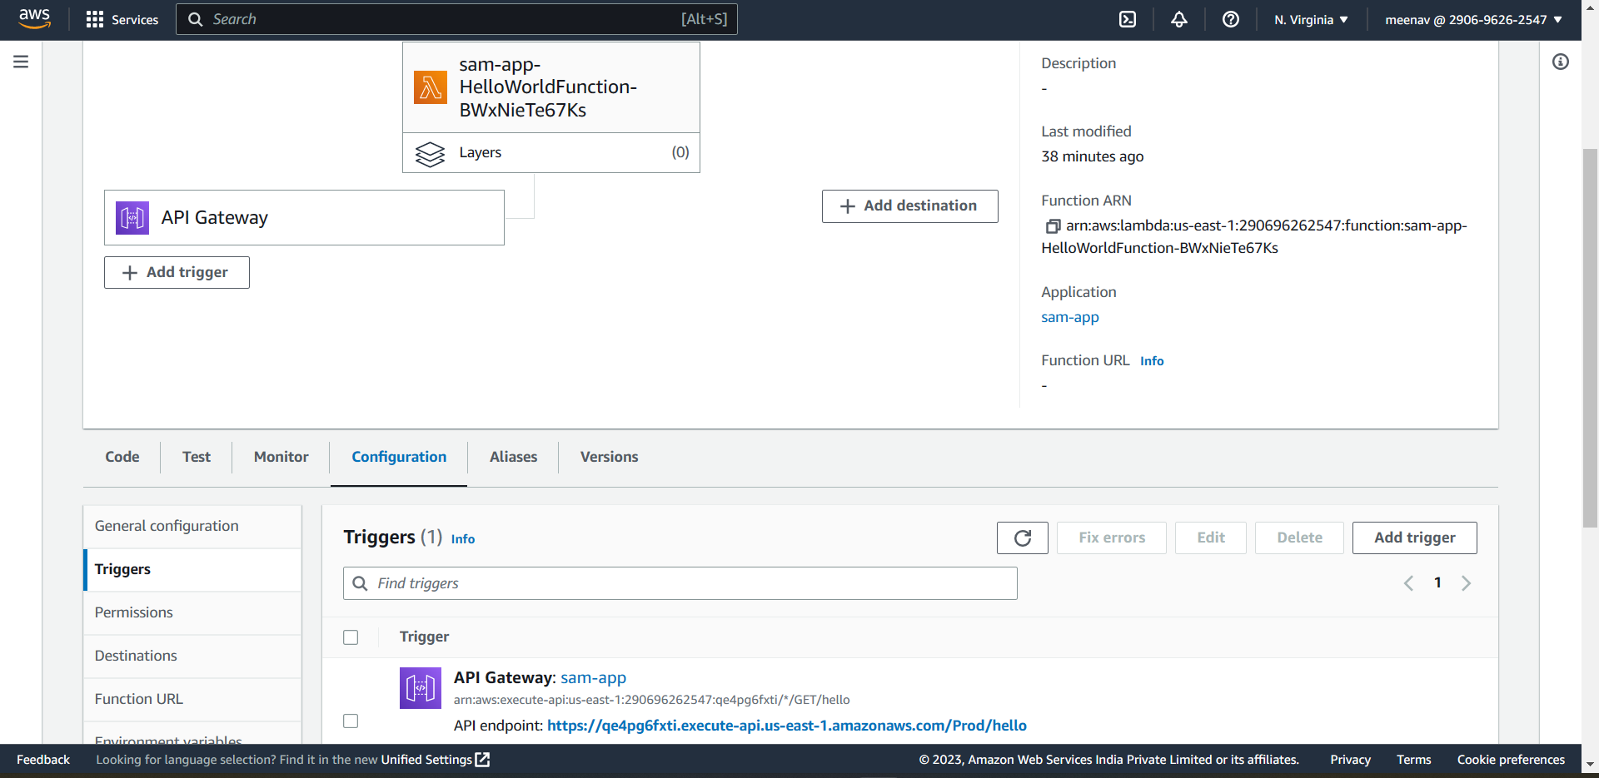

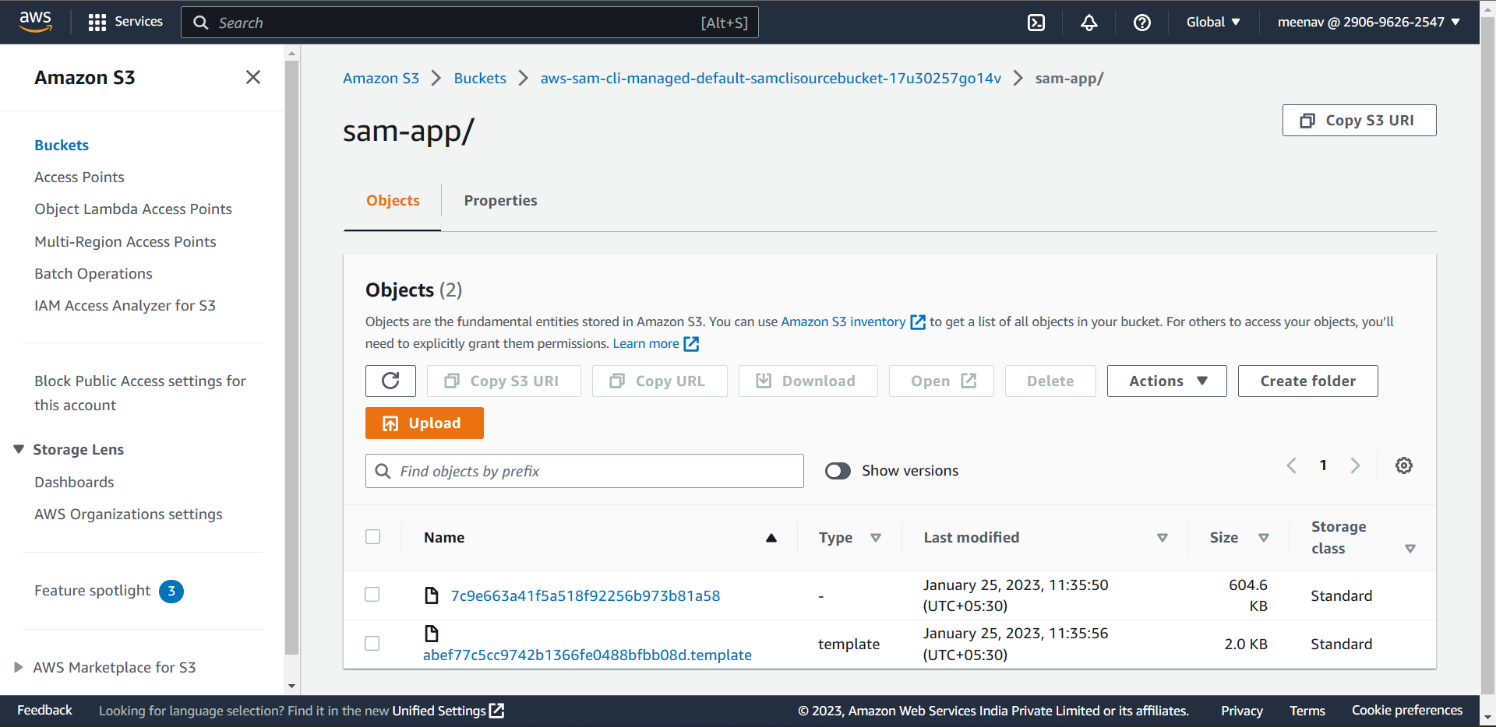

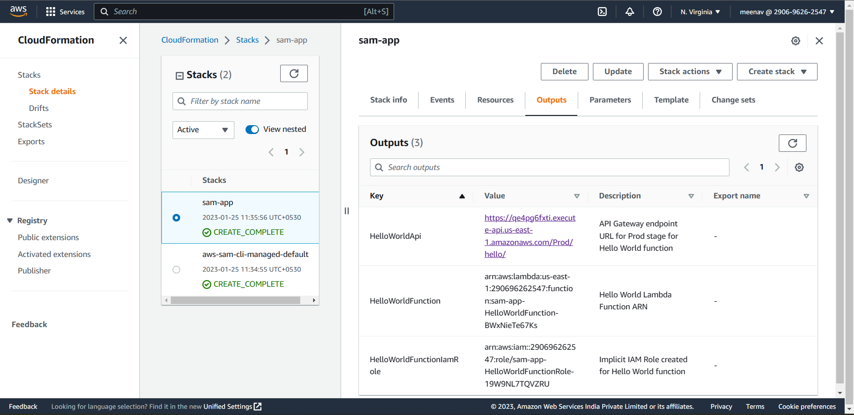

Once the application is deployed, we need to take the restapi url and either place it in the web or check with curl command on CLI

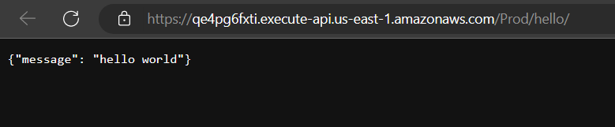

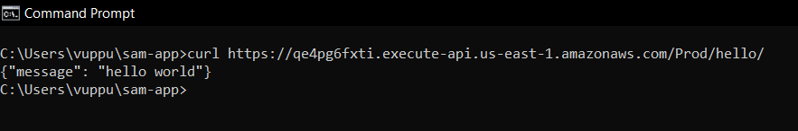

This success message indicates that we successfully deployed our serverless application to the AWS Cloud, and we are calling our live Lambda function.