

**Basic Linux Commands Assignments**

Assignment-1

Connect and disconnect with login Access

* What happens when you login a non-existent users or username?
  + Provide Screenshot and What you understand, explain in short brief?

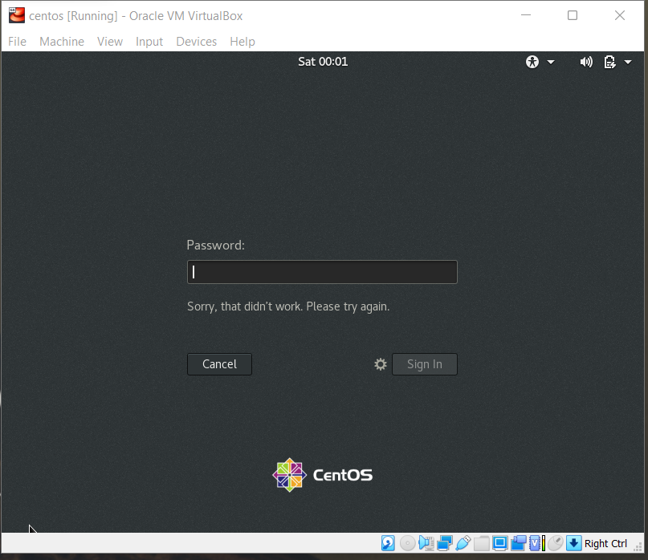

- we cannot login as a non-existent user, unless we add a new user in settings.

Assignment-2

Password changing

* Login into your account and then change password?
  + Change your password into **IneuR0n#42** and hit the **Enter** key
    - Explain what happen and give screenshot?

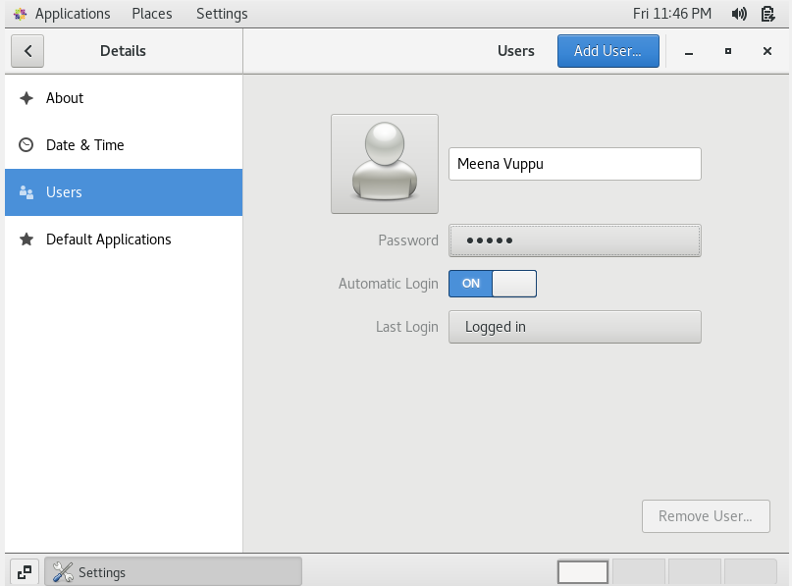

- Password changed successfully.

* + Try again to change password but use like password ***1234*** or ***abcd***
    - Explain what happen and give screenshot?

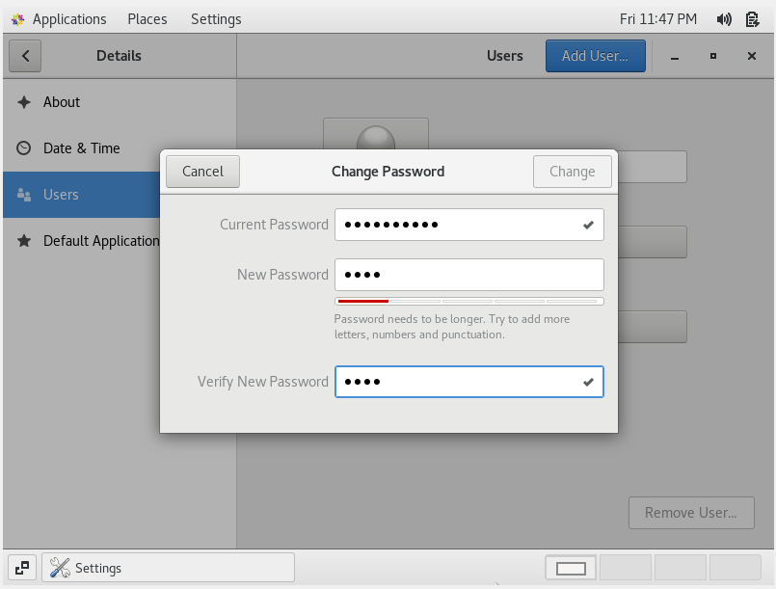

- Entered password didn’t met requirements, hence the change option is disabled.

* + Try again to change password but now don’t use any password just hit **Enter** key
    - Explain what happen and give screenshot?

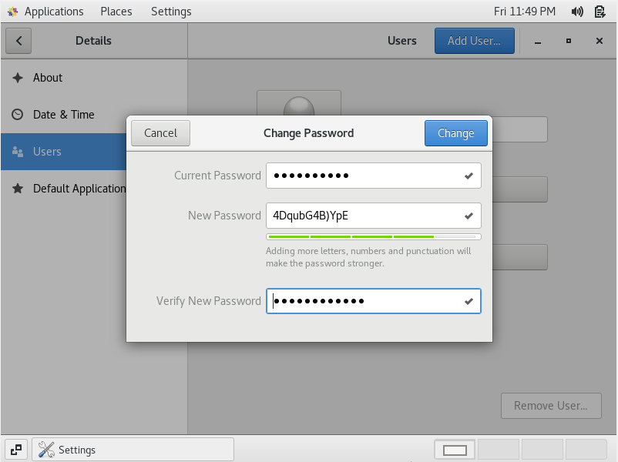

- If empty password was given, after pressing the enter key it suggested a random password.

Assignment-3

Working with Directories

* Enter the command **cd /** and then **ls** and then hit **Enter** key
  + Take screenshot and explain what output we got?

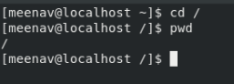

- Entered command takes us to the Root folder.

* Enter the command now **cd /home** and then hit **Enter** key
  + Do **ls,** provide screenshot and explain what is **/home** directory used for?

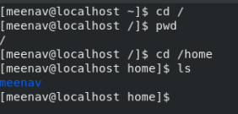

- /home directory displays the user name, and ls listed the users currently working in that home directory.

* Enter **cd ..** and hit **Enter** key [ *Note: here we have space after cd then use double dot*]
  + Check what happen and give screenshot?



- cd .. takes us to previous directory.

* Now enter **cd /var/www/html** and then type **cd** and hit **Enter** key
  + Explain what happen and give screenshot?

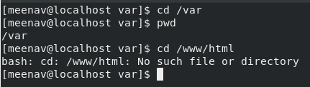

- There are nothing named www or html inside var.

* Now type **cd /root** and then hit **Enter** key
  + Do **ls,** check any output we have on screen if yes then take screenshot?

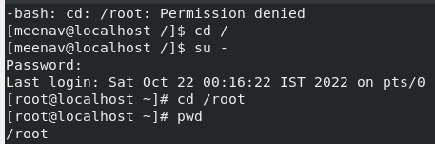

- We cannot access root directory unless we login as root user.

Assignment-4

Working with File Listing

* Go to **cd /etc** and type **ls**
  + Take screenshot and explain what files you have seeing?
  + Take screenshot and explain what different output you found compare to previous command you used? --didn’t understand the question

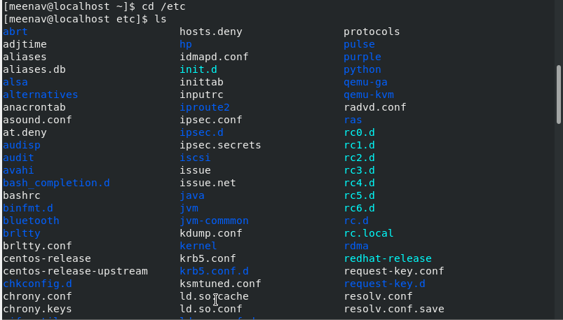

* Then type **ls -al** and hit **Enter** key
  + Take screenshot and explain what new file or directory you found?

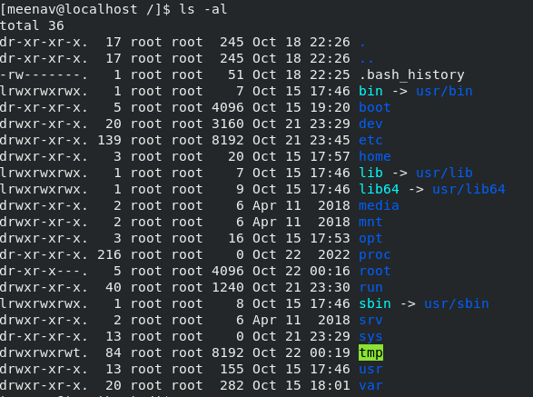

- Able to see the permissions of each file in root folder.

* Then use **ls -i** and hit **Enter** key
  + Now see what different output its shows and take screenshot?

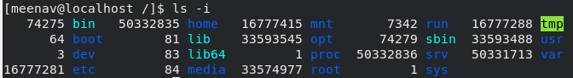

- It displayed the index value of each file.

* Then use **ls –help** and see other options about **ls** command
  + Explore it and try with other attribute we can use with **ls** command



- tried ls -s to see the size of each file.

Assignment-5

Know where you are and where you working

*Here we use* ***pwd, cd and ls*** *as combine task to understand where you working on terminal and how you can switch from one directory to another one.*

* Open terminal after restart the linux
  + Check which location you working, type **pwd** and take screenshot



* Now use **cd /var** and hit **Enter** key
  + Do **ls,** and see what output comes, give screenshot?

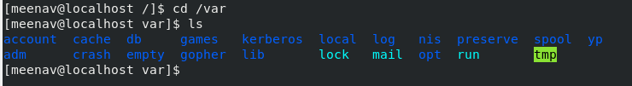

* Do explore other help options of each command to learn more other things we can do with these commands