**Assignment sheet for IAM**

**Assignment 1** :- Create an IAM user with username of your own wish and grant administrator policy.

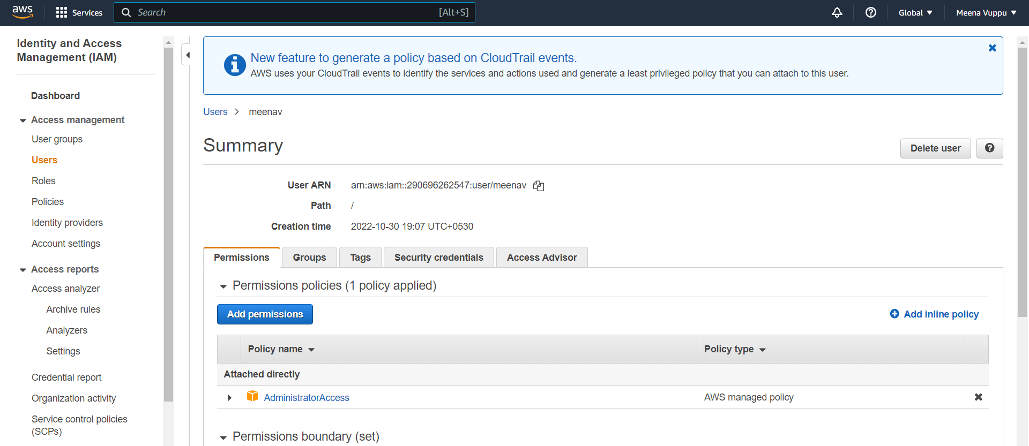

**Assignment 2** :- Hello students, in this assignment you need to prepare a developers team of avengers.

- Create 3 IAM users of avengers and assign them in developer’s groups with IAM policy.

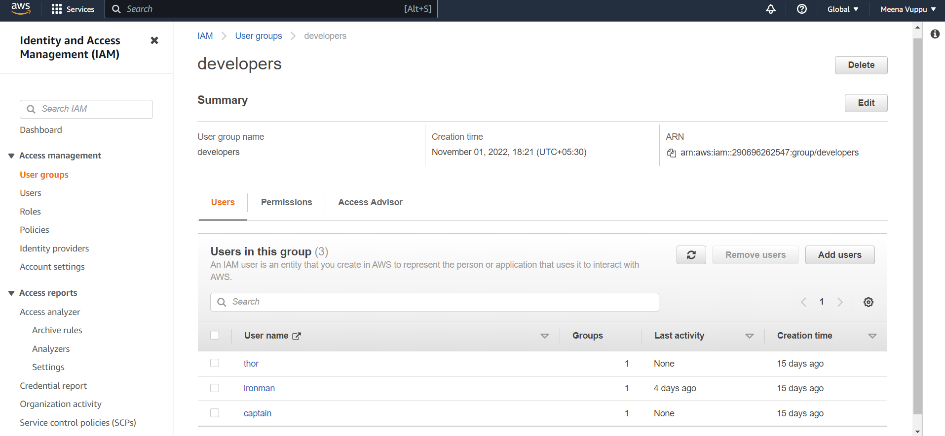

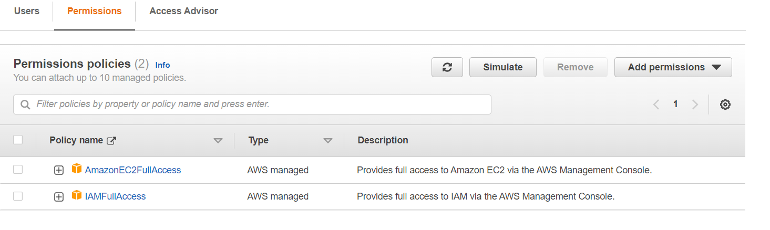

**Assignment 3** :- Define a condition in policy for expiration like

"DateGreaterThan": {"aws:CurrentTime": "2020-04-01T00:00:00Z"},

"DateLessThan": "2020-06-30T23:59:59Z"}

{"aws:CurrentTime":

Define the span of 4 months as per your wish

**Assignment 3** :- Prepare 15 authentic MCQ questions related to IAM.

**Assignment 4** :- Launch your linux instance in IAM and update your machine.