**COVID 19 CASES ANALYSIS**

**INTRODUCTION:**

The COVID-19 pandemic has underscored the importance of data analysis and visualization in understanding the spread and impact of the virus. Python, as a versatile and widely-used programming language, plays a significant role in COVID-19 cases analysis by providing the tools and libraries necessary to process, analyze, and visualize pandemic-related data. In this context, Python is a powerful tool for epidemiologists, data scientists, and policymakers.

**Key aspects of COVID-19 cases analysis in Python include:**

**Data Retrieval:**

Python can be used to fetch data from various sources, such as government health agencies, public APIs, and online databases. Libraries like **requests** and **pandas** enable data extraction and transformation.

**Data Cleaning and Preprocessing:**

Real-world data often requires cleaning and preprocessing. Python's **pandas** library is invaluable for cleaning, filtering and organizing COVID-19 data into a usable format.

**Data Visualization:**

Python offers a range of libraries for data visualization, with **matplotlib** and **seaborn** being popular choices. These tools help create clear and informative charts and graphs, making it easier to understand trends and patterns in COVID-19 cases.

**Temporal Analysis:**

Python's **datetime** and **pandas** libraries are used to analyze how COVID-19 cases evolve over time. Time series analysis and plotting help in tracking trends, seasonality, and the impact of interventions.

**Dashboard Development:**

Creating interactive dashboards is crucial for sharing COVID-19 analysis results with a wider audience. Python frameworks like **Dash** and visualization libraries like **Plotly** are ideal for building informative and user-friendly dashboards.

**Data Reporting:**

python can be used to generate automated reports and documents summarizing COVID-19 analysis findings. Libraries like **Jupyter Notebook** and COVID-19 pandemic has underscored the importance of data analysis and visualization in understanding the spread and impact of the virus. Python, as a versatile and widely-used programming language, plays a significant role in COVID-19 cases analysis by providing the tools and libraries necessary to process, analyze, and visualize pandemic-related data. In this context, Python is a powerful tool for epidemiologists, data scientists, and policymakers.

**Project Objectives**

The aim of this project is to enable how to utilize our Data Visualization and Data Analytics skills.To identify emerging trends in the spread of Covid-19

To assess the impact of cases and death rates on the spread of Covid-19 on various countries across the world.

To assess the impact of cases and death rates on the spread of Covid-19 on various days of a month in the year 2021.

To create predictive models to better anticipate future cases and death rates related to COVID-19.

To provide insights and analyze demographics that could lead to decision making.

**Analysis Objectives:**

Our analysis objectives encompass understanding the patterns, trends, and insights related to COVID-19 cases and deaths. We aim to address questions such as the impact of the pandemic on different regions, the progression of cases over time, and the correlation between various factors and COVID-19 outcomes.

**Data Source:** We obtained our data from Kaggle, a reputable platform for datasets. The dataset link is provided here: [COVID-19 Cases Dataset](https://www.kaggle.com/datasets/chakradharmattapalli/covid-19-cases).

**Data Loading:**

To begin the analysis, we loaded the COVID-19 dataset into our IBM Cognos environment. This step involved using the necessary functions and tools to import the data.

**Data Preprocessing:**

Data preprocessing is a critical step to ensure the data's accuracy and reliability. It involves several key aspects.

Handling Missing Values:

We meticulously dealt with missing data points. This might include imputation, removal of incomplete records, or other strategies based on the nature of the data.

Data Transformation:

Depending on the analysis objectives, we performed data transformations such as normalizing values, aggregating data over specific time periods, or converting data types to match the analytical requirements.

Data Cleaning:

Data cleaning involved removing outliers, duplicate entries, or any irrelevant information that could skew the analysis.

Data Verification:

To ensure the dataset's accuracy and reliability, we conducted verification steps, including cross-checking data with authoritative sources, validating data against known statistics, and conducting internal consistency checks.

Insights from analysis can be gained by utilizing data analysis tools and techniques in Python to understand COVID-19 case trends and impacts. Here's a high-level overview of how Python can be used for this purpose.

**Data Collection and Preprocessing**:

Python libraries like Pandas and NumPy can be used to collect and preprocess COVID-19 data from various sources such as government databases, research institutions, or APIs.

**Exploratory Data Analysis (EDA)**:

Pandas and Matplotlib/Seaborn can help in visualizing the data. You can create line plots, bar charts, heatmaps, and other visualizations to explore trends in cases, hospitalizations, and deaths over time. EDA helps in identifying patterns and anomalies.

**Time Series Analysis**:

Python's time series analysis libraries, such as Statsmodels and Prophet, can be used to model and forecast COVID-19 cases. This helps in understanding short-term and long-term trends.

**Geospatial Analysis**:

Libraries like GeoPandas, Folium, and Plotly can assist in geospatial analysis. You can create maps to visualize the spread of the virus by region, and overlay data like cases per capita or vaccination rates.

**Epidemiological Modeling**:

Python is well-suited for building epidemiological models. Libraries like SciPy and PyMC3 can be used to create SEIR (Susceptible-Exposed-Infectious-Removed) models or other epidemiological models to simulate and predict the spread of the virus.

**Statistical Analysis**:

Python offers powerful statistical analysis capabilities with libraries like SciPy and Statsmodels. You can perform hypothesis testing to assess the effectiveness of interventions or compare the impact of the virus across different demographic groups.

**Data Visualization**:

Python's visualization libraries, such as Matplotlib, Seaborn, Plotly, and Bokeh, enable you to create informative charts and graphs for reports and presentations.

**Regression Analysis**:

Linear or nonlinear regression can be performed to understand the relationship between variables like vaccination rates, testing, and case numbers.

**Program:**

import pandas as pd

import numpy as np

import seaborn as sns

import matplotlib.pyplot as plt

sns.set(color_codes=True)

print("modules are imported!!")

op:

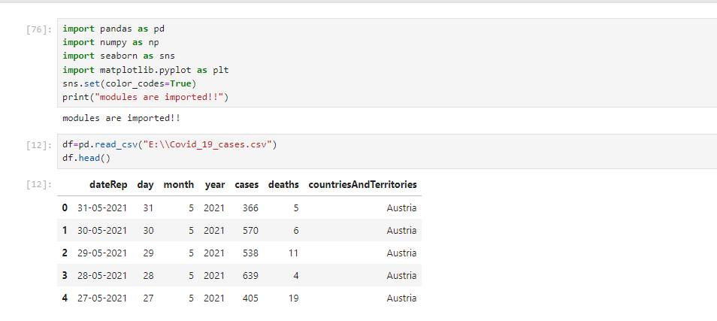

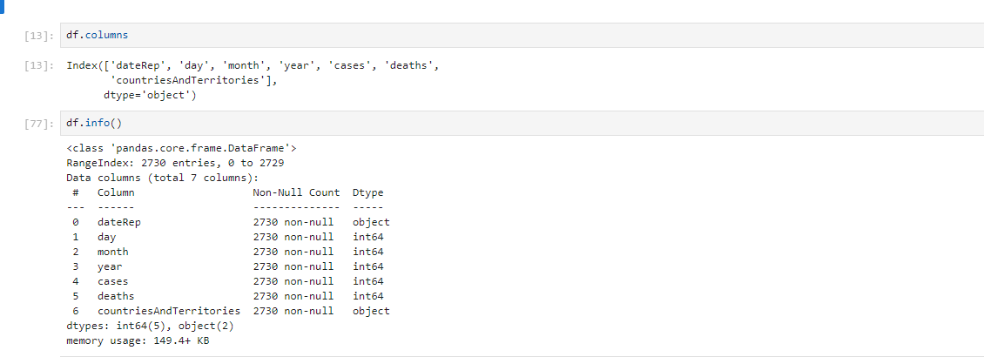

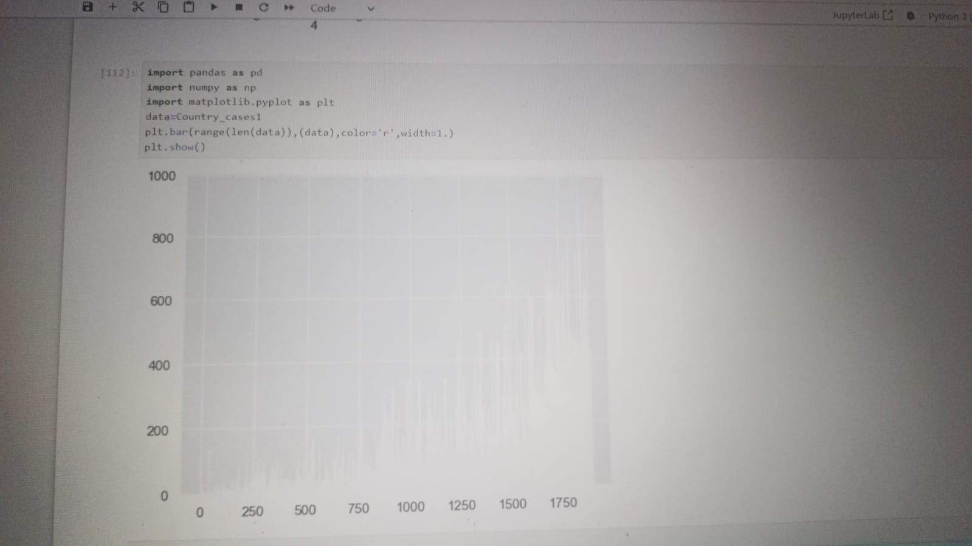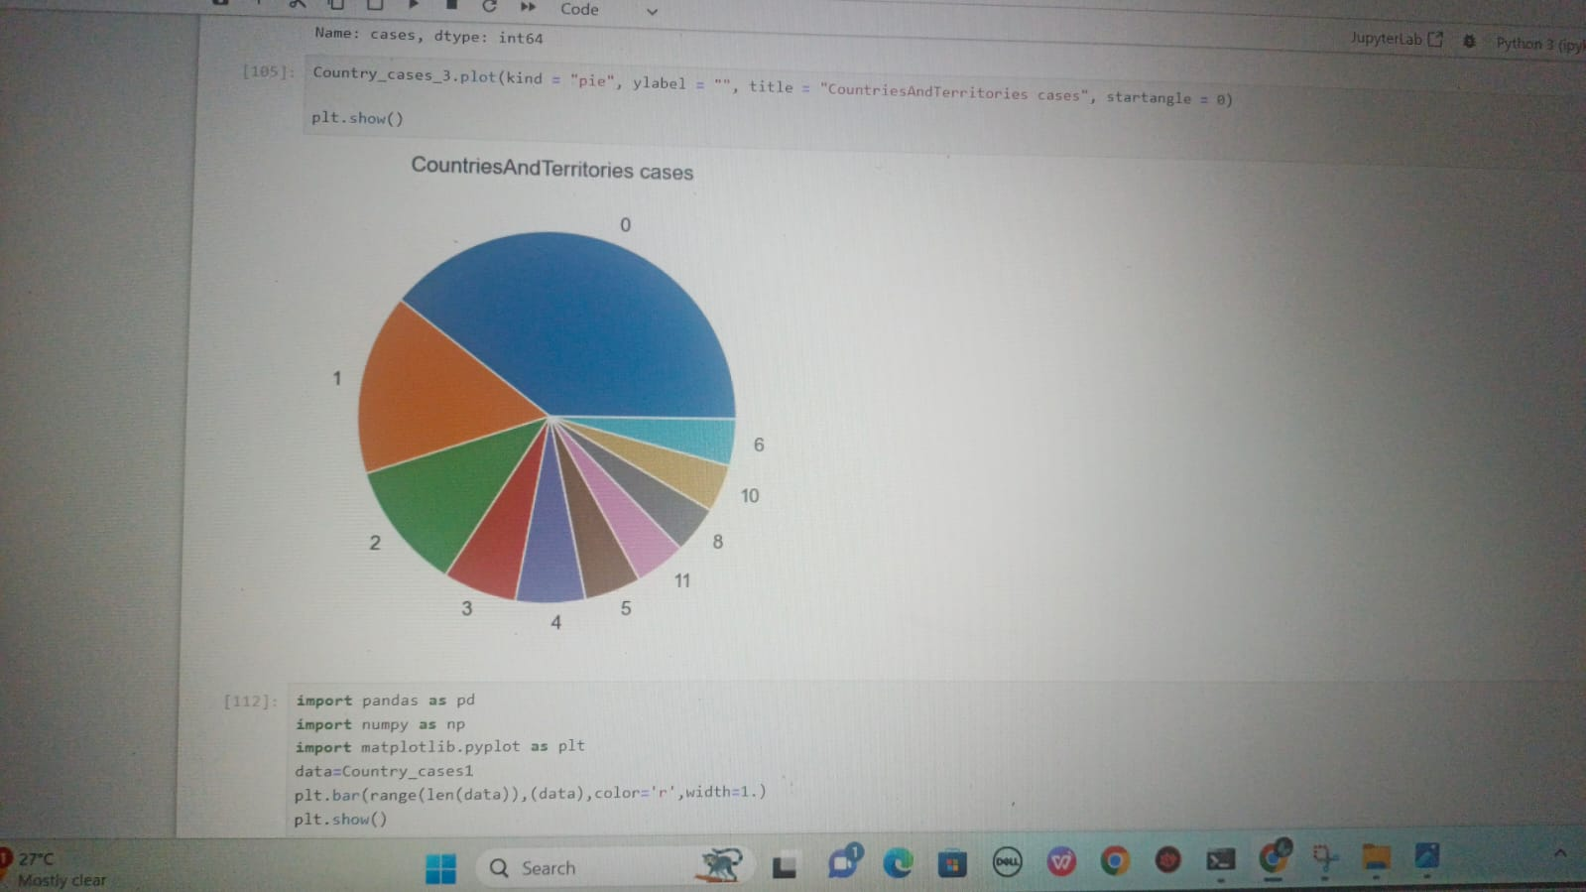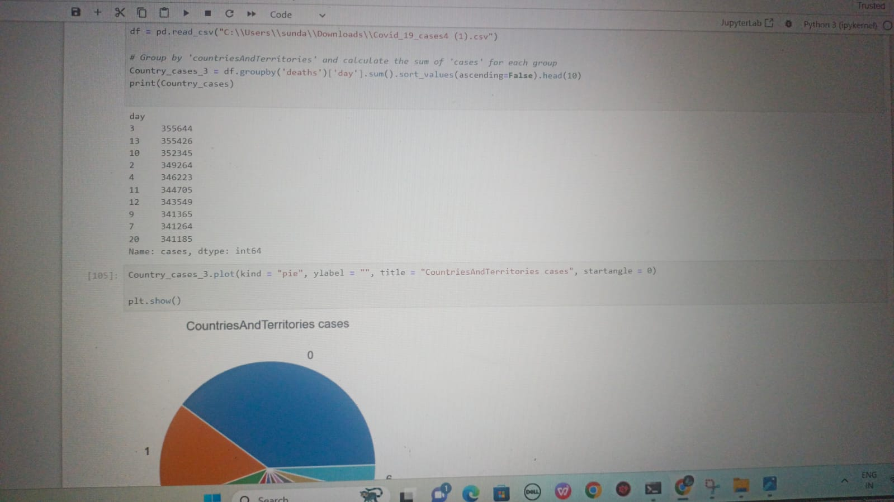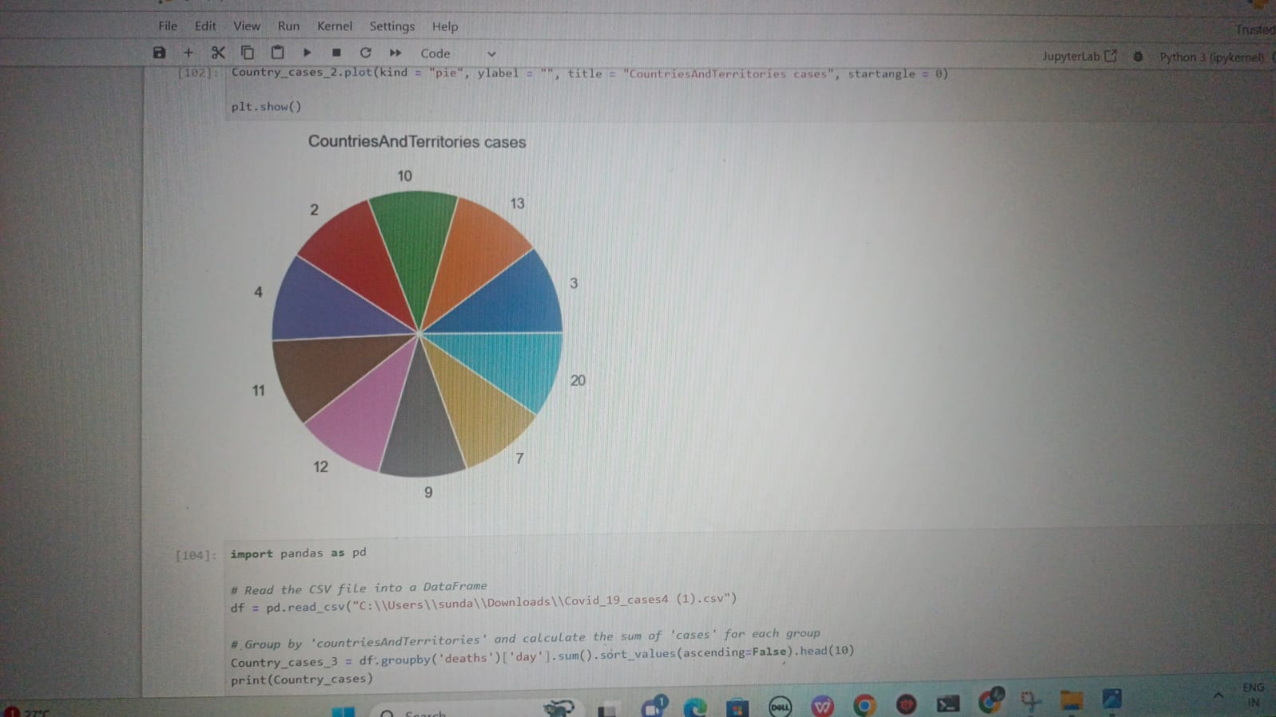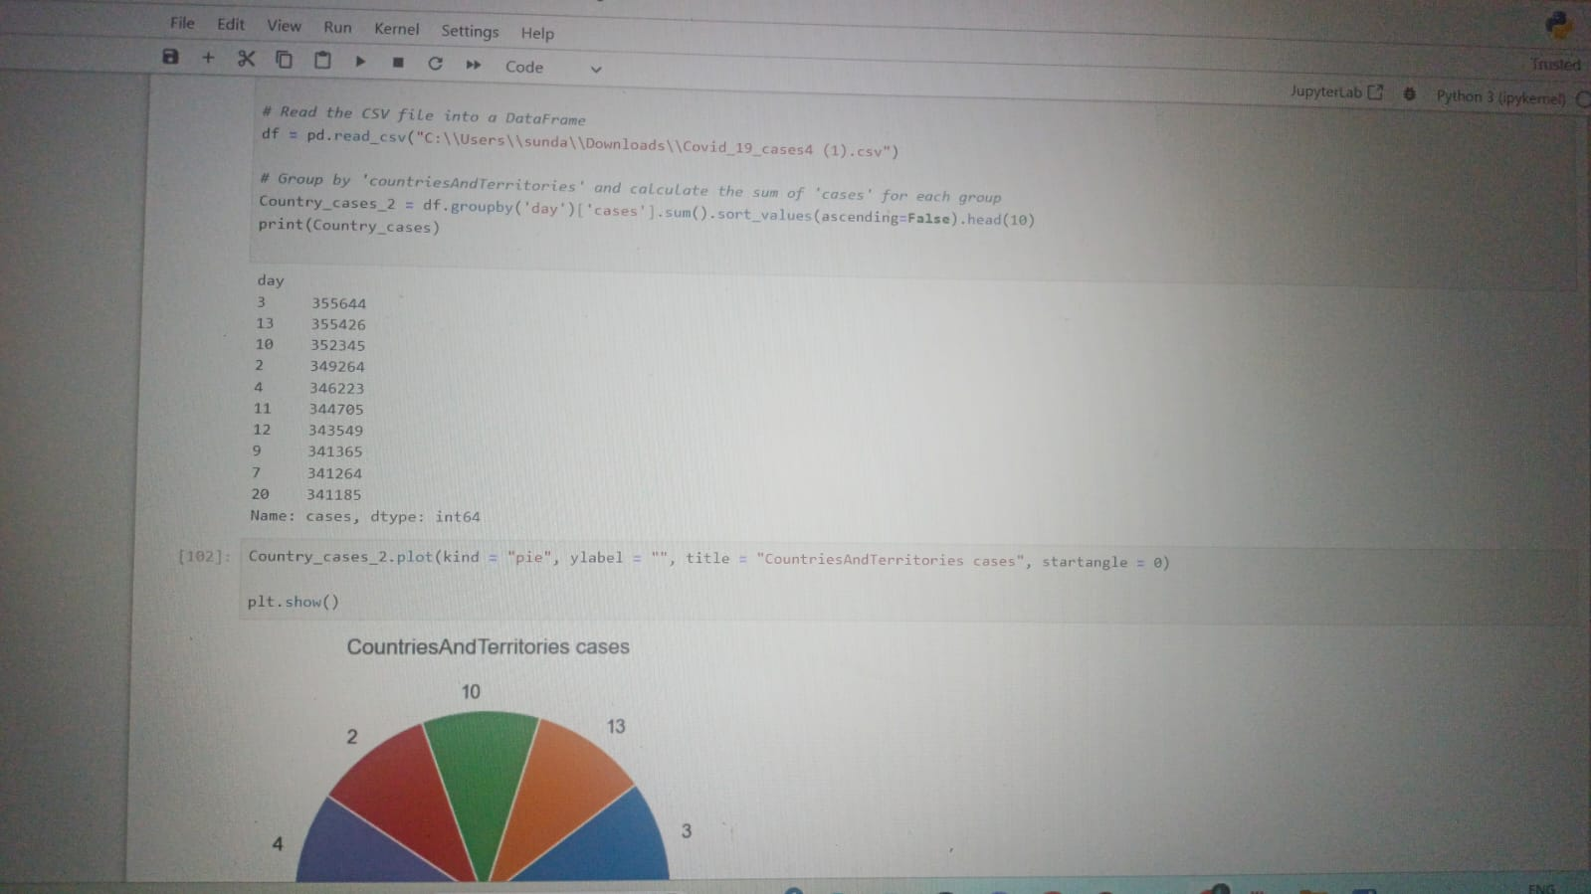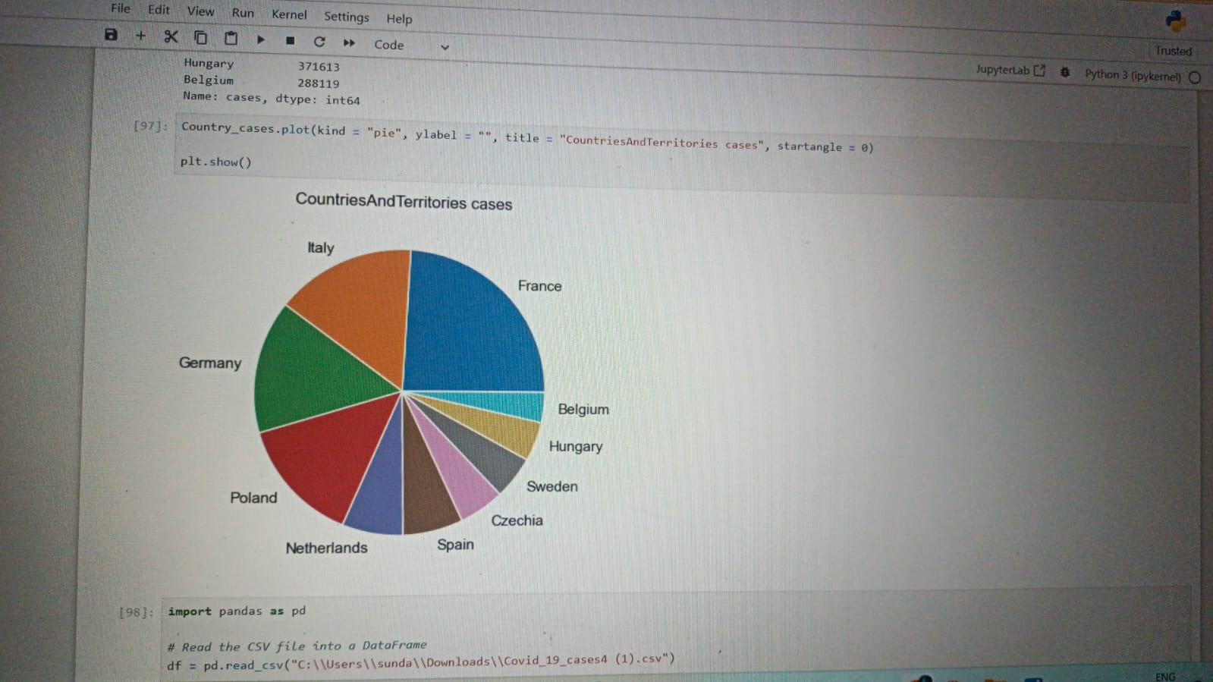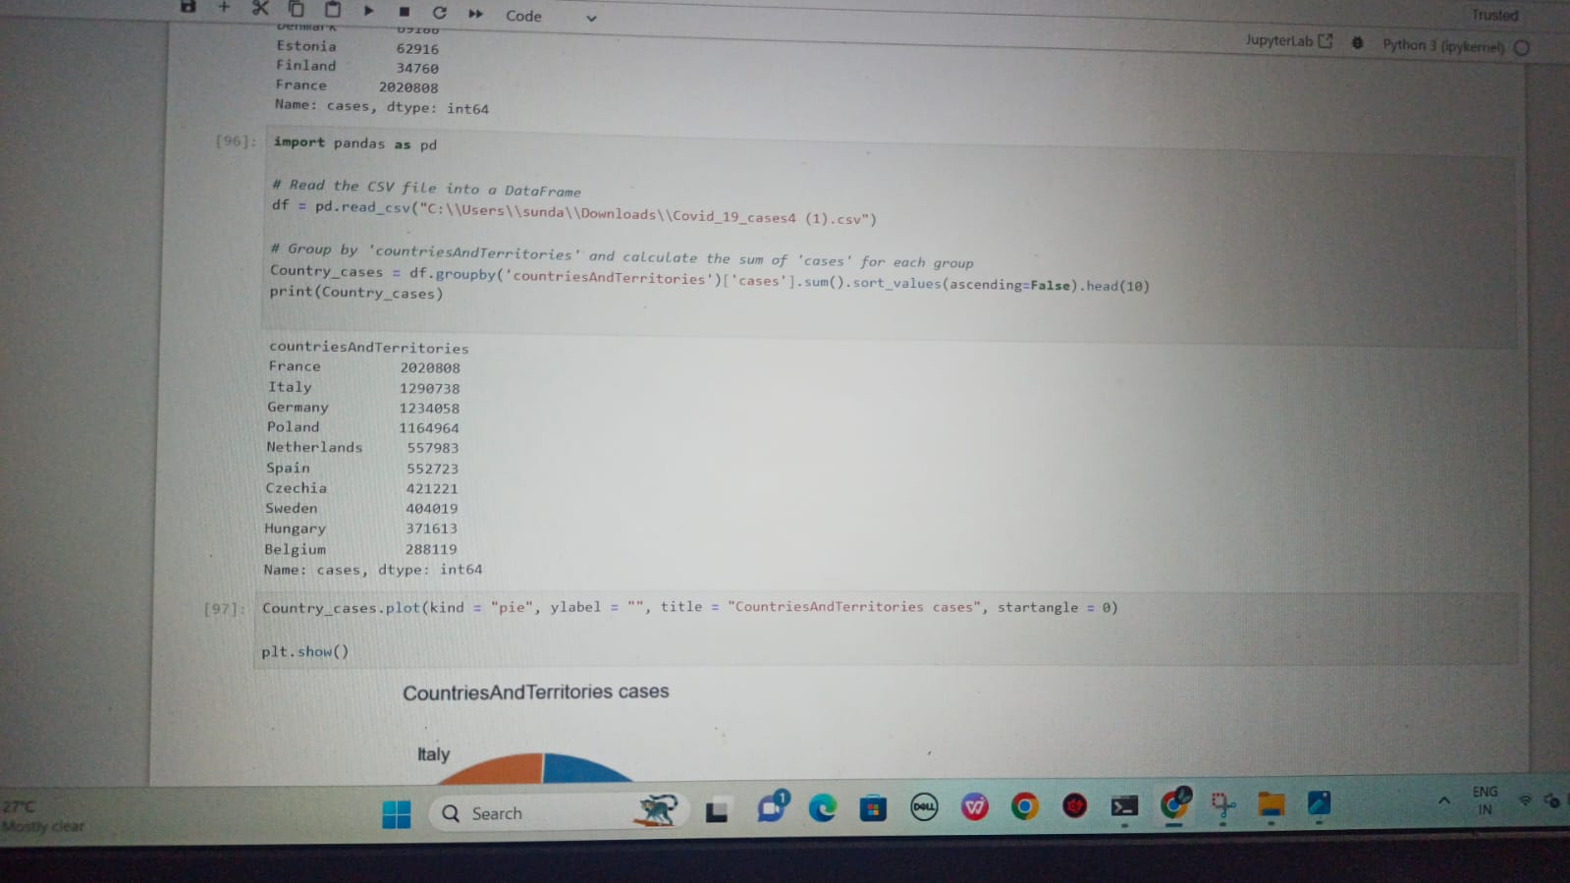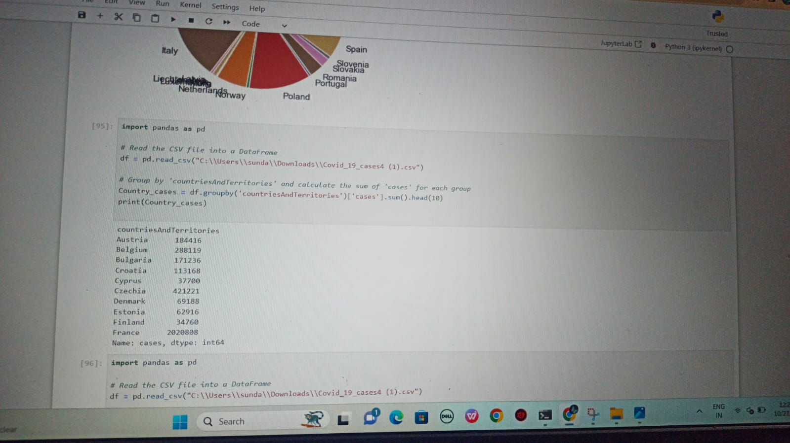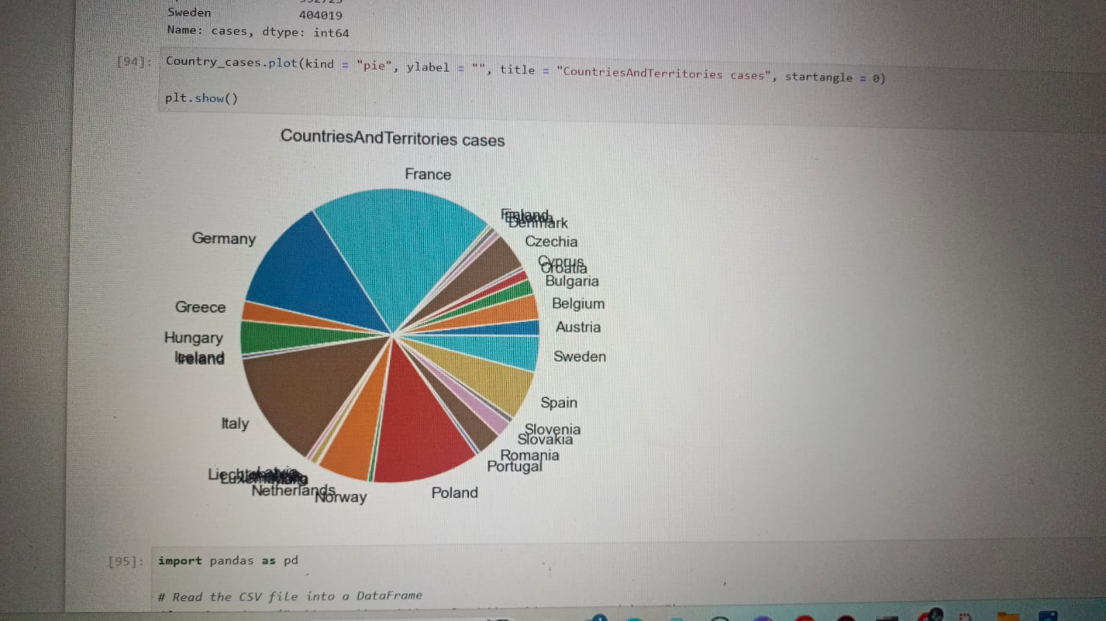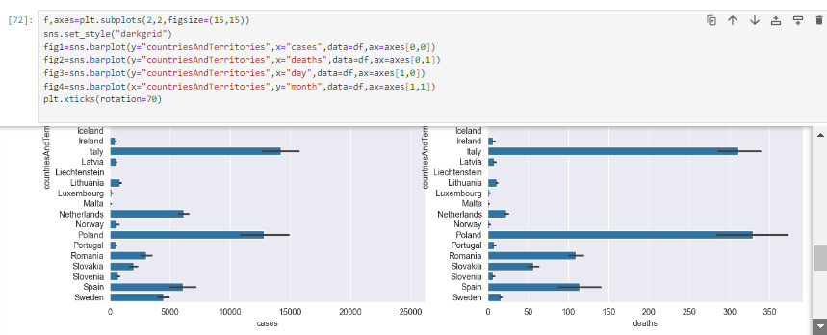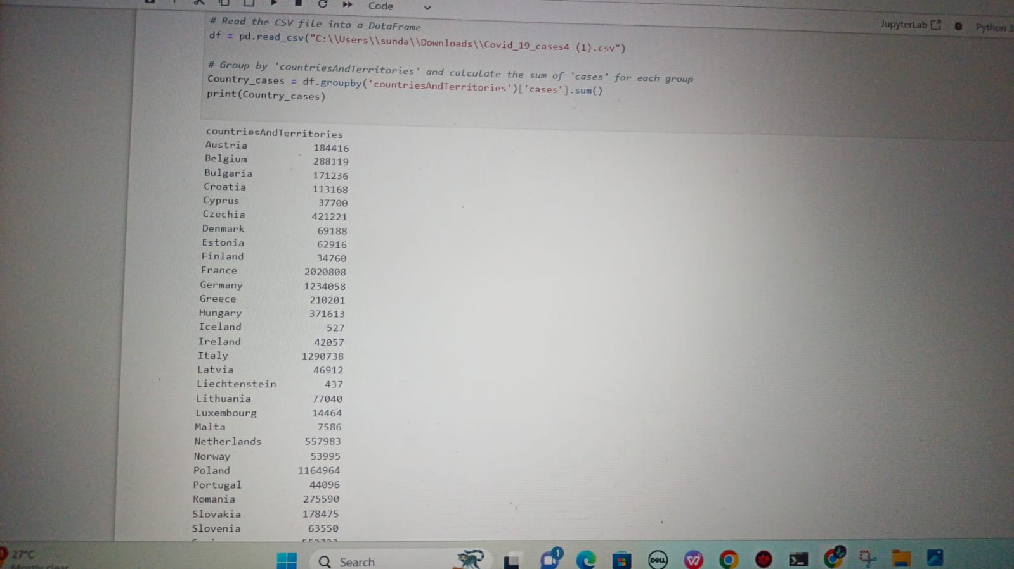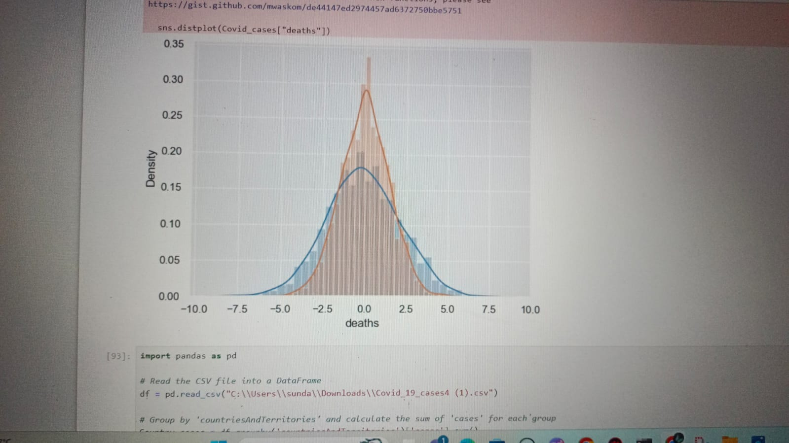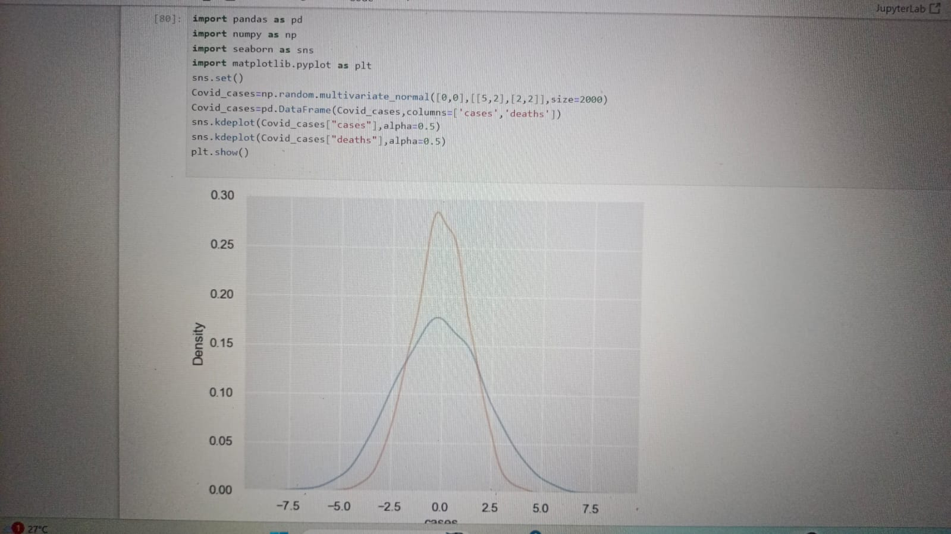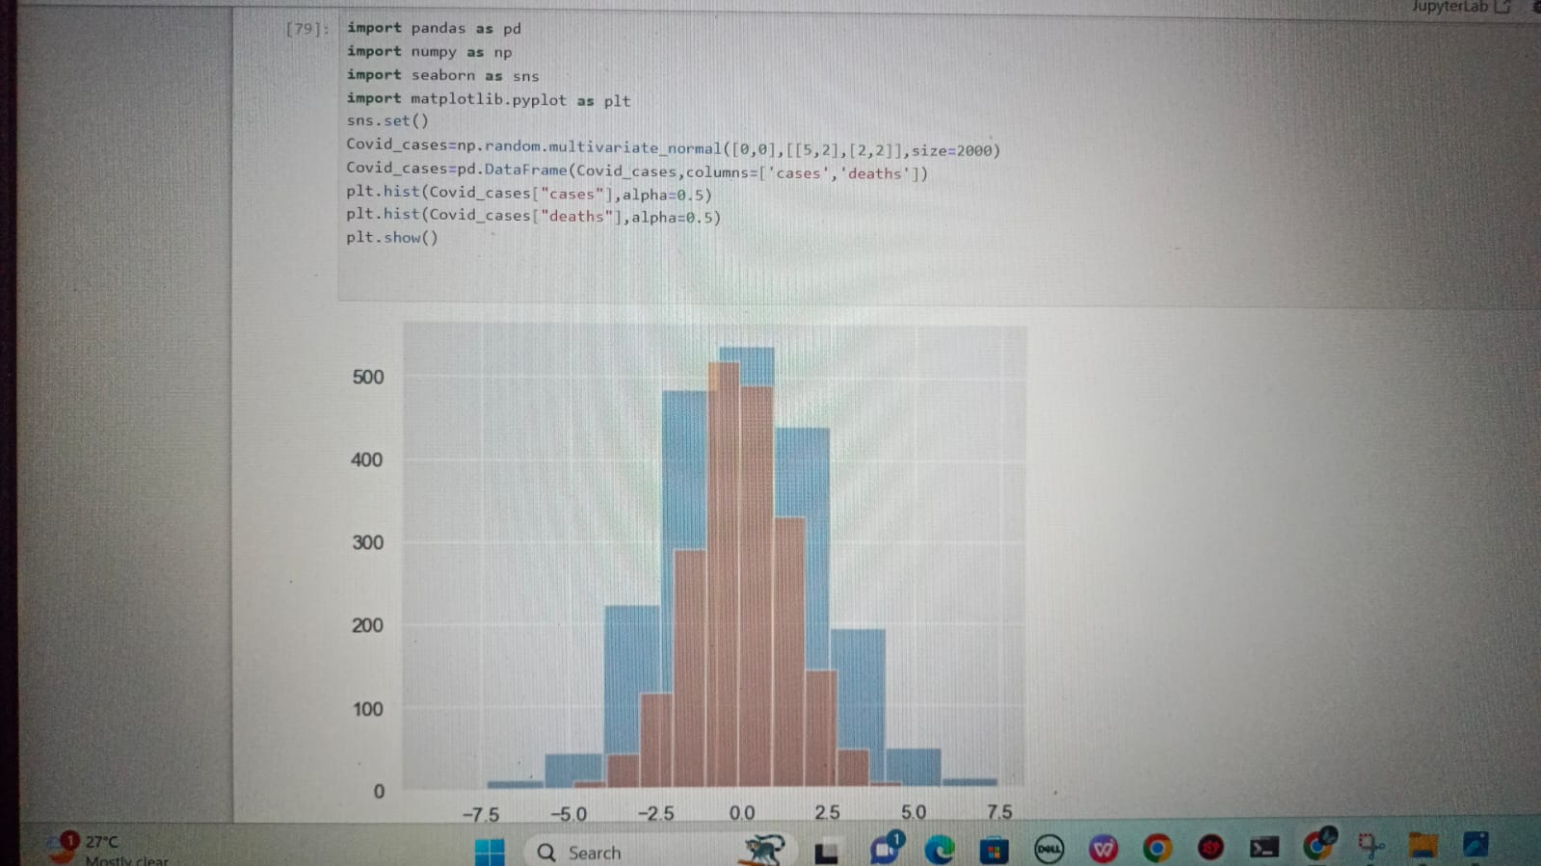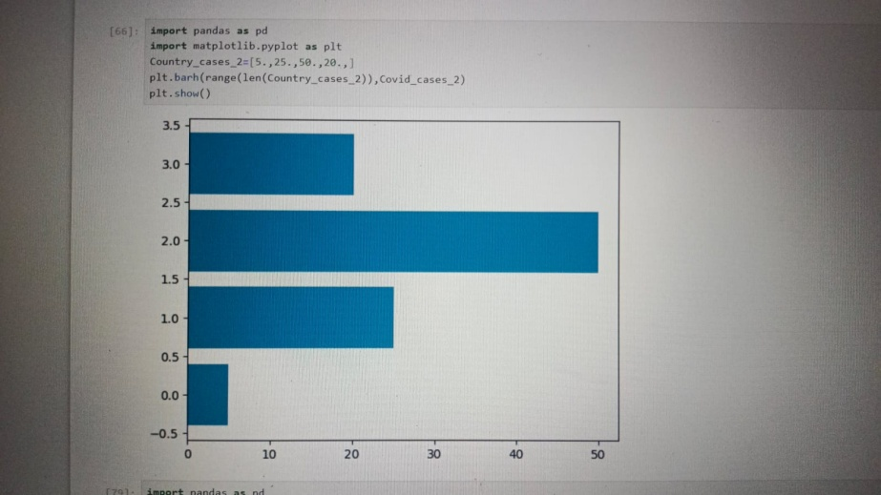

**CONCLUSION:**

**Trends**: Fluctuations in case numbers with peaks and troughs over time, with varying degrees of severity.

**Geographic Patterns**: Regional disparities, with some areas experiencing higher case rates than others.

**Interventions**: Evidence of the impact of measures like lockdowns and vaccinations in mitigating the spread.

**Demographics**: Differential susceptibility among age groups and demographics, with older individuals and certain populations more vulnerable.

**Healthcare Strain**: Periods of strain on healthcare systems, especially in terms of hospitalizations and intensive care unit (ICU) occupancy.

**Testing and Reporting**: Influence of testing and reporting practices on reported case numbers.

**Predictive Models**: Utilization of predictive models for forecasting future trends.

**Public Health Insights**: Valuable insights for public health recommendations and policy decisions.

**Lessons Learned and Preparedness**: Identifying areas for improvement and enhancing preparedness for future health emergencies.

These conclusions are based on data analysis and are subject to regional and temporal variations, as well as the quality of the data. Careful consideration of data quality and ethical practices is essential for responsible Analysis.

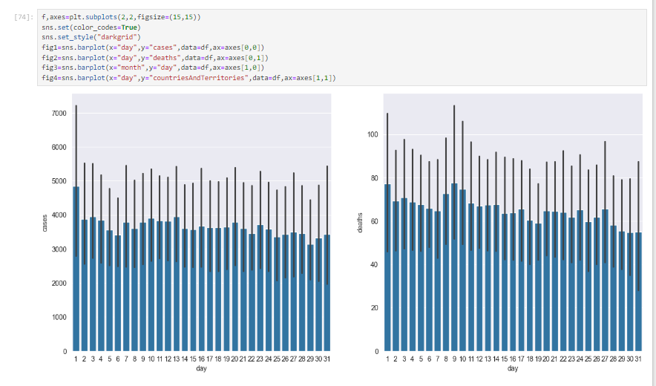

Thank You!