**Ejere Bethel**

**Q1. FEATURES OF PYTHON PROGRAMMING LANGUAGE**

**General-Purpose and High-Level:**

Python is a general-purpose language, meaning it can be used for various tasks like web development, data analysis, scripting, and more.

It's a high-level language, making it closer to human-readable English compared to lower-level languages that require more machine-specific instructions. This allows programmers to focus on the logic of their code rather than low-level details.

**Easy to Learn and Read:**

Python is known for its clear and concise syntax, making it easier to learn and understand, even for beginners.

Its use of whitespace indentation for code blocks contributes to readability and maintainability.

**Interpreted Language:**

Python code is interpreted at runtime rather than compiled into machine code beforehand. This allows for faster development cycles as changes can be tested quickly without recompiling the entire program.

**Object-Oriented Programming (OOP):**

Python supports object-oriented programming (OOP) concepts like classes, objects, inheritance, and polymorphism. This allows for code reusability, modularity, and better organization of complex programs.

**Extensive Standard Library:**

Python comes with a rich standard library that provides built-in modules and functions for various tasks like file I/O, networking, data structures, and more. This reduces the need to write code from scratch for common functionalities.

**Large Third-Party Library Ecosystem:**

Python boasts a vast ecosystem of third-party libraries available through PyPI (Python Package Index). These libraries provide functionalities for specific domains like machine learning (TensorFlow, PyTorch), web development (Django, Flask), data science (NumPy, Pandas), and many more.

**Cross-Platform:**

Python code can run on various operating systems (Windows, macOS, Linux) without modifications, making it a versatile language for development across different platforms.

**Strong Community and Resources:**

Python has a large and active community of developers, offering extensive online resources, tutorials, and forums for learning and support.

**Q2. Checking Python and PIP Version**

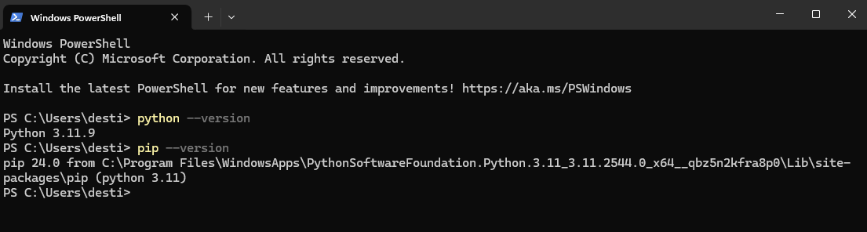

**Q3. Print Age, Sex and Age**

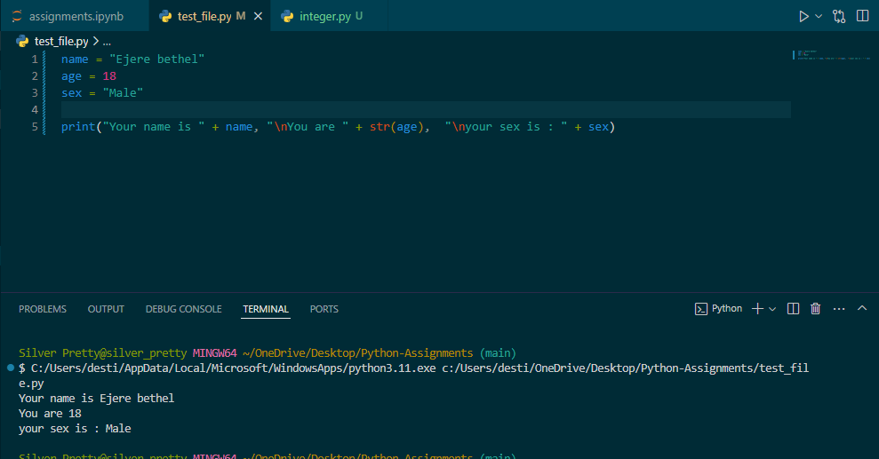

**Q4. Average of 3 Integer Numbers**

**Algorithm:**

1. **Declare variables for the 3 number and average**
2. **Enter the first number**
3. **Enter the second number**
4. **Enter the third number**
5. **Calculate the Average by adding the three numbers and divide the by 3**
6. **Print the Average.**

**Program:**

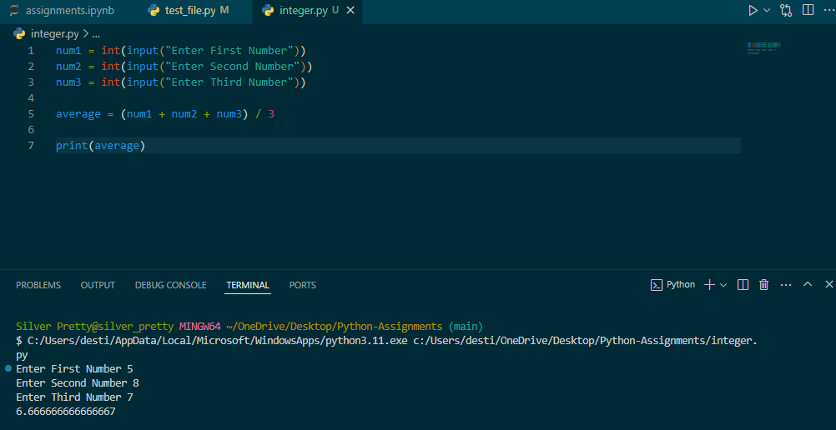

**Flowchart:**

Declare Variable num1, num2, num3, average

Enter the Value of Num1, Num2 and Num3

Average = (num1 + num2 + num3)/3

Print Average

**Volume of a Cylinder**

Enter Radius

Volume = (22/7) * (Radius * Radius ) * Height

Print Volume

**Dominion Chukwuma**

**FEATURES OF PYTHON PROGRAMMING LANGUAGE**

**General-Purpose and High-Level:**

Python is a general-purpose language, meaning it can be used for various tasks like web development, data analysis, scripting, and more.

It's a high-level language, making it closer to human-readable English compared to lower-level languages that require more machine-specific instructions. This allows programmers to focus on the logic of their code rather than low-level details.

**Easy to Learn and Read:**

Python is known for its clear and concise syntax, making it easier to learn and understand, even for beginners.

Its use of whitespace indentation for code blocks contributes to readability and maintainability.

**Interpreted Language:**

Python code is interpreted at runtime rather than compiled into machine code beforehand. This allows for faster development cycles as changes can be tested quickly without recompiling the entire program.

**Object-Oriented Programming (OOP):**

Python supports object-oriented programming (OOP) concepts like classes, objects, inheritance, and polymorphism. This allows for code reusability, modularity, and better organization of complex programs.

**Extensive Standard Library:**

Python comes with a rich standard library that provides built-in modules and functions for various tasks like file I/O, networking, data structures, and more. This reduces the need to write code from scratch for common functionalities.

**Large Third-Party Library Ecosystem:**

Python boasts a vast ecosystem of third-party libraries available through PyPI (Python Package Index). These libraries provide functionalities for specific domains like machine learning (TensorFlow, PyTorch), web development (Django, Flask), data science (NumPy, Pandas), and many more.

**Cross-Platform:**

Python code can run on various operating systems (Windows, macOS, Linux) without modifications, making it a versatile language for development across different platforms.

**Strong Community and Resources:**

Python has a large and active community of developers, offering extensive online resources, tutorials, and forums for learning and support.

**Checking Python and PIP Version**



**Print Age, Sex and Age**

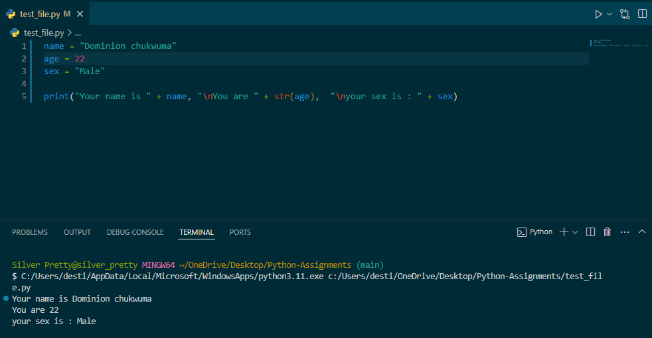

**Average of 3 Integer Numbers**

**Algorithm:**

1. **Enter the first number**
2. **Enter the second number**
3. **Enter the third number**
4. **Calculate the Average by adding the three numbers and divide the by 3**
5. **Print the Average.**

**Program:**

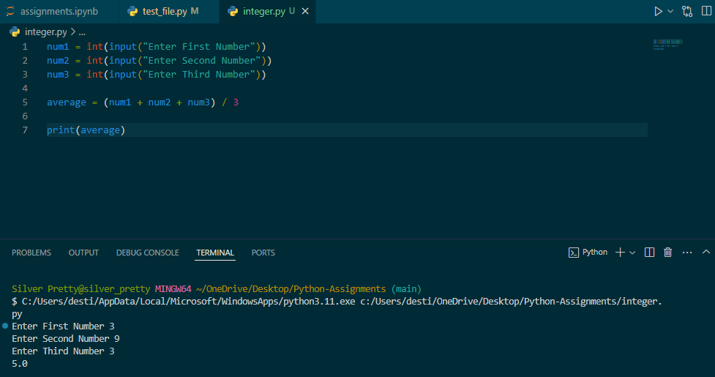

**Flowchart:**

Declare Variable num1, num2, num3, average

Enter the Value of Num1, Num2 and Num3

Average = (num1 + num2 + num3)/3

Print Average

**Volume of a Cylinder**

Enter Radius

Volume = (22/7) * (Radius * Radius ) * Height

Print Volume

**Amah Precious Chibueze**

**FEATURES OF PYTHON PROGRAMMING LANGUAGE**

**General-Purpose and High-Level:**

Python is a general-purpose language, meaning it can be used for various tasks like web development, data analysis, scripting, and more.

It's a high-level language, making it closer to human-readable English compared to lower-level languages that require more machine-specific instructions. This allows programmers to focus on the logic of their code rather than low-level details.

**Easy to Learn and Read:**

Python is known for its clear and concise syntax, making it easier to learn and understand, even for beginners.

**Interpreted Language:**

Python code is interpreted at runtime rather than compiled into machine code beforehand. This allows for faster development cycles as changes can be tested quickly without recompiling the entire program.

**Object-Oriented Programming (OOP):**

Python supports object-oriented programming (OOP) concepts like classes, objects, inheritance, and polymorphism. This allows for code reusability, modularity, and better organization of complex programs.

**Extensive Standard Library:**

Python comes with a rich standard library that provides built-in modules and functions for various tasks like file I/O, networking, data structures, and more. This reduces the need to write code from scratch for common functionalities.

**Large Third-Party Library Ecosystem:**

Python boasts a vast ecosystem of third-party libraries available through PyPI (Python Package Index). These libraries provide functionalities for specific domains like machine learning (TensorFlow, PyTorch), web development (Django, Flask), data science (NumPy, Pandas), and many more.

**Cross-Platform:**

Python code can run on various operating systems (Windows, macOS, Linux) without modifications, making it a versatile language for development across different platforms.

**Strong Community and Resources:**

Python has a large and active community of developers, offering extensive online resources, tutorials, and forums for learning and support.

**Checking Python and PIP Version**



**Print Age, Sex and Age**

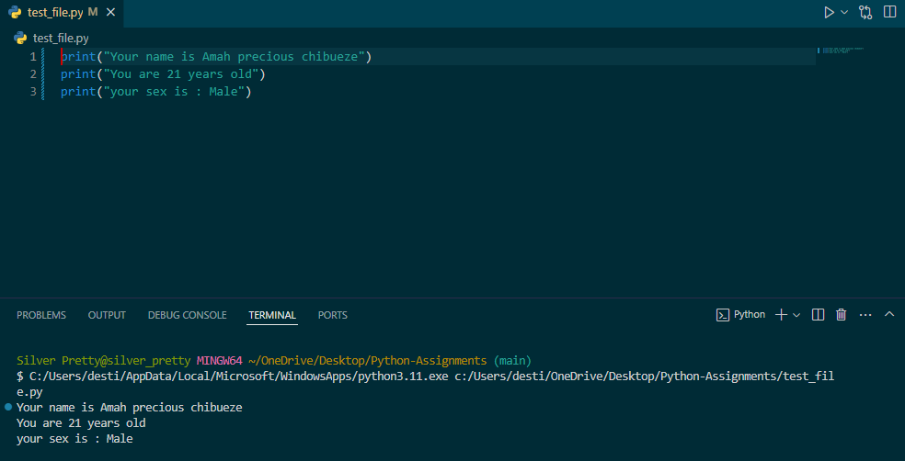

**Average of 3 Integer Numbers**

**Algorithm:**

1. **Enter the first number**
2. **Enter the second number**
3. **Enter the third number**
4. **Calculate the Average by adding the three numbers and divide the by 3**
5. **Print the Average.**

**Program:**



Declare Variable num1, num2, num3, average

Enter the Value of Num1, Num2 and Num3

Average = (num1 + num2 + num3)/3

Print Average

**Flowchart:**

**Volume of a Cylinder**

Enter Radius

Volume = (22/7) * (Radius * Radius ) * Height

Print Volume

**Opara Onyedikachi Confidence**

**PYTHON PROGRAMMING LANGUAGE FEATURES**

1. **General-Purpose and High-Level:** Python is a general-purpose language, meaning it can be used for various tasks like web development, data analysis, scripting, and more.
2. **Easy to Learn and Read:** Python is known for its clear and concise syntax, making it easier to learn and understand, even for beginners. Its use of whitespace indentation for code blocks contributes to readability and maintainability.
3. **Interpreted Language:** Python code is interpreted at runtime rather than compiled into machine code beforehand. This allows for faster development cycles as changes can be tested quickly without recompiling the entire program.
4. **Object-Oriented Programming (OOP):** Python supports object-oriented programming (OOP) concepts like classes, objects, inheritance, and polymorphism. This allows for code reusability, modularity, and better organization of complex programs.
5. **Extensive Standard Library:** Python comes with a rich standard library that provides built-in modules and functions for various tasks like file I/O, networking, data structures, and more.
6. **Large Third-Party Library Ecosystem:** Python boasts a vast ecosystem of third-party libraries available through PyPI (Python Package Index).
7. **Cross-Platform:** Python code can run on various operating systems (Windows, macOS, Linux) without modifications, making it a versatile language for development across different platforms.
8. **Strong Community and Resources:** Python has a large and active community of developers, offering extensive online resources, tutorials, and forums for learning and support.

**Checking Python and PIP Version**



**Print Name Age and Sex:**

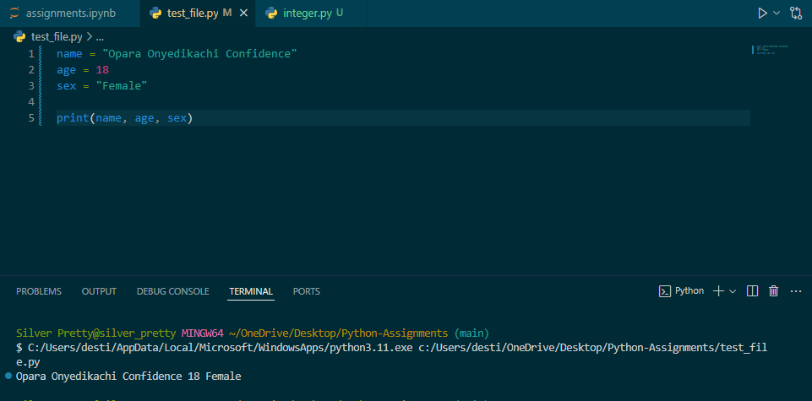

**Average of 3 Integer Numbers**

**Algorithm:**

1. **Enter the first number**
2. **Enter the second number**
3. **Enter the third number**
4. **Calculate the Average by adding the three numbers and divide the by 3**
5. **Print the Average.**

**Program:**



**Flowchart:**

Declare Variable num1, num2, num3, average

Enter the Value of Num1, Num2 and Num3

Average = (num1 + num2 + num3)/3

Print Average

**Volume of a Cylinder**

Enter Radius

Volume = (22/7) * (Radius * Radius ) * Height

Print Volume

**Chima Vera Onyinyechi**

**PYTHON PROGRAMMING LANGUAGE FEATURES**

1. **General-Purpose and High-Level:** Python is a general-purpose language, meaning it can be used for various tasks like web development, data analysis, scripting, and more.It's a high-level language, making it closer to human-readable English compared to lower-level languages that require more machine-specific instructions.
2. **Easy to Learn and Read:** Python is known for its clear and concise syntax, making it easier to learn and understand, even for beginners. Its use of whitespace indentation for code blocks contributes to readability and maintainability.
3. **Interpreted Language:** Python code is interpreted at runtime rather than compiled into machine code beforehand. This allows for faster development cycles as changes can be tested quickly without recompiling the entire program.
4. **Object-Oriented Programming (OOP):** Python supports object-oriented programming (OOP) concepts like classes, objects, inheritance, and polymorphism. This allows for code reusability, modularity, and better organization of complex programs.
5. **Extensive Standard Library:** Python comes with a rich standard library that provides built-in modules and functions for various tasks like file I/O, networking, data structures, and more. This reduces the need to write code from scratch for common functionalities
6. **Large Third-Party Library Ecosystem:** Python boasts a vast ecosystem of third-party libraries available through PyPI (Python Package Index). These libraries provide functionalities for specific domains like machine learning (TensorFlow, PyTorch), web development (Django, Flask), data science (NumPy, Pandas), and many more.
7. **Cross-Platform:** Python code can run on various operating systems (Windows, macOS, Linux) without modifications, making it a versatile language for development across different platforms.
8. **Strong Community and Resources:** Python has a large and active community of developers, offering extensive online resources, tutorials, and forums for learning and support.

**Checking Python and PIP Version**



**Name, Age and Sex:**

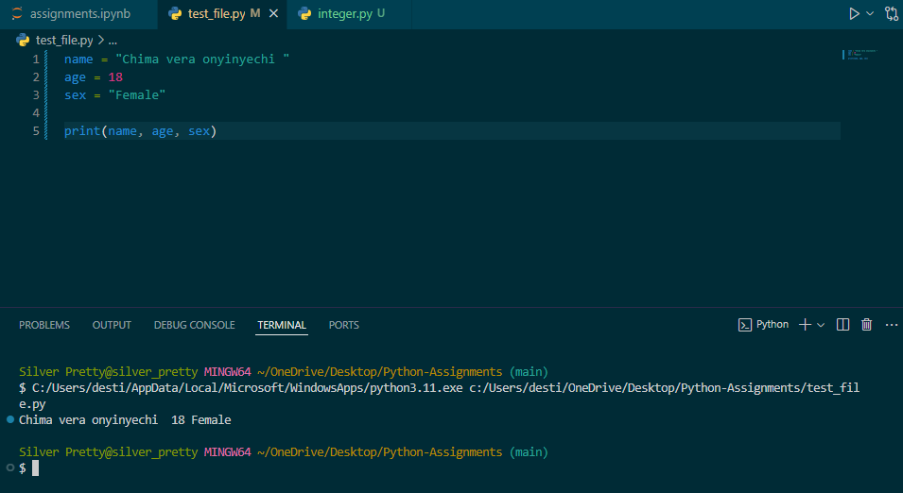

**Average of 3 Integer Numbers**

**Algorithm:**

1. **Enter the first number**
2. **Enter the second number**
3. **Enter the third number**
4. **Calculate the Average by adding the three numbers and divide the by 3**
5. **Print the Average.**

**Program:**



**Flowchart:**

Declare Variable num1, num2, num3, average

Enter the Value of Num1, Num2 and Num3

Average = (num1 + num2 + num3)/3

Print Average

**Volume of a Cylinder**

Enter Radius

Volume = (22/7) * (Radius * Radius ) * Height

Print Volume