**flyaway.com Application Screenshots**

# Version History:

|  |  |
| --- | --- |
| Author: | Meenakshi Yadav |
| Purpose: | Screenshots of the application |
| Date: | 8th November, 2021 |
| Version: | 1.0 |

Table of Content:

Flight Booking 4

Main Menu Screen Shot 4

Flight Search: 4

Selecting Date of Travel 5

Specifying Source, Destination and Number of Passengers 5

List of available flights for the given criteria 6

Adding first passenger’s details 6

Adding Second passenger’s details 7

Booking Details 8

Enter Payment Details 9

Booking Confirmation: 10

Admin Login: 11

Provide admin credentials 11

Application Administration Page 12

Manage Users 12

View all users 12

Reset Password: 13

Add New User 13

Manage Flights 14

View all flights 15

Edit flight details 16

Add New Flight 16

Add new flights details 17

Manage Source/Destinations 18

List of source/destinations 19

Edit source/destination: 19

Add New Source/Destination: 20

Database Tables 21

users 21

Flightdetails 22

Passengerdetails 23

Source/Destinations 24

# Flight Booking:

## Main Menu Screen Shot:

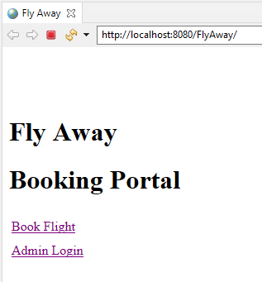

## Flight Search:

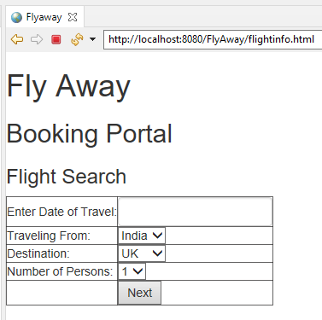

### Graphical user interface, application Description automatically generatedSelecting Date of Travel:

### Specifying Source, Destination and Number of Passengers:

Click Next

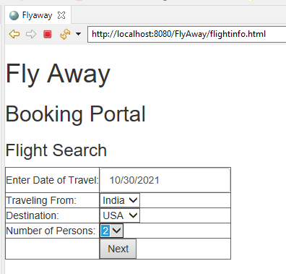

## List of available flights for the given criteria:

Select the suitable flight

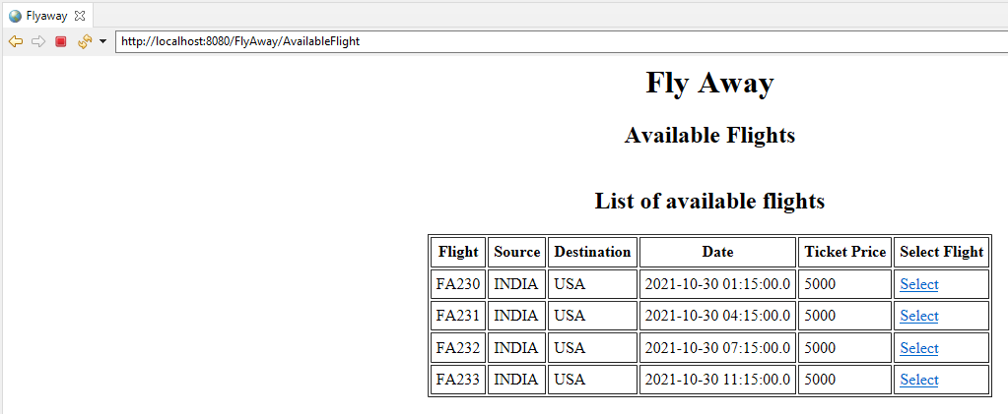

## Adding first passenger’s details:

Click Add

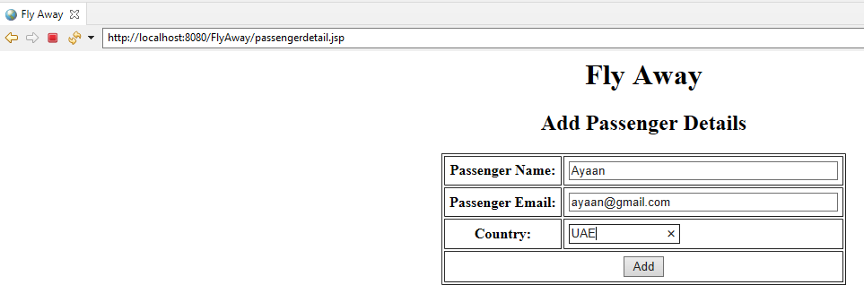

## Booking Details:

### PNR # generated

Flight, Passengers and Fare Details added Click Payment to pay

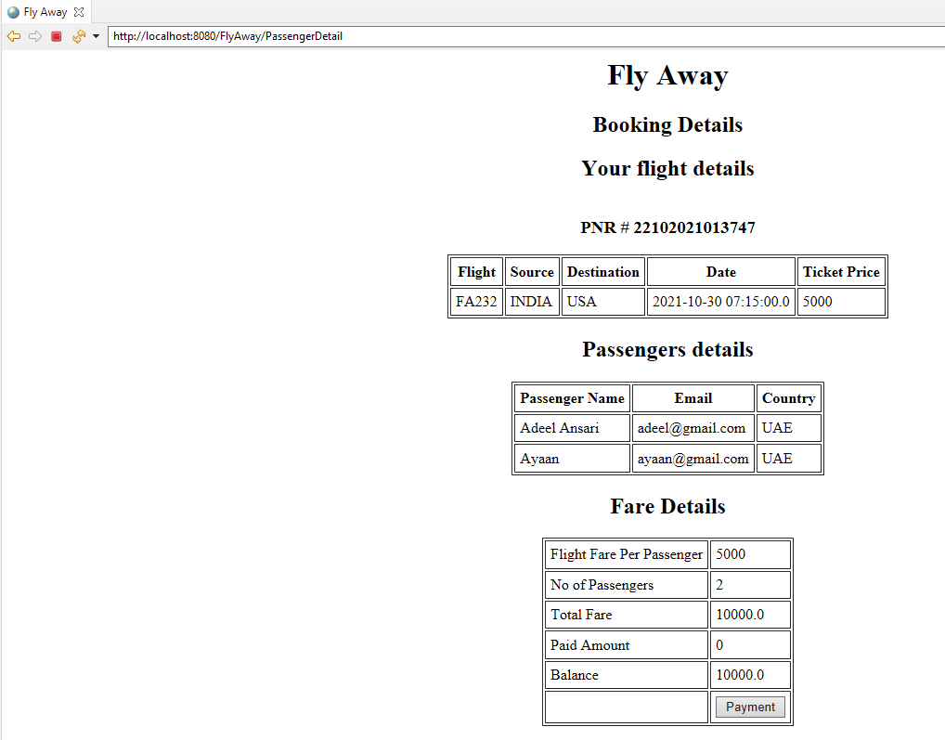







## Enter Payment Details:

Click Pay

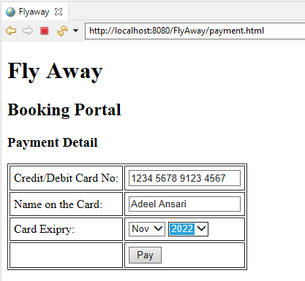

*****

***********************

***********************

## Booking Confirmation:









# Admin Login:

Click on Admin Login



## Provide admin credentials:

Provide username and password and click login (admin/admin)

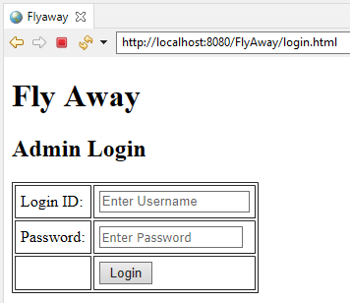

## Application Administration Page:

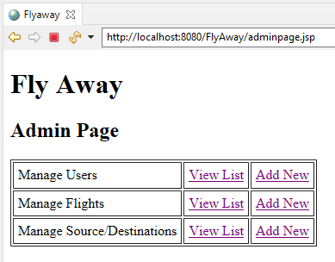

### Manage Users:

*View all users:*

To reset user’s password, click on “Reset Password”

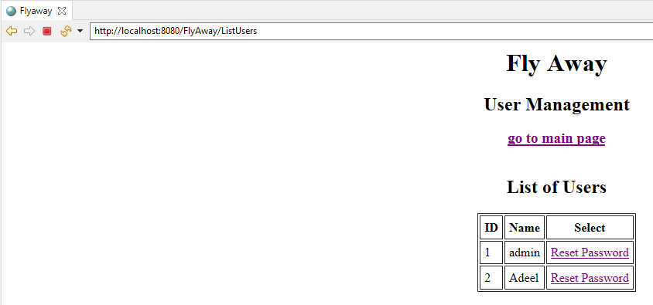

Reset Password:

*Add New User:*

Type new password and click “Reset Password”

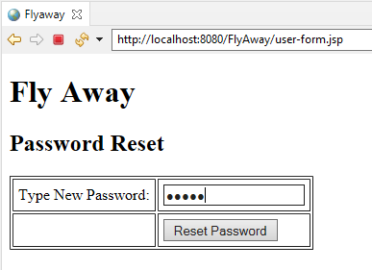

To add new user, click on “Add New”



Provide username and password, and click “Add”

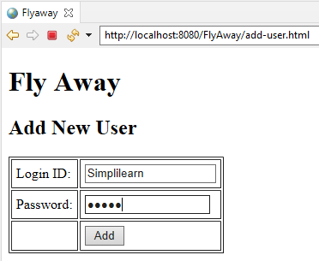

### Manage Flights:



*View all flights:*

To edit the flight details, click on “Edit Details”

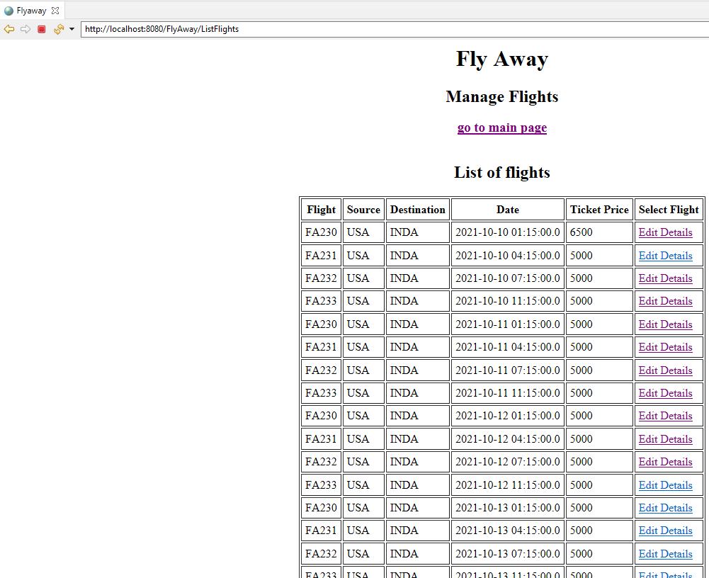

Edit flight details:

Modify the flight’s detail and click “Update”

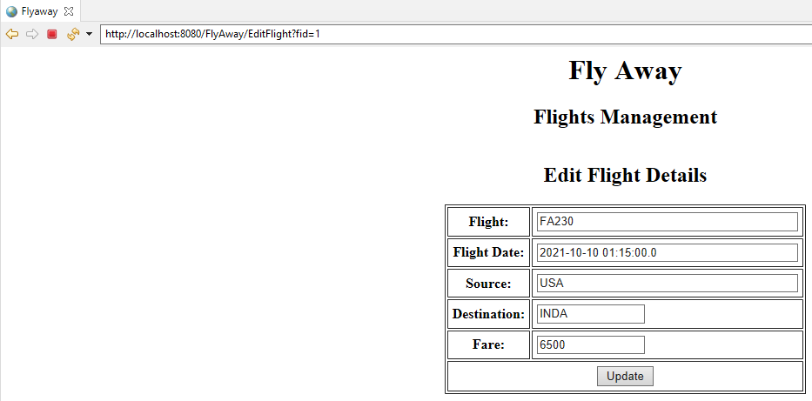

*Add New Flight:*

To add new flight, click on “Add New” for manage flights



Add new flights details:

Provide new flight’s details and click “Add”

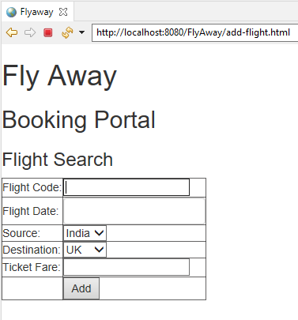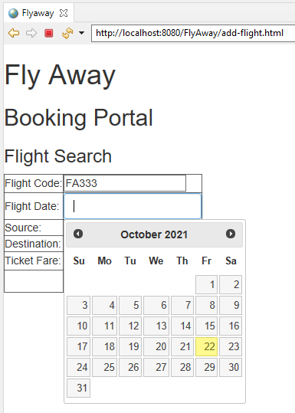

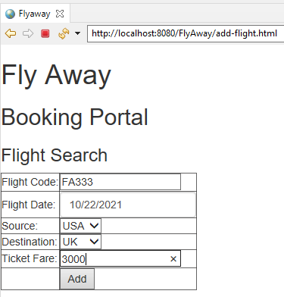

### Manage Source/Destinations:

To view list of all source/destinations, click on “View List” for manage source/destinations



*List of source/destinations:*

To edit destination, click on “Edit”

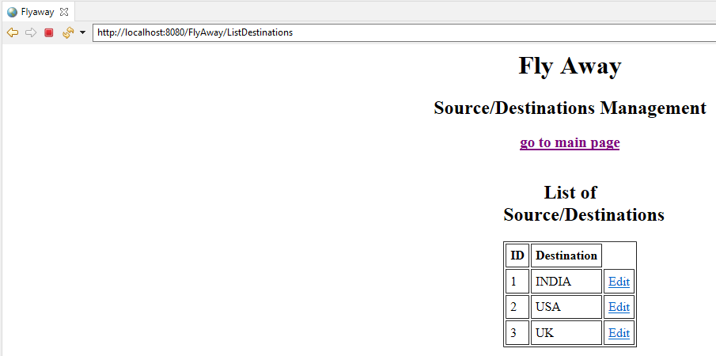

Edit source/destination:

Modify the source/destination and click “Update”

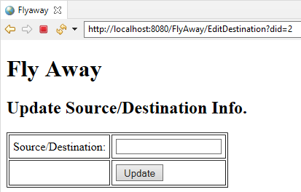

*Add New Source/Destination:*

To add new source/destination, click on “Add New” for Manage Source/Destinations



Click Add

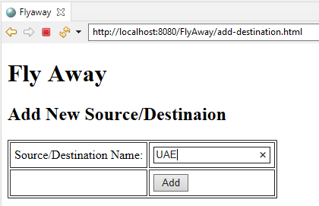

# Database Tables:

## users

\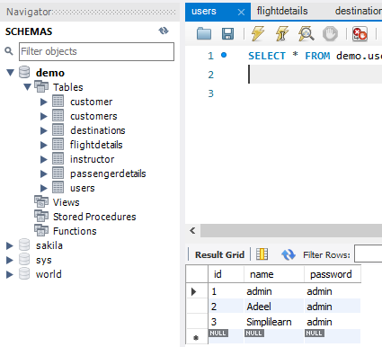

## Flightdetails

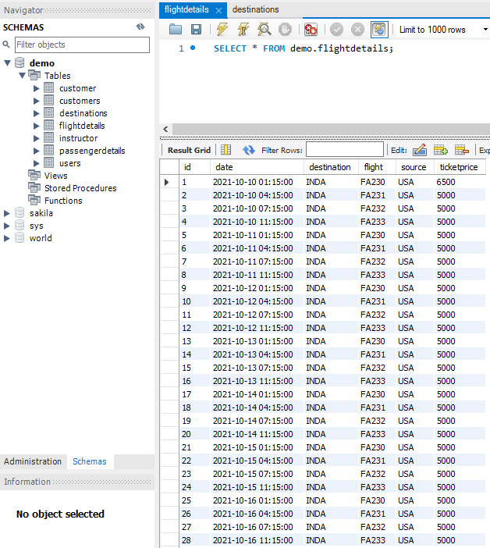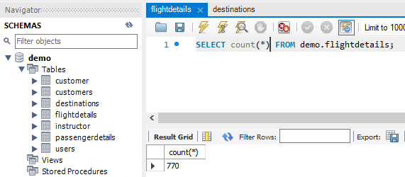

## Passengerdetails:

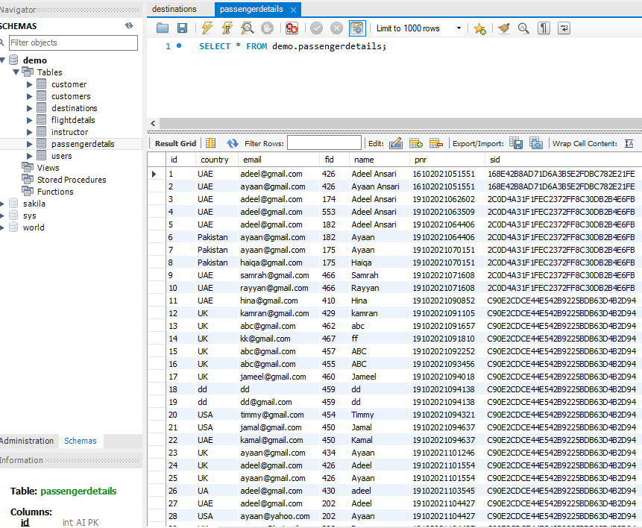

## Graphical user interface Description automatically generatedSource/Destinations: