|  |  |
| --- | --- |
| **EX.NO: 01** | **8-QUEENS PROBLEM** |
| **DATE:28.02.2024** |

**PROBLEM STATEMENT:**

You are given 8X8 chess board find a wayto place 8 queens such that no queens can attack any other queens. Aqueencanonly be attackedonly if it lies onthe same rowor columnor the same diagonalofanyother queenallthepossibleconfigurationusebacktrackingalgorithmtosolvethis problem.

**AIM:**

To backtracking to find all possible configurations of placing 8 queens on an 8x8 chess board without any queen attacking each other.

**ALGORITHM:**

**Step 1: Create an 8x8 board**: Initialize a 2D array to represent the chess board.

**Step 2: Start with the first row**: Begin placing queens from the first row.

**Step 3: Try each column**: For each column in the current row, try placing a queen.

**Step 4: Check for attacks**: Check if the queen can be attacked by any other queen already placed.

**Step 5: Place the queen**: If the queen is safe, place it on the board and move to the next row.

**Step 6: Recursively call the function**: Call the function again to place the next queen.

**Step 7: Backtrack if necessary**: If a queen cannot be placed without being attacked, backtrack to the previous row and try the next column.

**Step 8: Repeat steps 3-7**: Continue placing queens and backtracking until all 8 queens are placed or all possibilities are exhausted.

**Step 9: Print the solution**: If a solution is found, print the board configuration with the 8 queens placed.

**Step 10: Return if no solution**: If no solution is found, return an empty board or indicate that no solution exists.

**PROGRAM:**

N=int(input("Enterthenumberofqueens:")) board = [[0]*N for _ in range(N)]

defattack(I,j):

forkinrange(0,N):

ifboard[i][k]==1orboard[k][j]==1: return True

for k in range(0,N): forlinrange(0,N):

if(k+l==i+j)or (k-l==i-j): if board[k][l]==1:

returnTrue

return False defN_queens(n):

ifn==0:

returnTrue

for I in range (0,N): forjinrange(0,N):

if(not(attack(I,j)))and (board[i][j]!=1): board[i][j]=1

ifN_queens(n-1)==True: return True

board[i][j]=0 return False

N_queens(N) for Iinboard:

print(i)

**OUTPUT:**

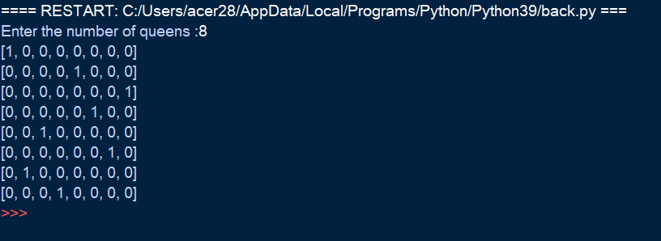

**RESULT:**

Thus the backtracking to find all possible configurations of placing 8 queens on an 8x8 chess board using python executed successfully.