|  |  |
| --- | --- |
| **EX.N0:04** | **A*SEARCH ALGORITHM** |
| **DATE:20.03 2024** |

**AIM:**

To implement the A* Search Algorithm using python.

**ALGORITHM:**

Step 1: Start

Step 2: initiate open list and close list

Step 3: While the open list is not empty, find the node with least f on the open list, call it “q”

Step 4: Stop working when you find the destination or you can’t find the destination going through all possible points

**PROGRAM:**

from collections import deque

class Graph:

    def __init__(self, adjacency_list):

        self.adjacency_list = adjacency_list

    def get_neighbors(self, v):

        return self.adjacency_list[v]

    def h(self, n):

        H = {

            'A': 1,

            'B': 1,

            'C': 1,

            'D': 1

        }

        return H[n]

    def a_star_algorithm(self, start_node, stop_node):

        open_list = set([start_node])

        closed_list = set([])

        g = {}

        g[start_node] = 0

        parents = {}

        parents[start_node] = start_node

        while len(open_list) > 0:

            n = None

            for v in open_list:

                if n == None or g[v] + self.h(v) < g[n] + self.h(n):

                    n = v

            if n == None:

                print('Path does not exist!')

                return None

            if n == stop_node:

                reconst_path = []

                while parents[n] != n:

                    reconst_path.append(n)

                    n = parents[n]

                reconst_path.append(start_node)

                reconst_path.reverse()

                print('Path found: {}'.format(reconst_path))

                return reconst_path

            for (m, weight) in self.get_neighbors(n):

                if m not in open_list and m not in closed_list:

                    open_list.add(m)

                    parents[m] = n

                    g[m] = g[n] + weight

                else:

                    if g[m] > g[n] + weight:

                        g[m] = g[n] + weight

                        parents[m] = n

                        if m in closed_list:

                            closed_list.remove(m)

                            open_list.add(m)

            open_list.remove(n)

            closed_list.add(n)

        print('Path does not exist!')

        return None

# Sample I/O

adjacency_list = {

    'A': [('B', 1), ('C', 3), ('D', 7)],

    'B': [('D', 5)],

    'C': [('D', 12)]

}

graph1 = Graph(adjacency_list)

graph1.a_star_algorithm('A', 'D')

**OUTPUT:**

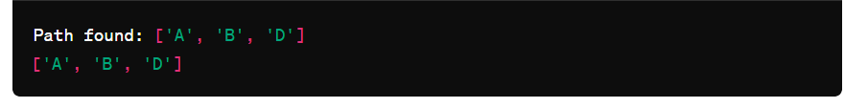

**RESULT:**

Thus, the program to implement the A* Search Algorithm using python has been done and executed successfully.