Class Performance Enhancement – Process Flow
Class Performance Enhancement – Process Flow
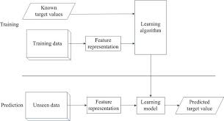
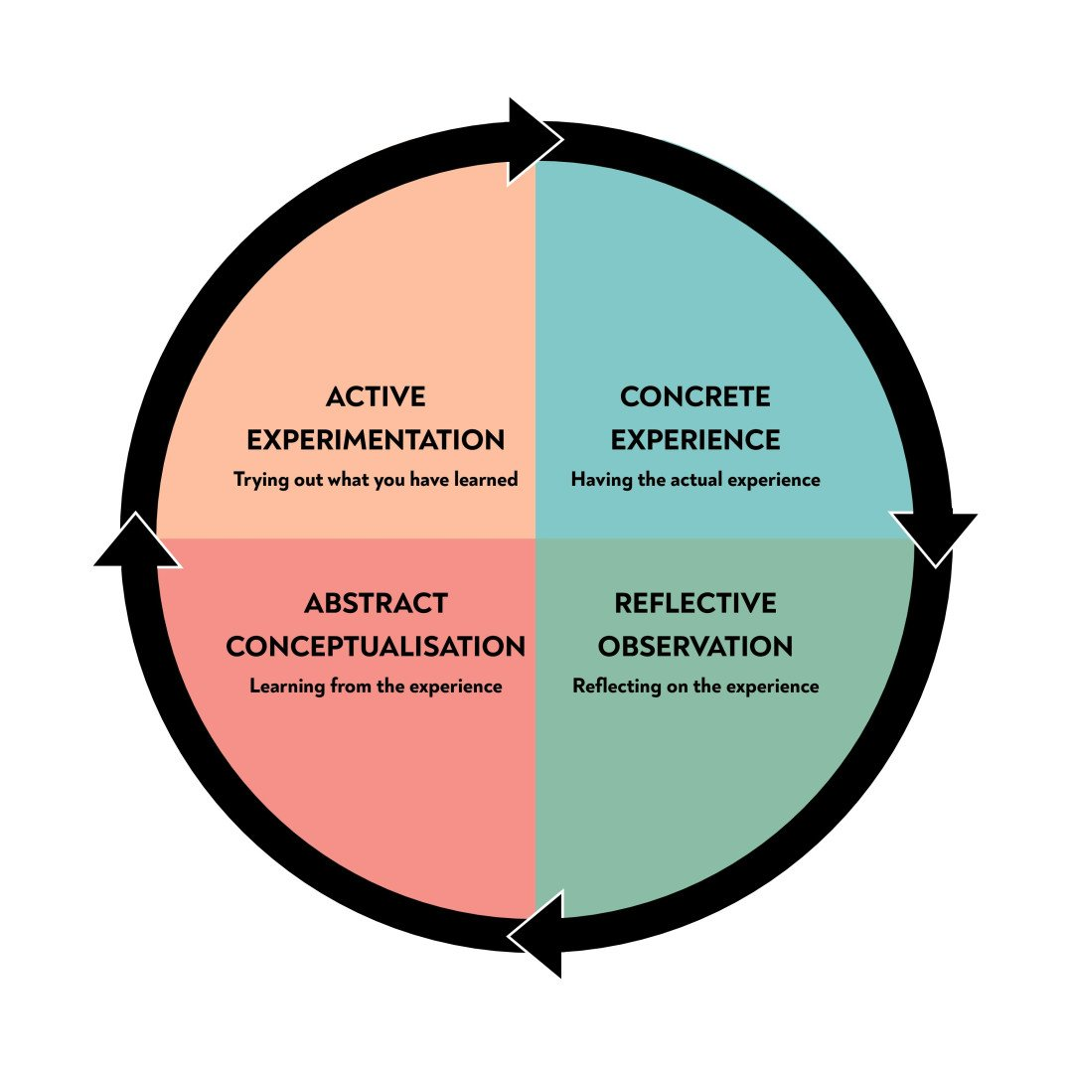
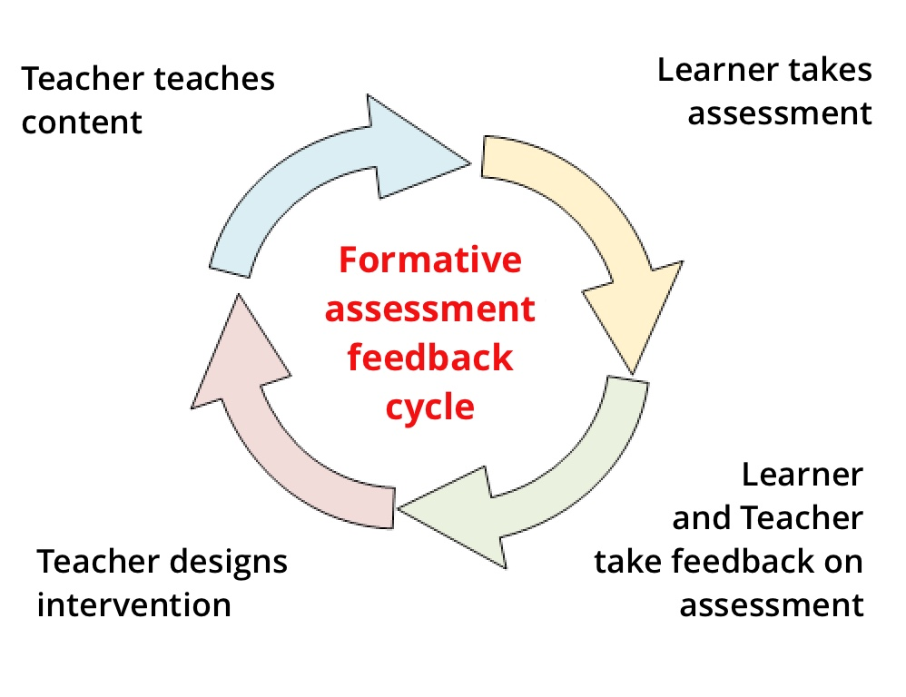
4
1. Initial Assessment
Purpose: Understand the current status of the class
- Analyze test scores, assignments, and attendance
- Observe classroom behavior and participation
- Identify high achievers, average learners, and slow learners
⬇️
2. Identify Gaps & Root Causes
Purpose: Know why performance is low or uneven
- Academic gaps (concept clarity, basics)
- Behavioral issues (lack of focus, discipline)
- Emotional or social factors (confidence, peer pressure)
- Learning barriers (language, learning pace)
⬇️
3. Set Clear & Measurable Goals
Purpose: Give direction and motivation
- Academic targets (e.g., improve average score by 15%)
- Behavioral goals (improved attendance, participation)
- Skill goals (communication, critical thinking)
- Set SMART goals (Specific, Measurable, Achievable, Relevant, Time-bound)
⬇️
4. Plan Differentiated Strategies
Purpose: Address diverse learning needs
- Remedial classes for slow learners
- Enrichment tasks for advanced students
- Group activities & peer learning
- Use varied teaching methods (visuals, discussions, activities)
⬇️
5. Engage Students Actively
Purpose: Increase interest and ownership
- Interactive teaching (questions, quizzes, games)
- Real-life examples and applications
- Encourage student voice and participation
- Build a positive, safe classroom environment
⬇️
6. Continuous Monitoring
Purpose: Track progress early and regularly
- Short tests, worksheets, oral questioning
- Observe behavioral and participation changes
- Maintain progress records
⬇️
7. Feedback & Support
Purpose: Guide improvement
- Provide timely, constructive feedback
- One-on-one mentoring for struggling students
- Communicate with parents when needed
- Appreciate improvement, not just high scores
⬇️
8. Review & Reflect
Purpose: Improve the process itself
- Compare outcomes with goals
- Identify what worked and what didn’t
- Modify teaching strategies accordingly
- Repeat the cycle for continuous improvement

4

1. Initial Assessment
Purpose: Understand the current status of the class
- Analyze test scores, assignments, and attendance
- Observe classroom behavior and participation
- Identify high achievers, average learners, and slow learners
⬇️

2. Identify Gaps & Root Causes
Purpose: Know why performance is low or uneven
- Academic gaps (concept clarity, basics)
- Behavioral issues (lack of focus, discipline)
- Emotional or social factors (confidence, peer pressure)
- Learning barriers (language, learning pace)
⬇️

3. Set Clear & Measurable Goals
Purpose: Give direction and motivation
- Academic targets (e.g., improve average score by 15%)
- Behavioral goals (improved attendance, participation)
- Skill goals (communication, critical thinking)
- Set SMART goals (Specific, Measurable, Achievable, Relevant, Time-bound)
⬇️

4. Plan Differentiated Strategies
Purpose: Address diverse learning needs
- Remedial classes for slow learners
- Enrichment tasks for advanced students
- Group activities & peer learning
- Use varied teaching methods (visuals, discussions, activities)
⬇️

5. Engage Students Actively
Purpose: Increase interest and ownership
- Interactive teaching (questions, quizzes, games)
- Real-life examples and applications
- Encourage student voice and participation
- Build a positive, safe classroom environment
⬇️

6. Continuous Monitoring
Purpose: Track progress early and regularly
- Short tests, worksheets, oral questioning
- Observe behavioral and participation changes
- Maintain progress records
⬇️

7. Feedback & Support
Purpose: Guide improvement
- Provide timely, constructive feedback
- One-on-one mentoring for struggling students
- Communicate with parents when needed
- Appreciate improvement, not just high scores
⬇️

8. Review & Reflect
Purpose: Improve the process itself
- Compare outcomes with goals
- Identify what worked and what didn’t
- Modify teaching strategies accordingly
- Repeat the cycle for continuous improvement

🔁 Continuous Improvement Loop
Assess → Plan → Act → Monitor → Reflect → Improve

How Poaching of Animals Affects Ecological Balance”
1. Basic Details
Class: 5

Subject: EVS / Environmental Studies

Topic: Poaching of Animals and Ecological Balance

Duration: 2–3 periods (40 minutes each)

2. Learning Outcomes (Student-Centered)

By the end of the lesson, students will be able to:

Define poaching in simple words

Identify animals commonly affected by poaching

Explain how animals help maintain ecological balance

Describe at least three effects of poaching on nature

Suggest ways to protect animals and stop poaching

Show concern for wildlife through discussion and activities

3. Outcome Mapping
Type Expected Outcome
Knowledge Outcome Students understand what poaching is and why it happens
Skill Outcome Students explain cause–effect relationships in nature
Value / Attitude Outcome Students develop empathy towards animals and nature
Application Outcome Students suggest actions to protect wildlife
4. Teaching–Learning Process (Aligned to Outcomes)
Step 1: Engagement (5–10 mins)

Activity:

Show pictures of wild animals (elephant, tiger, rhino)

Ask:

“What would happen if these animals disappeared?”

“Why do we need animals in forests?”

Outcome Addressed: Curiosity, prior knowledge

Step 2: Concept Introduction (10 mins)

Teacher Explanation (Simple Language):

Poaching means illegal hunting or killing of animals

Animals are killed for skin, tusks, horns, meat

Forests work like a balance system

Outcome Addressed: Knowledge outcome

Step 3: Understanding Ecological Balance (10 mins)

Explain with Examples:

Deer eat plants

Tigers eat deer

Plants give oxygen and food

➡️ If one animal is removed, nature’s balance breaks

Outcome Addressed: Concept clarity, cause–effect understanding

Step 4: Effects of Poaching (Activity-Based)

Group Activity: “What Happens If…?”
Each group discusses one effect:

Too many plants eaten

Too many animals or no animals

Forest damage

Humans affected (food chain breaks)

Outcome Addressed: Analytical & collaborative skills

5. Assessment (Outcome-Based)
Formative Assessment

Oral questioning

Think–pair–share

Worksheet (match the following / short answers)

Sample Questions

What is poaching?

Name two animals affected by poaching.

How does poaching disturb ecological balance?

6. Student Output / Evidence of Learning

Students will:

Draw a simple food chain

Write 3 effects of poaching

Create a “Save Animals” poster

Participate in role-play (Forest guard, animal, poacher)

7. Remedial & Enrichment
For Support

Use picture cards and storytelling

Simple sentence completion activities

For Advanced Learners

Short paragraph: “How can children help protect animals?”

Mini-project on a protected animal

8. Values & Life Skills Integrated

Respect for life

Responsibility towards nature

Awareness of laws and conservation

Empathy and teamwork

9. Real-Life Connection

Wildlife sanctuaries and national parks

Laws protecting animals

Role of people in conservation

Final Outcome Statement

Students understand that poaching harms animals, disturbs ecological balance, and affects humans, and they feel responsible for protecting wildlife.

If you want, I can:

Convert this into a lesson plan format

Create a student worksheet

Design a rubric for assessment

Simplify it further for slow learners

Just let me know 🌱🐘🦁

visual representation or table of the same information above

Below is a clear visual table representation of the Outcome-Based Design for Class 5 on
“How Poaching of Animals Affects Ecological Balance”.
This format is teacher-friendly and easy to include in lesson plans or notebooks.

Outcome-Based Design Table (Class 5 – EVS)
Component Details
Class / Subject Class 5 – Environmental Studies
Topic Poaching of Animals and Ecological Balance
Time Required 2–3 periods
1. Learning Outcomes
Outcome Type Expected Student Outcome
Knowledge Defines poaching in simple words
Understanding Explains how animals help nature
Application Describes effects of poaching
Skills Draws food chains and cause–effect links
Values Shows care and responsibility for animals
2. Teaching–Learning Process vs Outcomes
Teaching Step Teacher Activity Student Activity Outcome Achieved
Engagement Shows animal pictures Answers questions Curiosity & awareness
Explanation Explains poaching Listens & asks Concept clarity
Concept Building Explains food chain Identifies links Ecological understanding
Group Activity Guides discussion Discuss & present Analytical skills
Reflection Asks questions Shares ideas Value development
3. Effects of Poaching (Visual Cause–Effect Table)
Cause Effect on Nature
Animals killed illegally Decrease in animal population
Loss of predators Overgrowth of some animals
Broken food chain Ecological imbalance
Forest damage Humans affected too
4. Assessment Plan (Outcome-Based)
Assessment Type Tool Outcome Checked
Oral Q&A Understanding
Written Worksheet Knowledge
Activity Drawing food chain Application
Creative Poster making Values & awareness
5. Student Learning Evidence
Activity Expected Output
Drawing Simple food chain
Writing 3 effects of poaching
Art Save Animals poster
Role-Play Awareness of conservation
6. Support & Enrichment
Category Strategy
Remedial Storytelling, picture cards
Enrichment Mini project, paragraph writing
🔁 Visual Flow (Text-Based)

Poaching → Animal Loss → Food Chain Break → Ecological Imbalance → Human Impact

If you want, I can:

Convert this into a single-page chart

Create a flow diagram for classroom display

Make a student-friendly infographic

Provide a printable worksheet

Just tell me what format you need 📊🌿🐾

single page chart with picture

Here is a single-page chart design (with visuals) that you can print and display in the classroom for Class 5.

🐘 Poaching of Animals & Ecological Balance 🌿
(Single Page Visual Chart – Class 5 EVS)
4
What is Poaching?

👉 Poaching means illegal hunting or killing of wild animals for skin, tusks, horns, or meat.

Why Are Animals Important?

Animals are part of the food chain

They help keep nature balanced

Forests stay healthy because of animals

Simple Food Chain

🌱 Plants → Deer → Tiger

✔ Each living thing depends on another

What Happens When Poaching Occurs?
🛑 Poaching ⚠️ Result
Animals killed Animal population decreases
Predators lost Too many herbivores
Food chain breaks Nature becomes unbalanced
Forest damaged Humans are affected
How Poaching Affects Ecological Balance

➡️ Loss of animals
➡️ Broken food chains
➡️ Forests get damaged
➡️ Earth becomes unsafe for all

How Can We Help?

✅ Say NO to animal products
✅ Protect forests and wildlife
✅ Learn about wildlife laws
✅ Spread awareness: Save Animals, Save Earth

🌍 Message for Students

“Protecting animals protects our future.”

🐘 Poaching of Animals & Ecological Balance 🌿

(Single Page Visual Chart – Class 5 EVS)
