Use the Superstore_USA data and find the following scenarios

- Create a Combo Bar & Line chart

- Show the Sales & Profit with two differnt visual in one chart i.e. Sales as Bar grapgh and Profit as a line chart.

- Make sure to have different colors for different Charts.

We can use the concept of dual axis to create a combo bar and line chart.

Let’s first create 2 bar graphs for Sales and Profit for the Product sub-categories. Then change the bar graph to line for the graph representing Profit.

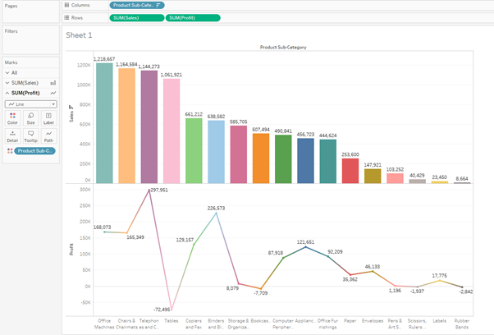

Choose dual axis on the Profit pill so both the graphs are combined. The right-click on the Profit axis and select synchronize axis.

Change the colours to represent Sales in dark yellow as bar graph and Profit in blue as line graph.

