**Acquisition:-**

**Problem statement :**

**Optiveriance** is planning to be merged with **PDCL Ltd. Brown** who is the **CEO of PDCL** is looking forward to a smooth transition and so after multiple rounds of discussion. They have decided to do audit of the business Infrastructure of **Optiveriance**.

**Justin** who the **Chief Data Officer** along with his team started auditing on the following grounds:-

First, we load the data into power bi desktop:

To do this, click on "Home" section and click on "Get data" and select "Excel data" as the data is in excel (.xlsx) format.

We will look at the datatypes, null values or if there are some errors in data in**Power Query Editor.**The Data looks just fine and no need for transformation.

Create a measure table where we will keep all the important measure and we will name it as **Imp Measures**.  Under "**Home**" section, click on "**Enter data**" and give it a name "**Important Measures**" then click on "**Load**".

**Task 1) What is the Total Sales.**

I used the following DAX formula which will sum Total Revenue to get Total Sales :

**Total** Sales = SUM(Sales[Total Revenue])

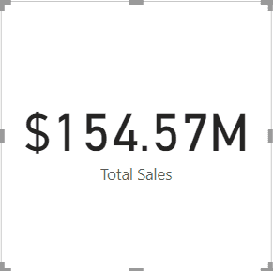

Total Sales

**Task 2) What about the Total Quantity.**

  Right-click on**Important Measures**table under **Fields**section and click on **New measure.**

Use  the DAX Formula as:-

**Total** Qty = SUM(Sales[**Order** Quantity])

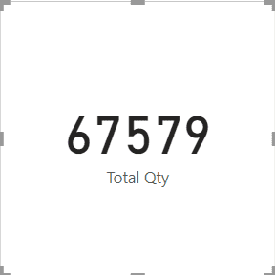

Total Quantity

**Task 3) Profit for the said period and the margin on the same.**

We will calculate**Total Cost** using below DAX formula:

Total Cost = SUMX(Sales,Sales[Order Quantity]*Sales[Total Unit Cost])

**& Total Profit** can be calculated using below DAX formula:

Profit = [Total Sales] - SUMX(Sales, Sales[Total Unit Cost] * Sales[Order Quantity])

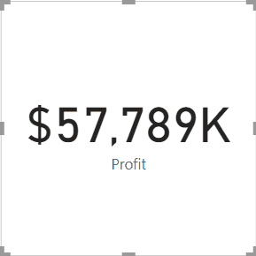

Total Profit

**Profit Margin**can be calculated using below DAX formula:

**Profit** Margin = ([Total Sales] - [Total Cost]) / [Total Sales]

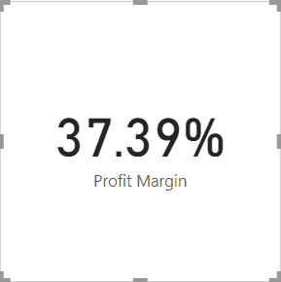

Profit Margin

**A date table will make the analysis stable.**

We need to create a Date table to create time intelligence measures and to make the analysis stable.

Before creating Date Calendar, we need to know the range of dates i.e "Start Date" and "End Date".

We create a date table by the following MQuery -

**let** fnDateTable = (StartDate **as** date, EndDate **as** date, FYStartMonth **as** number) **as** table =>

**let**

DayCount = Duration.Days(Duration.From(EndDate - StartDate)),

Source = List.Dates(StartDate,DayCount,#duration(1,0,0,0)),

TableFromList = Table.FromList(Source, Splitter.SplitByNothing()),

ChangedType = Table.TransformColumnTypes(TableFromList,{{"Column1", **type** date}}),

RenamedColumns = Table.RenameColumns(ChangedType,{{"Column1", "Date"}}),

InsertYear = Table.AddColumn(RenamedColumns, "Year", each Date.Year([Date]),**type** text),

InsertYearNumber = Table.AddColumn(RenamedColumns, "YearNumber", each Date.Year([Date])),

InsertQuarter = Table.AddColumn(InsertYear, "QuarterOfYear", each Date.QuarterOfYear([Date])),

InsertMonth = Table.AddColumn(InsertQuarter, "MonthOfYear", each Date.Month([Date]), **type** text),

InsertDay = Table.AddColumn(InsertMonth, "DayOfMonth", each Date.Day([Date])),

InsertDayInt = Table.AddColumn(InsertDay, "DateInt", each [Year] * 10000 + [MonthOfYear] * 100 + [DayOfMonth]),

InsertMonthName = Table.AddColumn(InsertDayInt, "MonthName", each Date.ToText([Date], "MMMM"), **type** text),

InsertCalendarMonth = Table.AddColumn(InsertMonthName, "MonthInCalendar", each (**try**(Text.Range([MonthName],0,3)) otherwise [MonthName]) & " " & Number.ToText([Year])),

InsertCalendarQtr = Table.AddColumn(InsertCalendarMonth, "QuarterInCalendar", each "Q" & Number.ToText([QuarterOfYear]) & " " & Number.ToText([Year])),

InsertDayWeek = Table.AddColumn(InsertCalendarQtr, "DayInWeek", each Date.DayOfWeek([Date])),

InsertDayName = Table.AddColumn(InsertDayWeek, "DayOfWeekName", each Date.ToText([Date], "dddd"), **type** text),

InsertWeekEnding = Table.AddColumn(InsertDayName, "WeekEnding", each Date.EndOfWeek([Date]), **type** date),

InsertWeekNumber= Table.AddColumn(InsertWeekEnding, "Week Number", each Date.WeekOfYear([Date])),

InsertMonthnYear = Table.AddColumn(InsertWeekNumber,"MonthnYear", each [Year] * 10000 + [MonthOfYear] * 100),

InsertQuarternYear = Table.AddColumn(InsertMonthnYear,"QuarternYear", each [Year] * 10000 + [QuarterOfYear] * 100),

ChangedType1 = Table.TransformColumnTypes(InsertQuarternYear,{{"QuarternYear", Int64.Type},{"Week Number", Int64.Type},{"Year", **type** text},{"MonthnYear", Int64.Type}, {"DateInt", Int64.Type}, {"DayOfMonth", Int64.Type}, {"MonthOfYear", Int64.Type}, {"QuarterOfYear", Int64.Type}, {"MonthInCalendar", **type** text}, {"QuarterInCalendar", **type** text}, {"DayInWeek", Int64.Type}}),

InsertShortYear = Table.AddColumn(ChangedType1, "ShortYear", each Text.End(Text.From([Year]), 2), **type** text),

AddFY = Table.AddColumn(InsertShortYear, "FY", each "FY"&(**if** [MonthOfYear]>=FYStartMonth then Text.From(Number.From([ShortYear])+1) **else** [ShortYear]))

**in**

AddFY

**in**

fnDateTable

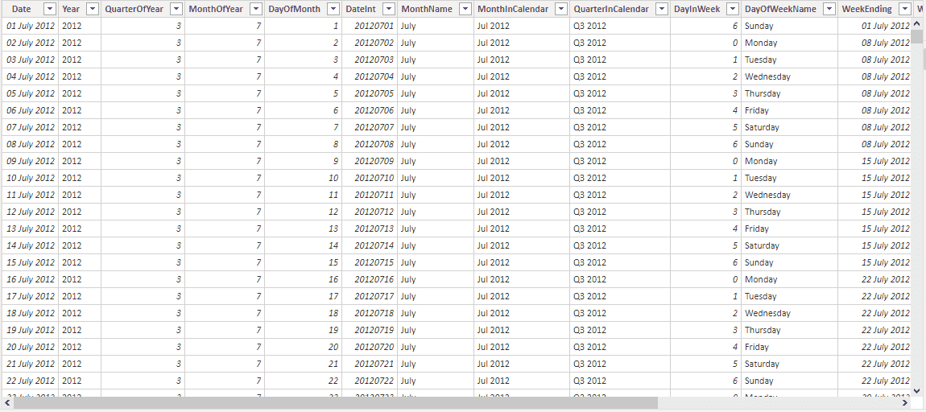

Date Dimension Table

**4.Comparing the performance LY for the selected year**

I used the following DAX measure for Performance LY for sales:

Performance LY = CALCULATE([Profit],DATEADD(DateDim[Date],-1,**YEAR**))

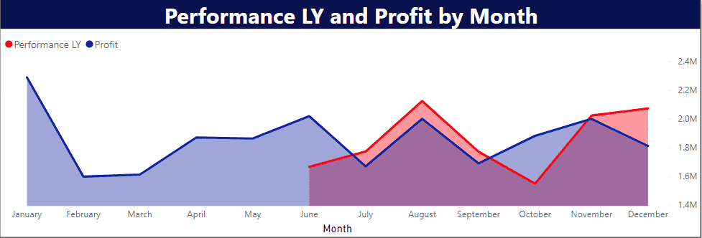

Performance of 2015 with 2014.

**5. Performance 2 years ago for selected year :**

I used following DAX formula :

**Performance** 2LY = CALCULATE([Profit],DATEADD(DateDim[Date],-2,YEAR))

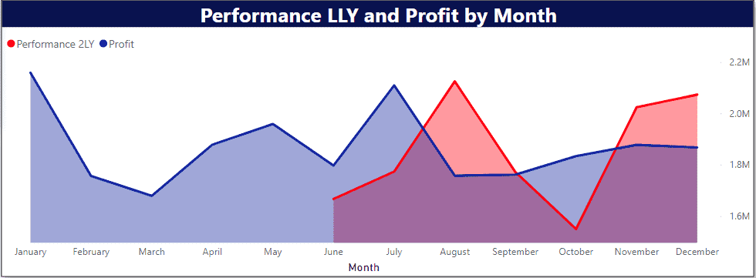

Performance 2 Years Back.

**6.Moving average in terms of sales and profit :**

I used following DAX formula to calculate Moving average in terms of sales  :

**For 3 Months Moving Average in Terms of Profit, I have used the DAX as below:-**

3 Months Moving Avg Profit = CALCULATE (

CALCULATE (

AVERAGEX ( Sales, Sales[Total Revenue] - (Sales[Total Unit Cost] * Sales[**Order** Quantity])),

DATESINPERIOD (

'DateDim'[Date],

LASTDATE ( DateDim[Date]),

-3,

**MONTH**

)

)

)

**For 3 Months Moving Average in Terms of Sales, I have used the DAX as below:-**

3 Months Moving Avg Sales =

CALCULATE (

AVERAGEX ( Sales, Sales[Total Revenue] ),

DATESINPERIOD (

'DateDim'[Date],

LASTDATE (DateDim[Date]),

-3,

**MONTH**

)

)

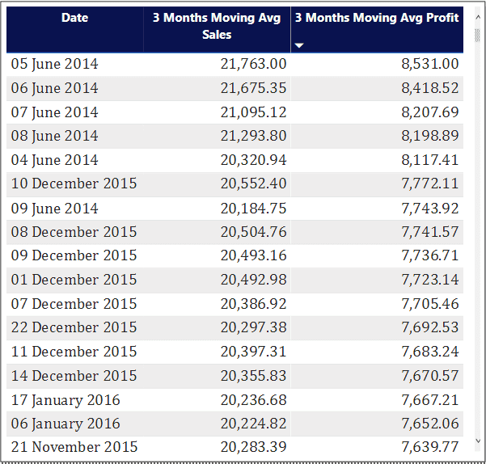

Moving Avg in terms of Profit and Sales.

**7. Quarter wise sales :**

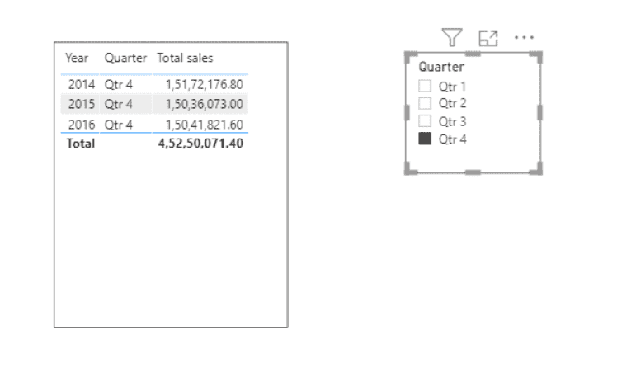

Quarter Wise Sales

**8. Total Sales, Profit and % Profit can be shown as a combo with card and line chart.**

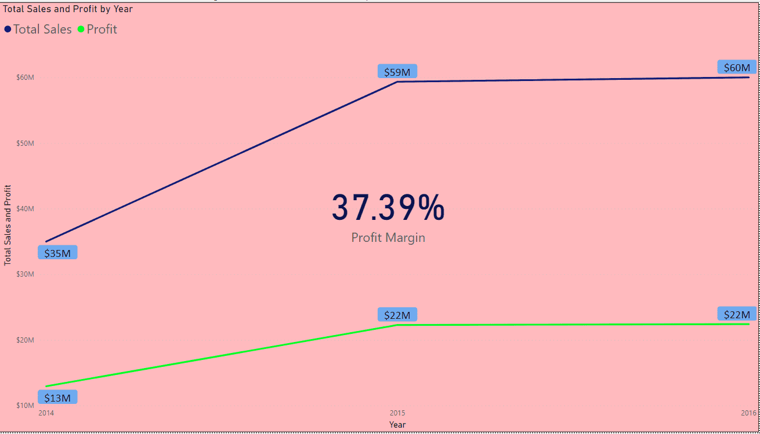

Total sales and Total profit vs year and % profit margin

**9. Cumulative performance Current year vs Last year :**

Cumulative Sales =

TOTALYTD(SUMX(Sales, (Sales[Total Revenue] - (Sales[Total Unit Cost] * Sales[**Order** Quantity]))),DateDim[Date])

Cummulative Sales LY =

TOTALYTD([Profit], SAMEPERIODLASTYEAR('DateDim'[Date]))

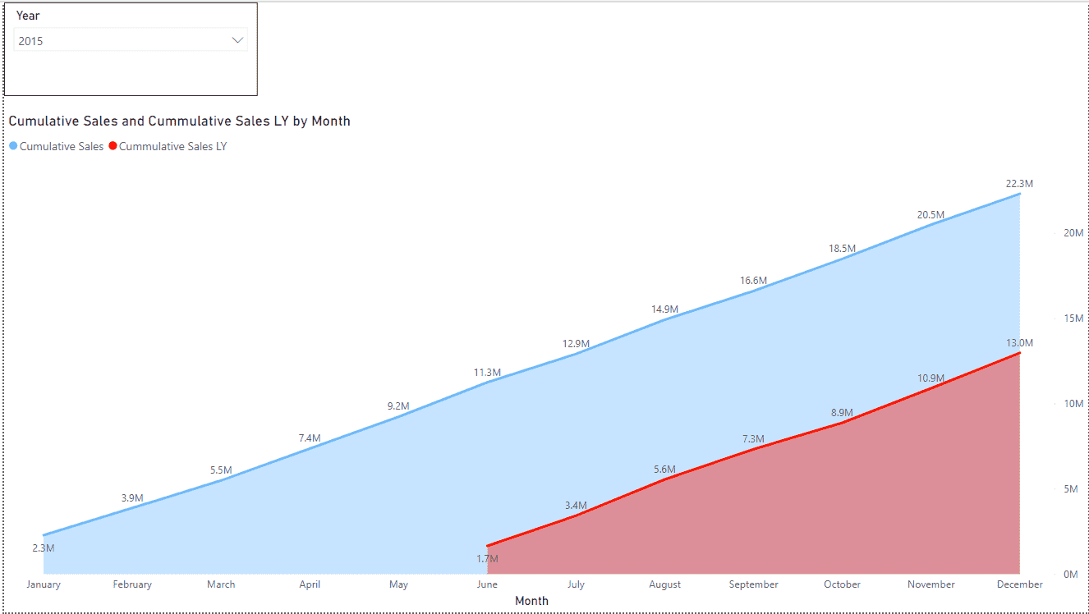

**10 . Top 7 performer in terms of Customer and Product :**

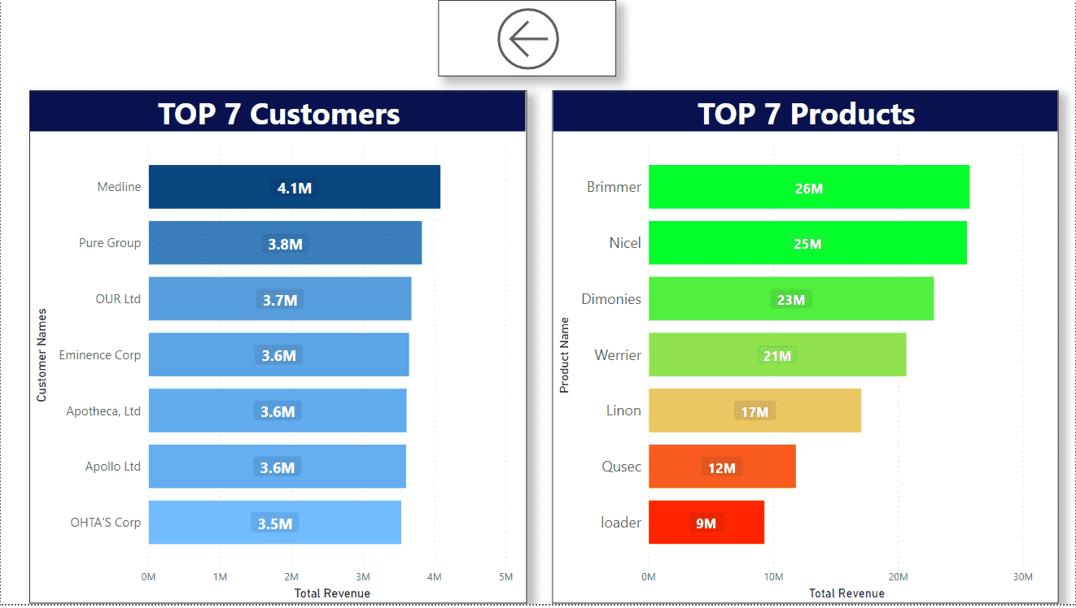

Top 7 Customers and Products

**11 . Sales by Region**

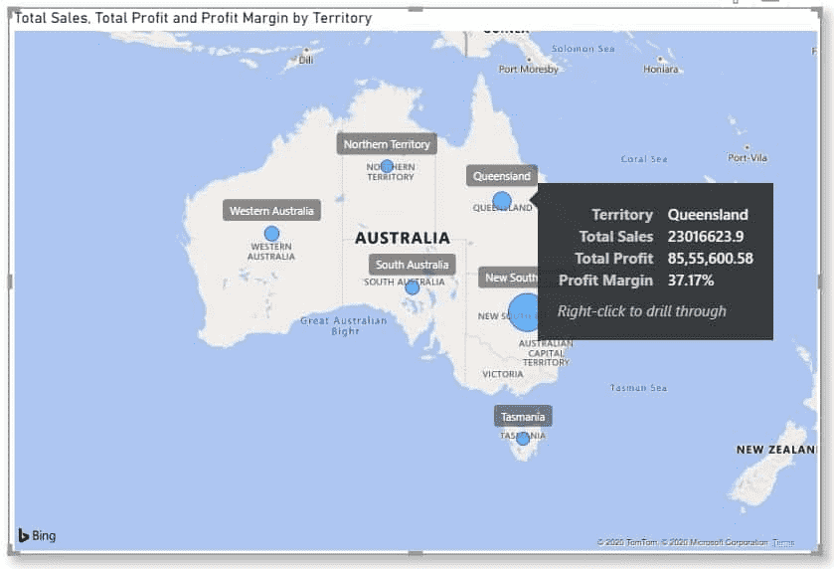

**Dashboard**

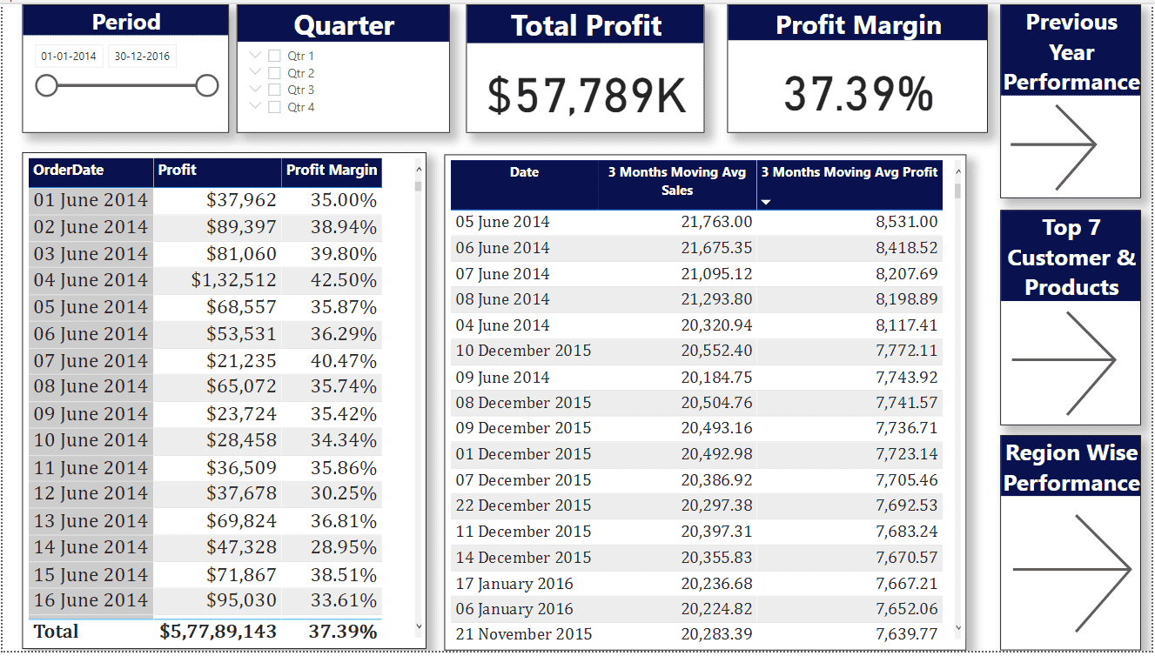

Main Dashboard.

**PRODUCT (Essies LTD).**

**Essies Ltd** is launching a new product and in the initial stage they are targeting some segmented customer and region. David the sales head has just got the new details from the frontline retailers. He has appointed Benson to infer some important insights.

We have been given Dataset in Excel format . There are some changes that I made into the dataset which are as follows:

1. Changed the data types of some columns using power query editor as they were not correct .

2.Removed the AddressLine2 ,Title  columns from Cust table . and Created new column using custom column which can properly assign titles based on gender and marital status columns.

For this I used following formula :

**if [Gender]="F" and [MaritalStatus]="S" then "Ms."else if [Gender]="F" and [MaritalStatus]="M" then "Mrs."else if [Gender]="M" then "Mr." else "Other"**

merged FirstName and LastName columns using Space separator then merged this column with Title in the same way and named the resultant column as CustomerName.

3. Removed ParentEmployeeNationalIDAlternate key column from Emp_Details table .Merged FirstName ,MiddleName and LastName columns and renamed it as EmployeeName .

4.Merged AddressLine1 and AddressLine2 in Reseller table and renamed it as Address .

5. CarrierTrackingNumber and CustomerPONumber columns are removed from Sales Deatils table

**Task 1. Create reference Date Table**

I used following M query for creating Date table :

**let** fnDateTable = (StartDate **as** date, EndDate **as** date, FYStartMonth **as** number) **as** table =>

**let**

DayCount = Duration.Days(Duration.From(EndDate - StartDate)),

Source = List.Dates(StartDate,DayCount,#duration(1,0,0,0)),

TableFromList = Table.FromList(Source, Splitter.SplitByNothing()),

ChangedType = Table.TransformColumnTypes(TableFromList,{{"Column1", **type** date}}),

RenamedColumns = Table.RenameColumns(ChangedType,{{"Column1", "Date"}}),

InsertYear = Table.AddColumn(RenamedColumns, "Year", each Date.Year([Date]),**type** text),

InsertYearNumber = Table.AddColumn(RenamedColumns, "YearNumber", each Date.Year([Date])),

InsertQuarter = Table.AddColumn(InsertYear, "QuarterOfYear", each Date.QuarterOfYear([Date])),

InsertMonth = Table.AddColumn(InsertQuarter, "MonthOfYear", each Date.Month([Date]), **type** text),

InsertDay = Table.AddColumn(InsertMonth, "DayOfMonth", each Date.Day([Date])),

InsertDayInt = Table.AddColumn(InsertDay, "DateInt", each [Year] * 10000 + [MonthOfYear] * 100 + [DayOfMonth]),

InsertMonthName = Table.AddColumn(InsertDayInt, "MonthName", each Date.ToText([Date], "MMMM"), **type** text),

InsertCalendarMonth = Table.AddColumn(InsertMonthName, "MonthInCalendar", each (**try**(Text.Range([MonthName],0,3)) otherwise [MonthName]) & " " & Number.ToText([Year])),

InsertCalendarQtr = Table.AddColumn(InsertCalendarMonth, "QuarterInCalendar", each "Q" & Number.ToText([QuarterOfYear]) & " " & Number.ToText([Year])),

InsertDayWeek = Table.AddColumn(InsertCalendarQtr, "DayInWeek", each Date.DayOfWeek([Date])),

InsertDayName = Table.AddColumn(InsertDayWeek, "DayOfWeekName", each Date.ToText([Date], "dddd"), **type** text),

InsertWeekEnding = Table.AddColumn(InsertDayName, "WeekEnding", each Date.EndOfWeek([Date]), **type** date),

InsertWeekNumber= Table.AddColumn(InsertWeekEnding, "Week Number", each Date.WeekOfYear([Date])),

InsertMonthnYear = Table.AddColumn(InsertWeekNumber,"MonthnYear", each [Year] * 10000 + [MonthOfYear] * 100),

InsertQuarternYear = Table.AddColumn(InsertMonthnYear,"QuarternYear", each [Year] * 10000 + [QuarterOfYear] * 100),

ChangedType1 = Table.TransformColumnTypes(InsertQuarternYear,{{"QuarternYear", Int64.Type},{"Week Number", Int64.Type},{"Year", **type** text},{"MonthnYear", Int64.Type}, {"DateInt", Int64.Type}, {"DayOfMonth", Int64.Type}, {"MonthOfYear", Int64.Type}, {"QuarterOfYear", Int64.Type}, {"MonthInCalendar", **type** text}, {"QuarterInCalendar", **type** text}, {"DayInWeek", Int64.Type}}),

InsertShortYear = Table.AddColumn(ChangedType1, "ShortYear", each Text.End(Text.From([Year]), 2), **type** text),

AddFY = Table.AddColumn(InsertShortYear, "FY", each "FY"&(**if** [MonthOfYear]>=FYStartMonth then Text.From(Number.From([ShortYear])+1) **else** [ShortYear]))

**in**

AddFY

**in**

fnDateTable

**2.Retail sales need to have priority in terms of High ,Mid and Low :**

  Created new column called **Priority** using custom column in power query editor .

**if** [SalesAmount] > 0 and [SalesAmount] <= 600 **then** "Low"

**else** **if** [SalesAmount] > 600 and [SalesAmount] < 1300 **then** "Mid"

**else** "High"

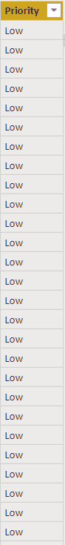

**3. Interactive slicer in terms of Country Flag in the report**

For this, we use a custom visual that is Enlighten World Flags.

We get the output as follows by putting the country name from the Region table in the Country field.

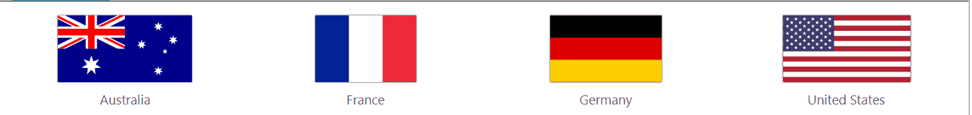

Country Flag Slicer

**Essies Dashboard needs to highlight the following:-**

**o Units Sold by Category**

**o Total Unit sold**

**o Retail Unit Sold**

**o Sales Unit Sold**

DAX for Retail Units Sold:-

Retail Unit Sold = SUM(RetailSales[OrderQuantity])

DAX for Sales Units Sold:-

Sales Unit Sold = SUM('Sales Details'[OrderQuantity])

DAX for Total Units Sold:-

Total Unit Sold = [Sales Unit Sold]+'Imp Measures'[Retail Unit Sold]

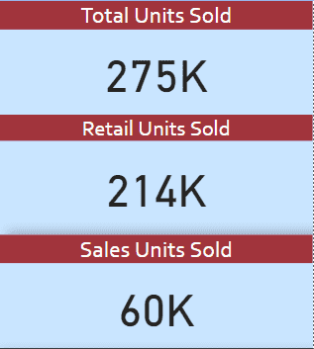

**Units Sold by Category:-**

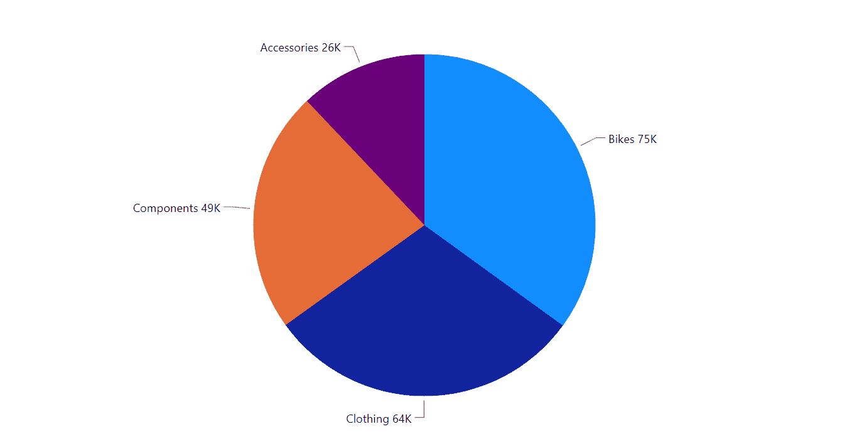

**Among all the new retailer top 10 should be highlighted in terms of unit sold.**

I have Used the Top N filter to get the top 10 Retailers by Unit Sold we have to drag and drop specific fields.Top

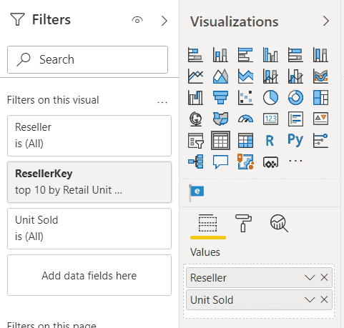

TOP N filter

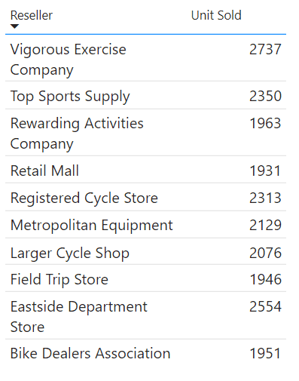

Top 10 Retailers

**Top performing Products in  terms of unit sold.**

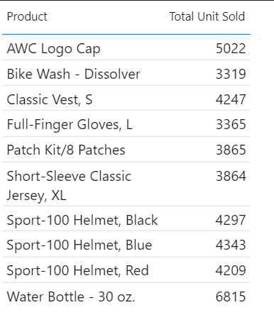

Top 10 Products

**Unit sold in promotion event in terms of reseller, no discount, & Customers**

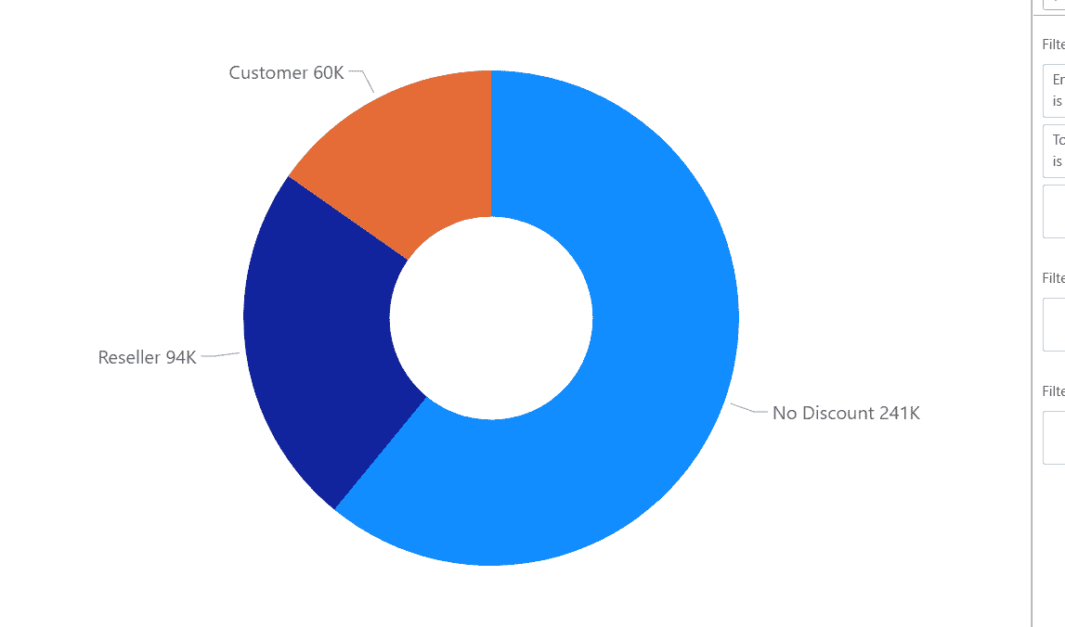

Promotion

**Top performing in subcategories in terms of Unit sold**

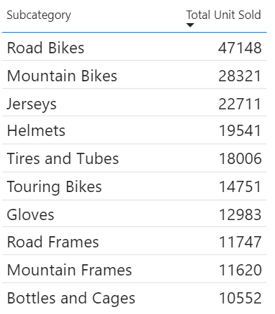

**Final Dashboard :**

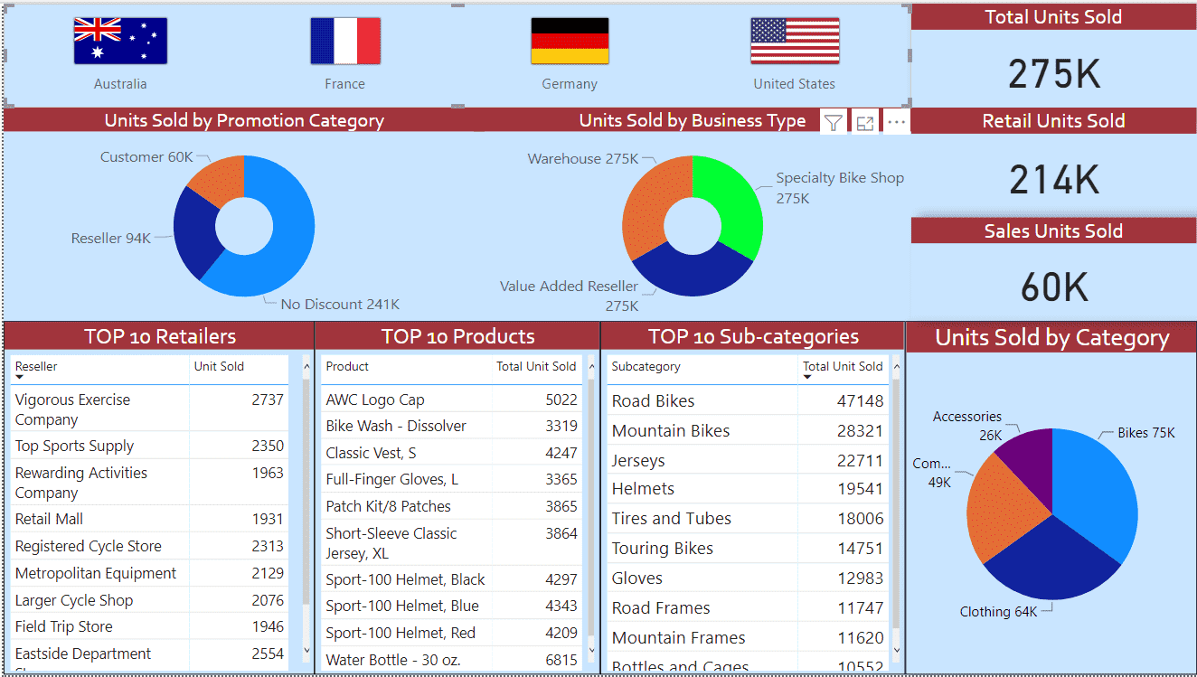

Main Dashboard

**STUDENT  SPEND  ANALYSIS.**

We will get the Insights into how much students are spending on different kind of purchases like Video games, Indoor games, Toys, Books, Gadgets etc.

**Table Visual**showing total amount of purchases by students across different locations-

In this task, format Total Amount of Purchase (TAP) based on Store Location and Store Setting using the following condition:

• If 0<TAP<35000, then records should be in red color

• If 35000<=TAP<60000, then records should be in yellow color

• If TAP>=60000, then records should be in Blue color

We do this as follows by going into formatting for a text table. We choose the field formatting option and do the following -

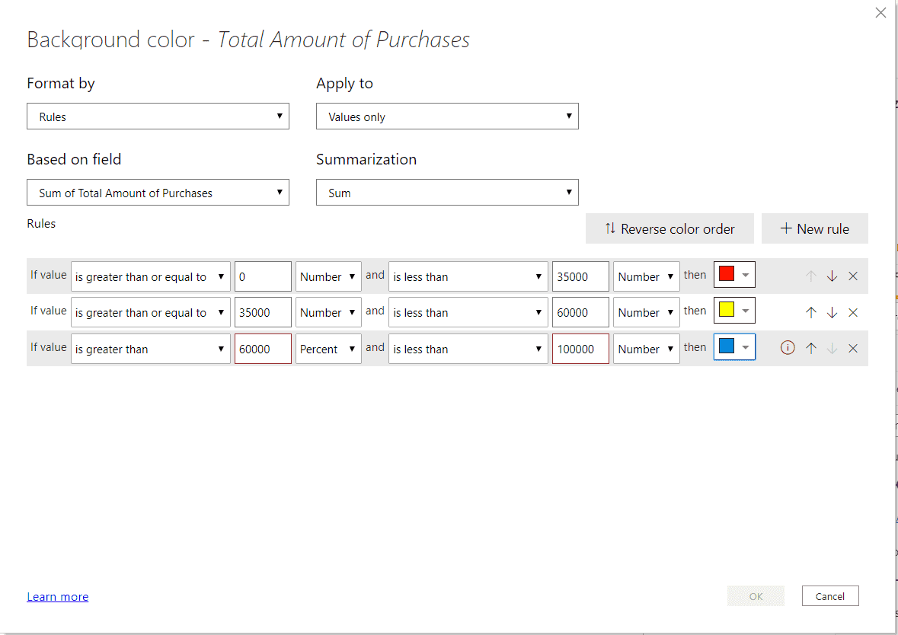

Conditional Formating

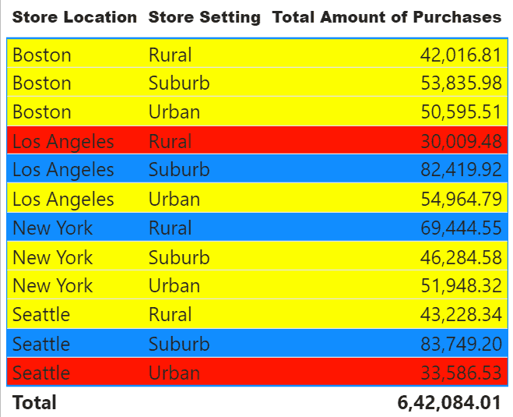

Tabular Visual.

**Matrix Visualization** – Create Matrix Visualization to show the amount spent on Outdoor sports across different ages and ‘Store setting’. Do the color formatting for the amount spent in total outdoor sports.

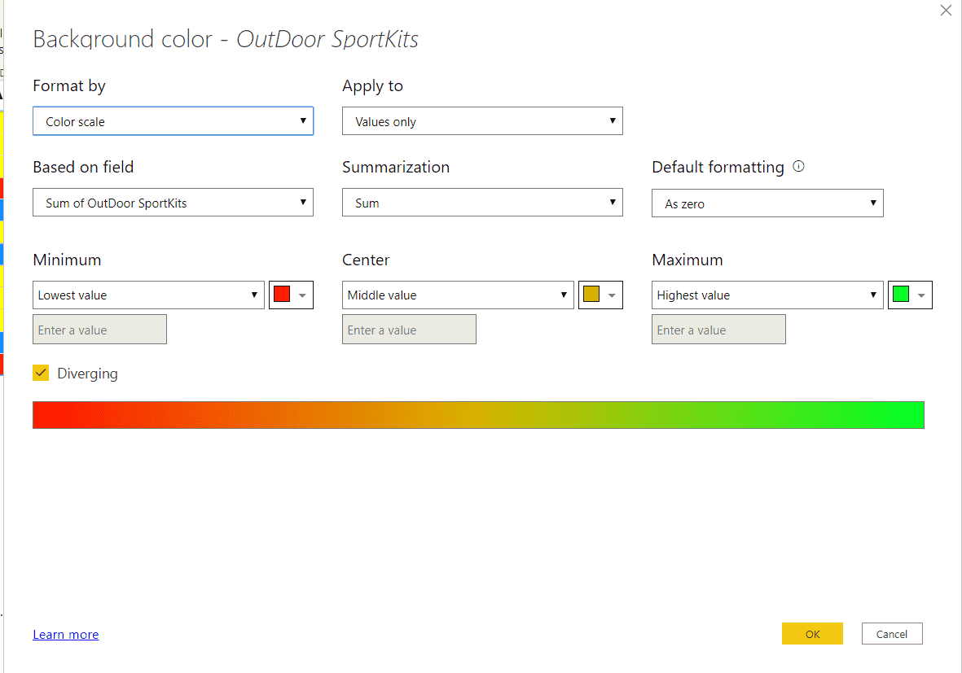

Conditional Formating for Outdoor.

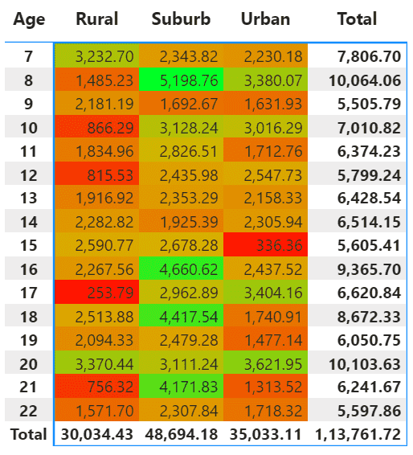

Matrix Visualization.

**Funnel chart** – Create a Funnel chart to show Total amount of purchase by ‘Store setting’. Show the data labels as Percentage of First.

We create a Funnel chart to show Total amount of purchase by ‘Store setting’. We need to show the data labels as Percentage of First.

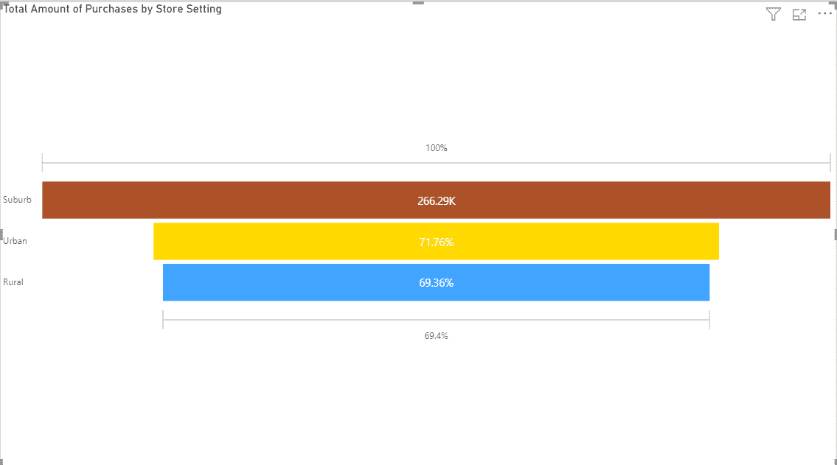

**Pie chart** – Show the total amount of purchase by different ‘Store location’ for Suburban ‘Store setting’ only.

We have to **Drag and Drop "Store Setting"** table into the Filter Pane and Select **Basic filtering** option for Filter Type. In Store Setting, only **"Suburb"** checkbox should be ticked.

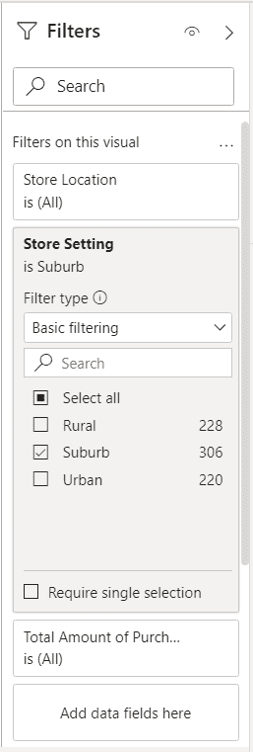

Filtering for Suburb Store Setting.

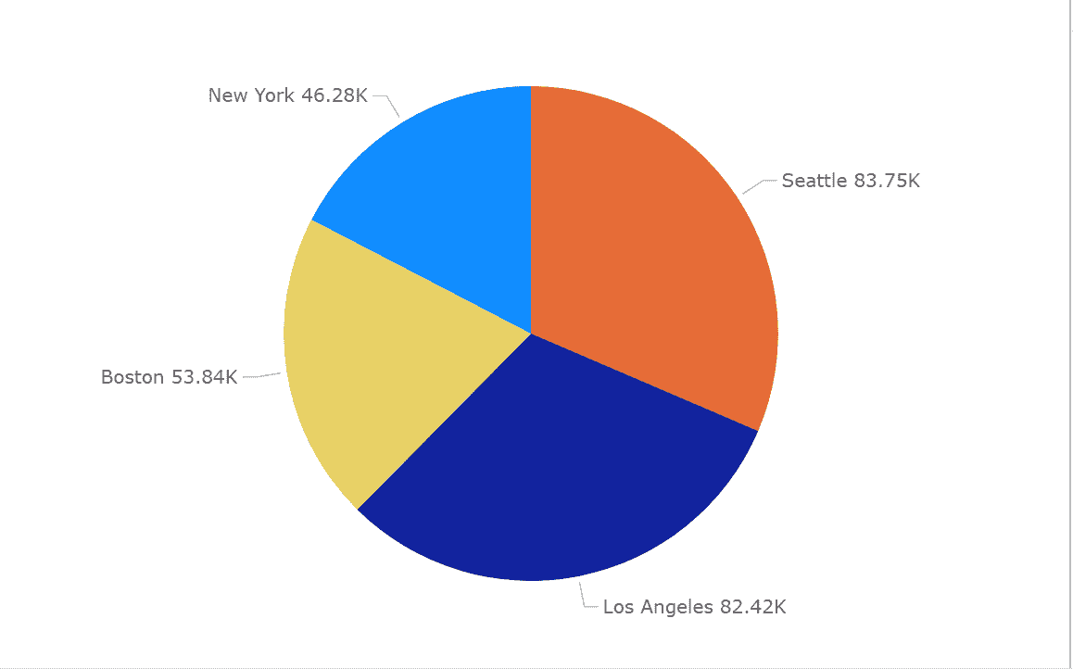

Pie Chart

**a) Scatter plot** - Video games purchase and Outdoor sports spent across the different ages.

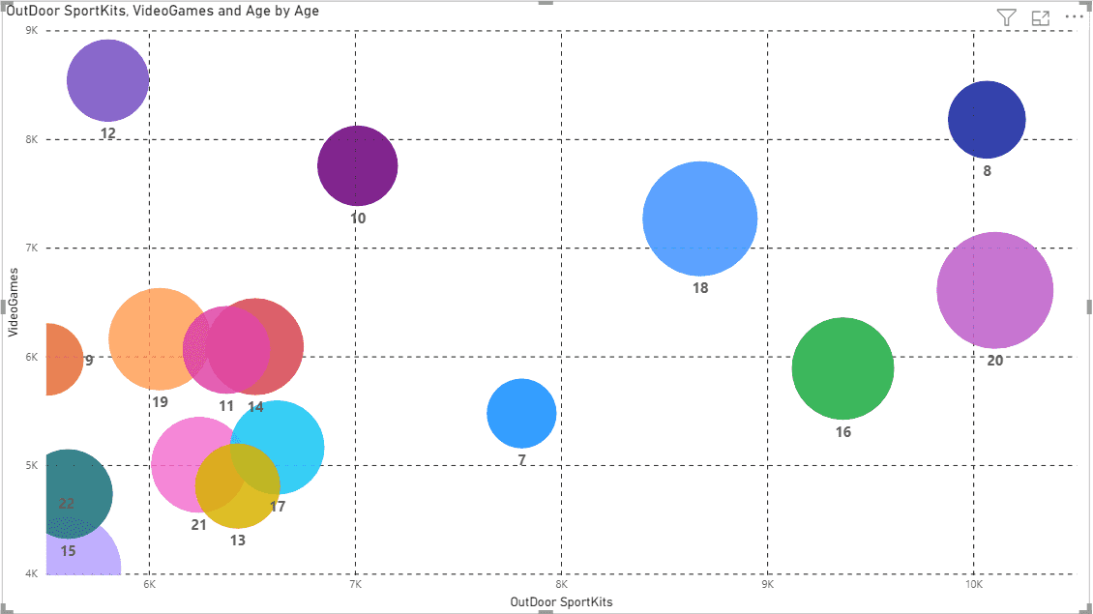

Scatter Plot

**b) Sand dance plot** - Indoor sports and Video games spent across the different age groups.

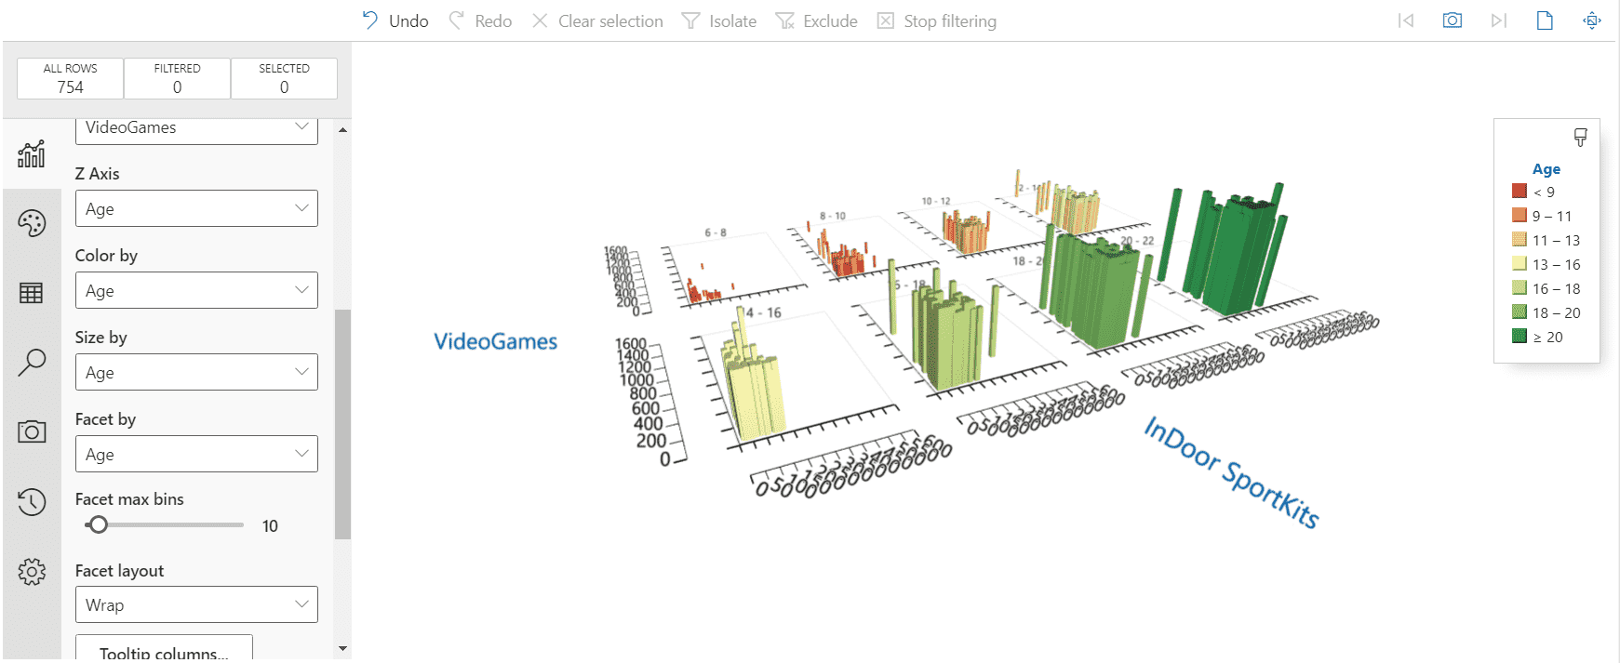

Sand Dance Plot.

**6.Restrict data access for the given users in User mapping table.**

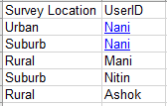

User

• Mani deals with Rural only.

• Nani deals with Urban only.

• Nitin deals with Suburb only.

• Ashok deals with Rural only.

To restrict access according to assigned roles:

**Modelling ->Manage roles ->Create**

Name it as **Mani**, select Student Survey table then click on 3 dots and select add filters and select Store Setting then substitute value as **"Rural"** and save.

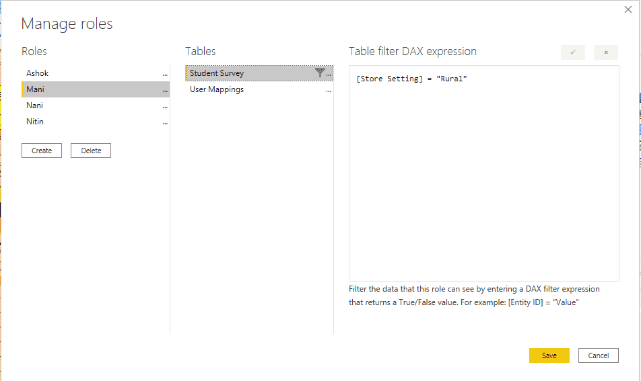

Assigning Roles to particular User.

**View As Role:-**

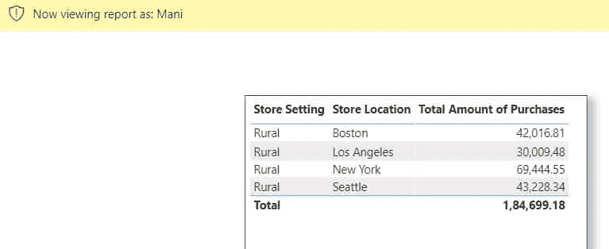

Viewing as Mani.

**To schedule refresh in power BI service :**

*My workspaces ->Project 3 ->click on 3 dots ->schedule refresh ->gateway connection ->data source credentials ->privacy level setting to private ->schedule refresh*

Give the time as per requirement , I have given schedule of **daily 4 hours.**

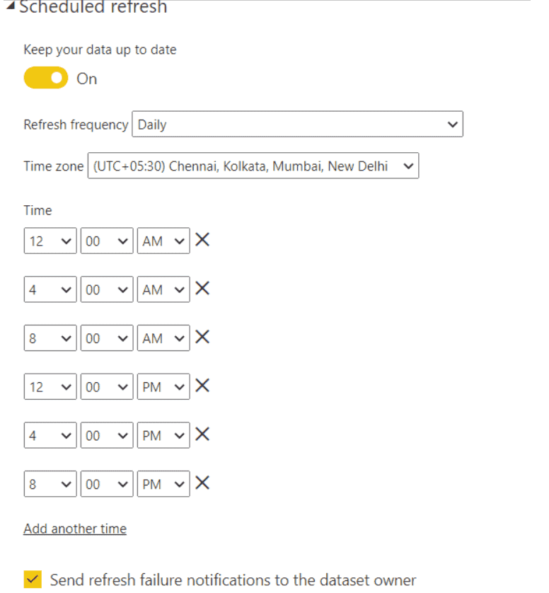

**8. Use Q&A feature of Power BI –**

a) To show average age of students

b) Donut chart for total amount of purchases by ‘Store location’

