**Assignment 1 - Dashboard**

**Problem statement**

You have been hired by a Bank that is currently operating in Europe. The bank has asked you to help them to ease the process of analyzing its data. The management has provided with a few queries for you to solve.

• Create a Map chart showing the number of transactions processed in each region.

• Create a Pie chart displaying the percentage of each transaction processed between genders.

• Create a Histogram displaying the distribution of age and transactions processed.

• Create a Histogram displaying the distribution of balance and transactions processed.

• Create a Tree-map displaying the number of transactions processed within the classification of each job.

• Create a Dashboard using all the charts. Make use of Action Filters as it will further improve the analyzing experience for the management.

**Solutions**

Task 1 - Map Chart

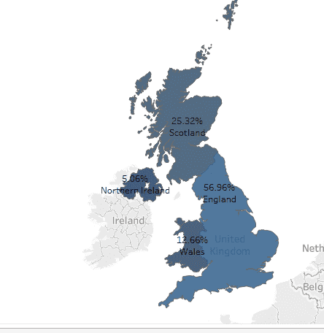

Task 2 - Pie Chart

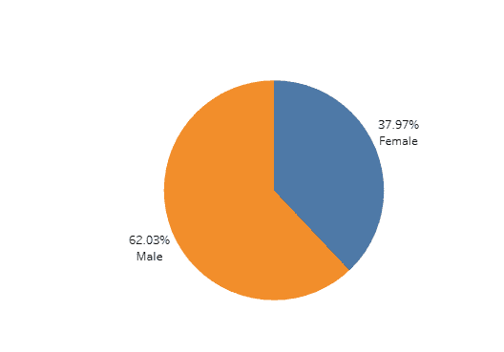

Task 3 - Histogram - Distribution of age and transactions processed

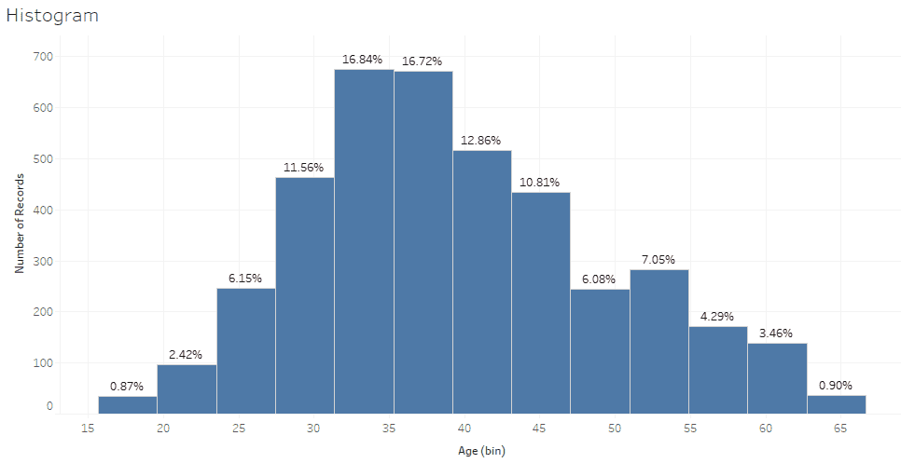

Task 4 - Histogram - Distribution of balance and transactions processed

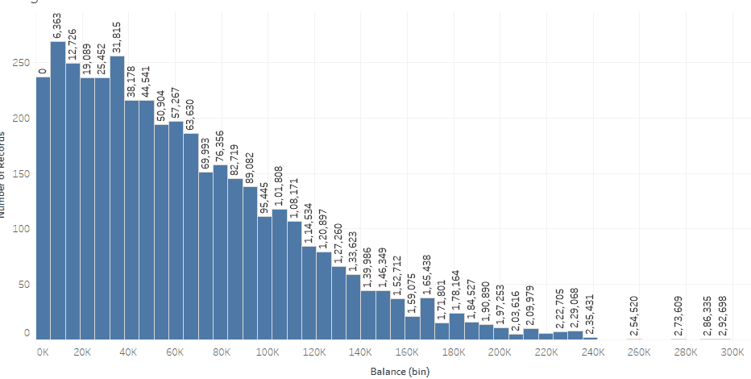

Task 5 - Tree Map

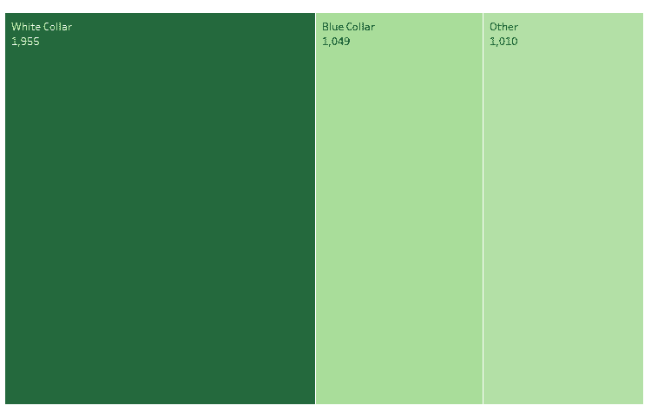

Task 6 - Dashboard

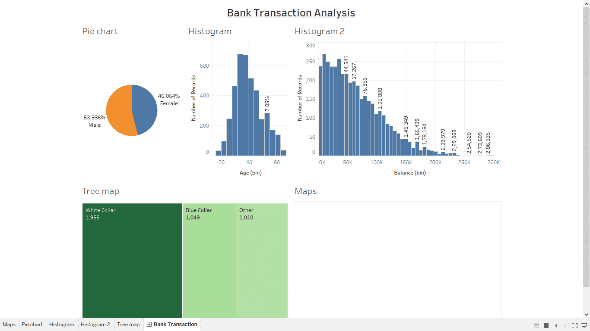

Task 7 - Action filter

