**Project 1 - Dow Jones Industrial Average**

We need to create a Heat Map Calender. I followed Kevin Taylor’s post on Tableau blog to create the heatmap Calender to depict the Daily Change in the Dow Jones Industrial Average.

1)      Creating the skeleton of a Calender

-          Drag the dimension Date to the Columns shelf

-          Right clock on the Date pill in Column shelf and choose Weekday from the discrete Date parts.

-          Drag the Date dimension to the Row shelf and select Week from the discrete date parts.

-          Right-click on Week and uncheck Show Header.

-          Drag the Date dimension onto the filter shelf.

-          Select Month/Year from the discrete data parts and click Next.

-          Select any month, year (we will select 2016 as per the requirement).

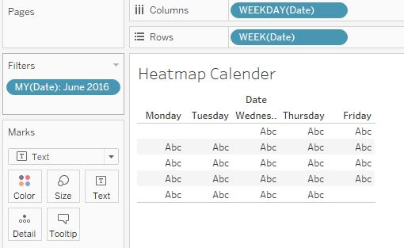

2) Add colour to the Calender by placing the measure on to the Colour under Mark and change the Shape to Square. Change the colour as per requirement by changing the Palette to Red-Black Diverging.

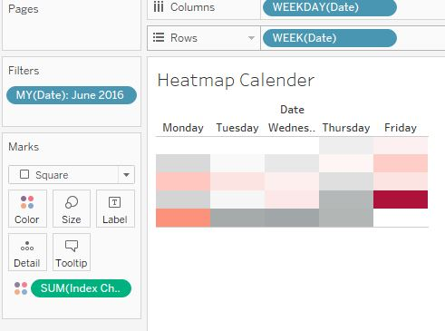

3)Further format the image to make it more presentable, with the dates.

-          Right-click and drag Date to the Label shelf and select DAY from the discrete date parts. Click the Label shelf and change alignment to Upper Right.

-          Right-click WEEKDAY(Date) in the Columns shelf and select Format

-          Under Header »»» Default »»» Dates »»» Select Abbreviation

-          Click the Colour shelf »»» click border »»» choose White

-          Right-click open space and click Format »»» Go to Format Borders »»» Under Row Divider »»» change Pane to None.

-          Select all 12 months from 2016, and set the view to Fit Height.

4) Create a calculated field Column Index to get each month to align to its corresponding column.

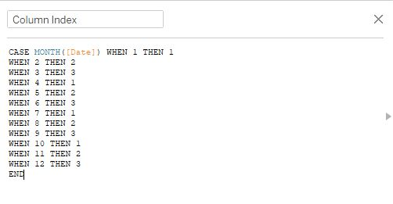

Drag the calculated Column Index from Measures to Dimensions and also to the left of WEEKDAY(Date) in the Columns shelf.

5) To collapse the Months so that they appear next to each other, we will create a Week Index using calculated field.

-          Create a calculation called Week Index as follows:

**DATEPART('week', [Date]) - {FIXED DATEPART('month',[Date]): MIN(DATEPART('week', [Date]))}**

This calculation first looks at the week number at the level of the visualization and then subtracts the minimum week number at the Month Level.

-          Drag Week Index from Measures to Dimensions and drag it to on top of WEEK(Day) in the Rows shelf

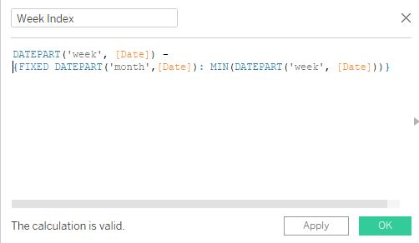

6) Right-click and drag Date to the left of Week Index in the Rows shelf and select Quarter(Date) from the discrete date parts.

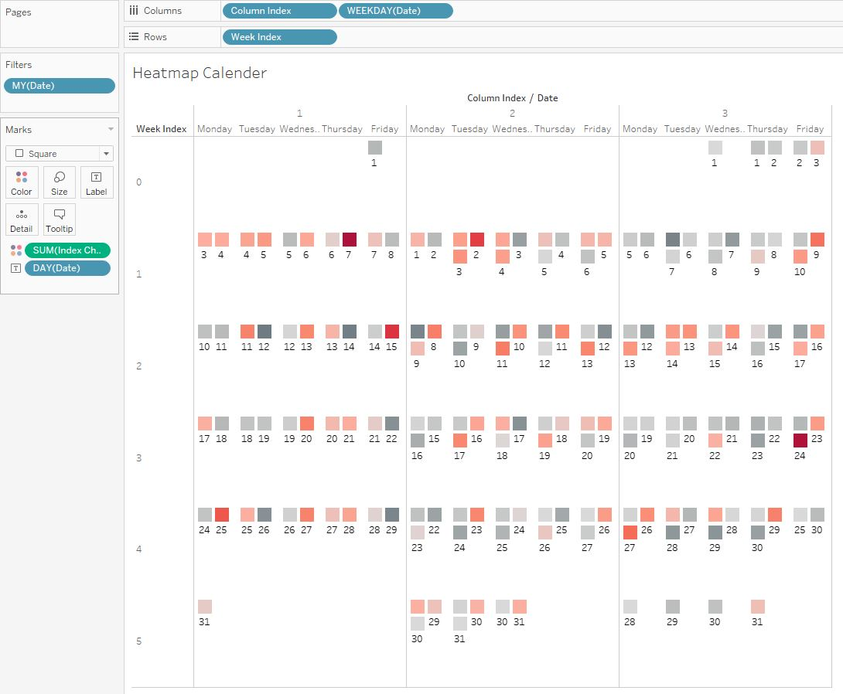

7) Format further by unchecking How header for Week Index, Column Index, Quarter of Date. Align the Quarter to Middle Center. Right-click and drag Date to the left of Column Index in the Columns shelf and select YEAR(Date) from the discrete date parts.

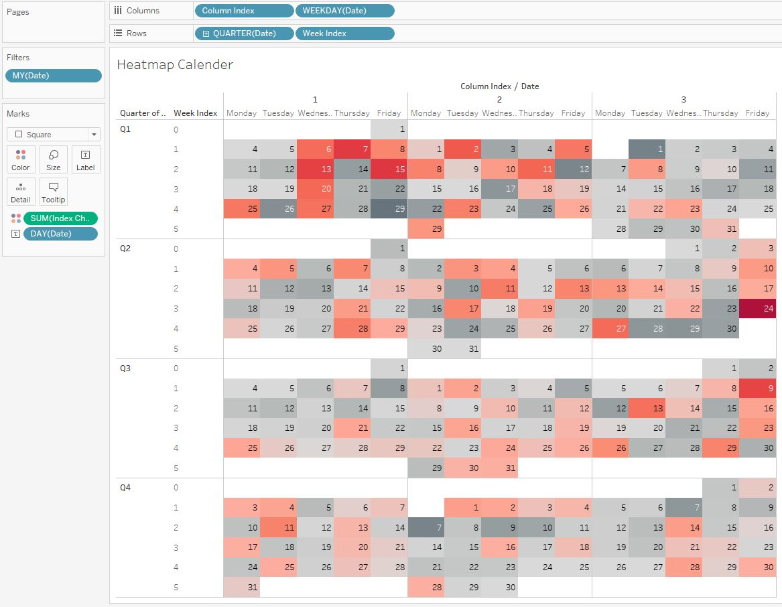

-          Right-click in whitespace and select Format

-          Go to Format Borders and change the pane setting for both the Row and Column Divider to the thickest width line and color set to white

Click the Color shelf and change the borders color to the bottom gray in the second column from the left.

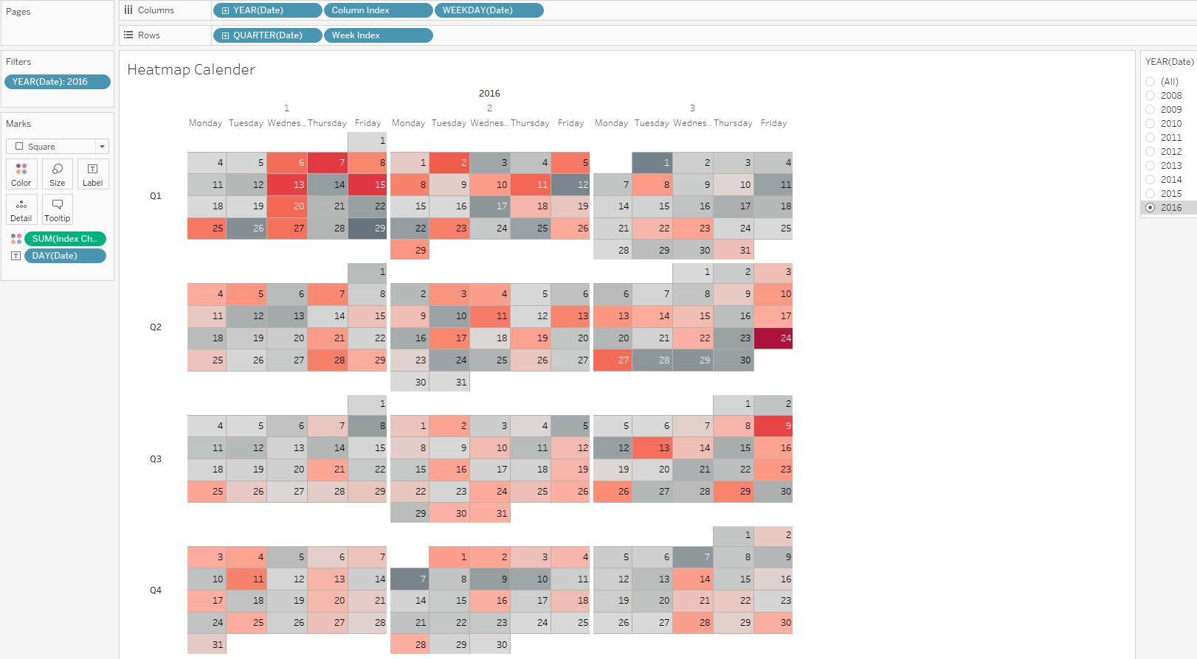

8) Further add Year to the filter shelf and show the filter as a single value dropdown and remove the previous month/year filtered we had selected in the beginning that was set to 2016.

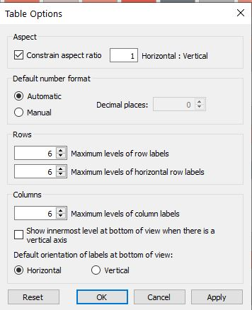

We can month labels above the first week of each quarters. Change the Week Index to continuous so we can use the secondary axis for month labels.  Double click on the axis and set the labels to reversed. Change the Square Mark to Gantt Bar. Drag and drop average number of records on Size so everything will be 1. Adjust the alignment of the Label marks to be Right Middle. Go to Analysis in the menu bar »»» Table Layout »»» Advanced and uncheck the Show innermost value at the bottom of view. So the Weekdays are shown at the top.

9) Now we need to use secondary axis to put month labels. We create a calculated field called Week Label.

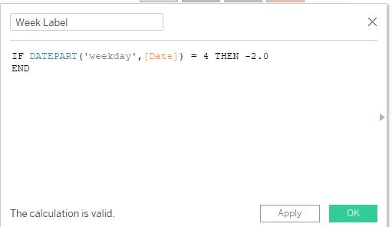

This says if I am on Wednesday then give a dot at -2.0

10) Drag and drop Week Label on the secondary axis and select synchronize axis. Keep only the Labels Mark and change it to Month. Change the Gantt Mark to Text.

Format further to remove the grid lines and zero lines.

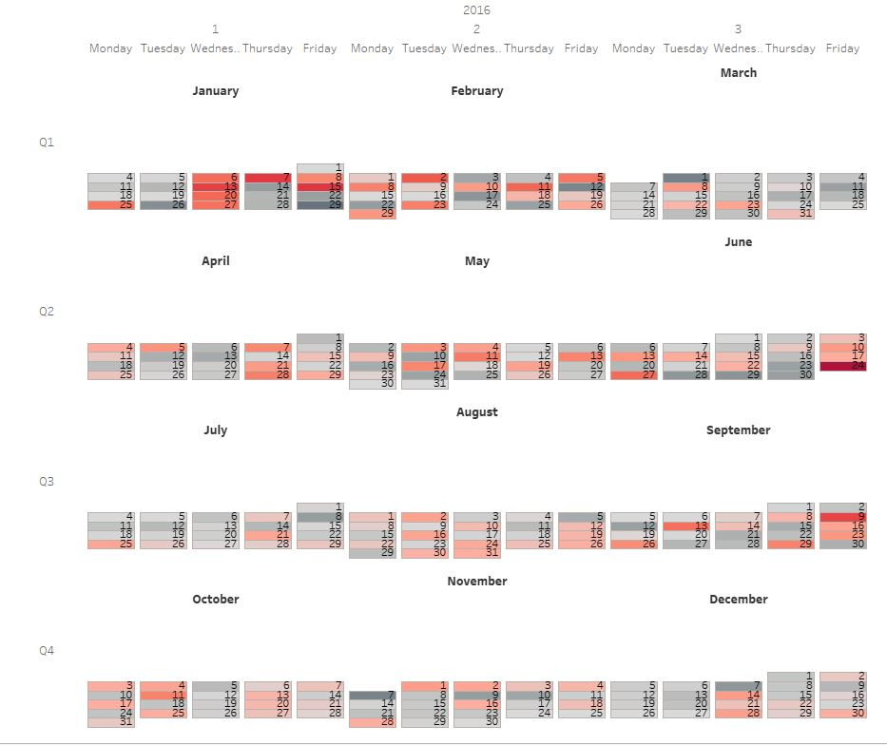

Change the attribute of Week label to Average from Sum.

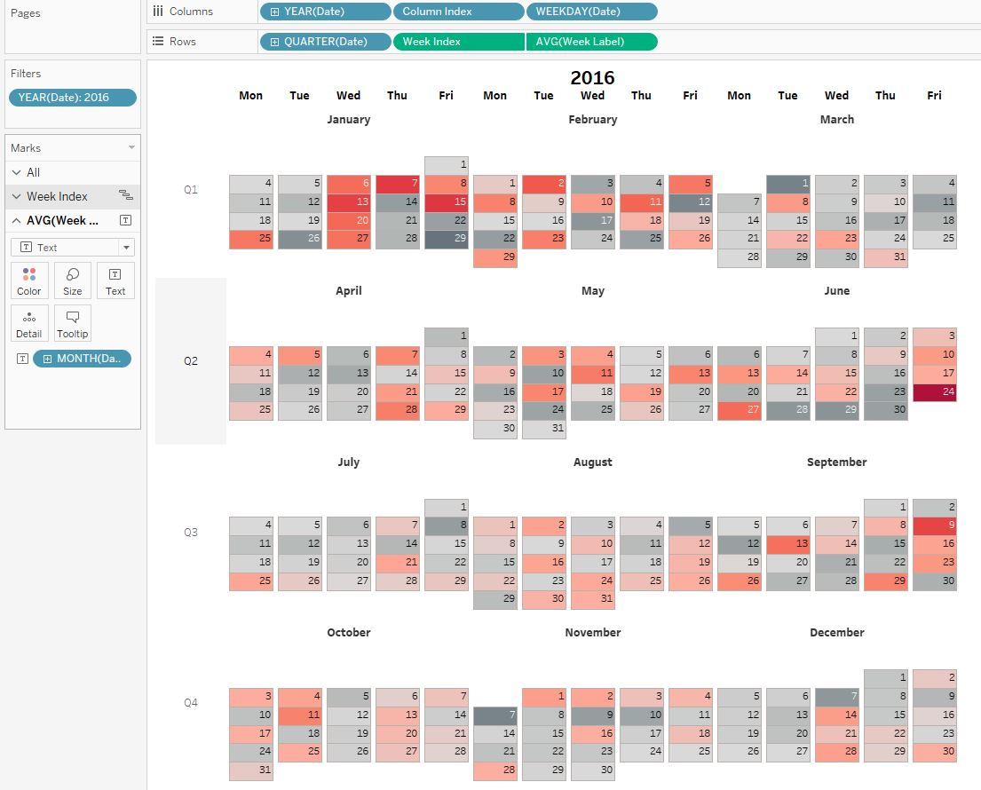

12) We can now use the image in the dashboard and format and align as per the requirement. Change the Desktop size to 800 x 800 pixels.

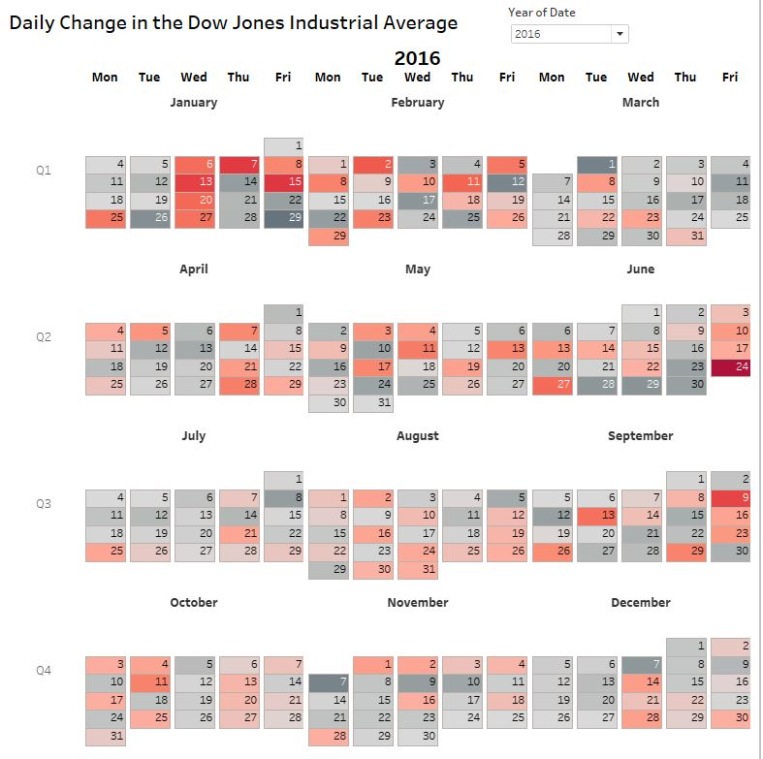

Final dashboard as per requirement