Sum for merged cells

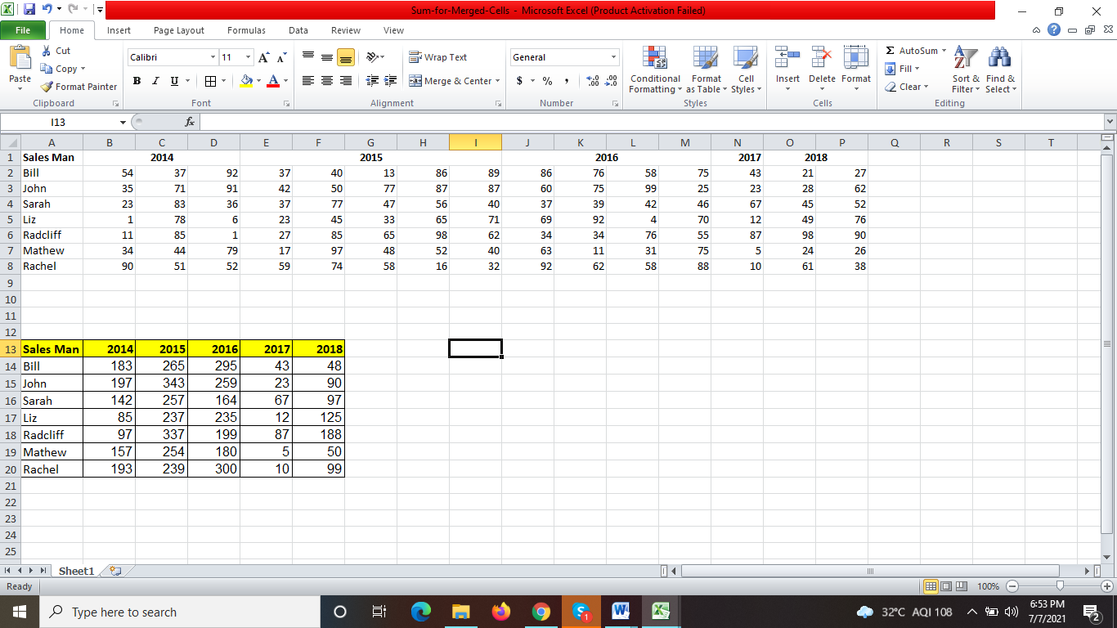

formula: =SUM(OFFSET($A$1,ROWS($1:1),MATCH(B$13,$1:$1,0)-1,,IFERROR(MATCH(C$13,$1:$1,0),COUNTA($2:$2)+1)-MATCH(B$13,$1:$1,0)))