We need to fill the blanks in PIC 1 using COUNTIF/COUNTIFS and SUMIF/SUMIFS.

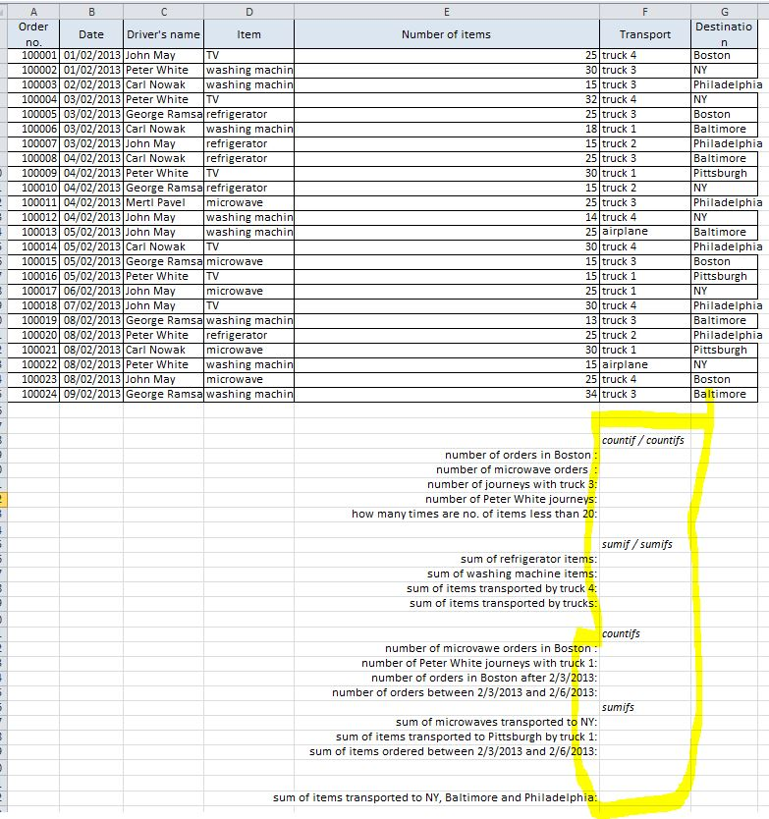

**COUNTIF**is used for counting cells with a single condition in one range.

**COUNTIFS** evaluate different criteria in the same or in different ranges.

We use COUNTIF to fill in the “number of orders in Boston” as in the below picture:

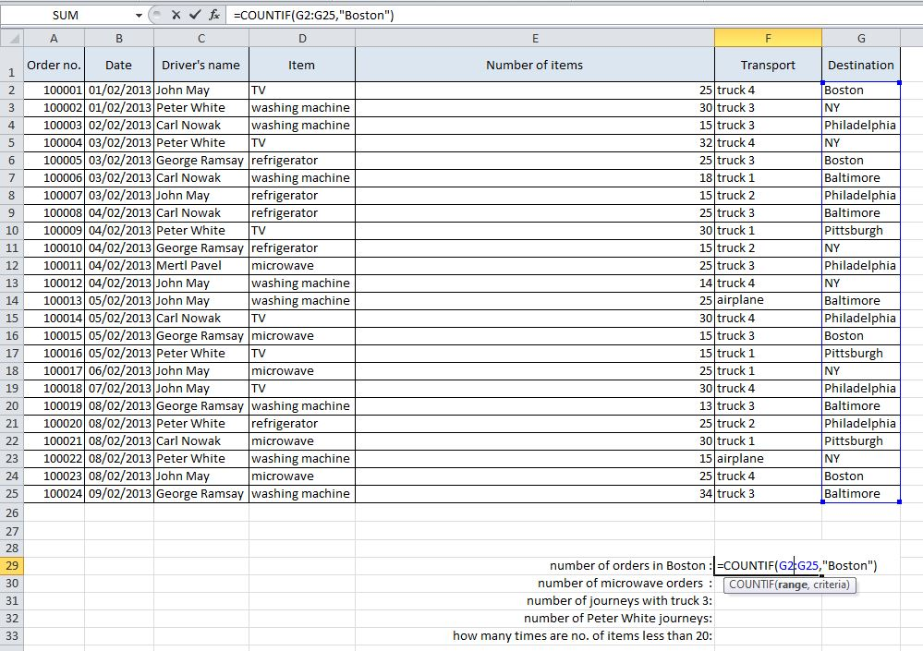

Similarly, we fill in  the remaining :

number of microwave orders  : =COUNTIF(D2:D25,"microwave")

number of journeys with truck 3: =COUNTIF(F2:F25,"truck 3")

number of Peter White journeys: =COUNTIF(C2:C25,"Peter White" )

how many times are no. of items less than 20:

=COUNTIF(E2:E25," < 20")

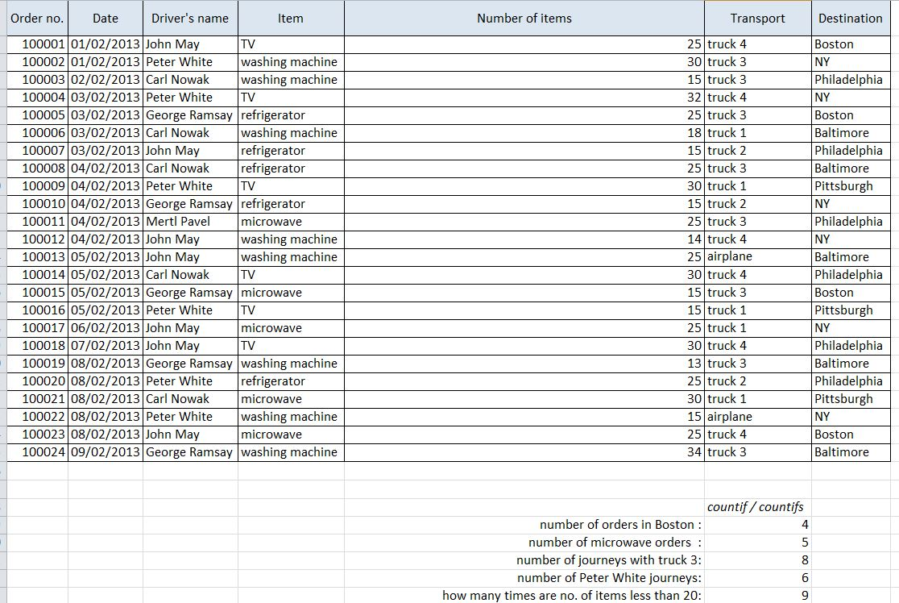

**SUMIFS** function sums cells in a range using supplied criteria.

**SUMIFS** can apply more than one set of criteria, with more than one range.

sum of refrigerator items:  =SUMIF(D2:D25,"refrigerator",E2:E25)

sum of washing machine items: = SUMIF(D2:D25,"washing machine",E2:E25)

sum of items transported by truck 4:=SUMIF(F2:F25,"truck 4",E2:E25)

sum of items transported by trucks: =SUMIF(F2:H39F25,"truck*",E2:E25)

The next exercise was done using the COUNTIF/COUNTIFS and SUMIF/SUMIFS formulas as in the below table:

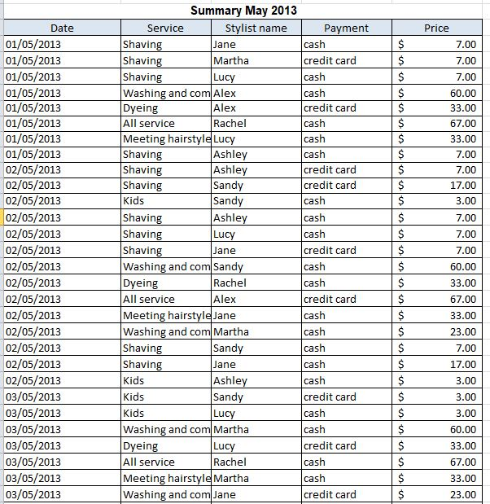

Saample of the data

